Supplementary Figures & Tables
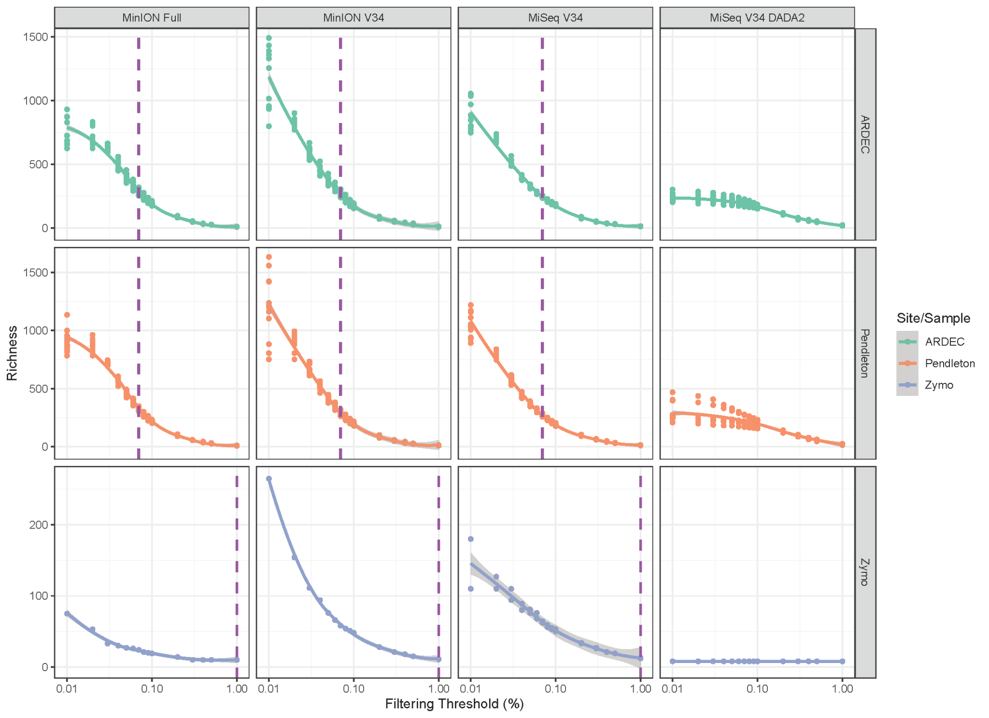
Figure S1. Richness estimates at various filtering thresholds for each of the four sequencing and bioinformatics methods (MinION Full, MinION v34, MiSeq v34, and MiSeq V34 DADA2). Purple dashed line indicates the threshold that is closest to the unfiltered richness estimate from the DADA2 pipeline.

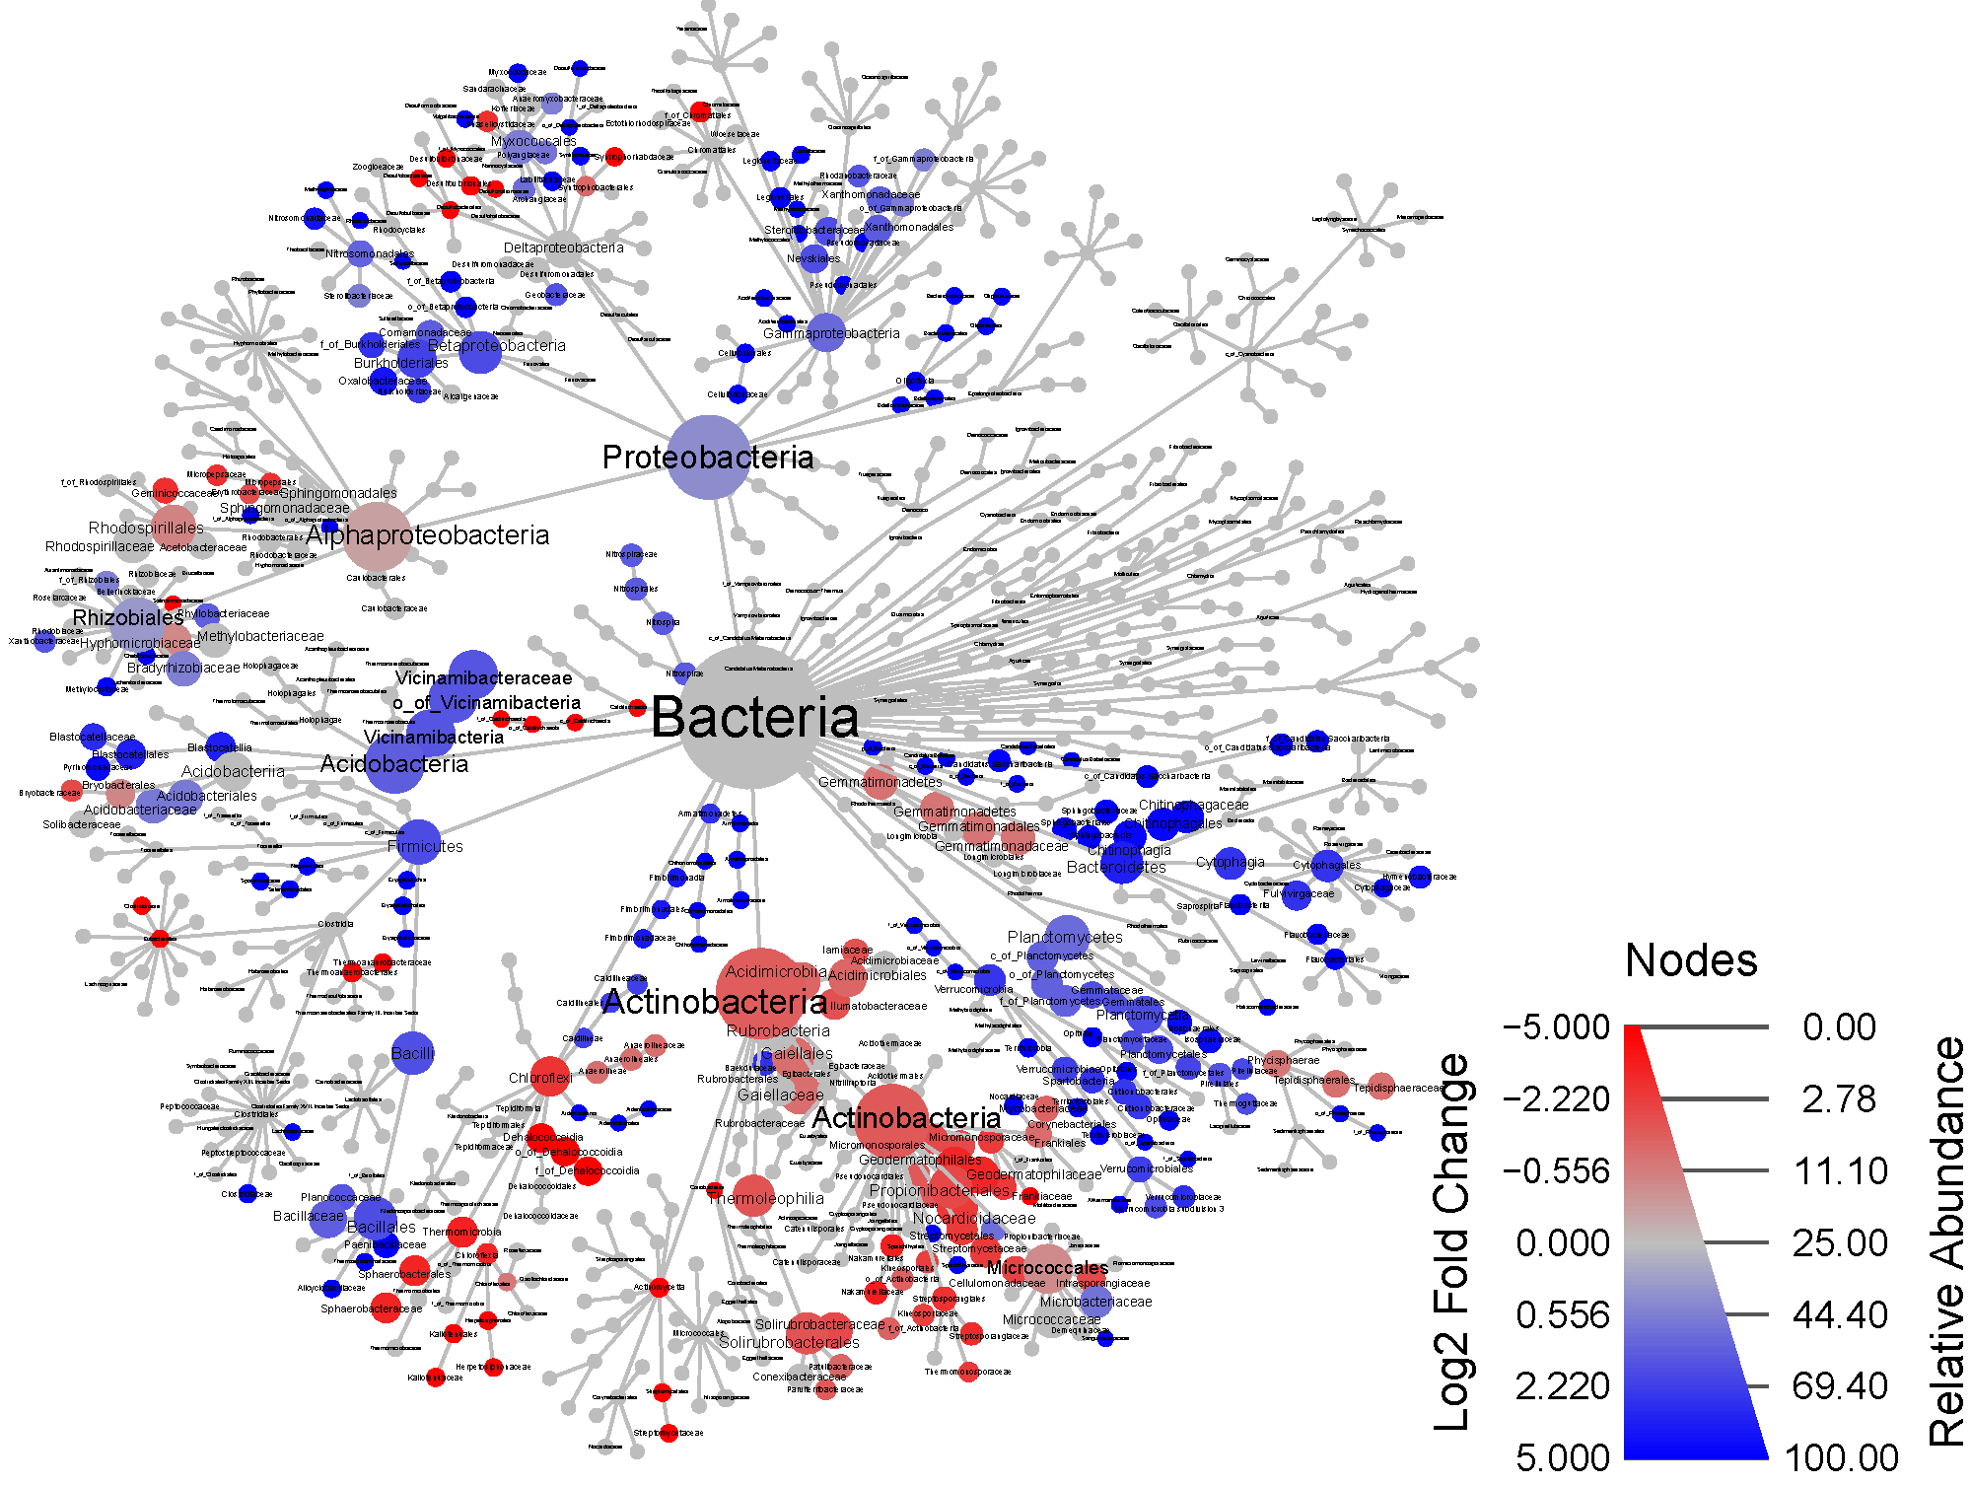
Figure S2. MinION Full vs MiSeq V34 DADA2
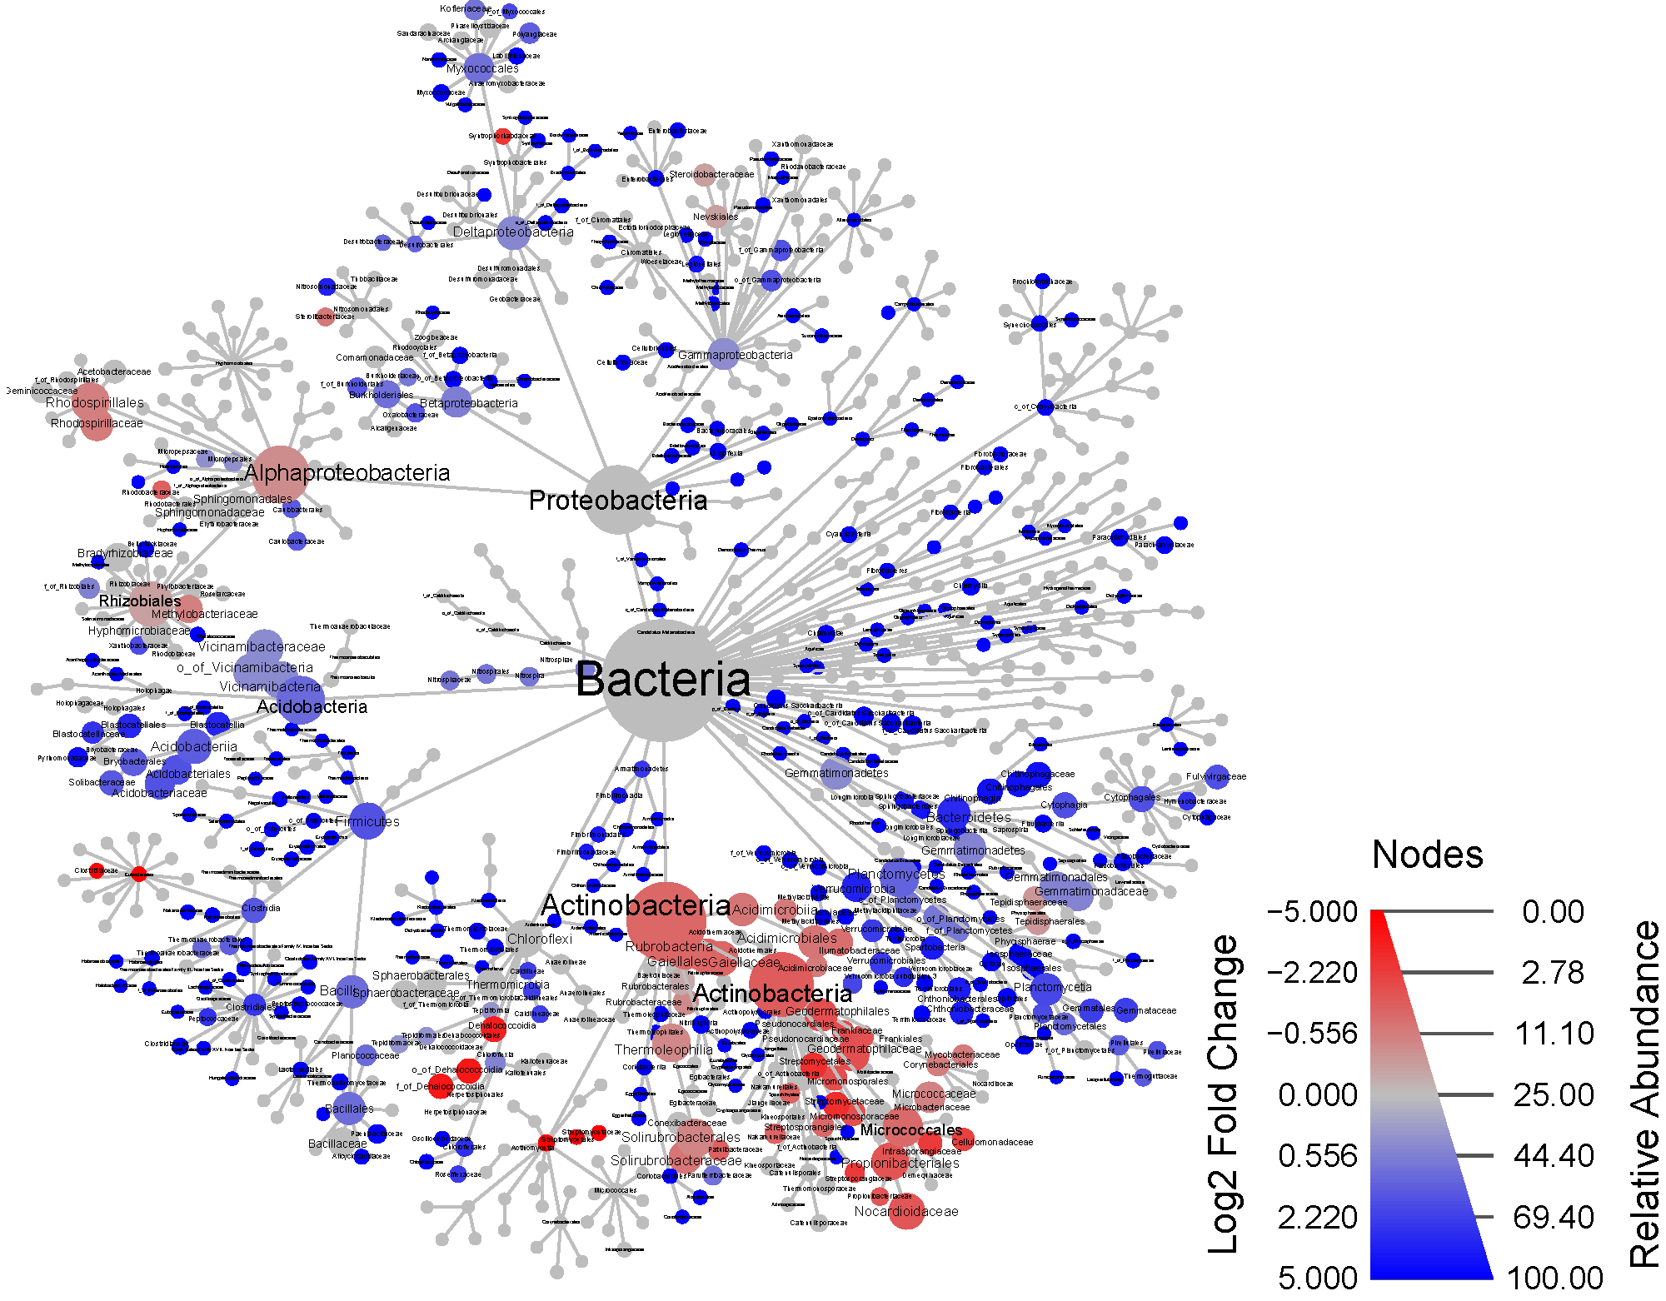
Figure S3. MinION V34 vs MiSeq V34 DADA2

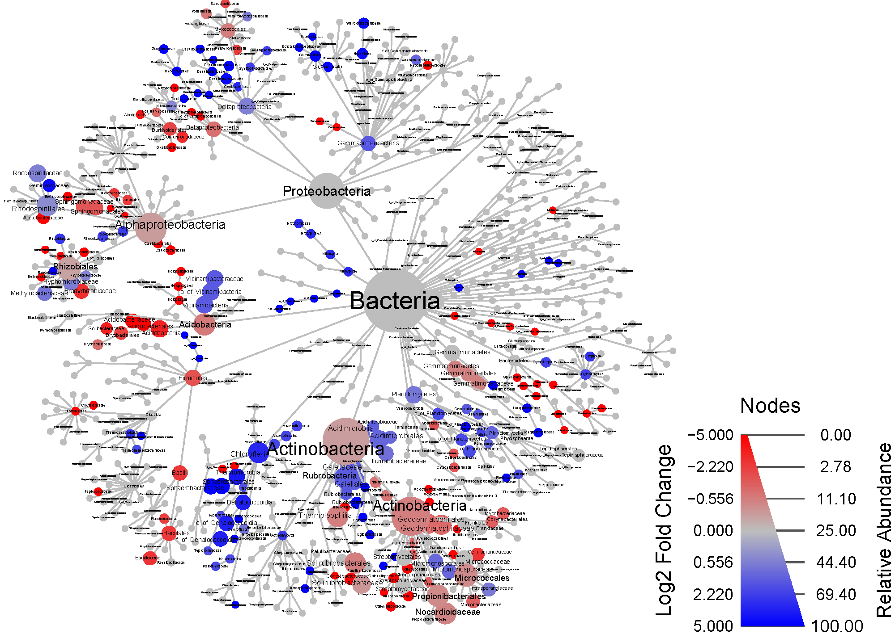
Figure S4. MiSeq V34 vs MiSeq V34 DADA2

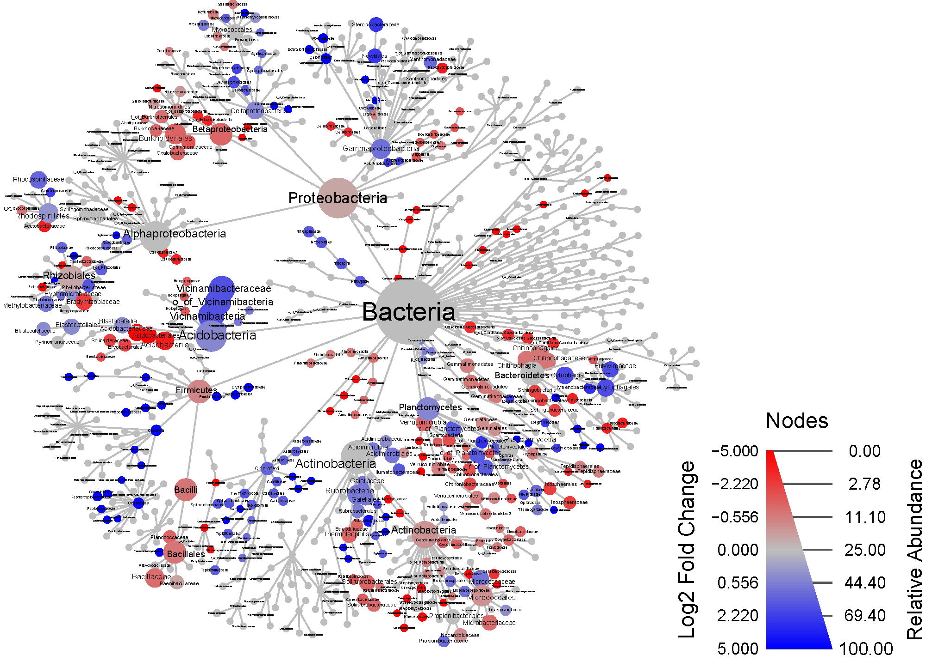
Figure S5. Taxonomic tree comparing site differences with the MinION Full method. Node size is the study-wide average relative abundance. Node color is the log2 median ratio comparing the ARDEC and Pendleton sites, non-significant Wilcox tests (FDR > 0.05) are shown in grey. Each node represents a taxonomic level from Kingdom to Family.

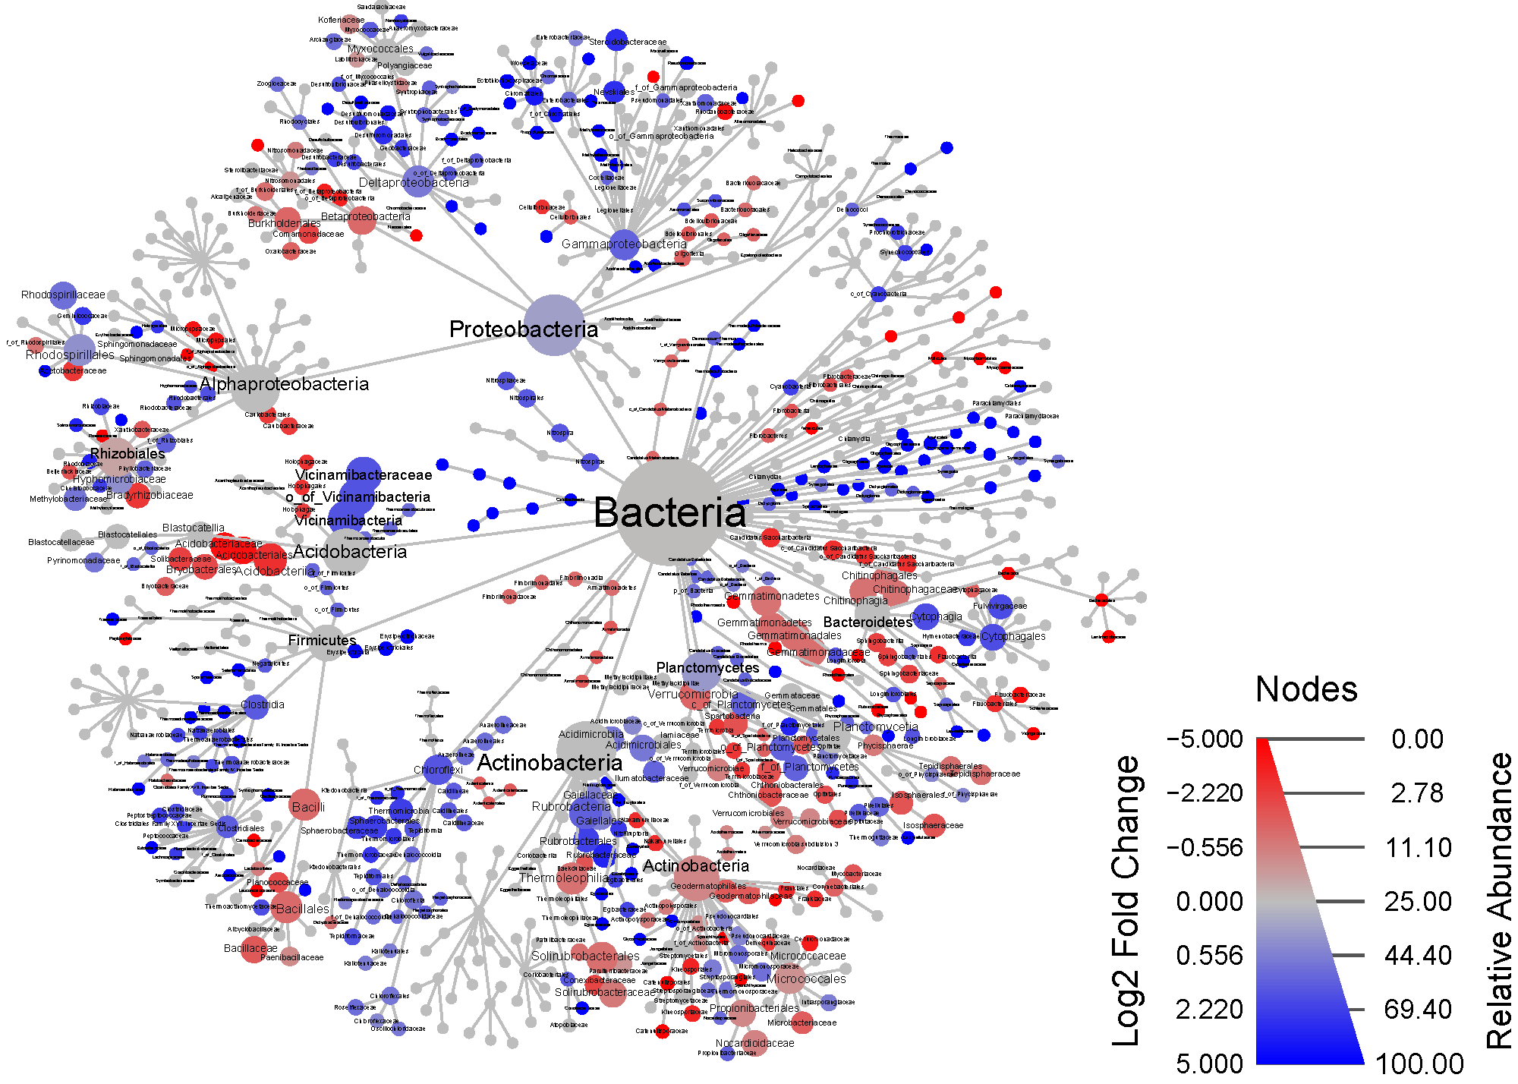

Figure S6. Taxonomic tree comparing site differences with the MinION V34 method. Node size is the study-wide average relative abundance. Node color is the log2 median ratio comparing the ARDEC and Pendleton sites, non-significant Wilcox tests (FDR > 0.05) are shown in grey. Each node represents a taxonomic level from Kingdom to Family.

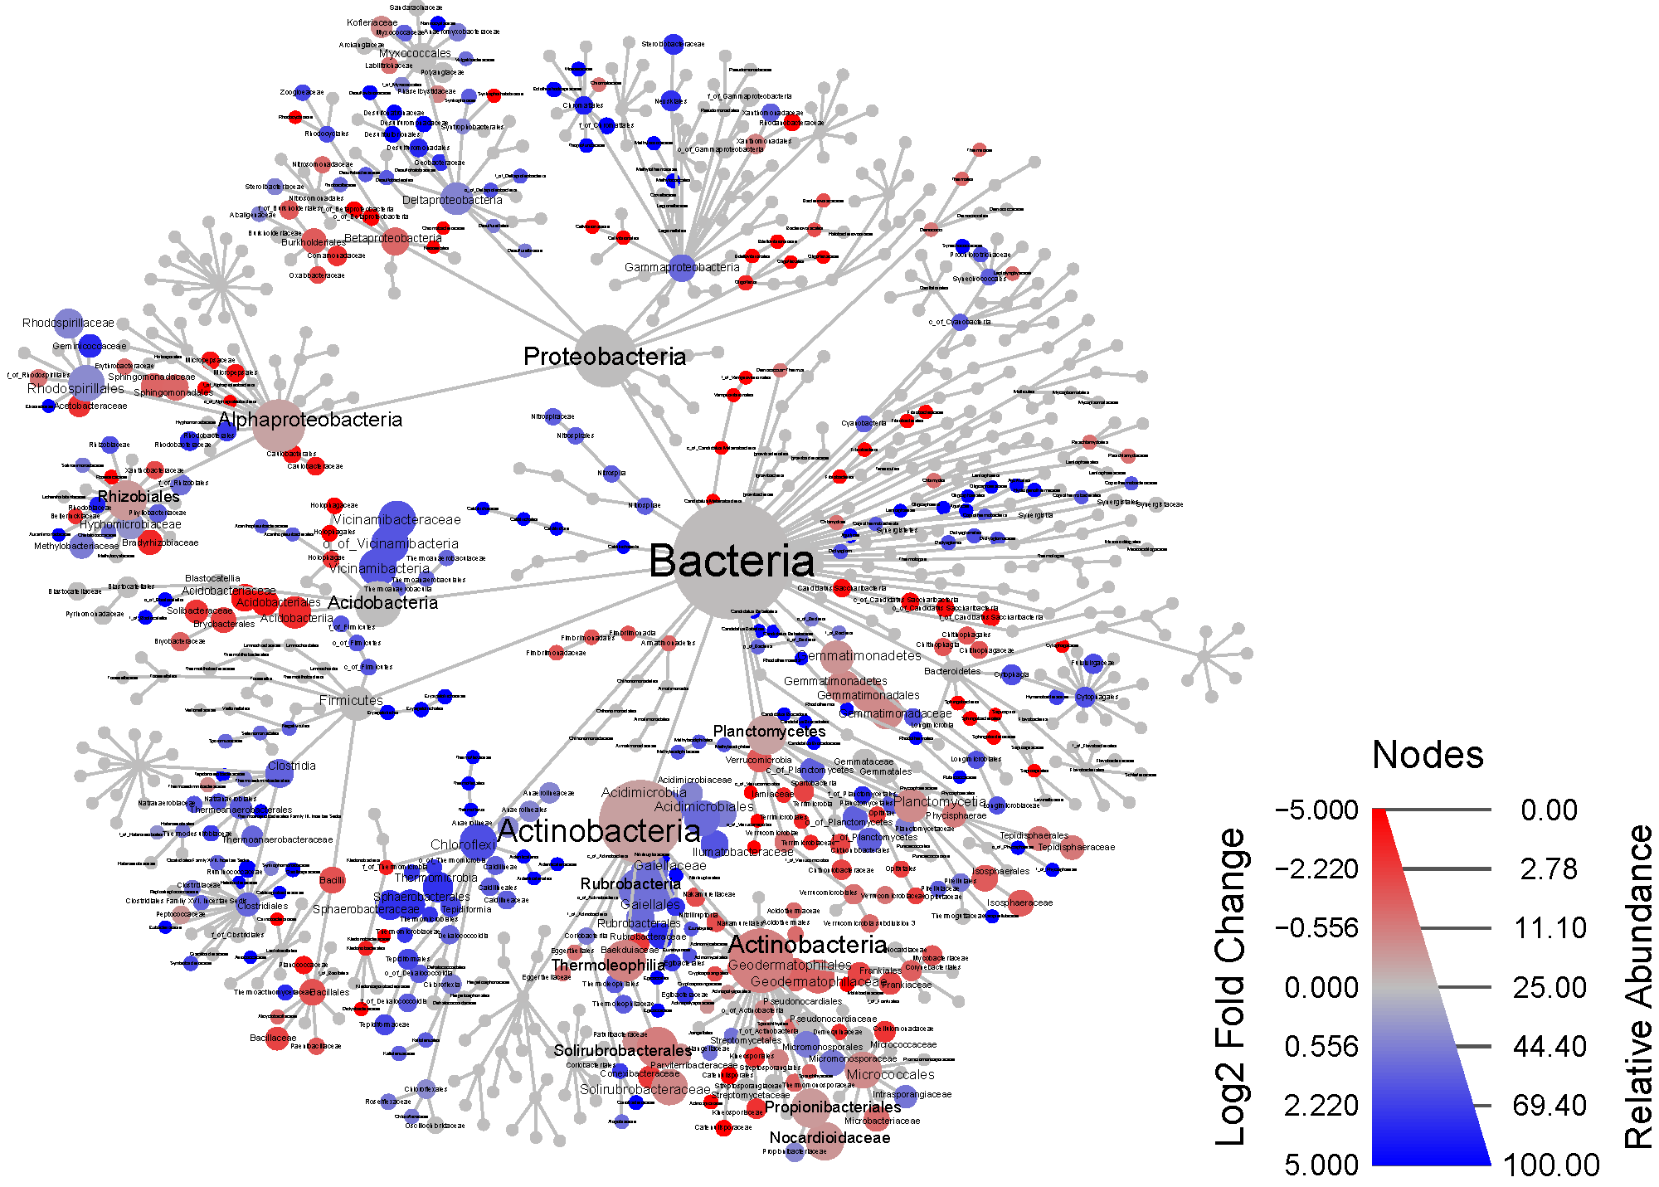
Figure S7. Taxonomic tree comparing site differences with the MiSeq V34 method. Node size is the study-wide average relative abundance. Node color is the log2 median ratio comparing the ARDEC and Pendleton sites, non-significant Wilcox tests (FDR > 0.05) are shown in grey. Each node represents a taxonomic level from Kingdom to Family.

Figure S8. Taxonomic tree comparing site differences with the MiSeq V34 DADA2 method. Node size is the study-wide average relative abundance. Node color is the log2 median ratio comparing the ARDEC and Pendleton sites, non-significant Wilcox tests (FDR > 0.05) are shown in grey. Each node represents a taxonomic level from Kingdom to Family.

