Supplementary information

Supplementary Table 1. Amyloid positive cognitive normal
 | CN (n=78) | CN Aβ+ (n=28)
Female, n (%) | 42 (53.8) | 20 (71.4)
Age (SD) (y) | 72.7±5.9 | 75.1±4.86
Education (SD) (y) | 16.67±2.5 | 16.4±2.6
GCDR (SD) | 0.0 | 0.0
MMSE (SD) | 28.6±1.1 | 28.0±1.9
MADAS-Cog (SD) | 6.4±3.1 | 14.6±8.4
Logical memory I:  Immediate recall (SD) | 13.1±3.3 | 12.5±3.2
Logical memory II:  Delayed recall (SD) | 11.2±3.5 | 10.8±2.3
Subjects with  Amyloid positive | 0 (0) | 28 (100)

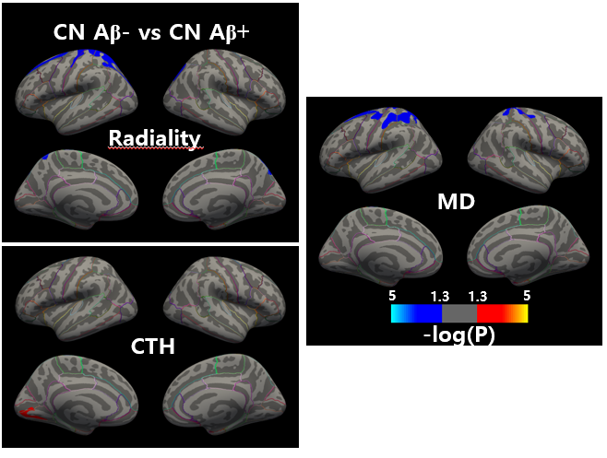
Supplementary Figure 1. Comparison of amyloid negative CN and amyloid positive CN
Group difference in radiality, cortical thickness and mean diffusivity from cognitive normal amyloid negative and positive. Radiality showed decrease in postcentral, CTH showed increase in insula, and MD showed decrease in postcentral cortex. Heat map indicate p-value interval of 0.05 to 10⁻⁵

Supplementary Table 1. Results of cut-off analysis
 | N | Accuracy | Sensitivity | Specificity | AUC
CN vs EMCI | 78 vs 51 | 70.5% | 70.2% | 72.7% | 0.766
CN vs LMCI | 78 vs 34 | 67.9% | 70.6% | 66.7% | 0.757
CN vs (EMCI+LMCI) | 78 vs 85 | 70.5% | 69.4% | 66.7% | 0.766
CN vs AD | 78 vs 39 | 78.6% | 79.5% | 78.1% | 0.867
CN vs (EMCI+LMCI+AD) | 78 vs 124 | 72.8% | 72.3% | 73.1% | 0.798

