Supplementary information
Eligibility criteria
Participants fulfilling all of the following inclusion criteria were eligible for the study:
- informed consent as documented by signature
- age between 18 years and 75 years
- BMI ≥ 30 kg/m2 and < 45 kg/m2
- stable body weight (<5% reported change during the previous 3 months)
- right-handed
- currently non-smoker (or consuming less than 5 cigarettes per day)

The presence of any one of the following exclusion criteria led to exclusion from the study:
- Contraindications to Saxenda®, e.g. known hypersensitivity or allergy to Saxenda®,
- Pregnancy,
- Renal failure (GFR<30 ml/min)
- Liver failure (AST>3N and/or ALT>3N)
- Drugs (e.g., Orlistat, phentermine and topiramate, buproprion and naltrexone taken for the underlying condition, obesity, and any centrally acting medication, glucocorticoides and insulin), were not permitted during the study,
- Known or suspected non-compliance, drug or alcohol abuse,
- Inability to follow the procedures of the study (e.g. due to language problems, psychological disorders, dementia),
- Participation in another study with investigational drug within the 30 days preceding and during the present study,
- Previous enrolment into the current study,
- Enrolment of the investigator, his/her family members, employees and other dependent persons,
- History of any psychiatric diseases, heart failure (NYHA II-IV), type 1 and type 2 diabetes mellitus,
- History of pancreatitis,
- Family or personal history of multiple endocrine neoplasia type 2 or familial medullary thyroid carcinoma,
- Allergies to chocolate, vanilia or strawberry,
- Deficits of smell and taste,
- Contraindications for fMRI (e.g. pacemaker or other implanted devices, claustrophobia).

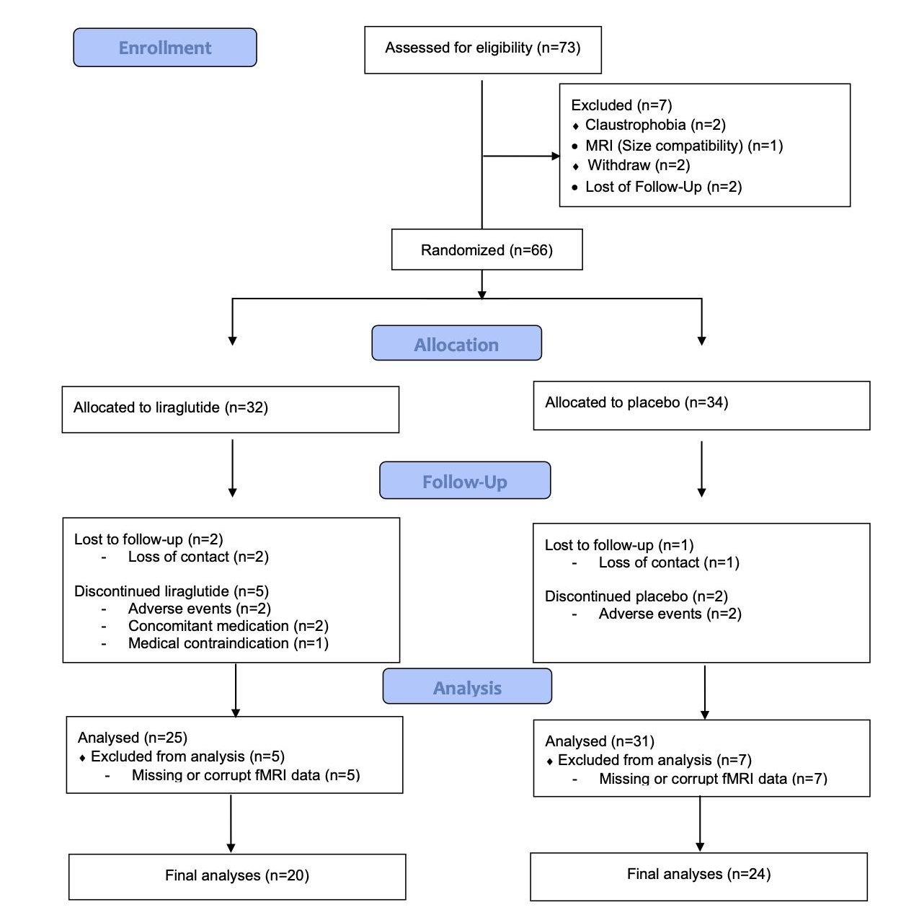
Figure 1. Study flow diagram.

Table 1: Baseline characteristics of the study population
 | Placebo average (SD)/N (%) | Liraglutide average (SD)/N (%) | Test
BMI (kg/m²) | 34.88 (2.87) | 35.89 (3.01) | t(df=41) = -1.12, p = .268, d = 0.34
Age (years) | 40.04 (14.10) | 37.40 (11.18) | t(df=41) = 0.67, p = .504, d = 0.21
Body weight (kg) | 101.70 (9.77) | 102.30 (16.96) | t(df=41) = -0.15, p = .885, d = 0.04
Waist circumference (cm) | 109.57 (9.67) | 110.00 (12.32) | t(df=41) = -0.13, p = .898, d = 0.04
Gender | Chi-square = 0.11, df = 1, p = .739, Phi = 0.05
Female (N) | 8 | 6
Male | 15 | 14

Table 2: Self-reported levels of hunger, as well as pleasantness, intensity and familiarity ratings for the selected tasteless solution and the milkshake at pretest
 | Liraglutide M (SD) | Placebo M (SD) | Test
Hunger level | 2.38 (2.93) | 1.92 (2.17) | t(df=38) = -0.57, p = 0.571
Pleasantness (tasteless) | 5.00 (2.22) | 5.19 (1.69) | t(df=38) = 0.30, p = 0.764
Intensity (tasteless) | 1.88 (2.29) | 2.67 (1.89) | t(df=38) = 1.19, p = 0.242
Familiarity (tasteless) | 5.31 (3.46) | 5.30 (3.20) | t(df=38) = -0.22, p = 0.825
Pleasantness (milkshake) | 7.95 (1.90) | 6.62 (2.97) | t(df=37) = -1.65, p = 0.107
Intensity (milkshake) | 7.36 (1.88) | 7.07 (2.27) | t(df=37) = -0.44, p = 0.666
Familiarity (milkshake) | 8.42 (1.93) | 7.30 (2.78) | t(df=37) = -1.46, p = 0.149

Table 3: Change in secondary end points from baseline to 16-week follow-up

