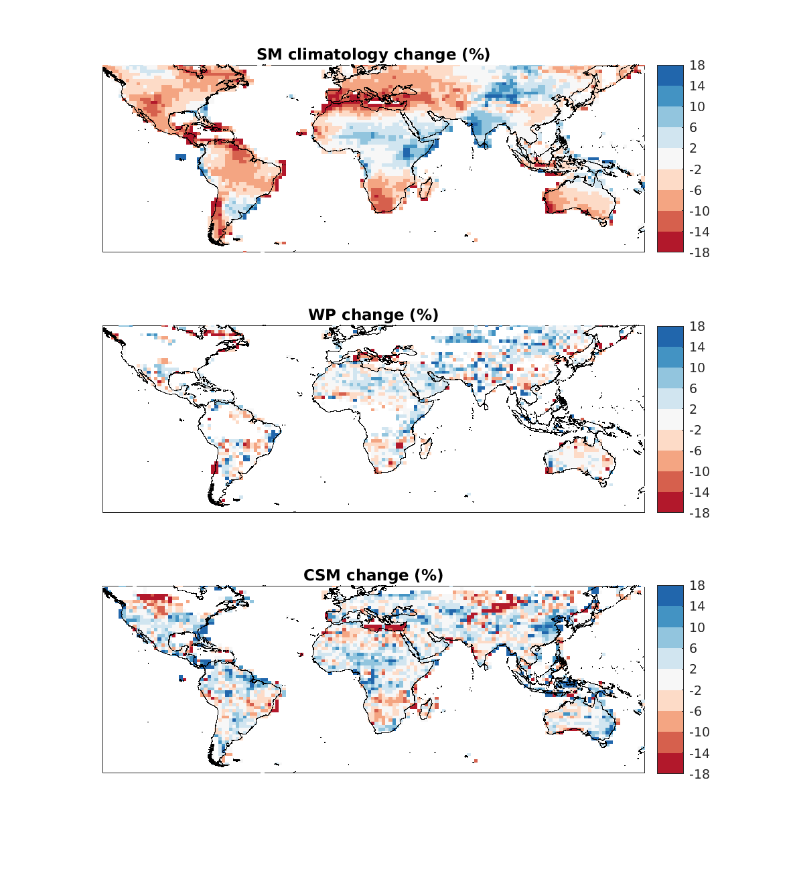

Figure S1. The ensemble mean of the percentage changes for (a) climatological soil moisture, (b) wilting point, and (c) critical soil moisture.
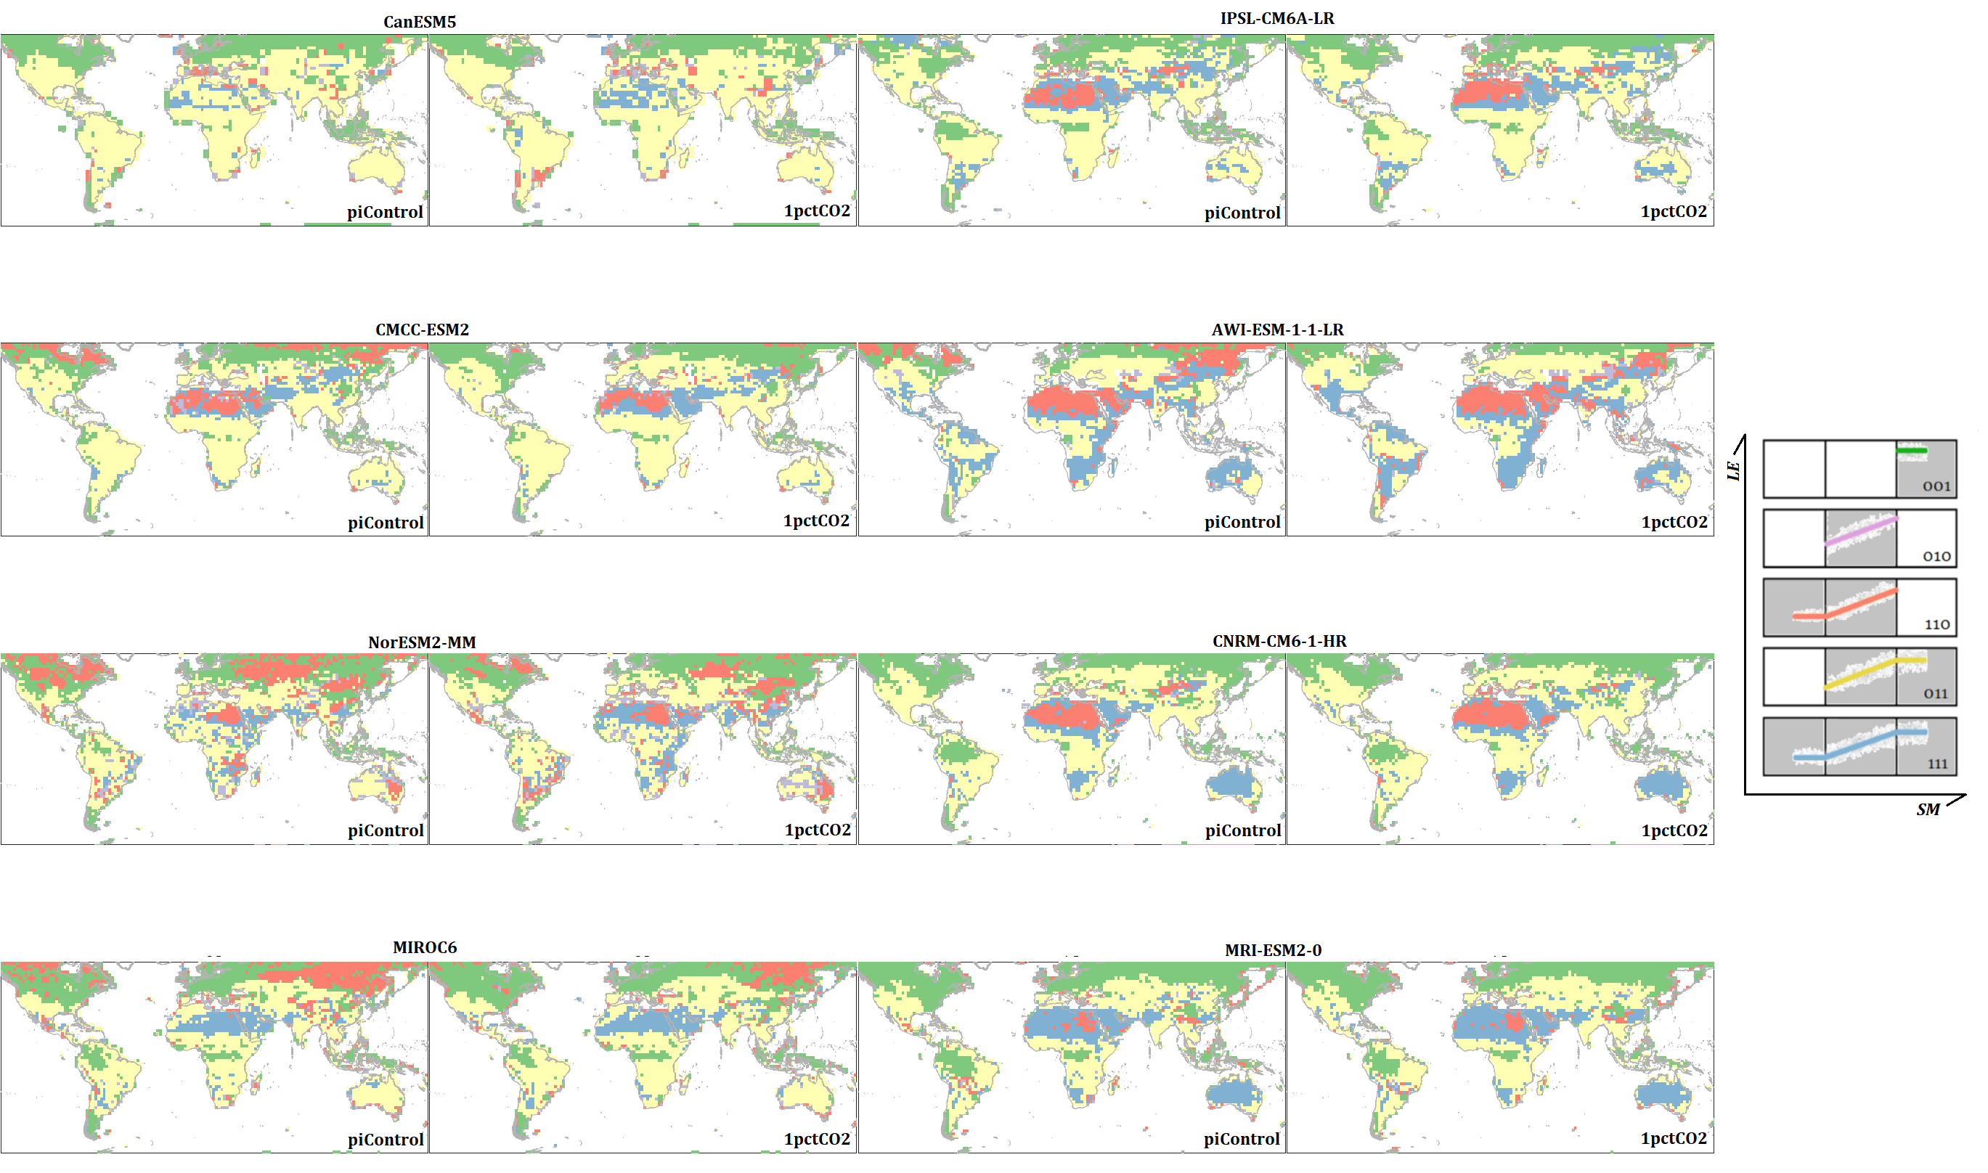
Figure S2. As in Fig.2 for individual climate models in pre-industrial climate (piControl) and warming climate (1pctCO2).
Figure S3. Change from piControl to 1pctCO2 in the fraction of days each model (rows) spends with SM in the indicated regime (columns), expressed as percentages (fraction × 100).

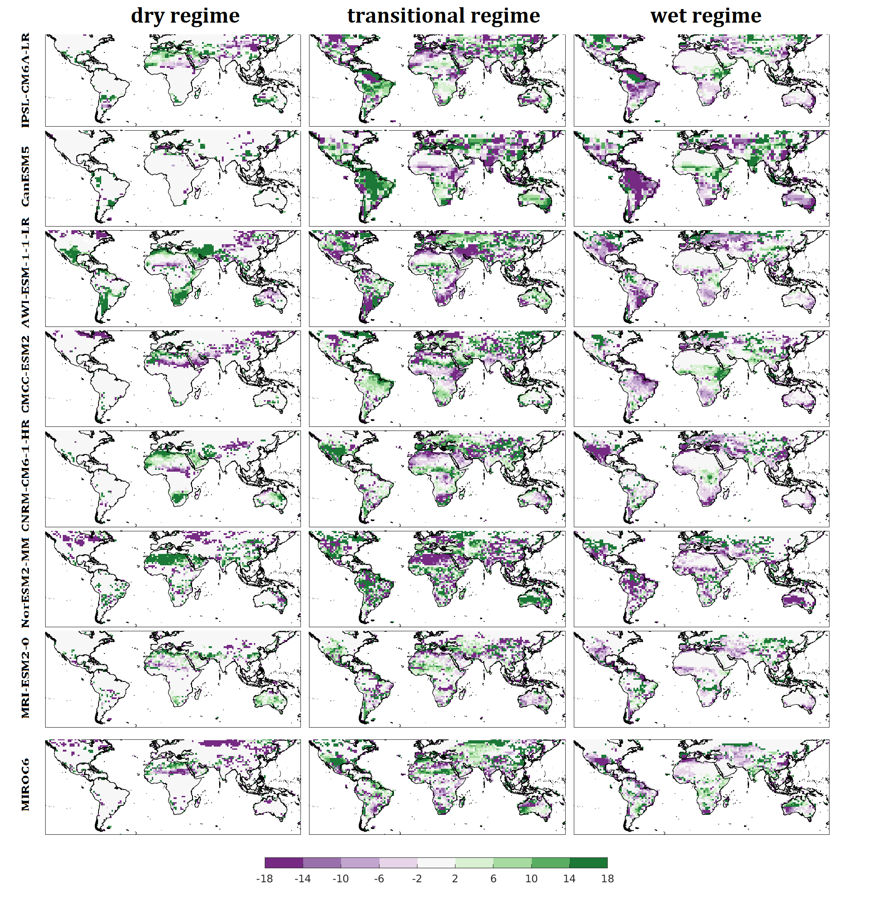
Location:  22°N,16°E | Candidate of  pre-industrial climate | Candidate of  warming climate | Migration  (Shift from/  Shift to)
MIROC6 | C111 | C111 | Dry/Transitional
AWI-ESM-1-1-LR | C110 | C110 | Dry/Transitional
CMCC-ESM2 | C110 | C111 | Dry/Transitional
CanESM5 | C011 | C111 | NA
CNRM-CM6-1-HR | C110 | C110 | Transitional/Dry
NorESM2-MM | C110 | C111 | Transitional/Dry
IPSL-CM6A-LR | C110 | C110 | NA
MRI-ESM2-0 | C110 | C111 | NA
Mode | C110 | C111 | Dry/Transitional
Table S1. An example of how the mode among models is obtained at a grid cell (22°N, 16°E) from soil moisture regimes in pre-industrial climate and warming climate, determined by the best-fit segmented regression candidates indentified in the breakpoint analysis (2nd and 3rd columns). The last column shows the main migration tendency of soil moisture between soil moisture regimes for each climate model (depicted in Fig.S3). If the changes within none of the soil moisture regimes, as calculated from the data shown in Fig.S3, is statistically significant, the model is tagged as NA.

Table S2: CMIP model data citations, resolutions (RES; unit: degree),
CMIP Label | RES  (lat x lon) | Full Citation
AWI-ESM-1-1-LR | 1.875x1.875 | Semmler, T., & Co-authors (2018). AWI AWI-CM1.1MR model output prepared for CMIP6 CMIP. Earth System Grid Federation. doi: https://doi.org/10.22033/ESGF/CMIP6.359.
CNRM-CM6-1-HR | 0.25x0.25 | Voldoire, A. (2018). CNRM-CERFACS CNRM-CM6-1 model output prepared for CMIP6 CMIP. Earth System Grid Federation. doi: https://doi.org/10.22033/ESGF/CMIP6.1375.
IPSL-CM6A-LR | 1.25x2.5 | Boucher, O.; Denvil, S.; Caubel, A.; Foujols, M. A. (2020). IPSL IPSL-CM6A-LR-INCA model output prepared for CMIP6 AerChemMIP. Earth System Grid Federation. doi: https://doi.org/10.22033/ESGF/CMIP6.13581.
MIROC6 | 1.4x1.4 | Takemura, T. (2019). MIROC MIROC6 model output prepared for CMIP6 AerChemMIP. Earth System Grid Federation. doi: https://doi.org/10.22033/ESGF/CMIP6.9121.
CMCC-ESM2 | 0.9375x1.25 | Lovato, T., & Butenschön, M. (2021). CMCC CMCC-ESM2 model output prepared for CMIP6 OMIP (Version 20210127). Earth System Grid Federation. https://doi.org/10.22033/ESGF/CMIP6.13167
CanESM5 | 2.8125x2.8125 | Swart, N. C., & Co-authors (2019). CCCma CanESM5 model output prepared for CMIP6 CMIP. (Version 20190502).Earth System Grid Federation. https://doi.org/10.22033/ESGF/CMIP6.1303
NorESM2-MM | 0.9375x1.25 | Bethke, I. & Co-authors (2019). NCC NorCPM1 model output prepared for CMIP6 CMIP. Earth System Grid Federation. doi: https://doi.org/10.22033/ESGF/CMIP6.10843.
MRI-ESM2-0 | 1.125x1.125 | Yukimoto, S. & Co-authors (2019). MRI MRI-ESM2.0 model output prepared for CMIP6 CMIP. Version.Earth System Grid Federation. https://doi.org/10.22033/ESGF/CMIP6.621

