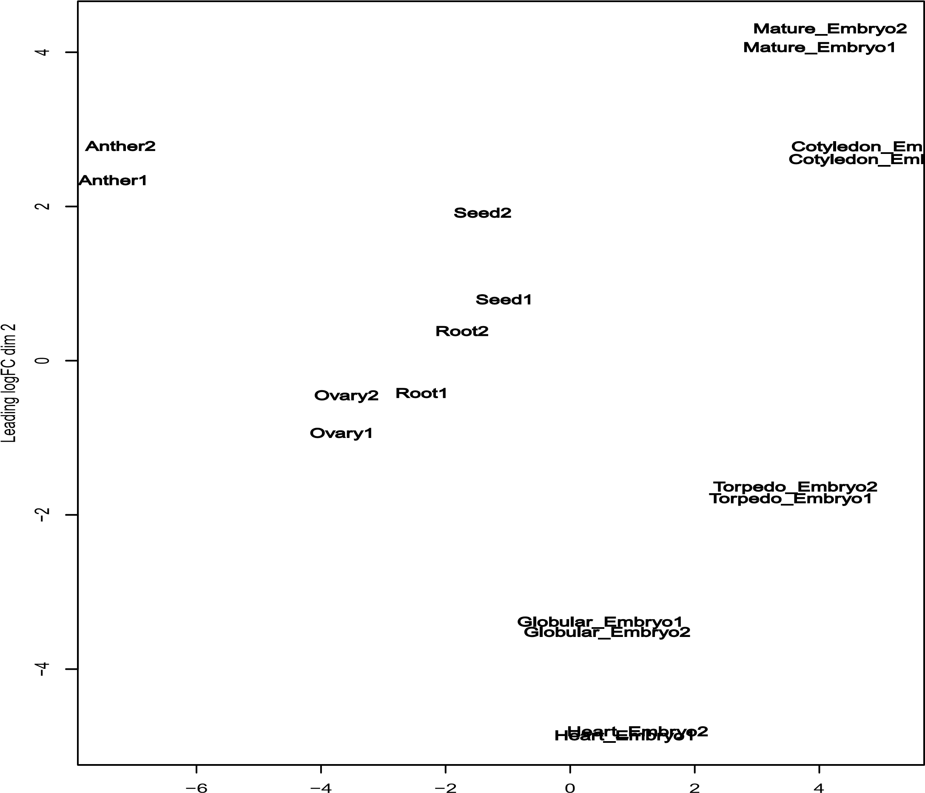

Figure S1. Multidimensional scaling (MDS) plot of nine different organs displaying the relative similarities among the biological replicates based on the log fold change values.

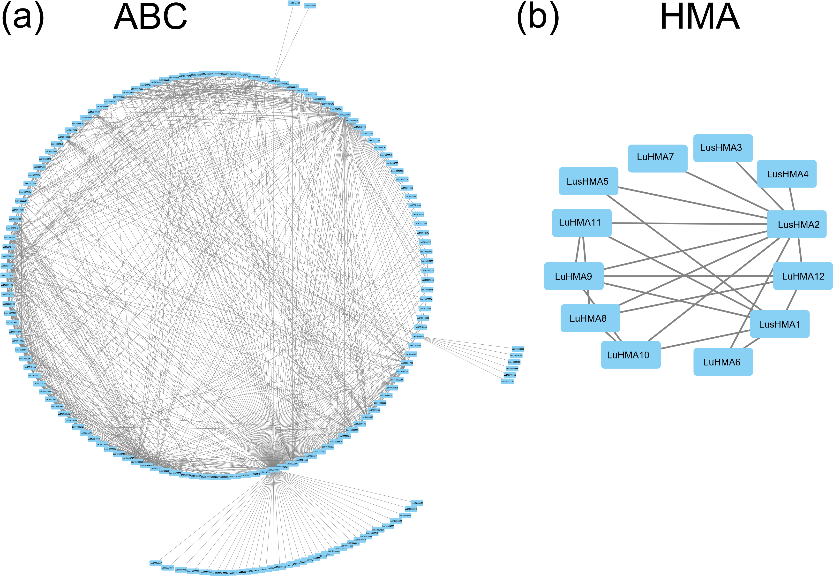

Figure S2. The interaction network of ABC transporter genes (a) and HMA genes (b).

Figure S3. The schematic representations of two most stable genes among nine Cd responsive genes based on their conserved gene structure (a), gene expression (b), non-synonymous/synonymous (c), and Pearson correlation coefficient (PCC) (d).

