Additional file 1
Appendix Table 1. Original and Modified PRISMA-NMA items 2
Appendix Table 2. List of included studies 3
Appendix Figure 1. Number of systematic reviews and network meta-analyses, and per-paper average original PRISMA-NMA score published between 2013 and 2018. 3
Appendix Figure 2. Geographic heat map with published NMAs between 2013 and 2018 4
Appendix Figure 3. Distribution of journal impact factor 4
Appendix Figure 4. Distribution of modified PRISMA-NMA score: a) overall, b) before and after 2015, and c) per journals endorsing or not the PRISMA-NMA guidelines. 5
Appendix Figure 5. Distribution of original PRISMA-NMA score: a) overall, b) before and after 2015, and c) per journals endorsing or not the PRISMA-NMA guidelines 5
Appendix Figure 6. Distribution of modified PRISMA-NMA score per year of publication 6
Appendix Table 3. Univariable and multivariable regression using the original PRISMA-NMA score 7
Appendix Table 4. Assessment of reporting quality per journal with impact factor >10 8
Appendix Figure 7. PRISMA-NMA score per study characteristics 9
Appendix Table 5. Assessment of reporting of NMAs using the modified PRISMA-NMA per year of publication 11
Appendix Figure 8. Distribution of journal impact factor in NMAs published in 2016 and 2017 14

Appendix Table 1. Original and Modified PRISMA-NMA items
* Sub-items were not included in the original or modified PRISMA-NMA score
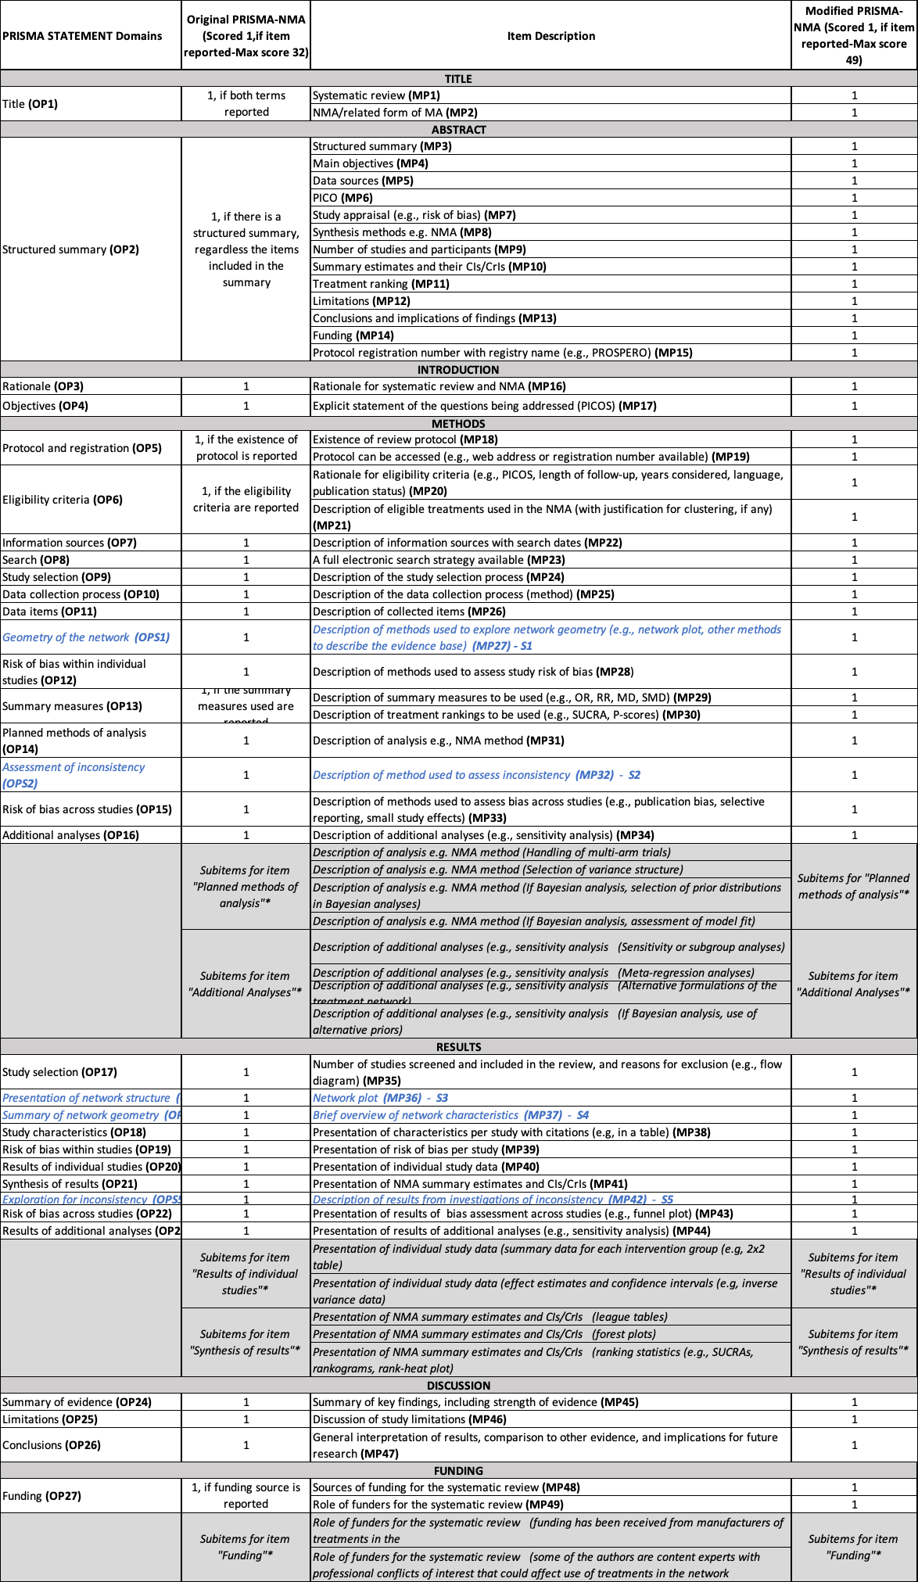

Appendix Table 2. List of included studies
See Supplementary file 2

Appendix Figure 1. Number of systematic reviews and network meta-analyses, and per-paper average original PRISMA-NMA score published between 2013 and 2018.
‘*’ denotes that the search was performed up to July 2018, and thus only 7 months of that year are reflected in this graph
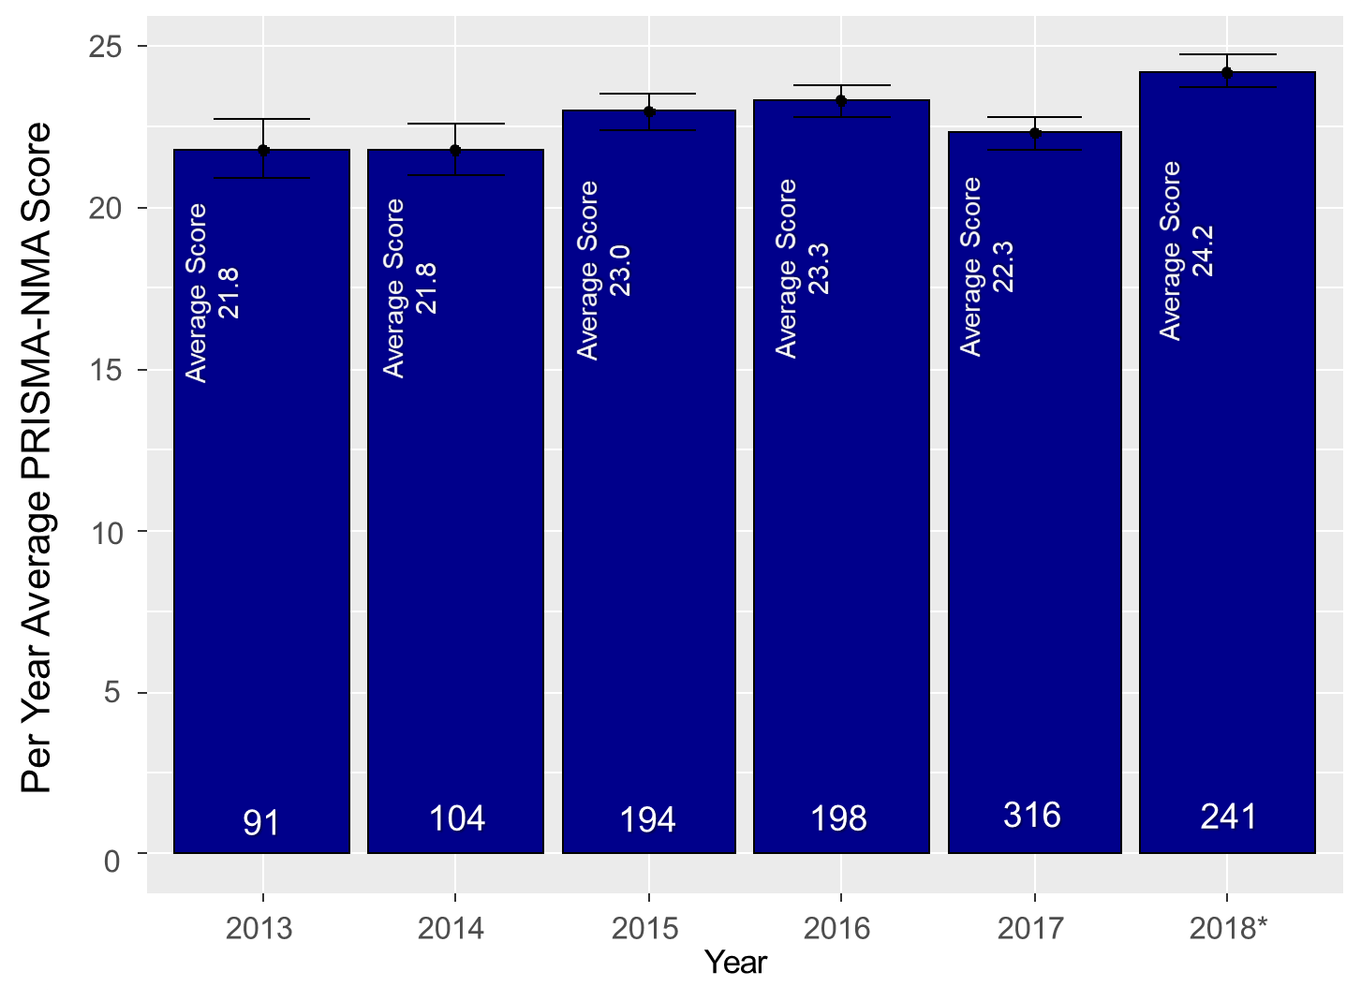

Appendix Figure 2. Geographic heat map with published NMAs between 2013 and 2018

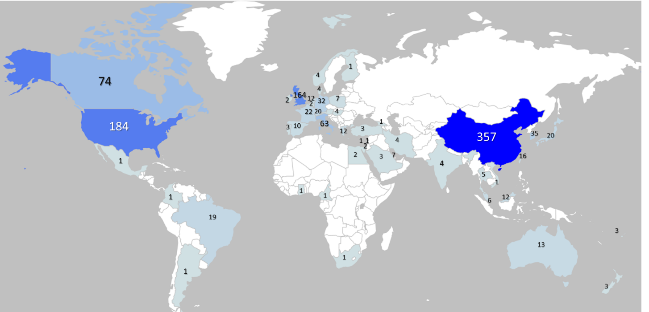

Appendix Figure 3. Distribution of journal impact factor
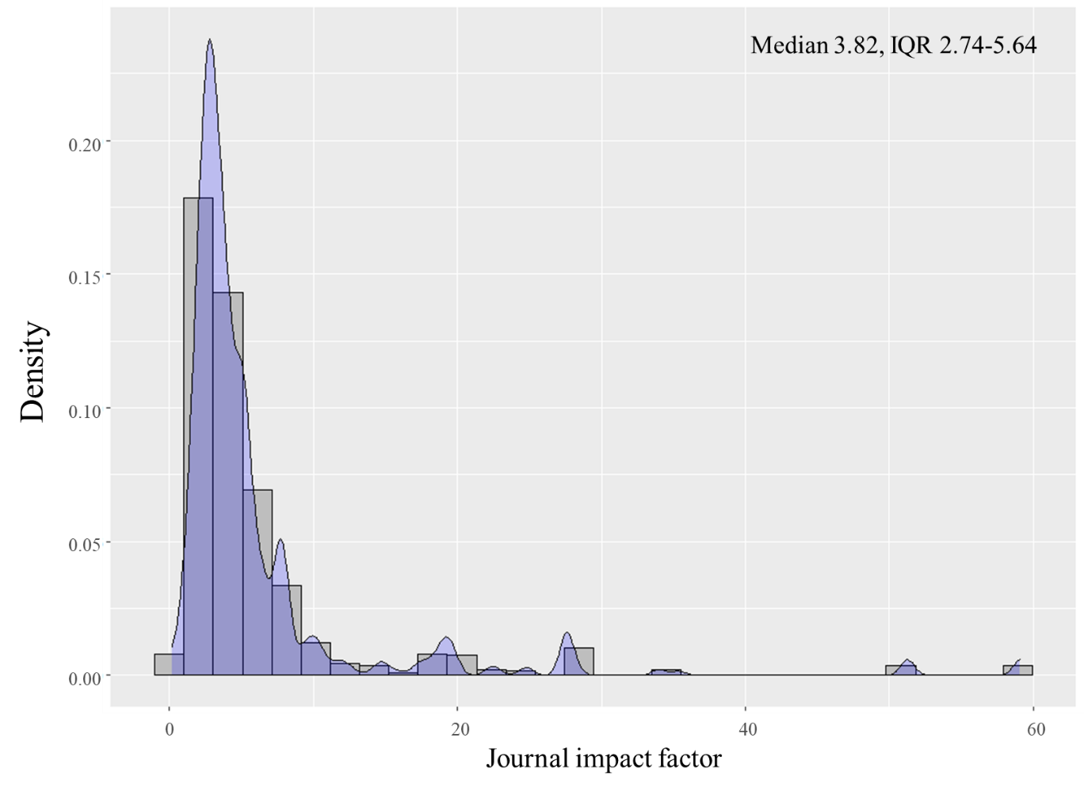

Appendix Figure 4. Distribution of modified PRISMA-NMA score: a) overall, b) before and after 2015, and c) per journals endorsing or not the PRISMA-NMA guidelines.
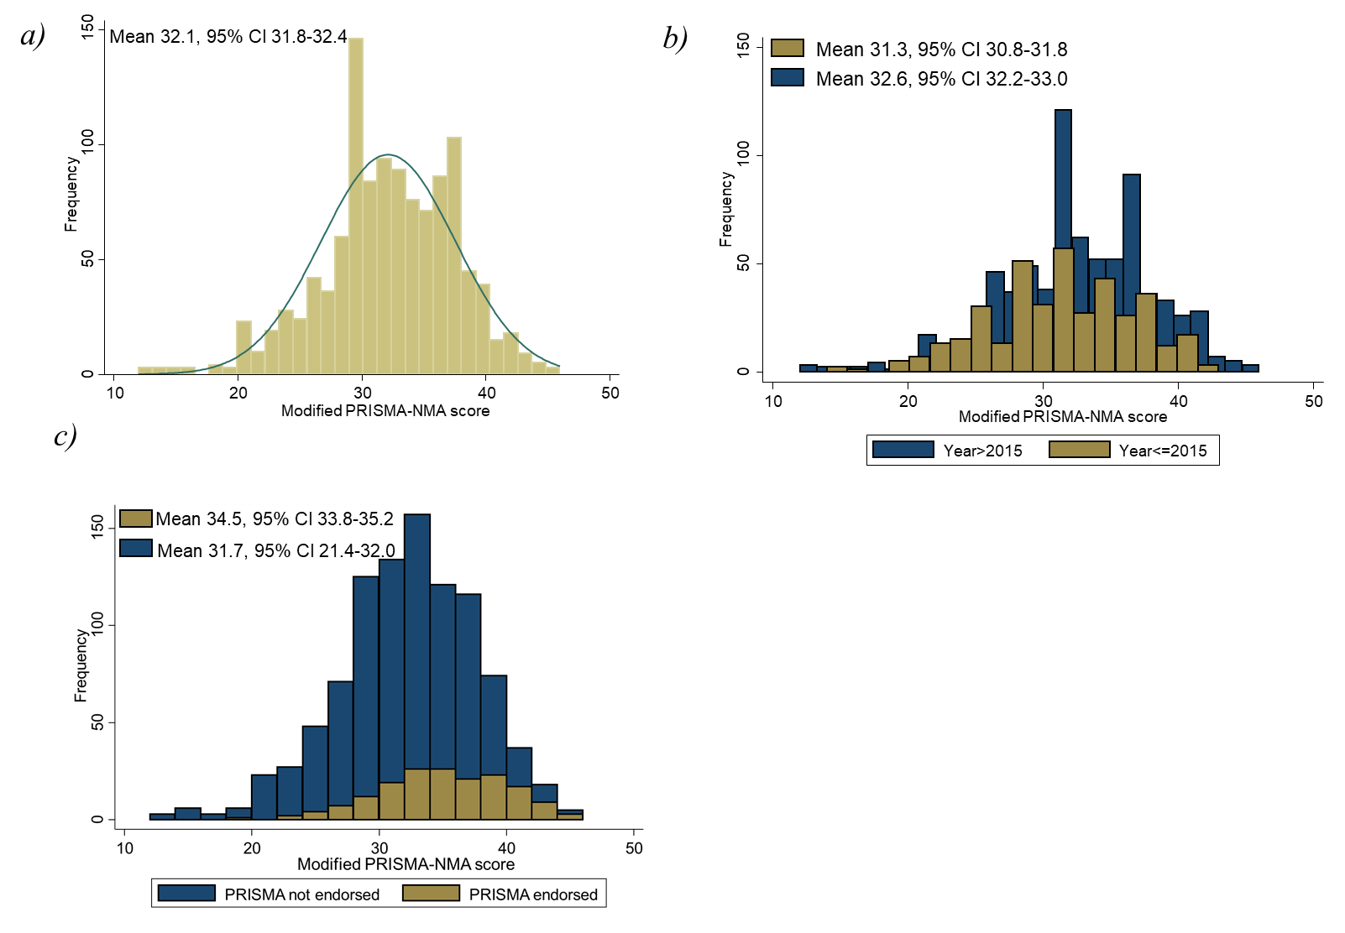

Appendix Figure 5. Distribution of original PRISMA-NMA score: a) overall, b) before and after 2015, and c) per journals endorsing or not the PRISMA-NMA guidelines

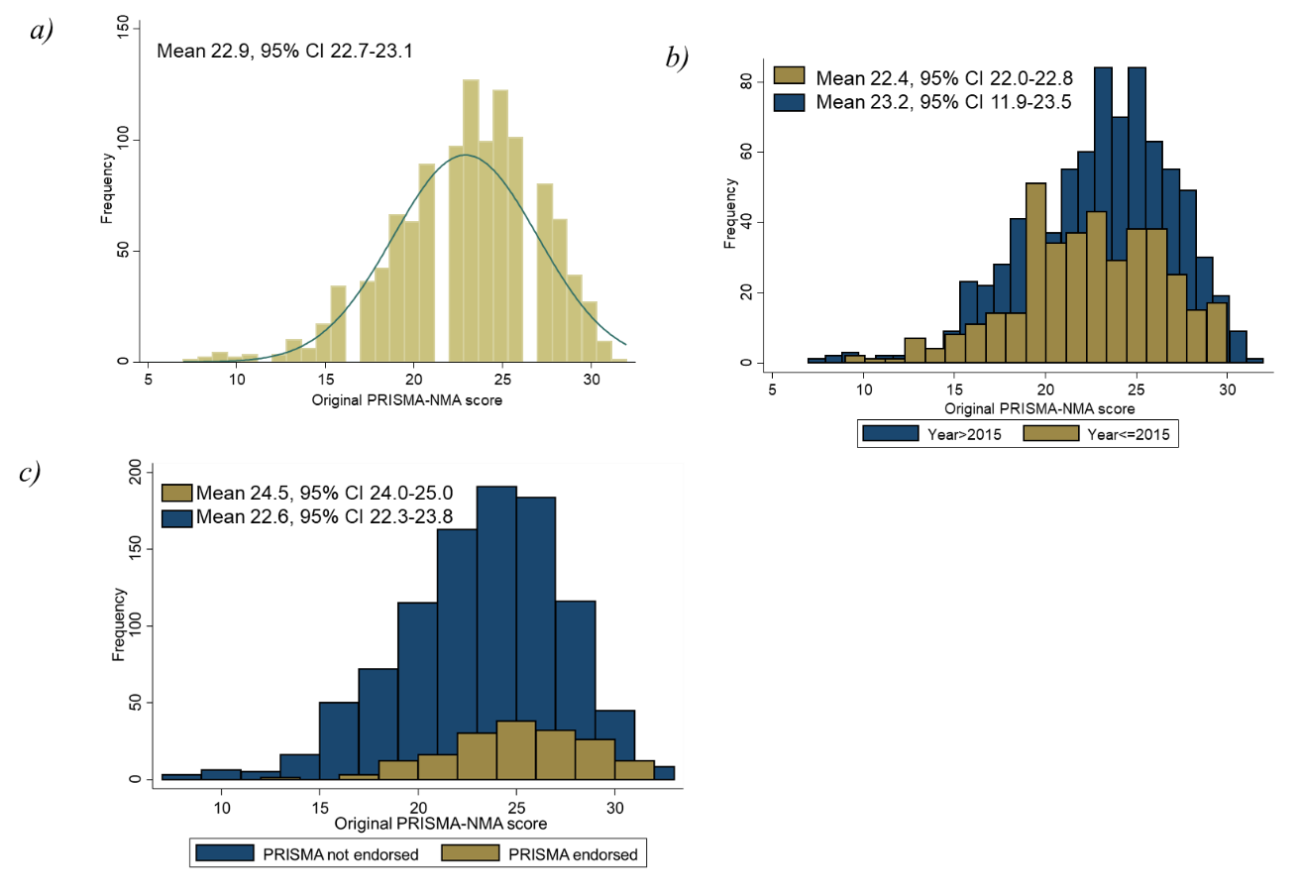

Appendix Figure 6. Distribution of modified PRISMA-NMA score per year of publication

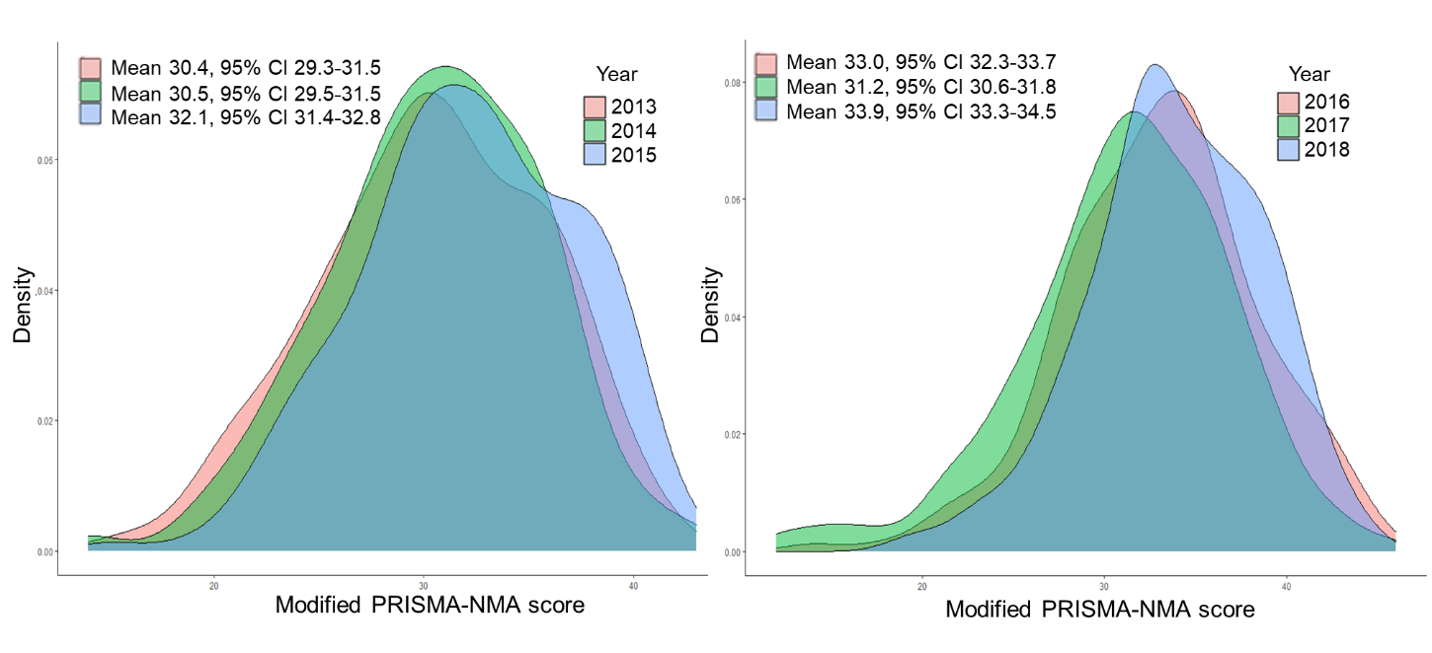

Appendix Table 3. Univariable and multivariable regression using the original PRISMA-NMA score
Covariates | Interpretation of the coefficient | Coefficient (95% CI) |  | Sample size
 |  | Original PRISMA-NMA Score | S1-S5 Score
Univariable analyses and subgroups
Published after 2015 vs until 2015 | Average increase in the score after 2015 | 0.69 (0.21, 1.18) | 0.32 (0.14, 0.49) | Before 2015: 389  After 2015: 755
Year of publication, subgroup: only NMAs published before 2015 | Average increase in the score per year | 0.48 (0.10, 0.86) | 0.22 (0.11, 0.33)
Year of publication, subgroup: only NMAs published after 2015 | Average increase in the score per year | 0.77 (0.28, 1.28) | 0.48 (0.32, 0.64)
Multivariable analyses
Year of publication | Average increase in the score per year | 0.46 (0.01, 0.92) | 0.44 (0.28, 0.60) | Year 2013: 91  Year 2014: 104  Year 2015: 194  Year 2016: 198  Year 2017: 316  Year 2018: 241
Treatment type | Average increase in the score if network includes pharmacological treatments | -0.52 (-1.06, 0.00) | -0.19 (-0.37, 0.00) | Pharmacological treatments: 907  Non-pharmacological treatments : 237
Funding type | Average increase in the score if non-sponsored/publicly-sponsored | 1.01 (0.40, 1.62) | 0.50 (0.29, 0.71) | Non-sponsored/publicly-sponsored: 974  Industry sponsored: 170
Review type | Average increase in the score if protocol exists | -3.49 (-3.97, -3.00) | -0.31 (-0.48, -0.14) | With protocol: 313  Without protocol: 831
Impact factor | Average increase in the score per impact factor increase (1 unit) | 0.06 (0.03, 0.09) | 0.02 (0.01, 0.03)

Appendix Table 4. Assessment of reporting quality per journal with impact factor >10
In bold we highlight journals that endorse the PRISMA checklist
Journal  (Impact Factor >10) | Total # of NMAs | Percentage of reported items in NMAs published <=2015 (mean) | Percentage of reported items in NMAs published >2015 (mean) | Mean Percentage Difference  (95% CI) | Percentage of reported items in NMAs published <=2015 (mean) | Percentage of reported items in NMAs published >2015 (mean) | Mean Percentage Difference  (95% CI)
 | Original PRISMA-NMA score |  |  |  | Modified PRISMA-NMA score
Lancet (60.392) | 8 | 78% | 87% | 9% ( -5%, 23%) | 76% | 84% | 8%(-3%, 21%)
Jama-Journal Of The American Medical Association (45.54) | 8 | 73% | 85% | 12% (6%, 19%) | 67% | 80% | 13% (8%, 17%)
World Psychiatry (40.595) | 3 | 72% | 83% | 11%* | 65% | 77% | 12%*
Lancet Oncology (33.752) | 2 | 81% | NA | NA | 72% | NA | NA
Journal of Clinical Oncology (32.956) | 1 | NA | 56% | NA | NA | 55% | NA
Bmj (30.223) | 21 | 79% | 88% | 9% (1%, 15%) | 71% | 82% | 11% (4%, 19%)
Lancet Diabetes & Endocrinology (25.34) | 1 | 78% | NA | NA | 76% | NA | NA
Jama Oncology (24.799) | 4 | 72% | 66% | -6%* | 65% | 62% | -3%*
Circulation (23.603) | 1 | 75% | NA | NA | 67% | NA | NA
European Heart Journal (22.673) | 3 | NA | 57% | NA | NA | 50% | NA
Annals Of Internal Medicine (21.317) | 11 | 81% | 85% | 4% (-6%, 15%) | 79% | 80% | 1% (-6%,8%)
Journal Of The American College Of Cardiology (20.589) | 4 | 64% | 69% | 5%* | 56% | 59% | 3%*
Gut (19.819) | 3 | NA | 84% | NA | NA | 76% | NA
Annals Of Oncology (18.274) | 1 | NA | 65% | NA | NA | 67% | NA
European Urology (17.947) | 5 | 69% | 72% | 3% (-19%, 25%) | 63% | 64% | 1% (-15%, 17%)
Intensive Care Medicine (17.679) | 4 | 66% | 70% | 4%* | 61% | 65% | 4%*
Jama Psychiatry (17.471) | 2 | NA | 77% | NA | NA | 74% | NA
Gastroenterology (17.373) | 5 | 86% | 86% | 0% (-12%, 11%) | 76 | 78% | 2% (-8%, 12%)
Lancet Psychiatry (16.209) | 2 | NA | 84% | NA | NA | 85% | NA
Lancet Hiv (14.813) | 3 | 78% | 81% | 3%* | 69% | 76% | 7%*
Lancet Gastroenterology & Hepatology (14.789) | 1 | NA | 75% | NA | NA | 69% | NA
Hepatology (14.679) | 2 | 81% | 84% | 3%* | 73% | 73% | 0%*
Jama Surgery (13.625) | 1 | NA | 91% | NA | NA | 82% | NA
Jama Neurology (13.608) | 1 | 75% | NA | NA | 65% | NA | NA
Journal Of Thoracic Oncology (13.357) | 2 | 50% | 34% | -16%* | 45% | 31% | -14%*
Jama Cardiology (12.794) | 1 | NA | 88% | NA | NA | 78% | NA
British Journal Of Sports Medicine (12.022) | 4 | 59% | 85% | 26%* | 55% | 78% | 23%*
European Journal Of Heart Failure (11.627) | 1 | 53% | NA | NA | 53% | NA | NA
Jnci-Journal Of The National Cancer Institute (11.577) | 4 | 75% | 80%% | 5%* | 69% | 71% | 2%*
Ageing Research Reviews (10.616) | 1 | NA | 8% | NA | NA | 78% | NA
Plos Medicine (10.5) | 2 | 72% | 97% | 25* | 69% | 92% | 23%*
Journal Of Allergy And Clinical Immunology (10.228) | 1 | 66% | NA | NA | 57% | NA | NA
American Journal Of Gastroenterology (10.171) | 2 | NA | 77% | NA | NA | 67% | NA
Annals Of Surgery (10.13) | 2 | 66% | 56% | -1%* | 61% | 53% | -8%*
Clinical Cancer Research (10.107) | 1 | 41% | NA | NA | 41% | NA | NA
* Inadequate number of studies per group to calculate a 95% confidence interval

Appendix Figure 7. PRISMA-NMA score per study characteristics

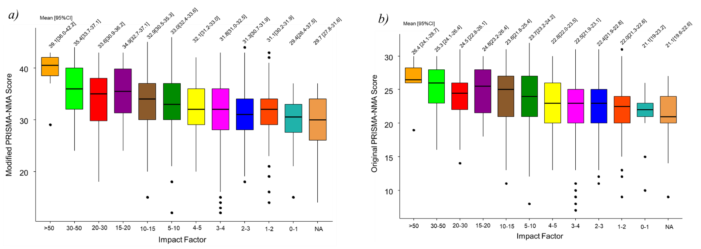
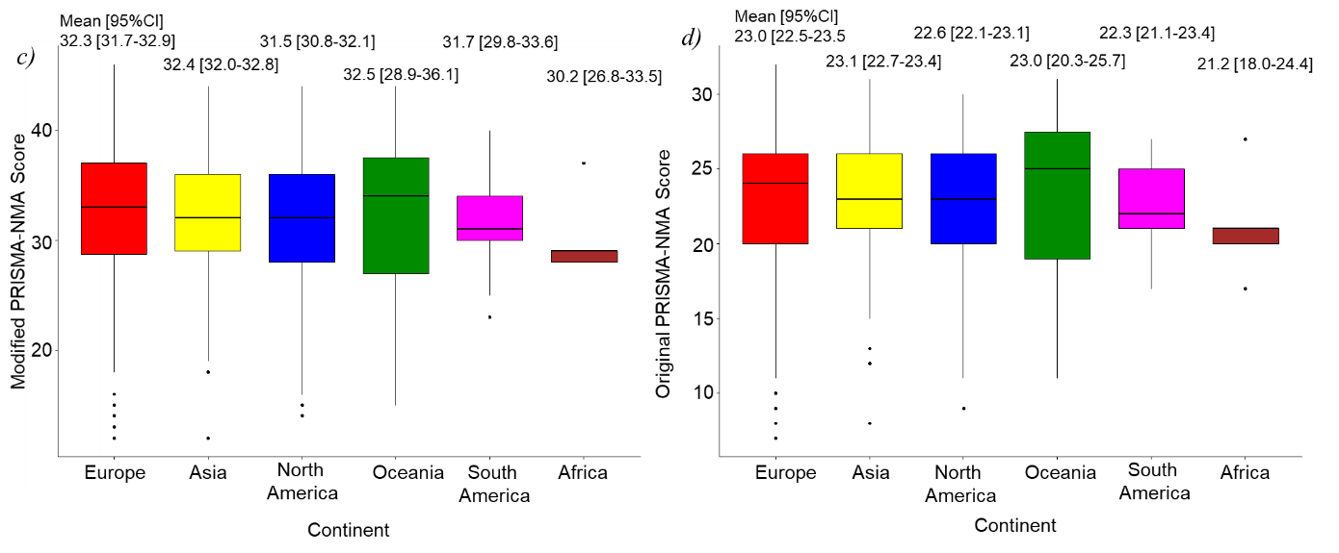

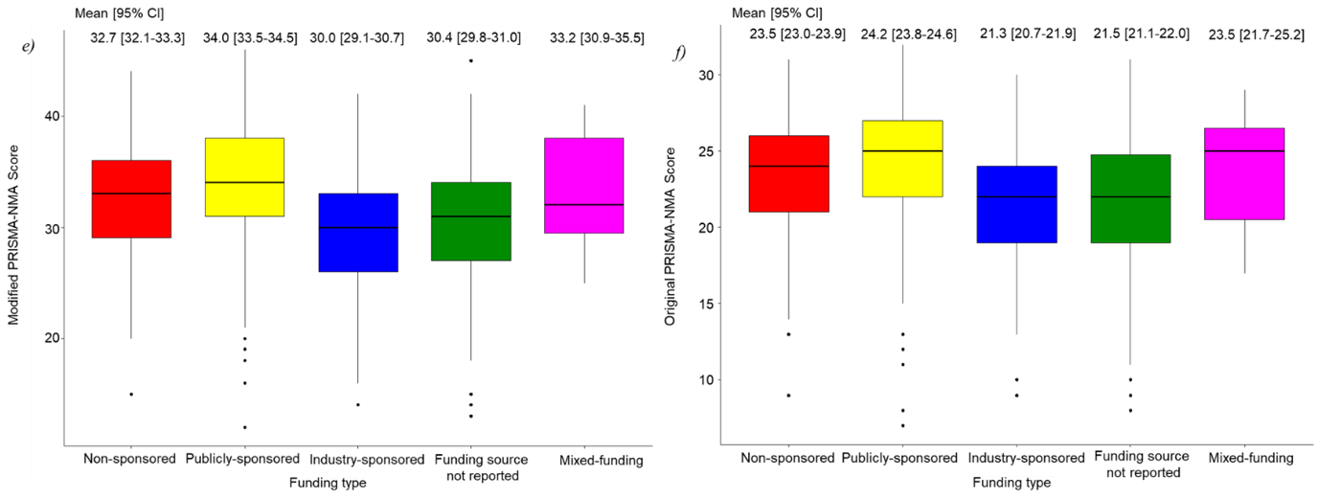

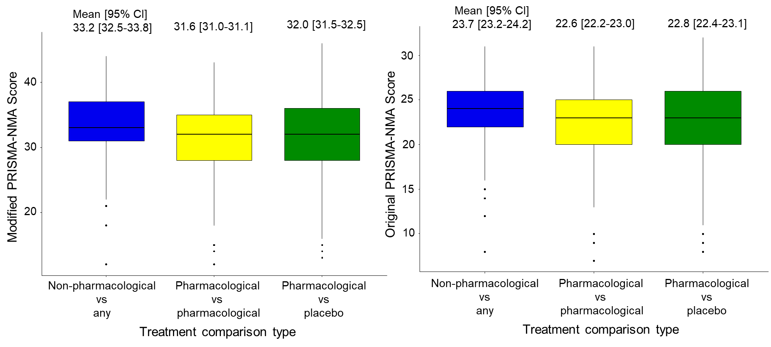

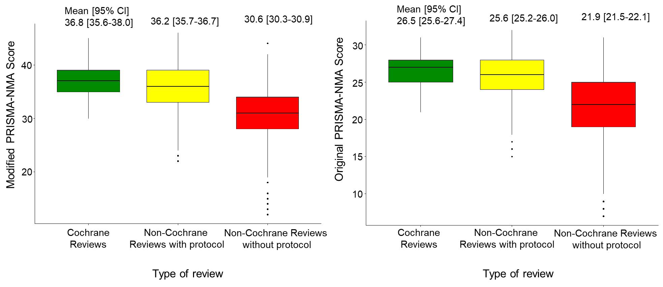

Appendix Table 5. Assessment of reporting of NMAs using the modified PRISMA-NMA per year of publication
Year of publication | 2013 | 2014 | 2015 | 2016 | 2017 | 2018
PRISMA ITEMS | # articles (%) | # articles (%) | # articles (%) | # articles (%) | # articles (%) | # articles (%)
TITLE
Systematic review | 25 (27%) | 29 (28%) | 85 (44%) | 83 (42%) | 113 (36%) | 99 (41%)
NMA/related form of MA | 73 (80%) | 84 (81%) | 165 (85%) | 174 (88%) | 291 (92%) | 222 (92%)
ABSTRACT
Structured summary | 83 (91%) | 95 (91%) | 156 (80%) | 165 (83%) | 247 (78%) | 186 (77%)
Main objectives | 89 (98%) | 101 (97%) | 190 (98%) | 192 (97%) | 299 (95%) | 236 (98%)
Data sources | 50 (55%) | 57 (55%) | 114 (59%) | 120 (61%) | 159 (50%) | 148 (61%)
PICO | 65 (71%) | 93 (89%) | 174 (90%) | 175 (88%) | 204 (65%) | 215 (89%)
study appraisal (e.g., risk of bias) | 12 (13%) | 10 (10%) | 29 (15%) | 15 (8%) | 31 (10%) | 35 (15%)
synthesis methods (e.g. NMA) | 84 (92%) | 100 (96%) | 182 (94%) | 186 (94%) | 288 (91%) | 235 (98%)
Number of studies and participants | 78 (86%) | 90 (87%) | 158 (81%) | 158 (80%) | 265 (84%) | 214 (89%)
summary estimates and their CIs/CrIs | 65 (71%) | 72 (69%) | 117 (60%) | 122 (62%) | 186 (59%) | 136 (56%)
treatment ranking | 22 (24%) | 19 (18%) | 51 (26%) | 104 (53%) | 115 (36%) | 117 (49%)
limitations | 7 (8%) | 11 (11%) | 32 (16%) | 23 (12%) | 26 (8%) | 26 (11%)
conclusions and implications of findings | 84 (92%) | 104 (100%) | 186 (96%) | 192 (97%) | 308 (97%) | 233 (97%)
funding | 9 (10%) | 9 (9%) | 19 (10%) | 20 (10%) | 9 (3%) | 6 (2%)
registration number with registry name (e.g. PROSPERO) | 3 (3%) | 4 (4%) | 12 (6%) | 26 (13%) | 28 (9%) | 22 (9%)
INTRODUCTION
Rationale for systematic review and NMA | 85 (93%) | 100 (96%) | 192 (99%) | 180 (91%) | 297 (94%) | 234 (97%)
Explicit statement of the questions being addressed (PICOS) | 70 (77%) | 94 (90%) | 179 (92%) | 185 (93%) | 229 (72%) | 238 (99%)
METHODS
Existence of review protocol | 15 (16%) | 16 (15%) | 45 (23%) | 57 (29%) | 68 (22%) | 93 (39%)
Protocol can be accessed (e.g., Web address or registration number available) | 11 (12%) | 8 (8%) | 30 (15%) | 49 (25%) | 60 (19%) | 71 (29%)
rationale for eligibility criteria (e.g., PICOS, length of follow-up, years considered, language, publication status) | 82 (90%) | 96 (92%) | 179 (92%) | 187 (94%) | 293 (93%) | 231 (96%)
Description of eligible treatments used in the NMA (with justification for clustering, if any) | 74 (81%) | 82 (79%) | 150 (77%) | 176 (89%) | 272 (86%) | 199 (83%)
Description of information sources with search dates) | 88 (97%) | 97 (93%) | 187 (96%) | 191 (96%) | 299 (95%) | 225 (93%)
A full electronic search strategy available | 36 (40%) | 47 (45%) | 92 (47%) | 117 (59%) | 150 (47%) | 116 (48%)
Description of the study selection process | 72 (79%) | 79 (76%) | 170 (88%) | 180 (91%) | 259 (82%) | 200 (83%)
Description of the data collection process (method) | 61 (67%) | 68 (65%) | 111 (57%) | 181 (91%) | 231 (73%) | 183 (76%)
Description of collected items) | 57 (63%) | 66 (63%) | 136 (70%) | 174 (88%) | 230 (73%) | 185 (77%)
Description of methods used to explore network geometry (e.g., network plot, other methods to describe the evidence base) | 12 (13%) | 10 (10%) | 41 (21%) | 45 (23%) | 76 (24%) | 71 (29%)
Description of methods used to assess study risk of bias | 67 (74%) | 79 (76%) | 152 (78%) | 160 (81%) | 249 (79%) | 208 (86%)
Description of summary measures to be used (e.g., OR, RR, MD, SMD) | 85 (93%) | 98 (94%) | 183 (94%) | 181 (91%) | 285 (90%) | 212 (88%)
Description of treatment rankings to be used (e.g., SUCRA, P-scores) | 33 (36%) | 36 (35%) | 95 (49%) | 138 (70%) | 222 (70%) | 185 (77%)
Description of analysis methods (e.g., NMA method) | 85 (93%) | 99 (95%) | 187 (96%) | 185 (93%) | 307 (97%) | 235 (98%)
Description of method used to assess inconsistency | 47 (52%) | 54 (52%) | 133 (69%) | 126 (64%) | 214 (68%) | 188 (78%)
Description of methods used to assess bias across studies (e.g., publication bias, selective reporting, small study effects) | 27 (30%) | 26 (25%) | 72 (37%) | 59 (30%) | 104 (33%) | 124 (51%)
Description of additional analyses (e.g., sensitivity analysis) | 51 (56%) | 61 (59%) | 113 (58%) | 111 (56%) | 123 (39%) | 138 (57%)
RESULTS
# of studies screened and included in the review, and reasons for exclusion (e.g., flow diagram) | 86 (95%) | 95 (91%) | 178 (92%) | 183 (92%) | 288 (91%) | 229 (95%)
Network plot | 68 (75%) | 69 (66%) | 161 (83%) | 168 (85%) | 284 (90%) | 221 (92%)
Brief overview of network characteristics | 72 (79%) | 73 (70%) | 166 (86%) | 168 (85%) | 258 (82%) | 221 (92%)
Presentation of characteristics per study with citations (e.g., in a table) | 80 (88%) | 95 (91%) | 170 (88%) | 185 (93%) | 282 (89%) | 229 (95%)
Presentation of risk of bias per study | 51 (56%) | 56 (54%) | 134 (69%) | 134 (68%) | 193 (61%) | 166 (69%)
Presentation of individual study data | 52 (57%) | 62 (60%) | 101 (52%) | 59 (30%) | 125 (40%) | 112 (46%)
Presentation of NMA results (summary estimates and CIs/CrIs, ranking statistics) | 88 (97%) | 99 (95%) | 188 (97%) | 194 (98%) | 301 (95%) | 238 (99%)
Description of results from investigations of inconsistency | 40 (44%) | 44 (42%) | 111 (57%) | 112 (57%) | 192 (61%) | 156 (65%)
Presentation of results of bias assessment across studies (e.g., funnel plot) | 20 (22%) | 26 (25%) | 63 (32%) | 55 (28%) | 106 (34%) | 98 (41%)
Presentation of results of additional analyses (e.g., sensitivity analysis) | 44 (48%) | 56 (54%) | 108 (56%) | 106 (54%) | 126 (40%) | 142 (59%)
DISCUSSION
Summary of key findings, including strength of evidence | 91 (100%) | 104 (100%) | 192 (99%) | 196 (99%) | 314 (99%) | 238 (99%)
Discussion of study limitations | 85 (93%) | 93 (89%) | 182 (94%) | 186 (94%) | 301 (95%) | 233 (97%)
General interpretation of results, comparison to other evidence, and implications for future research | 90 (99%) | 103 (99%) | 169 (87%) | 182 (92%) | 301 (95%) | 220 (91%)
FUNDING
Sources of funding for the systematic review | 71 (78%) | 84 (81%) | 141 (73%) | 139 (70%) | 216 (68%) | 169 (70%)
Role of funders for the systematic review | 21 (23%) | 23 (22%) | 57 (29%) | 39 (20%) | 39 (12%) | 38 (16%)
Total # of articles | 91 | 104 | 194 | 198 | 316 | 241

Abbreviations: CI, confidence interval; CrI, credible interval NMA, network meta-analysis

Appendix Figure 8. Distribution of journal impact factor in NMAs published in 2016 and 2017

