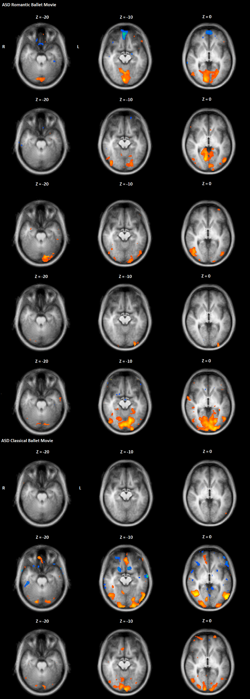
Figure 1. Individual contrasts for ASD participants. Note that orange indicates high intra-SC, whereas blue indicates low intra-SC. Note that each row is an individual participant.
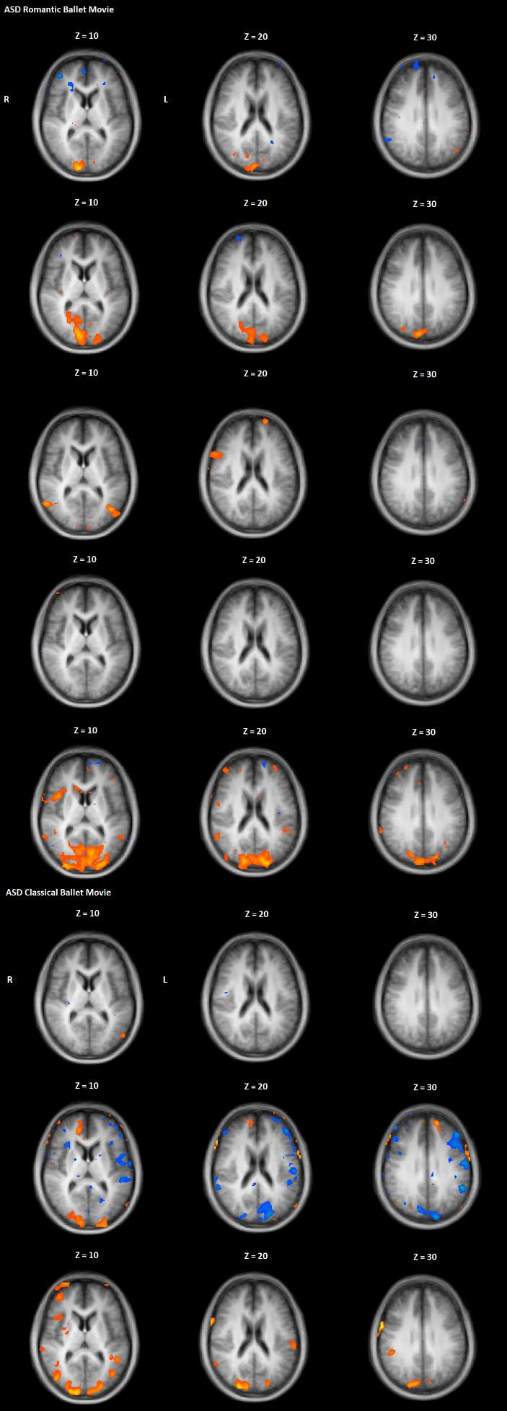
Figure 1. Continuation. Individual contrasts for ASD participants. Note that orange indicates high intra-SC, whereas blue indicates low intra-SC. Note that each row is an individual participant.
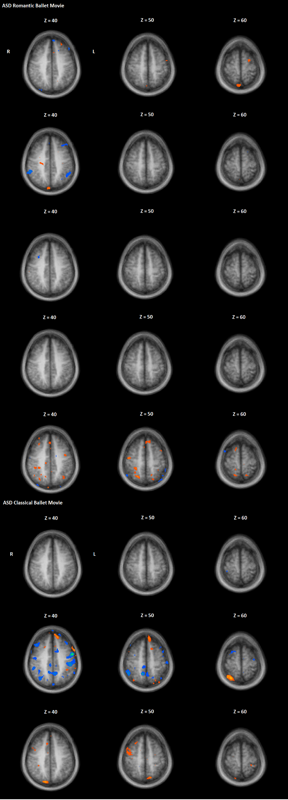
Figure 1. Continuation. Individual contrasts for ASD participants. Note that orange indicates high intra-SC, whereas blue indicates low intra-SC. Note that each row is an individual participant.
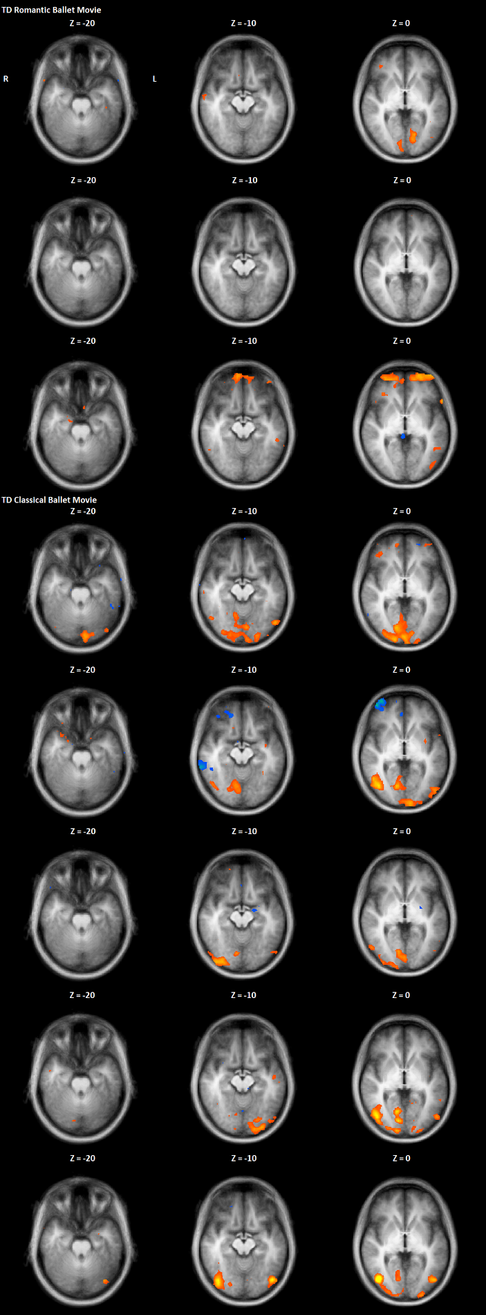
Figure 7. Individual contrasts for TD participants. Note that orange indicates high intra-SC, whereas blue indicates low intra-SC. Note that each row is an individual participant.
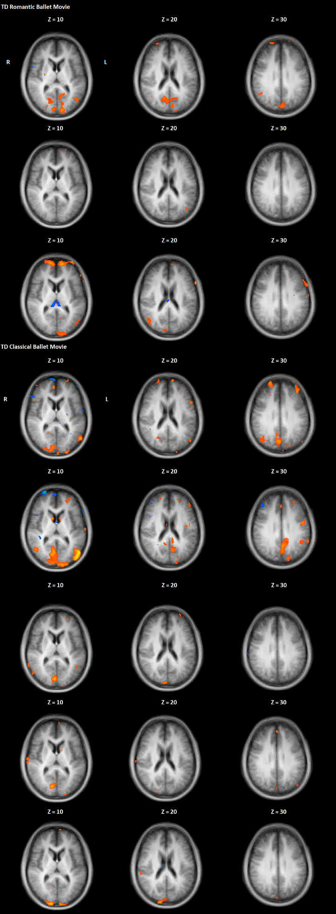
Figure 7. Continuation. Individual contrasts for TD participants. Note that orange indicates high intra-SC, whereas blue indicates low intra-SC. Note that each row is an individual participant.
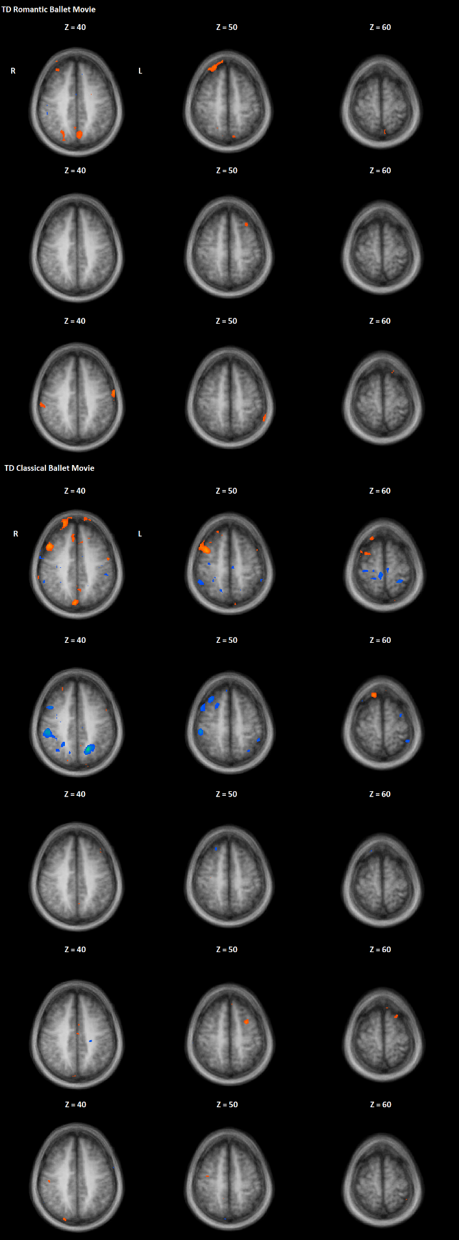
Figure 7. Continuation. Individual contrasts for TD participants. Note that orange indicates high intra-SC, whereas blue indicates low intra-SC. Note that each row is an individual participant.

