Linear Diamides Derivative-Nucleated Biodegradable Poly(ethylene succinate) Polyester: Crystallization Kinetics and Aggregated Structure Manipulated by Hydrogen Bond Interaction

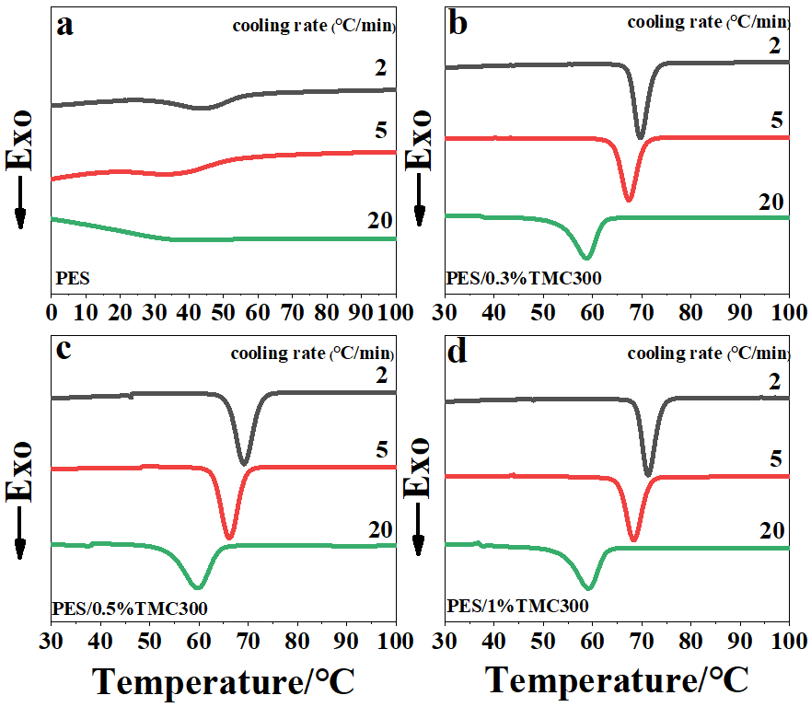
Fig. S1 Non-isothermal DSC curves at various rates for neat PES and PES/TMC300.

Table S1 DSC data in non-isothermal cooling at various rates.
Sample | 2 °C/min |  |  | 5 °C/min |  |  | 20 °C/min
 | T_{c} (°C) | -∆H_{c} (J/g) |  | T_{c} (°C) | -∆H_{c} (J/g) |  | T_{c} (°C) | -∆H_{c} (J/g)
PES | 43.5 | 26.9 |  | 32.5 | 18.2 |  | N.P. | —
PES/0.3%EBH | 69.7 | 49.5 |  | 67.4 | 48.1 |  | 58.8 | 45.1
PES/0.5%EBH | 69.2 | 50.3 |  | 66.6 | 49.8 |  | 59.6 | 47.8
PES/1%EBH | 71.4 | 51.9 |  | 68.4 | 50.3 |  | 59.2 | 48.7
N.P., no peak is discernible; —, no data are available.

