Detailed data related to physiotherapy survey outcomes:

 | Strongly disagree | Disagree | Neither | Agree | Strongly agree
I know how to deliver exercise and education to people with knee osteoarthritis following current CPG
Pre-course | 0% | 3% | 21% | 67% | 9%
Post-course (1-2 weeks) | 0% | 0% | 0% | 22% | 78%
12 months post-course | 1% | 0% | 0% | 20% | 79%
I have been trained in delivering exercise and education to people with knee osteoarthritis following current CPG
Pre-course | 1% | 17% | 34% | 43% | 5%
Post-course (1-2 weeks) | 0% | 0% | 0% | 16% | 84%
12 months post-course | 1% | 0% | 1% | 15% | 83%
I have the skills to deliver exercise and education to people with knee osteoarthritis following current CPG
Pre-course | 0% | 4% | 19% | 65% | 12%
Post-course (1-2 weeks) | 0% | 0% | 0% | 22% | 77%
12 months post-course | 1% | 0% | 0% | 18% | 80%
I am confident I can deliver exercise and education to people with knee osteoarthritis following current CPG
Pre-course | 0% | 4% | 19% | 60% | 16%
Post-course (1-2 weeks) | 0% | 0% | 0% | 21% | 79%
12 months post-course | 1% | 0% | 1% | 20% | 78%
I am confident I can deliver exercise and education to people with knee osteoarthritis following current CPG, even when the patient is not motivated
Pre-course | 1% | 15% | 37% | 41% | 6%
Post-course (1-2 weeks) | 0% | 0% | 5% | 47% | 47%
12 months post-course | 1% | 3% | 6% | 50% | 40%
 | I do not use this intervention | Not confident at all | Below average | Average | Confident | Very confident
I am confident in prescribing neuromuscular exercise
Pre-course | 2% | 2% | 13% | 45% | 32% | 6%
Post-course (1-2 weeks) | 0% | 0% | 0% | 4% | 30% | 66%
12 months post-course | 0% | 1% | 0% | 5% | 35% | 59%
I am confident in providing education related to-self management
Pre-course | 0% | 0% | 2% | 29% | 53% | 17%
Post-course (1-2 weeks) | 0% | 0% | 0% | 1% | 32% | 67%
12 months post-course | 0% | 0% | 0% | 2% | 29% | 69%
I am confident in providing education related to physical activity participation
Pre-course | 0% | 0% | 4% | 35% | 49% | 12%
Post-course (1-2 weeks) | 0% | 0% | 0% | 2% | 39% | 59%
12 months post-course | 0% | 0% | 0% | 3% | 34% | 64%
I am confident in discussing the importance of weight management
Pre-course | 0% | 1% | 7% | 41% | 39% | 12%
Post-course (1-2 weeks) | 0% | 0% | 1% | 10% | 41% | 48%
12 months post-course | 0% | 1% | 0% | 10% | 38% | 51%
 | Never | Rarely | Some of the time | Most of the time | All the time
Discuss treatment goals
Pre-course | 0% | 0% | 12% | 40% | 48%
Post-course (1-2 weeks) | 0% | 0% | 3% | 34% | 63%
12 months post-course | 0% | 0% | 2% | 31% | 67%
Prescribe neuromuscular exercise
Pre-course | 2% | 10% | 33% | 32% | 22%
Post-course (1-2 weeks) | 1% | 2% | 13% | 32% | 52%
12 months post-course | 0% | 1% | 4% | 19% | 76%
Refer to, or provide supervised exercise programs
Pre-course | 1% | 7% | 39% | 34% | 19%
Post-course (1-2 weeks) | 0% | 4% | 21% | 39% | 36%
12 months post-course | 0% | 1% | 8% | 39% | 52%
Discuss the importance of weight management
Pre-course | 2% | 7% | 35% | 34% | 22%
Post-course (1-2 weeks) | 1% | 5% | 27% | 39% | 28%
12 months post-course | 1% | 1% | 11% | 36% | 52%
CPG – Clinical practice guidelines

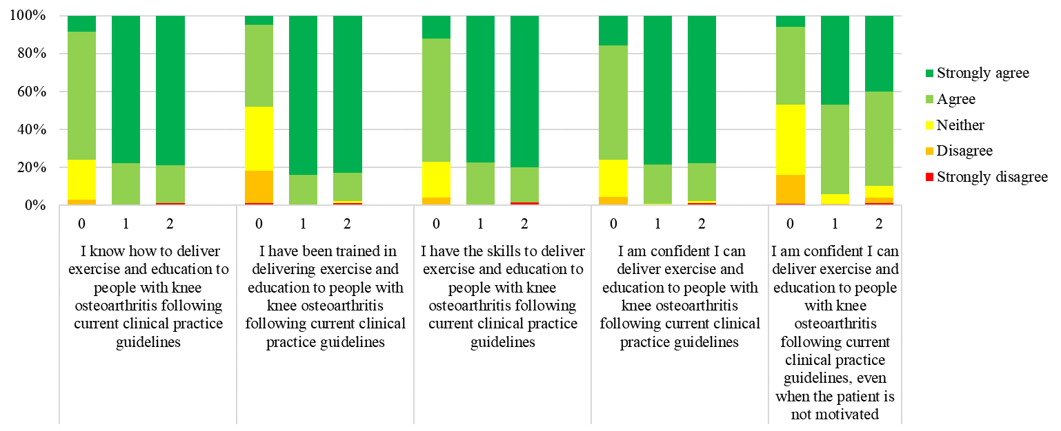
0 – Pre-course
1 – Post-course
2 – 12 months post-course
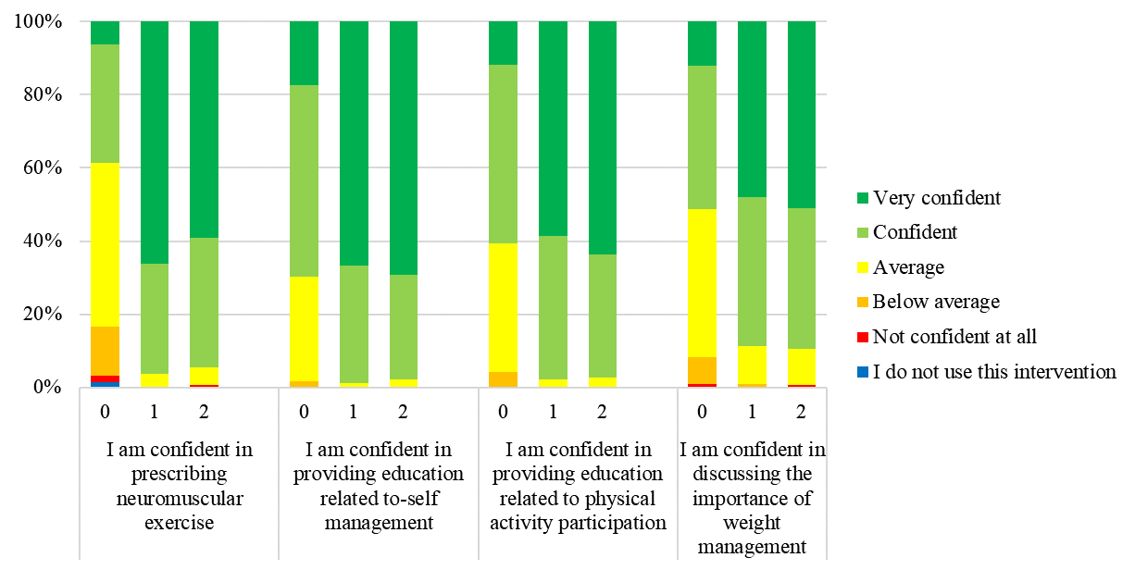
0 – Pre-course
1 – Post-course
2 – 12 months post-course

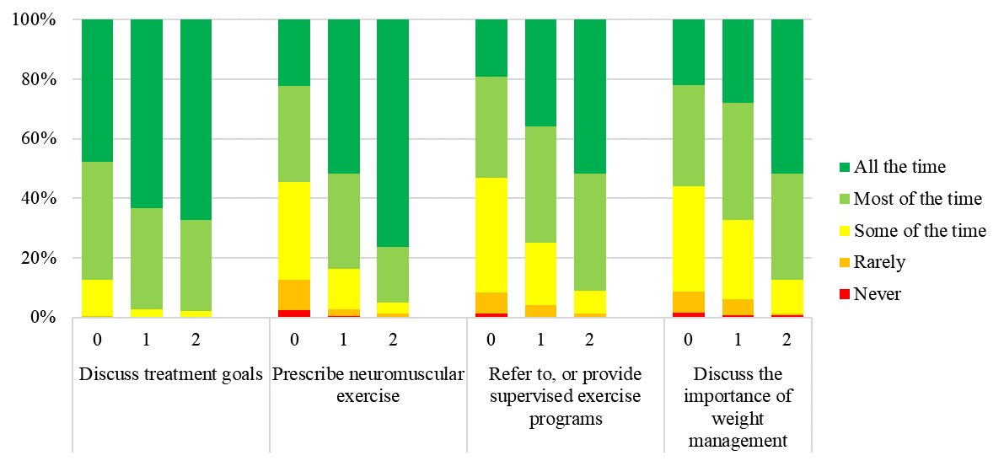
0 – Pre-course
1 – Post-course
2 – 12 months post-course

