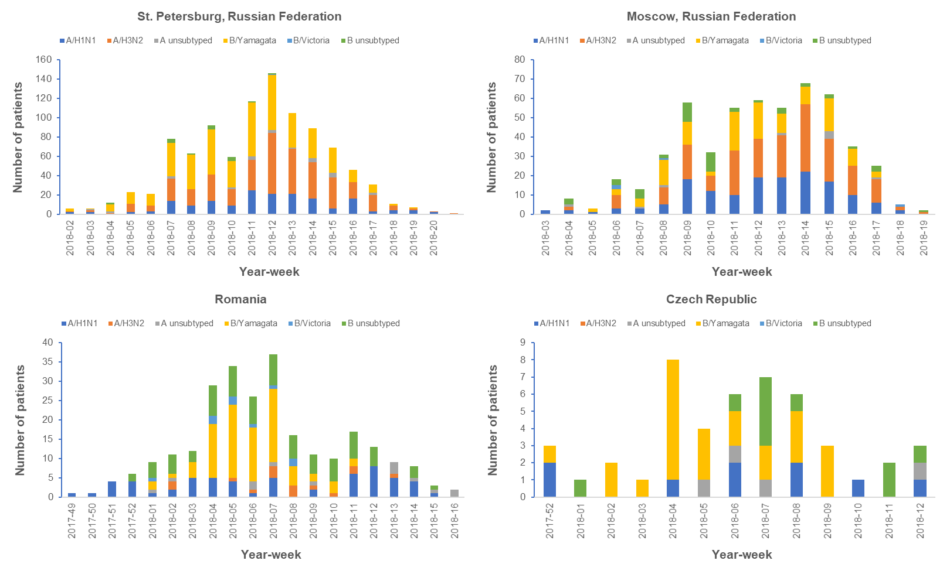
Supplemental Figure 1. Influenza strain circulation by year-week for individual sites within the East Europe influenza transmission zone
Influenza strains were detected by reverse transcription-polymerase chain reaction. An individual patient could have been positive for more than one strain of influenza.

