Supplementary Figure Legends

Figure S1. CODEX imaging of tissue biomarker expression in patients with UC. (a) Schematic overview of data acquisition process from (1) sample collection and (2) tissue sectioning to (3) tissue staining and (4) CODEX imaging. (b) Top left: CODEX image of a biopsy section from patient UC1 with Hoechst nuclear stain (gray), CD85j (cyan), Ki67 (yellow), CD19 (blue), CD31 (red), TIGIT (purple), and Vimentin (green) shown as a 7-color composite image selected from a total of 52 protein and 2 nuclear markers stained on the same tissue section. Bottom left: Zoomed-in view of representative staining for Vimentin, CD19, CD31, CD85j, TIGIT, and Ki67. Right: Zoomed-in view of the region denoted in the white box in panel (a) shown as a 7-color composite image (large panel) and as H&E and 2-color images of Hoechst and each of the indicated markers individually (small panels). Scale bars: yellow, 0.04 mm; white, 0.10 mm; black, 0.50 mm. (c) Top left: CODEX image of a biopsy section from patient UC1 with Hoechst nuclear stain (gray), CD66 (cyan), CD134 (yellow), CD3 (blue), IL6R (red), CD69 (purple), and CD4 (green) shown as a 7-color composite image selected from a total of 52 protein and 2 nuclear markers stained on the same tissue section. Bottom left: Zoomed-in view of representative staining for CD4, CD3, IL6R, CD66, CD69, and CD134. Right: Zoomed-in view of the region denoted in the white box in panel (a) shown as a 7-color composite image (large panel) and as H&E and 2-color images of Hoechst and each of the indicated markers individually (small panels). Scale bars: yellow, 0.04 mm, white, 0.10 mm; black, 0.50 mm. (d) Top left: CODEX image of a biopsy section from patient UC1 with Hoechst nuclear stain (gray), CD11c (cyan), MMP12 (yellow), CD57 (blue), CD56 (red), HIF1a (purple), and CD8 (green) shown as a 7-color composite image selected from a total of 52 protein and 2 nuclear markers stained on the same tissue section. Bottom left: Zoomed-in view of representative staining for CD8, CD57, CD56, CD11c, HIF1a, and MMP12. Right: Zoomed-in view of the region denoted in the white box in panel (a) shown as a 7-color composite image (large panel) and as H&E and 2-color images of Hoechst and each of the indicated markers individually (small panels). Scale bars: yellow, 0.04 mm; white, 0.10 mm; black, 0.50 mm. (el) Top left: CODEX image of a biopsy section from patient UC1 with Hoechst nuclear stain (gray), CD7 (cyan), CD49f (yellow), CD34 (blue), CD137 (red), VCAM1 (purple), and CD54 (green) shown as a 7-color composite image selected from a total of 52 protein and 2 nuclear markers stained on the same tissue section. Bottom left: Zoomed-in view of representative staining for CD54, CD34, CD137, CD7, VCAM1, and CD49f. Right: Zoomed-in view of the region denoted in the white box in panel (a) shown as a 7-color composite image (large panel) and as H&E and 2-color images of Hoechst and each of the indicated markers individually (small panels). Scale bars: yellow, 0.04 mm; white, 0.10 mm; black, 0.50 mm. (f) Top left: CODEX image of a biopsy section from patient UC1 with Hoechst nuclear stain (gray), CD38 (cyan), CD123 (yellow), CD36 (blue), CD16 (red), CD1c (purple), and TCRyd (green) shown as a 7-color composite image selected from a total of 52 protein and 2 nuclear markers stained on the same tissue section. Bottom left: Zoomed-in view of representative staining for TCRyd, CD36, CD16, CD38, CD1c, and CD123. Right: Zoomed-in view of the region denoted in the white box in panel (a) shown as a 7-color composite image (large panel) and as H&E and 2-color images of Hoechst and each of the indicated markers individually (small panels). Scale bars: yellow, 0.04 mm; white, 0.10 mm; black, 0.50 mm. (g) Top left: CODEX image of a biopsy section from patient UC1 with Hoechst nuclear stain (gray), CD40 (cyan), CD127 (yellow), CD45 (blue), HLA-ABC (red), FoxP3 (purple), and CD90 (green) shown as a 7-color composite image selected from a total of 52 protein and 2 nuclear markers stained on the same tissue section. Bottom left: Zoomed-in view of representative staining for CD90, CD45, HLA-ABC, CD40, FoxP3, and CD127. Right: Zoomed-in view of the region denoted in the white box in panel (a) shown as a 7-color composite image (large panel) and as H&E and 2-color images of Hoechst and each of the indicated markers individually (small panels). Scale bars: yellow, 0.04,mm; white, 0.10 mm; black, 0.50 mm. (h) Top left: CODEX image of a biopsy section from patient UC1 with Hoechst nuclear stain (gray), Podoplanin (cyan), CD120b (yellow), PanCk (blue), CD104 (red), CD278 (purple), and CD45RA (green) shown as a 7-color composite image selected from a total of 52 protein and 2 nuclear markers stained on the same tissue section. Bottom left: Zoomed-in view of representative staining for Cd45RA, Cytokeratin, CD104, Podoplanin, CD278, and CD120b. Right: Zoomed-in view of the region denoted in the white box in panel (a) shown as a 7-color composite image (large panel) and as H&E and 2-color images of Hoechst and each of the indicated markers individually (small panels). Scale bars: yellow, 0.04 mm; white, 0.10 mm; black, 0.50 mm. (i) Top left: CODEX image of a biopsy section from patient UC1 with Hoechst nuclear stain (gray), CD5 (cyan), Empty (yellow), CD117 (blue), CD279 (red), Empty (purple), and CollagenIV (green) shown as a 7-color composite image selected from a total of 52 protein and 2 nuclear markers stained on the same tissue section. Bottom left: Zoomed-in view of representative staining for Collagen IV, CD117, CD279, and CD5. Right: Zoomed-in view of the region denoted in the white box in panel (a) shown as a 7-color composite image (large panel) and as H&E and 2-color images of Hoechst and each of the indicated markers individually (small panels). Scale bars: yellow, 0.04 mm; white, 0.10 mm; black, 0.50 mm. (j) Top left: CODEX image of a biopsy section from patient UC1 with Hoechst nuclear stain (gray), CD21 (cyan), CD2 (yellow), HLA-DR (blue), CD152 (red), CD274 (purple), and CD15 (green) shown as a 7-color composite image selected from a total of 52 protein and 2 nuclear markers stained on the same tissue section. Bottom left: Zoomed-in view of representative staining for CD15, HLA-DR, CD152, CD21, CD274, and CD2. Right: Zoomed-in view of the region denoted in the white box in panel (a) shown as a 7-color composite image (large panel) and as H&E and 2-color images of Hoechst and each of the indicated markers individually (small panels). Scale bars: yellow, 0.04 mm; white, 0.10 mm; black, 0.50 mm.

Figure S2. Biomarker profiles for VorteX cell clusters. (a) Minimum spanning tree representations of cell clusters. Cell types were identified in VorteX based on k-means clustering of cell-marker-intensity profiles, using the markers indicated in black. Markers in red were excluded from cluster-based identification. The size of each node represents the relative abundance of the corresponding cell type. The color of each node, from blue (lowest) to red (highest), represents the relative expression level of each marker. (b) Bar plots depicting min-max normalized marker intensities for each cluster. Markers that did not substantially impact clustering and some “redundant” markers (markers that strongly correlate with other markers) were excluded for visualization purposes only.

Figure S3. Cell cluster mapping. Representative images depicting the indicated cell cluster for each panel mapped to the tissue (yellow plus sign). Left: DRAQ5 nuclear staining for the whole tissue specimen with the indicated cell cluster overlaid (scale bar 200 μm). Right: Zoomed-in images of representative biomarkers that either co-localize or counter-localize with the overlaid cell cluster (scale bar 20 μm).

Figure S4. Manual gating of cell types and correlation with Vortex clustering. (a) Representative manual gating schematic. Manual gating of cell types was performed for each tissue section based on canonical biomarker expression. Visual confirmation of gated populations was performed by mapping these populations to their corresponding CODEX image as described in Figure S3 for VorteX clusters. Manual cell gating was performed blind to the VorteX clustering-based classifications. (b) Correlation between VorteX and manual gating for all cell types within a sample (top panel), or for each cell type across multiple samples (bottom). In general we observed good correlation between semi-autonomous (VorteX) identification and manual identification of cell types. (c) Violin plots indicating cellular abundance, by cell type, as a fraction of total cell numbers. Tissue samples are binned within each Mayo Score classification (H=healthy, 1= Mayo 1, 2=Mayo 2, 3=Mayo 3).

Figure S5. Cellular neighborhoods versus clinical Mayo Scores. Violin plots depicting the fraction of cells in the indicated cellular neighborhood versus Mayo Score. Tukey’s multiple comparisons test. * p<0.05, ** p<0.01, ***p<0.001. HC (n=6), 1 (n=2), 2 (n=9) 3 (n=8).

Figure S6. Biomarker expression across cell populations and disease states. (a-f) Scaffolds depicting minimum spanning tree representations of cell populations and expression of a) Ki67, b) CD152, c) CD126, d) CD69, e) CD134, and f) HLA-DR along trajectories of UC pathogenesis and healing during TNF therapy. Node size represents the average frequency of each cell population for each cohort and color represents the relative expression of indicated biomarker. Color scale: green-low, red-high.

Figure S7. Sex differences in UC. (a) Volcano plot of cell types (yellow), cell contacts (red), and cellular neighborhoods (orange) between male and female UC patients. Points to the right are enriched in males, points to the left are enriched in females. (b) TNFi responders versus nonresponders, binned by sex and disease score. Female patients were more likely to respond than male patients. We did not observe substantial differences in responsiveness between patients with Mayo score of 2 versus Mayo score of 3. (c-d) Sex difference comparisons between top differential neighborhoods in patients with a Mayo score of 2. c) Female patients were enriched for lymphoid aggregates (p=0.014), which are part of the adaptive immune response. d) Male patients were enriched for granulocyte aggregates, part of the innate immune response (p=0.095).

Figure S8. L1-penalized logistic regression prediction of TNFi response in UC patients. (a-c) Feature weights from L1 logistic regression models are illustrated as histogram density plots. The number of runs plotted were a) 300, b) 1000, and c) 300 and were determined by increasing the number of runs until minimal differences were observed between subsequent plots. Every 1 unit shift in the x-axis corresponds to a 1 log change in the odds ratio for predicting TNFi response. (d) Heatmap of pairwise average feature weights. Feature weights are presented as the average over 300 runs.

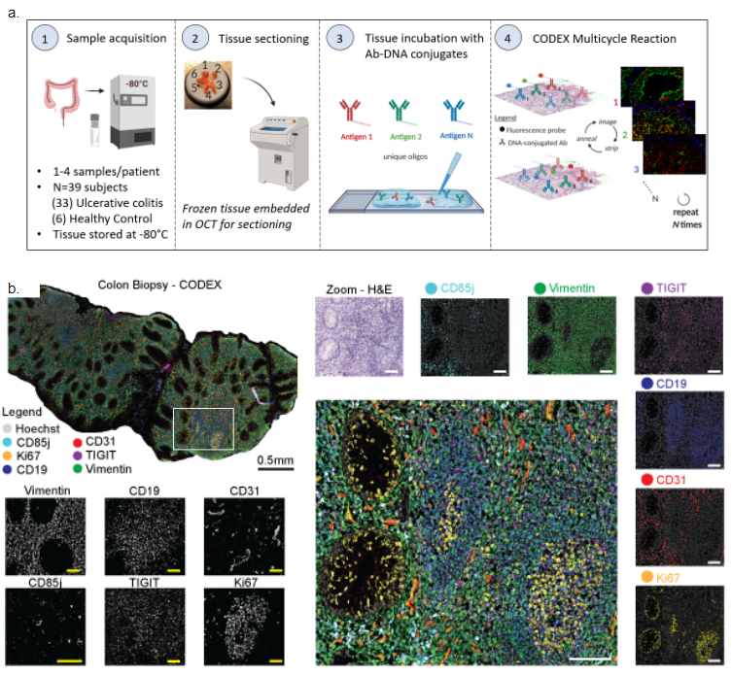

Figure S1a-b. CODEX imaging of tissue biomarker expression in patients with Ulcerative Colitis.

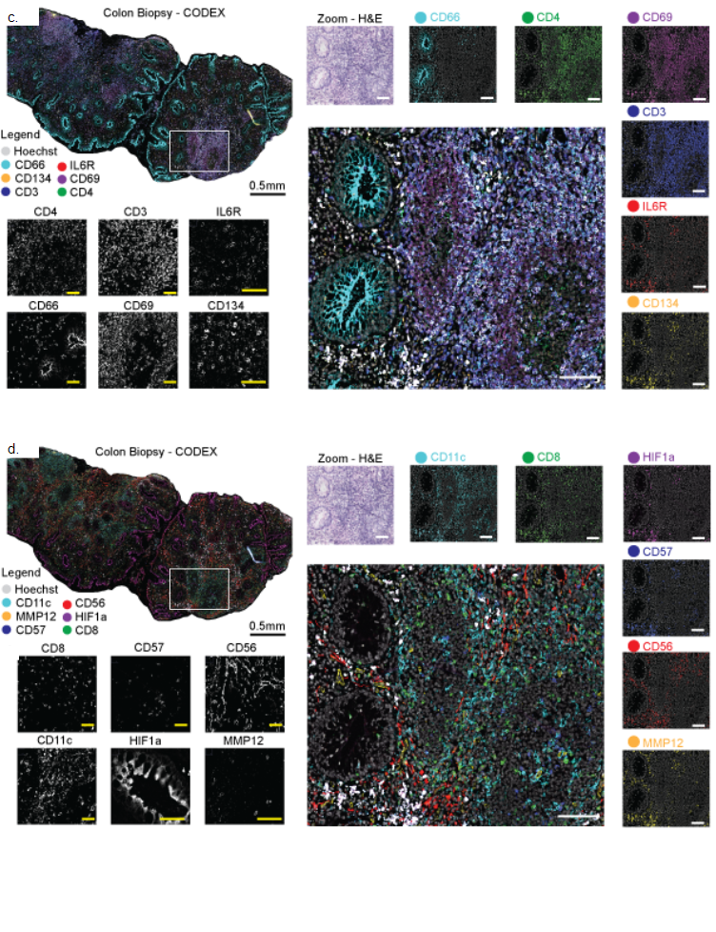
Figure S1c-d. CODEX imaging of tissue biomarker expression in patients with Ulcerative Colitis.

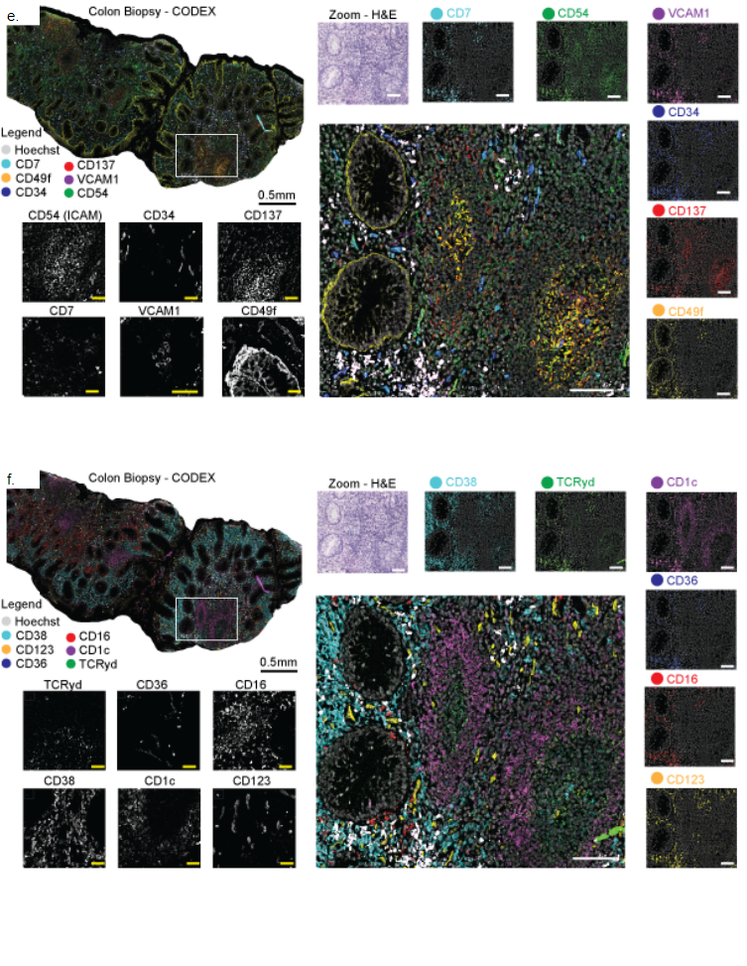

Figure S1e-f. CODEX imaging of tissue biomarker expression in patients with Ulcerative Colitis.
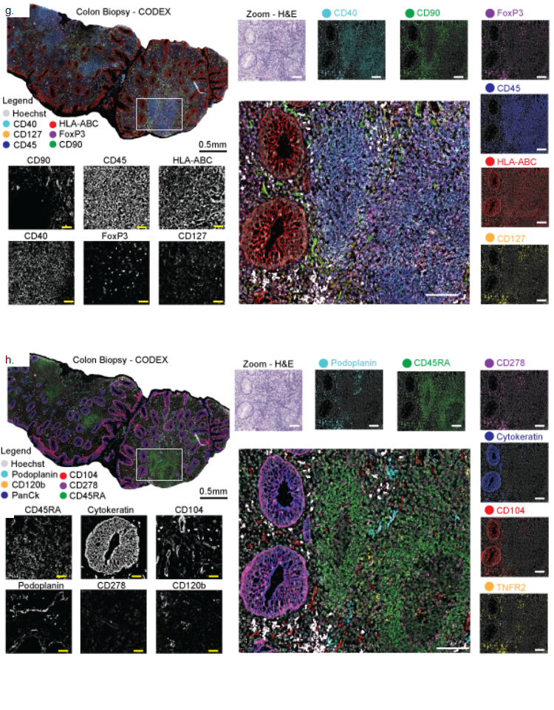

Figure S1g-h. CODEX imaging of tissue biomarker expression in patients with Ulcerative Colitis.
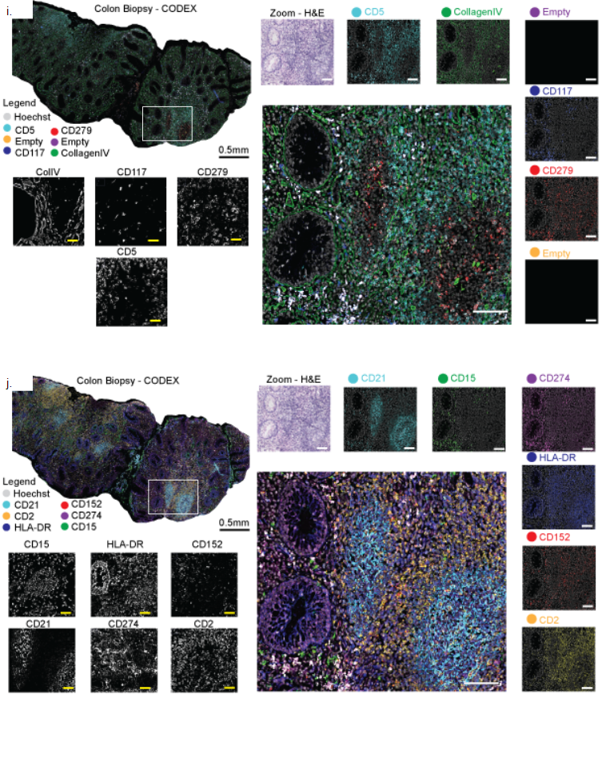
Figure S1i-j. CODEX imaging of tissue biomarker expression in patients with Ulcerative Colitis.

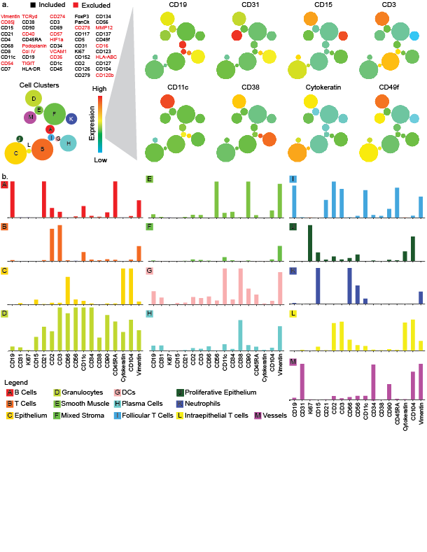
Figure S2. Biomarker profiles for Vortex cell clusters.

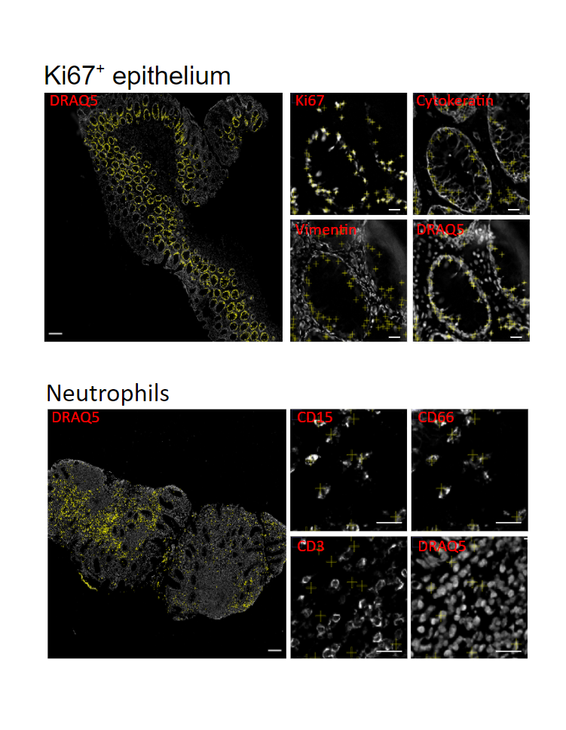

Figure S3a-b. Cell cluster mapping.
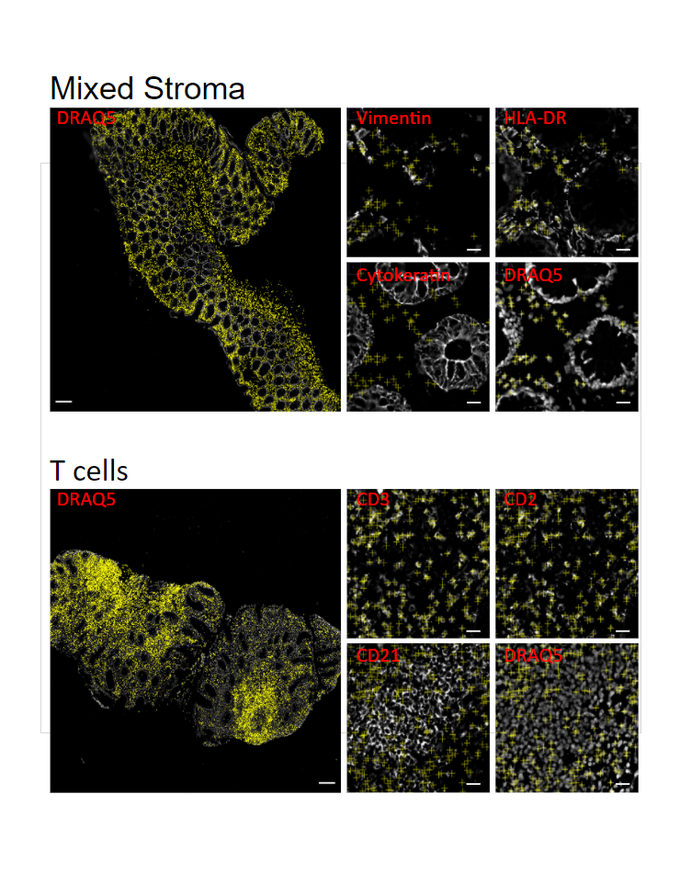
Figure S3c-d. Cell cluster mapping.

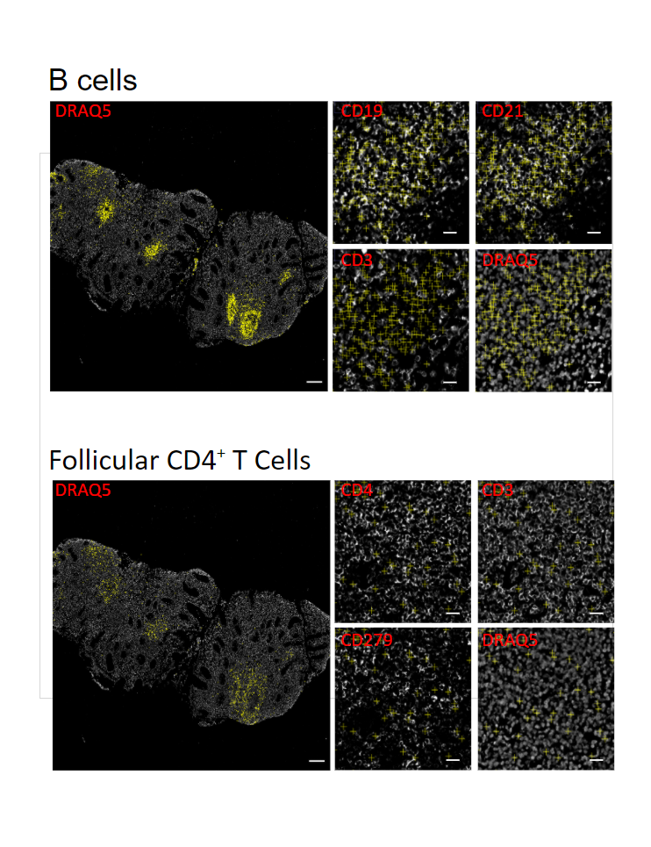
Figure S3e-f. Cell cluster mapping.

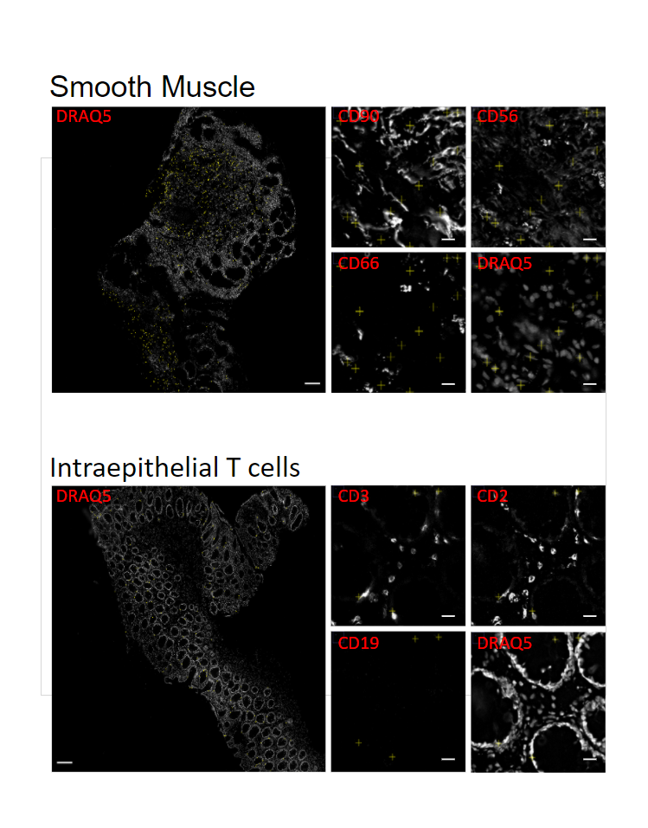

Figure S3g-h. Cell cluster mapping.
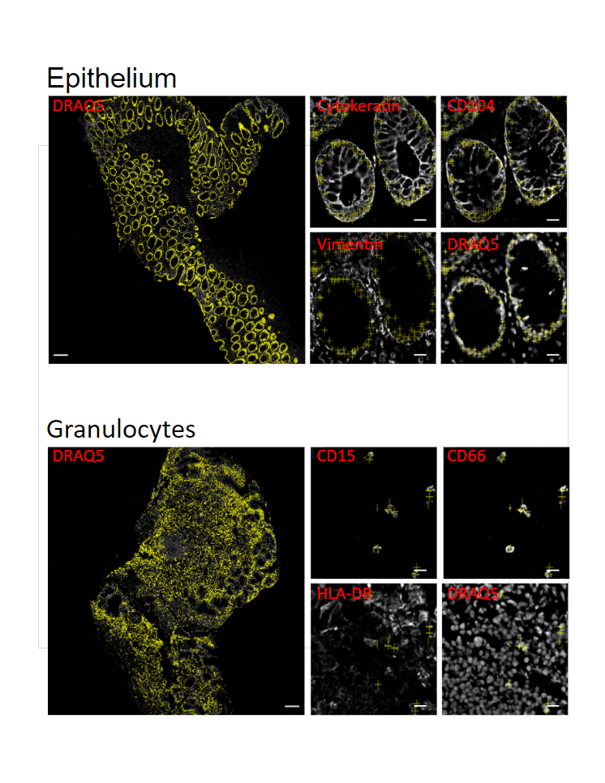 Figure S3i-j. Cell cluster mapping
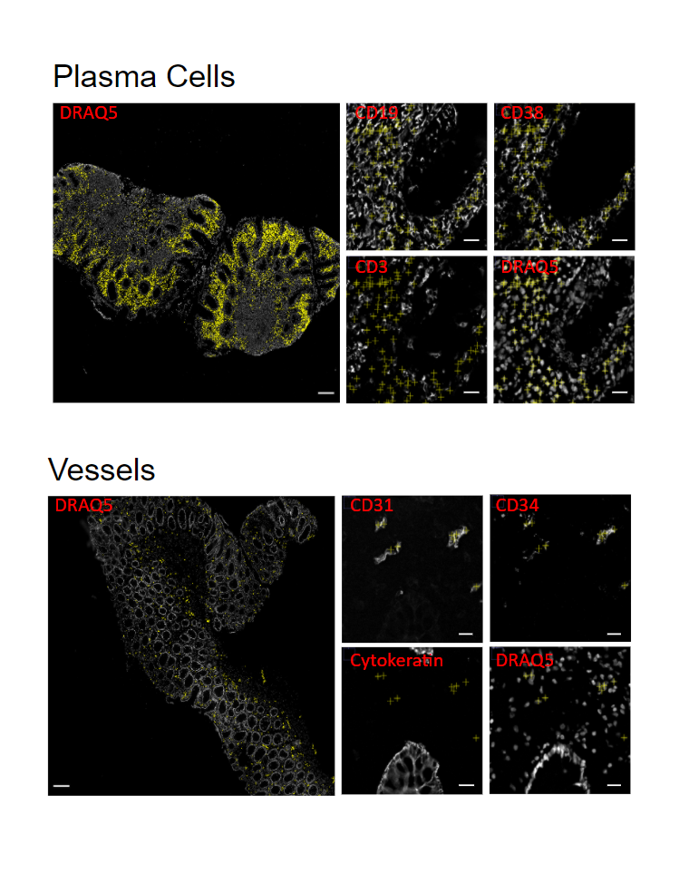 Figure S3k-l. Cell cluster mapping.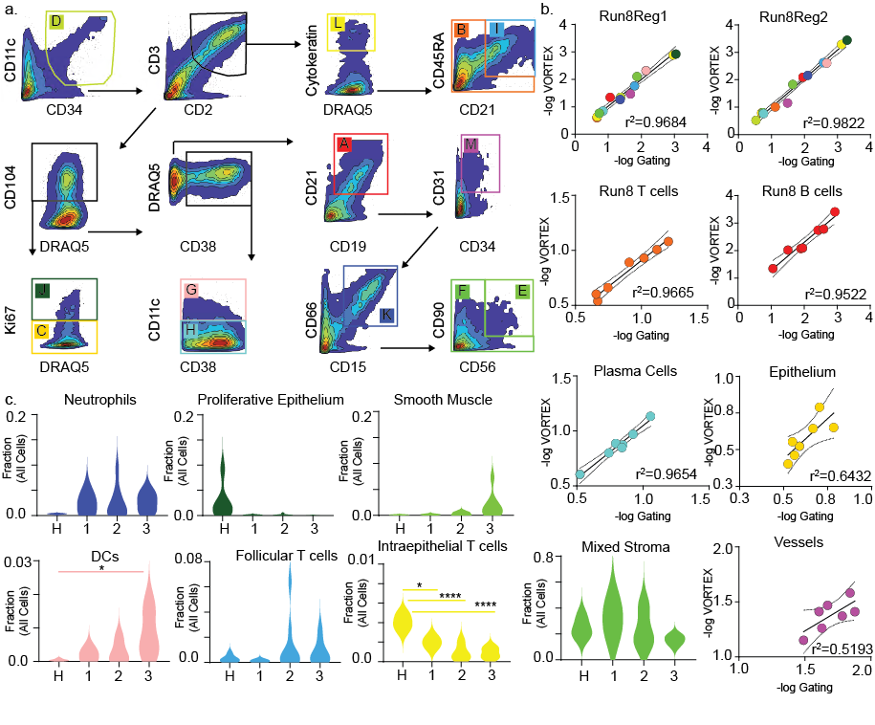 Figure S4. Manual gating of cell types and correlation with Vortex clustering.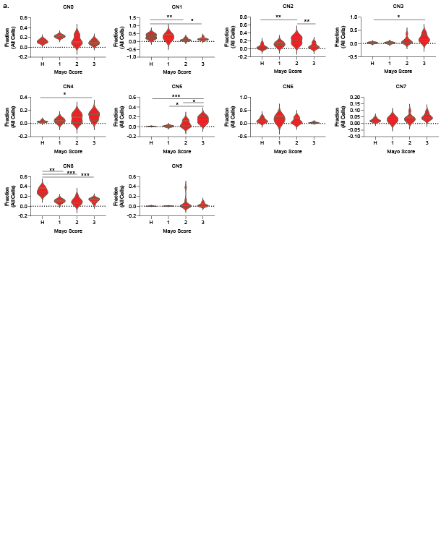 Figure S5. Cellular neighborhoods versus clinical Mayo Scores.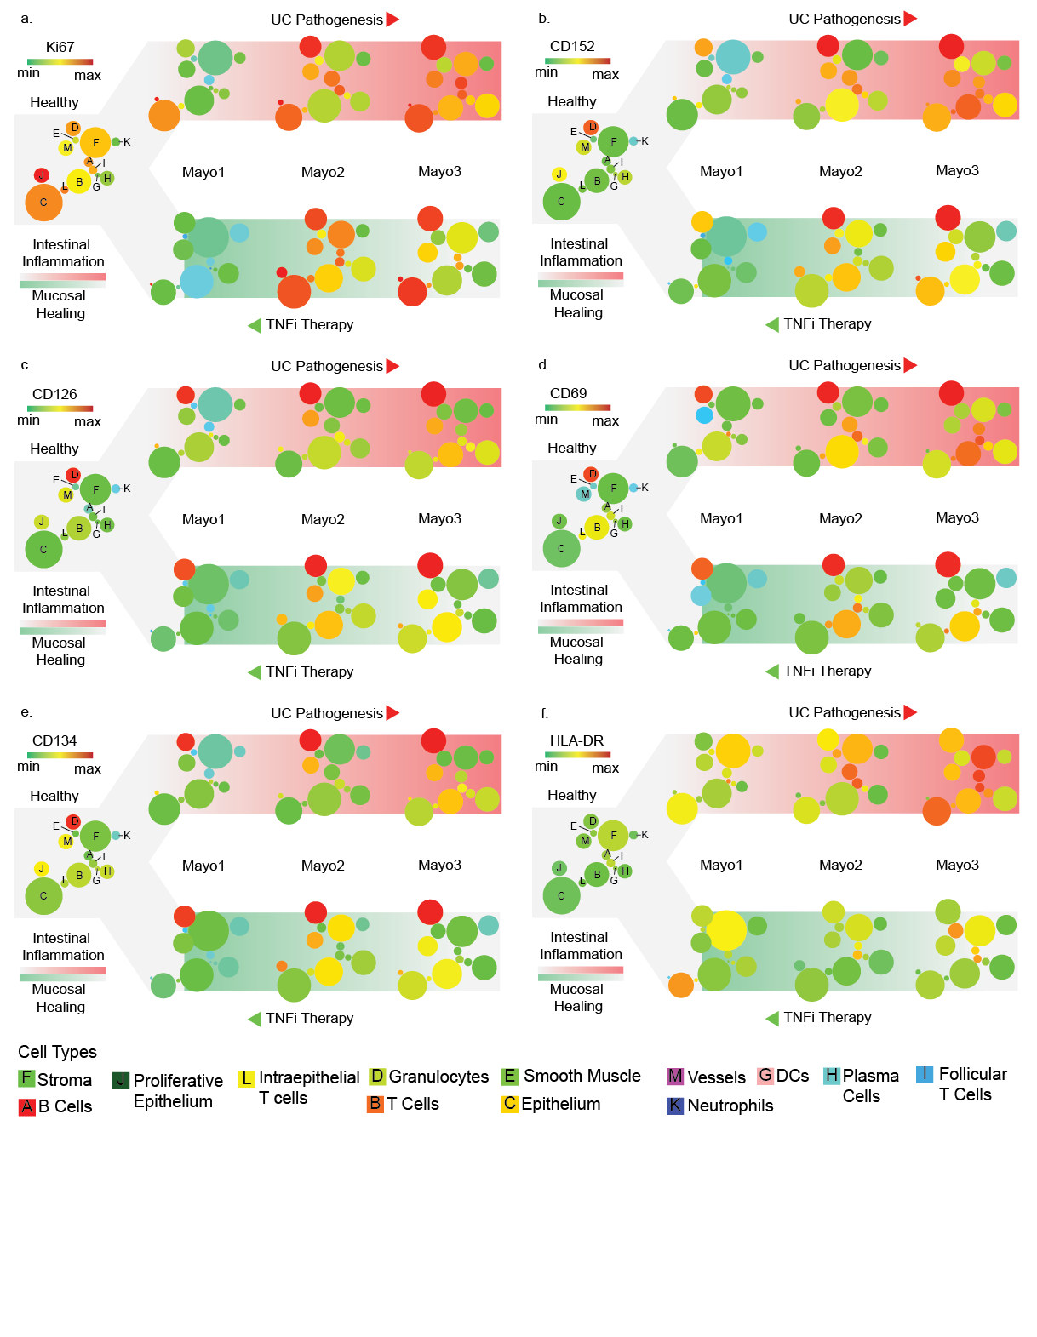 Figure S6. Biomarker expression across cell populations and disease states.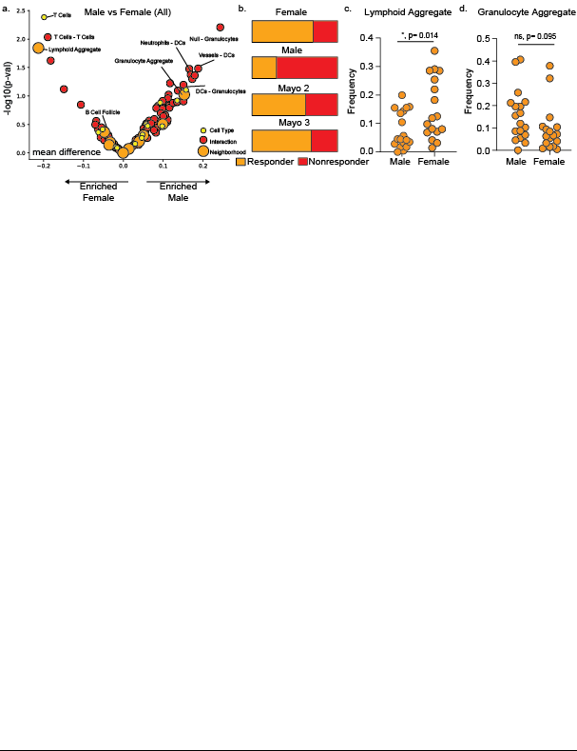
Figure S7. Sex differences in UC.
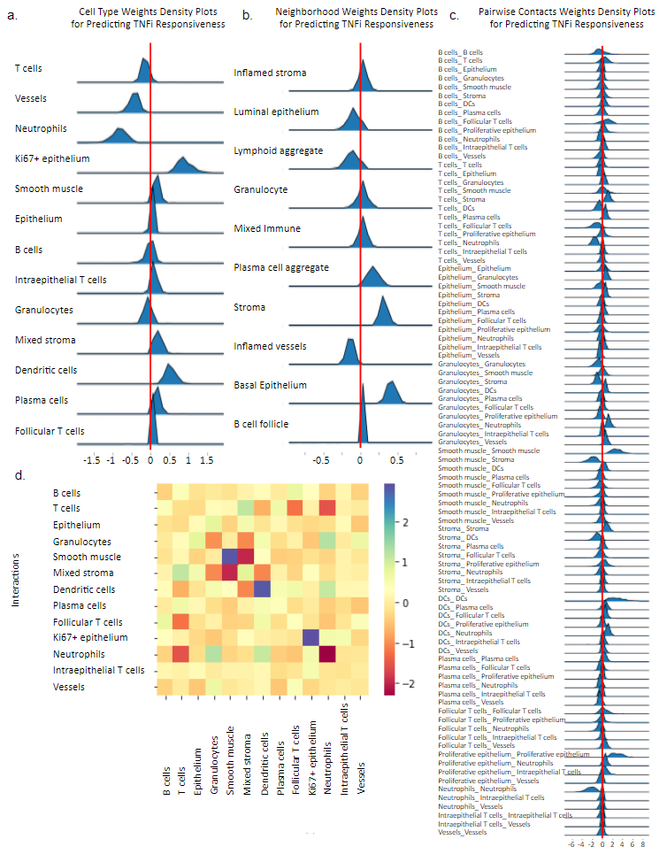

Figure S8. L1-penalized logistic regression prediction of TNFi response in UC patients.

Supplementary Tables

Table S1. Patient demographics, medical characteristics, TNFi therapy outcomes, and tissue data collected through the Inflammatory Bowel Disease Biobank at the University of California, San Diego.
Patient Characteristics | UCª | UC TNFi^{b} | HC^{c}
Patients (n) | 14 | 15 | 5
Female | 7 | 8 | 1
Male | 7 | 7 | 4
Age, years (mean ± SD) | 39.9 ± 14.3 | 43.3 ± 18.2 | 65.2 ± 8.8
Age range, years | 21 - 67 | 23 - 78 | 50 - 73
Disease Characteristics
Disease duration, years (mean ± SD) | 8.86 ± 10.8 | 7.2 ± 5.9 | ---
Disease duration range, years | 1 - 40 | 2 - 26 | ---
Colonic Segment Bx Location
Rectum | 11 (78.6%) | 13 (86.7%) | 5 (100%)
Right Colon | 3 (21.4%) | 0 | 0
Left Colon | 0 | 2 (13.3%) | 0
Mayo ES Classification
Mayo Score 0 | 0 | 0 | ---
Mayo Score 1 | 2 (14.3 %) | 2 (13.3%) | ---
Mayo Score 2 | 7 (50%) | 6 (40%) | ---
Mayo Score 3 | 5 (35.7%) | 7 (46.7%) | ---
TNFi Therapy Outcomes
Subsequent non-responders | 3 (21.4%)* | 7 (46.7%) | ---
Subsequent responders | 3 (21.4%)* | 6 (40%) | ---
N/A | 8 (57.2%) | 2 (13.3%) | ---

ª Subjects labeled “UC” had not been treated with TNFi at time of biopsy. An asterisk indicates that the patient received TNFi therapy subsequently, and response was retrieved from the patient history. b Subjects labeled “UC TNFi” were being treated with TNFi at the time of biopsy. c Subjects labeled “HC” were controls without IBC.

Table S2. Antibody panel information

Antigen | Clone(s) | Manufacturer | Catalog No. | CODEX oligo | Working dilution | Exposure time
Vimentin | RV202 | BD | 550513 | 7 | 1:100 | 1/3 s
CD85j | HP-F1 | ThermoFisher | 16-5129-82 | 8 | 1:100 | 1/3 s
CD15 | HI98 | Biolegend | 301902 | 15 | 1:100 | 1/6 s
CD21 | Bu32 | Biolegend | 354902 | 21 | 1:100 | 1/3 s
CD4 | A161A1 | Biolegend | 357402 | 28 | 1:100 | 1/3 s
CD66 | B1.1/CD66 | BD | 551354 | 41 | 1:100 | 1/4 s
CD8 | SK1 | Biolegend | 344702 | 43 | 1:100 | 1/3 s
CD11c | B-ly6 | BD | 555391 | 44 | 1:100 | 1/3 s
CD54 | HA58 | BD | 555510 | 46 | 1:100 | 1/1.2 s
CD7 | CD7-6B7 | Biolegend | 343102 | 58 | 1:100 | 1/3 s
TCRyd | B1 | Biolegend | 331202 | 63 | 1:100 | 1/3 s
CD38 | HB-7 | Biolegend | 356602 | 66 | 1:100 | 1/6 s
CD90 | 5 E10 | BD | 555593 | 68 | 1:100 | 1/5 s
CD40 | HB14 | Biolegend | 313002 | 70 | 1:100 | 1/1.5 s
CD45RA | HI100 | Biolegend | 304102 | 72 | 1:100 | 1/3 s
podoplanin | NC-08212.77 | Biolegend | 337002 | 32 | 1:100 | 1/3.5 s
collagen IV | ab6586 | Abcam | ab6586 | 33 | 1:100 | 1/15 s
CD19 | HIB19 | Biolegend | 302202 | 2 | 1:100 | 1/3 s
TIGIT | A15153G | Biolegend | 372702 | 5 | 1:100 | 1/2 s
HLA-DR | TU36 | Biolegend | 361602 | 11 | 1:100 | 1/10 s
CD274 | 29E.2A3 | Biolegend | 329702 | 14 | 1:100 | 1/5 s
CD3 | UCHT1 | BD | 555330 | 20 | 1:100 | 1/3 s
CD69 | FN50 | Biolegend | 310902 | 24 | 1:100 | 1/6 s
CD57 | HCD57 | Biolegend | 359602 | 30 | 1:100 | 1/3 s
HIF-1a | 1A3 | Abcam | ab82832 | 36 | 1:100 | 1/1.2 s
CD34 | 561 | Biolegend | 343602 | 38 | 1:100 | 1/3 s
VCAM-1 | 51-10c9 | BD | 555645 | 48 | 1:100 | 1/2 s
CD36 | CB38 | ThermoFisher | MA1-10209 | 49 | 1:100 | 1/3 s
CD1c | L161 | Biolegend | 331502 | 55 | 1:100 | 1/3 s
CD45 | HI30 | Biolegend | 304002 | 56 | 1:100 | 1/20 s
FoxP3 | 236A/E7 | ThermoFisher | 14-4777-82 | 57 | 1:100 | 1/4 s
cytokeratin | C-11 | Biolegend | 628602 | 67 | 1:100 | 1/7.5 s
CD278 | C398.4A | Biolegend | 313502 | 71 | 1:100 | 1/3 s
CD117 | YB5.B8 | ThermoFisher | 14-1179-82 | 74 | 1:100 | 1/3 s
CD5 | UCHT2 | Biolegend | 300602 | 75 | 1:100 | 1/10 s
CD31 | WM59 | Biolegend | 303102 | 3 | 1:100 | 1/4 s
Ki67 | B56 | BD | 556003 | 6 | 1:100 | 1/12 s
CD152 | BNI3 | BD | 555851 | 23 | 1:100 | 1/3 s
CD2 | RPA-2.10 | Biolegend | 300202 | 25 | 1:100 | 1/3 s
CD126 | BDm5 | BD | 551462 | 81 | 1:100 | 1/2 s
CD134 | BerACT35 | Biolegend | 350002 | 69 | 1:100 | 1/2 s
CD56 | B159 | BD | 555514 | 29 | 1:100 | 1/3 s
MMP12 | ab137444 | Abcam | ab137444 | 45 | 1:100 | 1/2.3 s
CD137 | b4-1 | Biolegend | 309802 | 53 | 1:100 | 1/2 s
CD49f | GoH3 | BD | 555734 | 51 | 1:100 | 1/3 s
CD16 | 3G8 | BD | 555404 | 52 | 1:100 | 1/3 s
CD123 | 656 | Biolegend | 306002 | 59 | 1:100 | 1/3 s
HLA-ABC | G46-2.6 | BD | 555551 | 60 | 1:100 | 1/3 s
CD127 | A019D5 | Biolegend | 351302 | 61 | 1:100 | 1/1.2 s
CD104 | 450-9D | BD | 555721 | 76 | 1:100 | 1/3 s
TNFR2 | BD-htnfr-m1 | BD | 551311 | 77 | 1:100 | 1/2 s
CD279 | EH12.2H7 | Biolegend | 329902 | 79 | 1:100 | 1/3 s

Table S3. Reagents
Reagent | Source | Identifier
Antibodies and Proteins
Purified antibodies, see Table S2 | Various | Various
Oligonucleotides
CODEX oligonucleotides, see Table S3 | TriLink Biotechnologies and Integrated DNA Technologies | N/A
Biological Samples
Fresh frozen tissue | University of California, San Diego | N/A
Chemicals and Reagents
PBS | Thermo Fisher Scientific | 14190-250
NaCl | Thermo Fisher Scientific | S271-10
Na2HPO4 | Sigma | S7907
NaH2PO4 ∙ 7 H2O | Sigma | S9390
MgCl2 ∙ 6 H2O | Sigma | M2670
NaN3 | Sigma | S8032
EDTA | Sigma | 93302
TCEP | Sigma | C4706
NaOH | Sigma | S8263
BS3 | Thermo Fisher Scientific | 21580
Poly-L-Lysine | Sigma | P8920
DMSO | Thermo Fisher Scientific | D128-4
DMSO | Sigma | 472301
DMSO ampoules | Sigma | D2650
Paraformaldehyde ampoules, 16% | Thermo Fisher Scientific | 50-980-487
BSA | Sigma | A3059
Tris 1 M, pH 8.0 | Teknova | T1080
Candor PBS antibody stabilizer solution | Thermo Fisher Scientific | NC0436689
Salmon sperm DNA, sheared | Thermo Fisher Scientific | AM9680
TritonTM X-100 | Sigma | T8787
Ethanol, 100% | Sigma | E7023
Acetone, 100% | Thermo Fisher Scientific | A929-4
Methanol, 100% | Thermo Fisher Scientific | A412-4
Trizma® HCl | Sigma | T3253
Trizma® Base | Sigma | T1503
Drierite indicating desiccant | Thermo Fisher Scientific | 07-578-3A
Bondic polyacrylamide gel | Amazon | B018IBEHQU
Antibody diluent | Agilent | S080981-2
Protein block, serum-free | Agilent | X090930-2
Dual endogenous enzyme-blocking reagent | Agilent | S200380-2
Hematoxylin, ready-to-use | Agilent | S330930-2
Eosin Y solution | Sigma | HT110116
Cytoseal XYL | Thermo Fisher Scientific | 8312-4
Sally Hansen Nail Polish, clear | Amazon | B00CMFMYEG
Critical Commercial Instruments, Consumables, Kits and Assays
LTS filter tips, 10 μl | Rainin | 30389225
LTS filter tips, 200 μl | Rainin | 30389239
LTS filter tips, 1000 μl | Rainin | 30389212
AmiconTM Ultra Centrifugal Filters, 50kDa | Thermo Fisher Scientific | UFC505096
NalgeneTM Rapid Flow 500 ml filter, 0.2 μm | Thermo Fisher Scientific | 09-740-28C
Glass coverslips, 22x22 mm, # 1 1/2 | Electron Microscopy Sciences | 72204-01
Frosted microscope slides | Thermo Fisher Scientific | 12-550-343
Glass coverslip storage box | Qintay | CS-22
22x22 mm coverslip mounting gaskets | Qintay | TMG-22
WheatonTM Coverslip glass jars | Thermo Fisher Scientific | 02-912-637
Dumont #5/45 coverslip forceps | Fine Science Tools | 11251-33
8-strip tubes, 0.2 ml | E&K Scientific | 280008
8-strip caps, flat top | E&K Scientific | 491008
8-strip caps, dome top | E&K Scientific | 491018
CODEX acrylic plates | Bayview Plastic Solutions | custom made
BZ-X710 fluorescence microscope | Keyence | N/A
Hoechst 33342 | Thermo Fisher Scientific | 62249
DRAQ5 | Cell Signaling Technology | 4084L
CorningTM clear 96-well plates | Thermo Fisher Scientific | 07-200-762
Axygen aluminum sealing film | VWR Scientific | 47734-817
CODEX System | Akoya Biosciences | N/A
Software and Algorithms
BZ-X viewer | Keyence | N/A
CODEX driver | Akoya Biosciences | N/A
CODEX Toolkit, version 1.3.5 | https://github.com/nolanlab/CODEX | (Goltsev et al., 2018)
Microvolution software for deconvolution | www.microvolution.com | N/A
ImageJ (Fiji version 2.0.0) | http://imagej.net | N/A
VorteX (X-shift clustering algorithm) | https://github.com/nolanlab/VORTEX | (Samusik et al., 2016)
CellEngine | www.cellengine.com | (Bjornson-Hooper et al., 2019)
R, version 3.4.3 | www.r-project.org | N/A
R studio desktop, version 1.1.423 | www.rstudio.com | N/A
Neighborhood analysis notebooks | https://github.com/nolanlab | (Schuerch et al, 2020)
Tensorly Python package | http://tensorly.org/ | (Kossaifi et al., 2019)
Statsmodel Python package | https://www.statsmodels.org/ | (Seabold and Perktold, 2010)
Scikit learn Python package | https://scikit-learn.org/ | (Pedregosa et al., 2011)
Survival R package | https://cran.r-project.org/web/packages/ survival/index.html | (Therneau, 2015)
Glmnet R package | https://cran.r-project.org/web/packages/ glmnet/index.html | (Friedman et al., 2010)
Visreg R package | https://cran.r-project.org/web/packages/ visreg/index.html | (Breheny and Burchett, 2013)
Deldir R package | https://cran.r-project.org/web/packages/ deldir/index.html | N/A
ComplexHeatmap R package | release/bioc/html/ ComplexHeatmap.html | (Gu et al., 2016)
The Human Protein Atlas | www.proteinatlas.org | N/A
Pathology Outlines | www.pathologyoutlines.com | N/A
Stock Solutions | Composition
Staining solution 1 (S1) | 5 mM EDTA, 0.5% w/v bovine serum albumin, and 0.02% w/v NaN₃ in PBS, store at 4 °C.
Staining solution 2 (S2) | 61 mM NaH₂PO₄ ∙ 7 H₂O, 39 mM NaH₂PO₄, and 250 mM NaCl in a 1:0.7 v/v mix of S1 and double-distilled (dd)H₂O; final pH 6.8-7.0.
Staining solution 4 (S4) | 0.5 M NaCl in S1.
TE Buffer | 10 mM Tris pH 8.0, 1 mM EDTA and 0.02% w/v NaN₃ in ddH₂O.
Tris buffer | 50 mM, pH 7.2 (at room temperature/25 °C) was prepared using 7.02 g/L Trizma HCl and 0.67 g/L Trizma base in ddH₂O.
Conjugation buffer C (C) | 150 mM NaCl, 2 mM Tris buffer solution, pH 7.2, 1 mM EDTA and 0.02% w/v NaN₃ in ddH2O
Codex 2.0 buffer (H2) | 150 mM NaCl, 10 mM Tris, pH 7.5, 10 mM MgCl₂ ∙ 6 H₂O, 0.1% w/vTriton X-100, and 0.02% w/v NaN₃ in ddH₂O. [DRH1]
Blocking reagent 1 (B1) | 1 mg/ml mouse IgG (Sigma) in S2.
Blocking reagent 2 (B2) | 1 mg/ml rat IgG (Sigma) in S2.
Blocking reagent 3 (B3) | Sheared salmon sperm DNA, 10 mg/ml (Thermo Fisher).
Blocking reagent 4 (B4) | Mixture of 57 non-modified CODEX oligonucleotides (see Table S2) at a final concentration of 0.5 mM each.
BS3 fixative solution (BS3) | 200 mg/ml BS3 in DMSO, fresh, stored at -20 °C in 15 μl aliquots. [DRH2]
TCEP solution | 0.5 M TCEP in ddH₂O, pH 7.0.
Rendering buffer | 20% DMSO (v/v) in H2 buffer.
Stripping buffer | 80% DMSO (v/v) in H2 buffer.

