Supplementary Table 1. Primer sequence

Mouse
 | Forward (5’-3’) | Reverse (5’-3’)
GAPDH | CGACCTTCACCATTTTGTCTACA | GCTTAAGAGACAGCCGCATCT
Cd200r | AGGAGGATGAAATGCAGCCTTA | TGCCTCCACCTTAGTCACAGTATC
Trem2 | TGGGACCTCTCCACCAGTT | GTGGTGTTGAGGGCTTGG
Cx3cr1 | TGGCCCAGCAAGCATAG | CATGTCTGCTACCCTCACAAA
Il1b | GGCTGGACTGTTTCTAATGC | ATGGTTTCTTGTGACCCTGA
Il6 | GCAAGTGCATCATCGTTGTTCATAC | CCACTTCACAAGTCGGAGGCTTA
Tnfa | GAGTCCGGGCAGGTCTACTTT | CAGGTCACTGTCCCAGCATCT
Il10 | GCAGCTCTAGGAGCATGTGG | ACAGCCGGGAAGACAATAACT
Arg1 | GGAATCTGCATGGGCAACCTGTGT | AGGGTCTACGTCTCGCAAGCCA
Ido | GGCTTCTTCCTCGTCTCTCTATTG | TGACGCTCTACTGCACTGGATAC
Kmo | CCTGTAGAGGACAATATAGGATCAACAA | GCAAGCCCCATCTACTGCAT
C1qa | Qiagen PPM24525E
C3ar1 | Qiagen PPM04821A

Supplementary Table 2. Statistics of two-way ANOVA in behavior assessment in 5W/10W and Orx group.
5W Behavior - PPI
 | SS  (Sum-of-squares) | Df  (Degrees of freedom) | MS  (Mean squares) | F  (F ratio) | p-value
Treatment  (Veh vs. PN-DEX) | 53.89 | 1 | 53.89 | 0.1386 | P=0.7104
Decibel  (3 dB, 6 dB, 12 dB) | 1002 | 2 | 500.8 | 1.288 | P=0.2799
Interaction  Treatment x Decibel | 3476 | 6 | 579.3 | 2.273 | P=0.0388

10W Behavior - PPI
 | SS  (Sum-of-squares) | Df  (Degrees of freedom) | MS  (Mean squares) | F  (F ratio) | p-value
Treatment *  (Veh vs. PN-DEX) | 1417 | 1 | 1417 | 5.898 | P=0.0162
Decibel ****  (3 dB, 6 dB, 12 dB) | 41236 | 5 | 8247 | 34.33 | P<0.0001
Interaction *  Treatment x Decibel | 2815 | 5 | 563 | 2.343 | P=0.0436
10W Behavior - LI
Treatment  (Veh vs. PN-DEX) | 89.23 | 1 | 89.23 | 0.5127 | P=0.4804
Conditioning  (NPE vs. PE) | 393 | 1 | 393 | 2.258 | P=0.1449
Interaction **  Treatment x Conditioning | 1448 | 1 | 1448 | 8.319 | P=0.0078
10W Behavior – Locomotor activity
Treatment *  (Veh vs. PN-DEX) | 90715093 | 1 | 90715093 | 6.591 | P=0.0200
Time ****  (1 min. bins) | 132185617 | 23 | 5747201 | 16.79 | P<0.0001
Interaction ****  Treatment x Time | 27350861 | 23 | 1189168 | 3.475 | P<0.0001

Orx Behavior - PPI
 | SS  (Sum-of-squares) | Df  (Degrees of freedom) | MS  (Mean squares) | F  (F ratio) | p-value
Treatment **** | 7954 | 3 | 2651 | 10.40 | P<0.0001
Decibel **** | 5763 | 2 | 2882 | 11.31 | P<0.0001
Interaction *  Treatment x Decibel | 311.2 | 2 | 155.6 | 0.4002 | P=0.6712

Supplementary Table 3. Statistics of two-way ANOVA in microglia morphology analysis.
mPFC – Soma size
 | SS  (Sum-of-squares) | Df  (Degrees of freedom) | MS  (Mean squares) | F  (F ratio) | p-value
Treatment  (Veh vs. PN-DEX) | 6210 | 1 | 6210 | 74.66 | P<0.0001
Timepoint  (5W vs. 10W) | 1904 | 1 | 1904 | 22.89 | P<0.0001
Interaction  Treatment x Timepoint | 3269 | 1 | 3269 | 39.3 | P<0.0001
mPFC – Endpoint
Treatment  (Veh vs. PN-DEX) | 580.1 | 1 | 580.1 | 14 | P=0.0013
Timepoint  (5W vs. 10W) | 377.3 | 1 | 377.3 | 9.107 | P=0.0068
Interaction **  Treatment x Timepoint | 506.7 | 1 | 506.7 | 12.23 | P=0.0023
mPFC – Average branch length
Treatment  (Veh vs. PN-DEX) | 94.09 | 1 | 94.09 | 8.922 | P=0.0073
Timepoint ***  (5W vs. 10W) | 137.4 | 1 | 137.4 | 13.02 | P=0.0018
Interaction  Treatment x Timepoint | 12.48 | 1 | 12.48 | 1.183 | P=0.2896
mPFC – Sholl analysis
Treatment ****  (Veh vs. PN-DEX) | 1117 | 3 | 372.3 | 20.04 | P<0.0001
Timepoint ****  (5W vs. 10W) | 20714 | 9 | 2302 | 123.9 | P<0.0001
Interaction ***  Treatment x Timepoint | 1039 | 27 | 38.47 | 2.071 | P=0.0013
mPFC – Mean intersections
Treatment  (Veh vs. PN-DEX) | 27.45 | 1 | 27.45 | 0.5374 | P=0.4641
Timepoint  (5W vs. 10W) | 146.2 | 1 | 146.2 | 2.863 | P=0.0917
Interaction *  Treatment x Timepoint | 27.45 | 1 | 27.45 | 0.5374 | P=0.4641

STR – Soma size
 | SS  (Sum-of-squares) | Df  (Degrees of freedom) | MS  (Mean squares) | F  (F ratio) | p-value
Treatment  (Veh vs. PN-DEX) | 105.2 | 1 | 105.2 | 1.651 | P=0.1331
Timepoint  (5W vs. 10W) | 151.6 | 1 | 151.6 | 2.379 | P=0.1233
Interaction  Treatment x Timepoint | 144 | 1 | 144 | 2.26 | P=0.1991
STR – Endpoint
Treatment  (Veh vs. PN-DEX) | 69.39 | 1 | 69.39 | 3.553 | P=0.0741
Timepoint  (5W vs. 10W) | 13.78 | 1 | 13.78 | 0.7056 | P=0.4109
Interaction **  Treatment x Timepoint | 188.1 | 1 | 188.1 | 9.632 | P=0.0056
STR – Average branch length
Treatment  (Veh vs. PN-DEX) | 30.57 | 1 | 30.57 | 3.257 | P=0.0862
Timepoint ***  (5W vs. 10W) | 174.7 | 1 | 174.7 | 18.62 | P=0.0003
Interaction  Treatment x Timepoint | 29.38 | 1 | 29.38 | 3.13 | P=0.0921
STR – Sholl analysis
Treatment ****  (Veh vs. PN-DEX) | 436.2 | 3 | 145.4 | 10.29 | P<0.0001
Timepoint ****  (5W vs. 10W) | 10415 | 7 | 1488 | 105.3 | P<0.0001
Interaction ***  Treatment x Timepoint | 717.7 | 21 | 34.18 | 2.418 | P=0.0006
STR – Mean intersections
Treatment  (Veh vs. PN-DEX) | 11.35 | 1 | 11.35 | 2.53 | P=0.1186
Timepoint  (5W vs. 10W) | 17.96 | 1 | 17.96 | 4.002 | P=0.0514
Interaction *  Treatment x Timepoint | 26.03 | 1 | 26.03 | 5.802 | P=0.0201
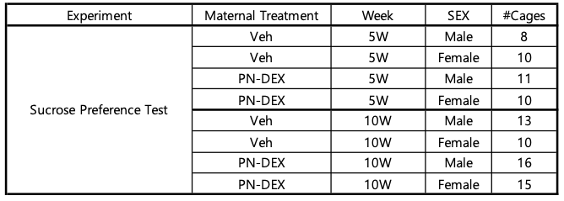
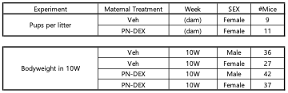
Supplementary Table 4. The number of mice used in behavior assessment.

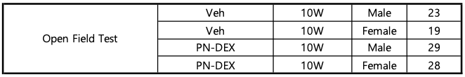
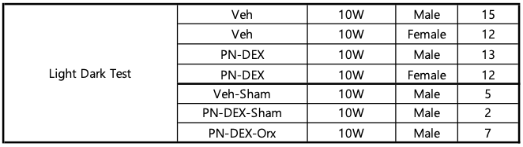
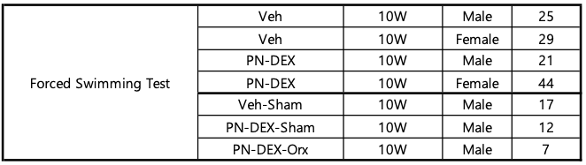
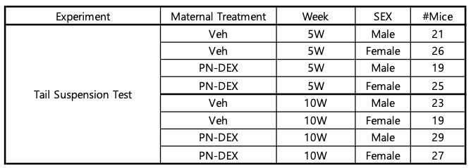
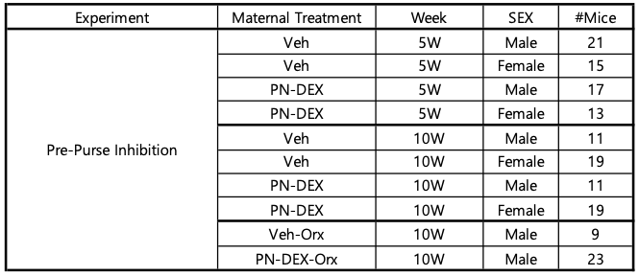

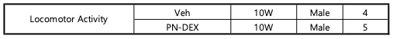

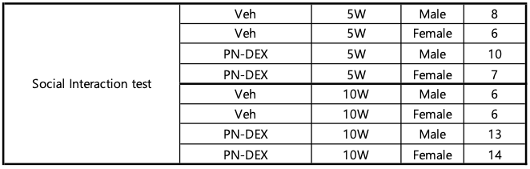

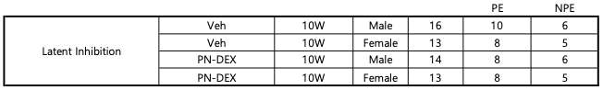

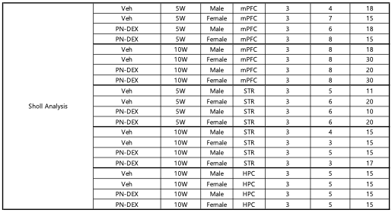
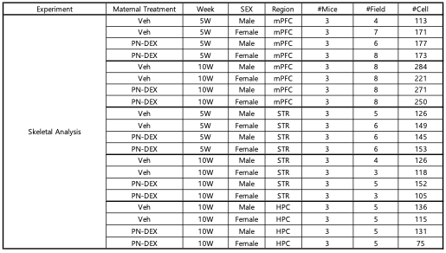
Supplementary Table 5. The number of mice used in molecular works.
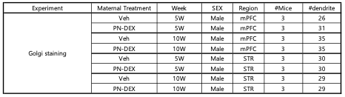
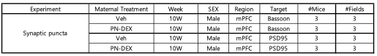
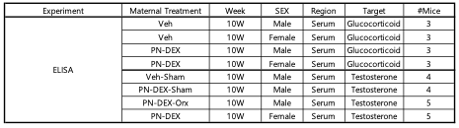
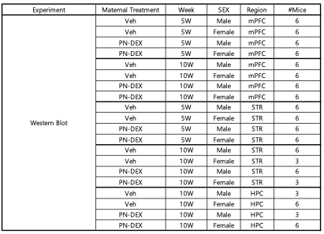
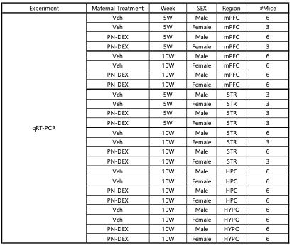

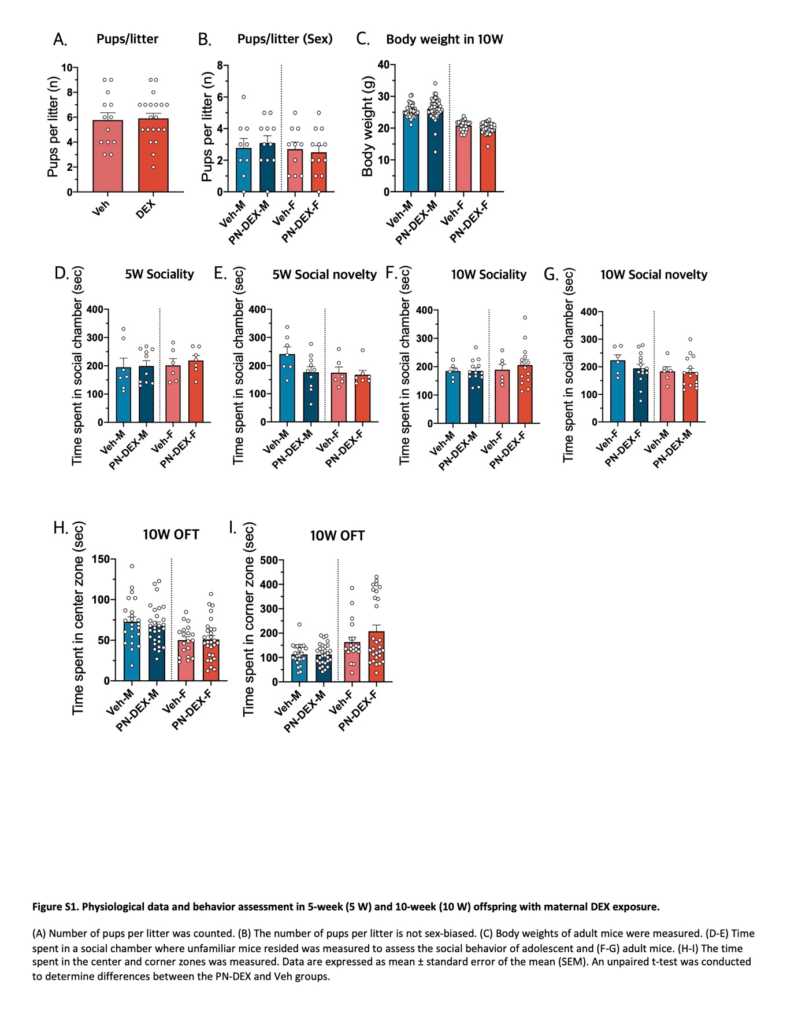

Supplementary figure 1. Physiological data and behavior assessment in 5-week (5 W) and 10-week (10 W) offspring with maternal DEX exposure.

(A) Number of pups per litter was counted. (B) The number of pups per litter is not sex-biased. (C) Body weights of adult mice were measured. (D-E) Time spent in a social chamber where unfamiliar mice resided was measured to assess the social behavior of adolescent and (F-G) adult mice. (H-I) The time spent in the center and corner zones was measured. Data are expressed as mean ± standard error of the mean (SEM). An unpaired t-test was conducted to determine differences between the PN-DEX and Veh groups.

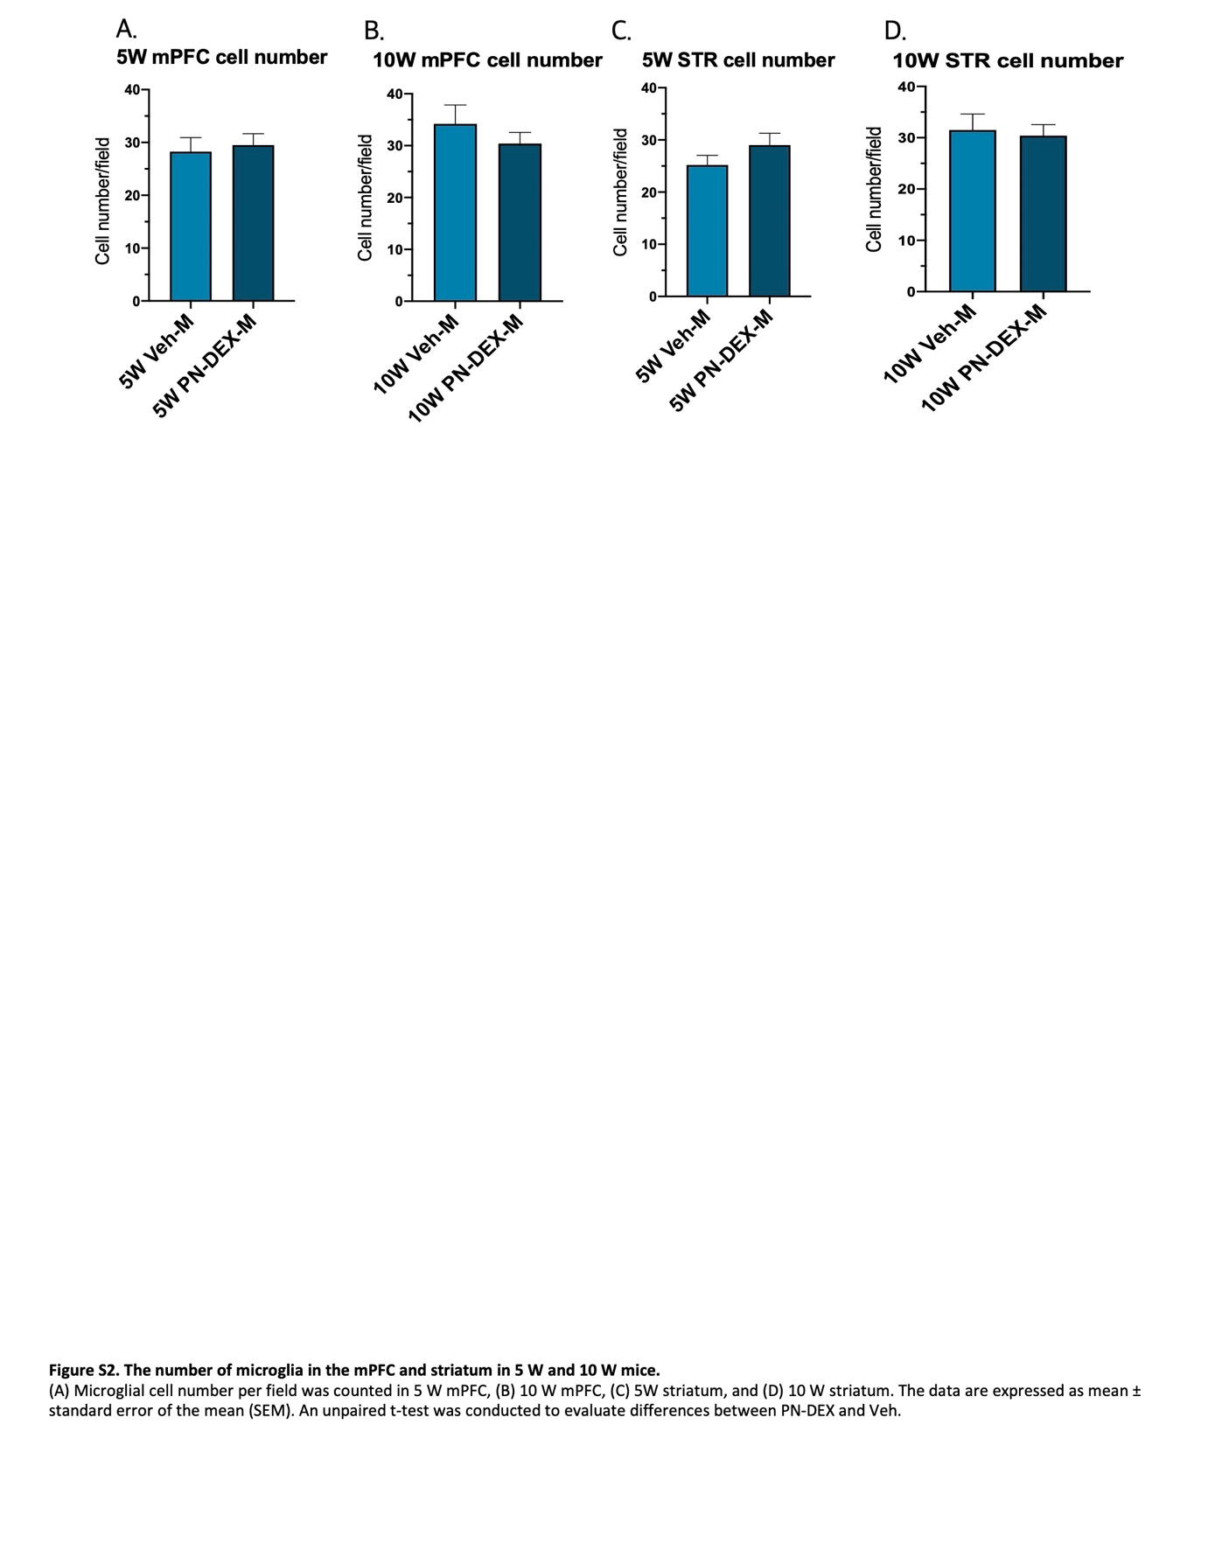

Supplementary figure 2. The number of microglia in the mPFC and striatum in 5 W and 10 W mice.
(A) Microglial cell number per field was counted in 5 W mPFC, (B) 10 W mPFC, (C) 5W striatum, and (D) 10 W striatum. The data are expressed as mean ± standard error of the mean (SEM). An unpaired t-test was conducted to evaluate differences between PN-DEX and Veh.

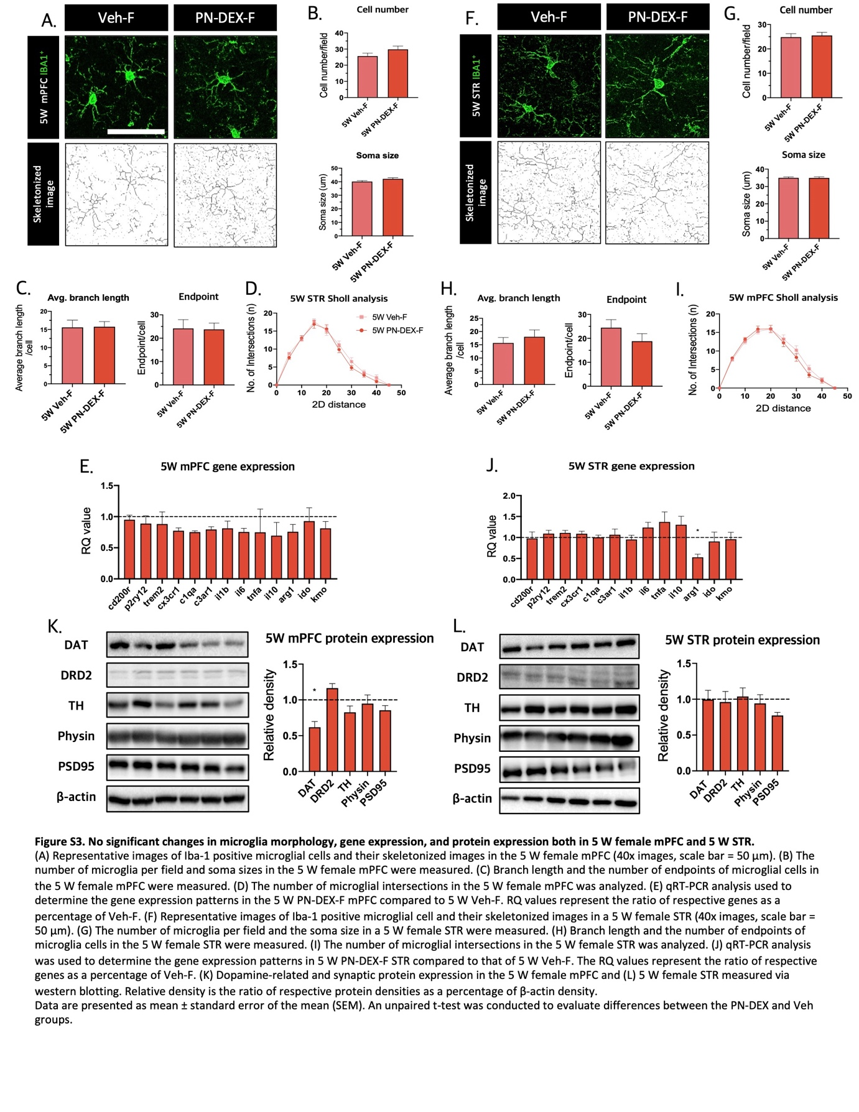

Supplementary figure 3. No significant changes in microglia morphology, gene expression, and protein expression both in 5 W female mPFC and 5 W STR.

(A) Representative images of Iba-1 positive microglial cells and their skeletonized images in the 5 W female mPFC (40x images, scale bar = 50 µm). (B) The number of microglia per field and soma sizes in the 5 W female mPFC were measured. (C) Branch length and the number of endpoints of microglial cells in the 5 W female mPFC were measured. (D) The number of microglial intersections in the 5 W female mPFC was analyzed. (E) qRT-PCR analysis used to determine the gene expression patterns in the 5 W PN-DEX-F mPFC compared to 5 W Veh-F. RQ values represent the ratio of respective genes as a percentage of Veh-F. (F) Representative images of Iba-1 positive microglial cell and their skeletonized images in a 5 W female STR (40x images, scale bar = 50 µm). (G) The number of microglia per field and the soma size in a 5 W female STR were measured. (H) Branch length and the number of endpoints of microglia cells in the 5 W female STR were measured. (I) The number of microglial intersections in the 5 W female STR was analyzed. (J) qRT-PCR analysis was used to determine the gene expression patterns in 5 W PN-DEX-F STR compared to that of 5 W Veh-F. The RQ values represent the ratio of respective genes as a percentage of Veh-F. (K) Dopamine-related and synaptic protein expression in the 5 W female mPFC and (L) 5 W female STR measured via western blotting. Relative density is the ratio of respective protein densities as a percentage of β-actin density.
Data are presented as mean ± standard error of the mean (SEM). An unpaired t-test was conducted to evaluate differences between the PN-DEX and Veh groups.
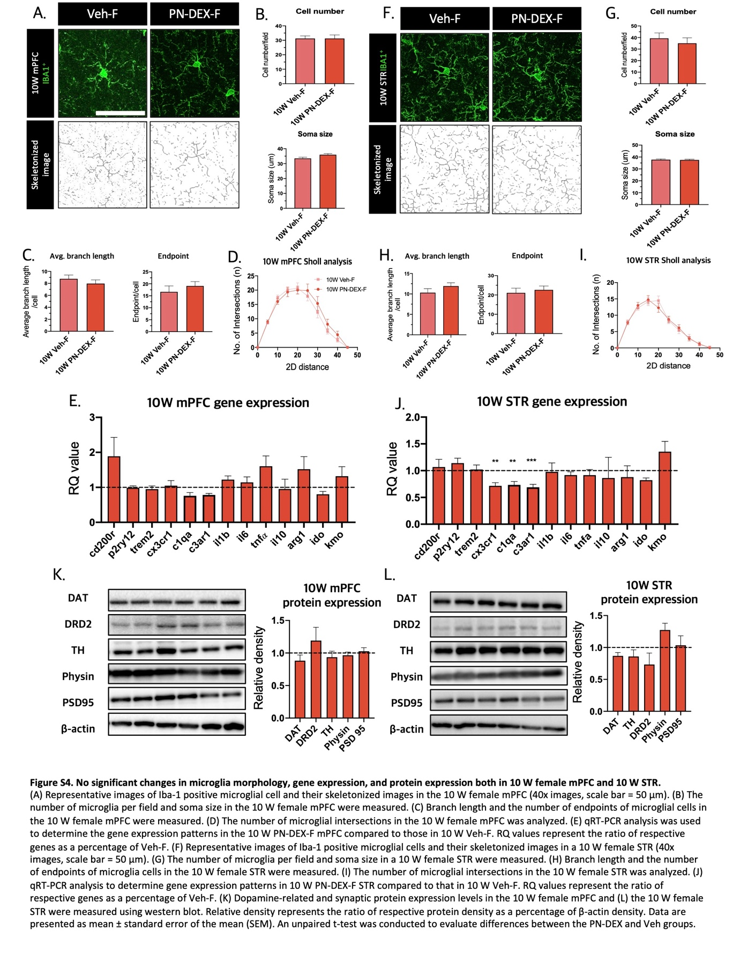

Supplementary figure 4. No significant changes in microglia morphology, gene expression, and protein expression both in 10 W female mPFC and 10 W STR.

(A) Representative images of Iba-1 positive microglial cell and their skeletonized images in the 10 W female mPFC (40x images, scale bar = 50 µm). (B) The number of microglia per field and soma size in the 10 W female mPFC were measured. (C) Branch length and the number of endpoints of microglial cells in the 10 W female mPFC were measured. (D) The number of microglial intersections in the 10 W female mPFC was analyzed. (E) qRT-PCR analysis was used to determine the gene expression patterns in the 10 W PN-DEX-F mPFC compared to those in 10 W Veh-F. RQ values represent the ratio of respective genes as a percentage of Veh-F. (F) Representative images of Iba-1 positive microglial cells and their skeletonized images in a 10 W female STR (40x images, scale bar = 50 µm). (G) The number of microglia per field and soma size in a 10 W female STR were measured. (H) Branch length and the number of endpoints of microglia cells in the 10 W female STR were measured. (I) The number of microglial intersections in the 10 W female STR was analyzed. (J) qRT-PCR analysis to determine gene expression patterns in 10 W PN-DEX-F STR compared to that in 10 W Veh-F. RQ values represent the ratio of respective genes as a percentage of Veh-F. (K) Dopamine-related and synaptic protein expression levels in the 10 W female mPFC and (L) the 10 W female STR were measured using western blot. Relative density represents the ratio of respective protein density as a percentage of β-actin density. Data are presented as mean ± standard error of the mean (SEM). An unpaired t-test was conducted to evaluate differences between the PN-DEX and Veh groups.

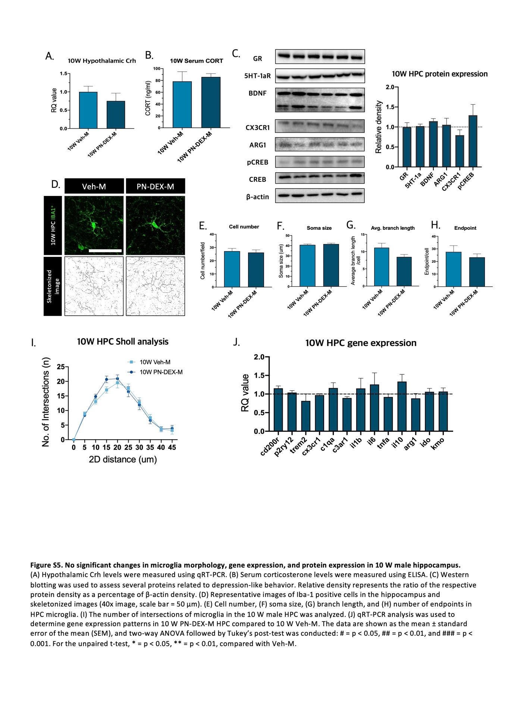

Supplementary figure 5. No significant changes in microglia morphology, gene expression, and protein expression in 10 W male hippocampus.

(A) Hypothalamic Crh levels were measured using qRT-PCR. (B) Serum corticosterone levels were measured using ELISA. (C) Western blotting was used to assess several proteins related to depression-like behavior. Relative density represents the ratio of the respective protein density as a percentage of β-actin density. (D) Representative images of Iba-1 positive cells in the hippocampus and skeletonized images (40x image, scale bar = 50 µm). (E) Cell number, (F) soma size, (G) branch length, and (H) number of endpoints in HPC microglia. (I) The number of intersections of microglia in the 10 W male HPC was analyzed. (J) qRT-PCR analysis was used to determine gene expression patterns in 10 W PN-DEX-M HPC compared to 10 W Veh-M. The data are shown as the mean ± standard error of the mean (SEM), and two-way ANOVA followed by Tukey’s post-test was conducted: # = p < 0.05, ## = p < 0.01, and ### = p < 0.001. For the unpaired t-test, * = p < 0.05, ** = p < 0.01, compared with Veh-M.

