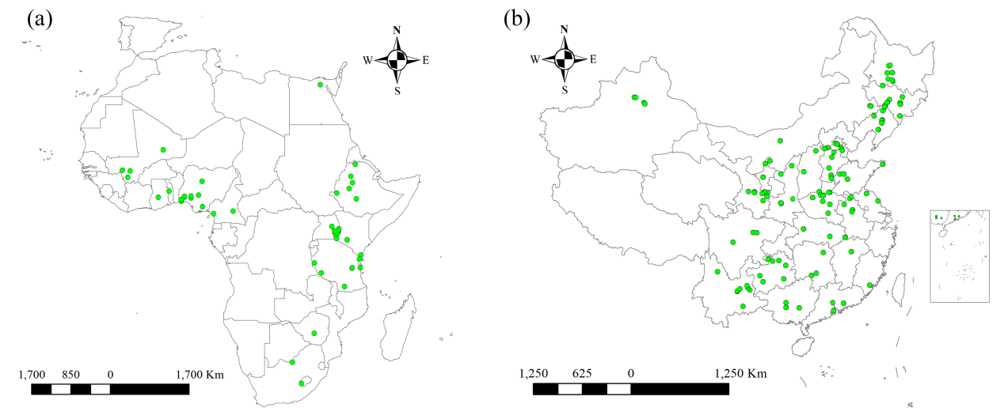
Figure S1. Distribution of case studies in meta-analysis (a) Africa and (b) China

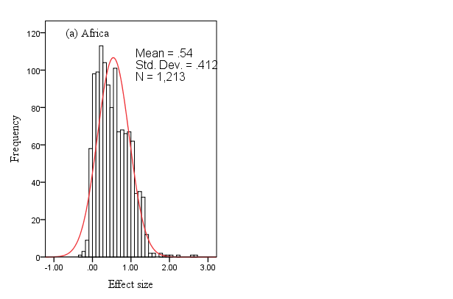

Figure S2. Frequency distribution of the response ratio (RR, the effect of fertilizer rate on yield) among all observations in the overall dataset RR = ln (yield treatment/yield control), where yield treatment and yield control were the yield of plots with P nutrient and nutrient omission, respectively.

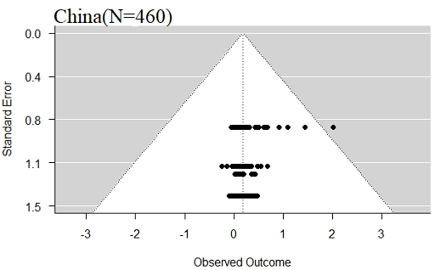
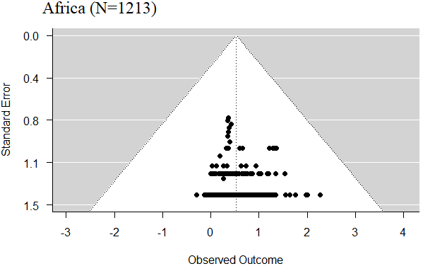

Figure S3. The funnel plot indicating the publication bias of the studies in Africa and China using random effect model.

