Supporting Information

The impact of cell culture media on the interaction of biopolymer-functionalized gold nanoparticles with cells: mechanical and toxicological properties

Brahmaiah Meesaragandla,^{1,2} Yesaswini Komaragiri,^{2,3} Rabea Schlüter,⁴ Oliver Otto,^{2,3} and Mihaela Delcea^{1,2,3}*
¹Institute of Biochemistry, University of Greifswald, Felix-Hausdorff-Straße 4, 17489 Greifswald, Germany
²ZIK HIKE - Zentrum für Innovationskompetenz „Humorale Immunreaktionen bei kardiovaskulären Erkrankungen“, Fleischmannstraße 42, 17489 Greifswald, Germany
³DZHK (Deutsches Zentrum für Herz-Kreislauf-Forschung), partner site Greifswald, Germany
⁴Imaging Center of the Department of Biology, University of Greifswald, Friedrich-Ludwig-Jahn-Str. 15, 17489 Greifswald, Germany.
*Corresponding author, delceam@uni-greifswald.de

Figure S1. UV-Vis absorption spectra of different surface-functionalized AuNPs.
Figure S2. TEM images of AuNPs functionalized with citrate, dex-10, chitosan and dextrin molecules.
Figure S3. DLS and zeta potential data of AuNPs functionalized with citrate, dex-10, dextrin and chitosan ligands.
Figure S4. Zeta potential data of AuNPs in protein poor- and protein rich medium.
Figure S5. Osmolarity of protein poor- and protein rich CCM with different surface-functionalized AuNPs.
Figure S6. Time-dependent mechanical alterations of HL 60 cells in presence of AuNPs in RPMI without FCS.
Figure S7. Time dependent cytotoxicity results of HL 60 cells in presence of different surface-functionalized AuNP in RPMI media without FCS.

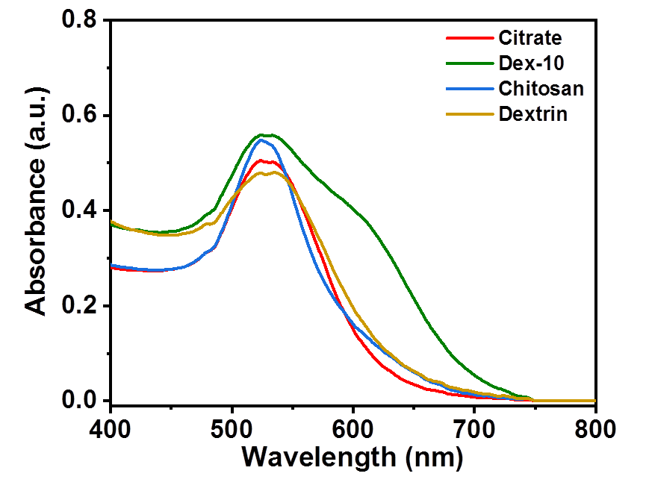

Figure S1. A) UV-Vis absorption spectra of AuNPs functionalized with citrate, dex-10, chitosan and dextrin ligands (AuNPs concentration = 100 nM).

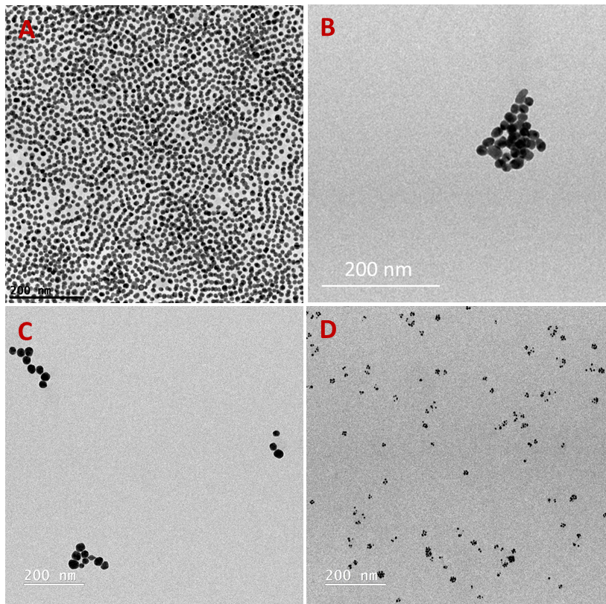
Figure S2. TEM images of AuNPs functionalized with citrate (A), dex-10 (B), chitosan (C) and dextrin (D) ligands.

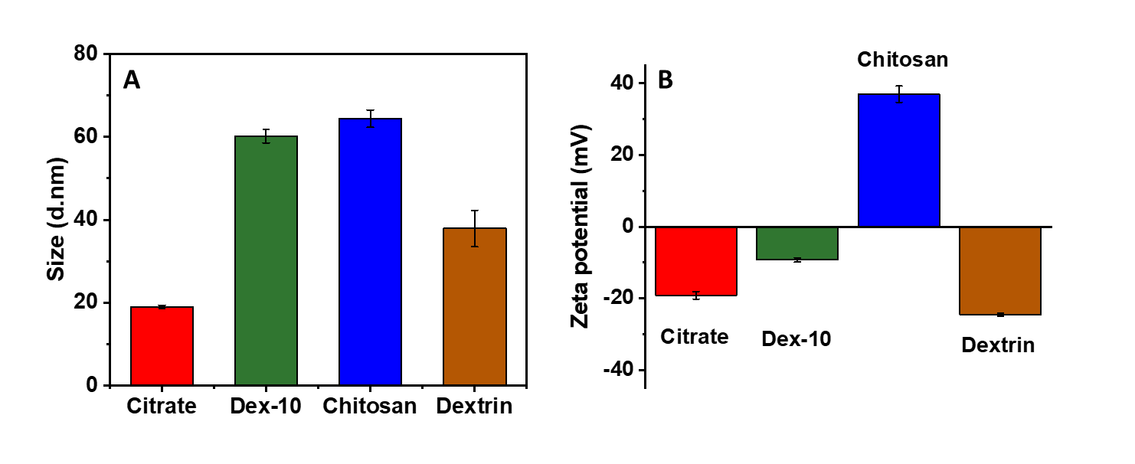
Figure S3. DLS (A) and zeta potential (B) data of biopolymer-functionalized AuNPs.

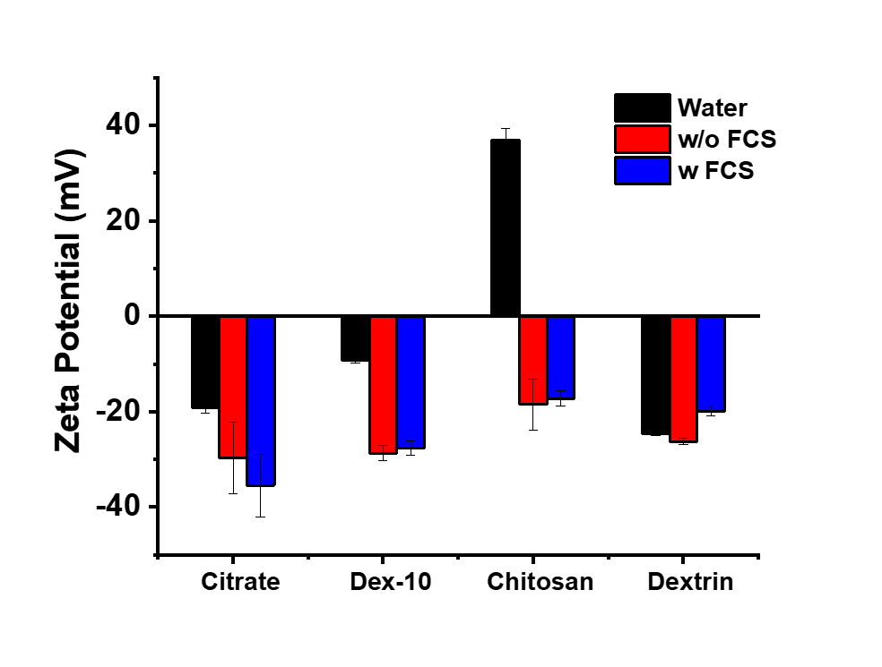
Figure S4. Charge distribution of different surface-functionalized AuNPs in protein poor- and rich media at 37 ºC after 24 h incubation.

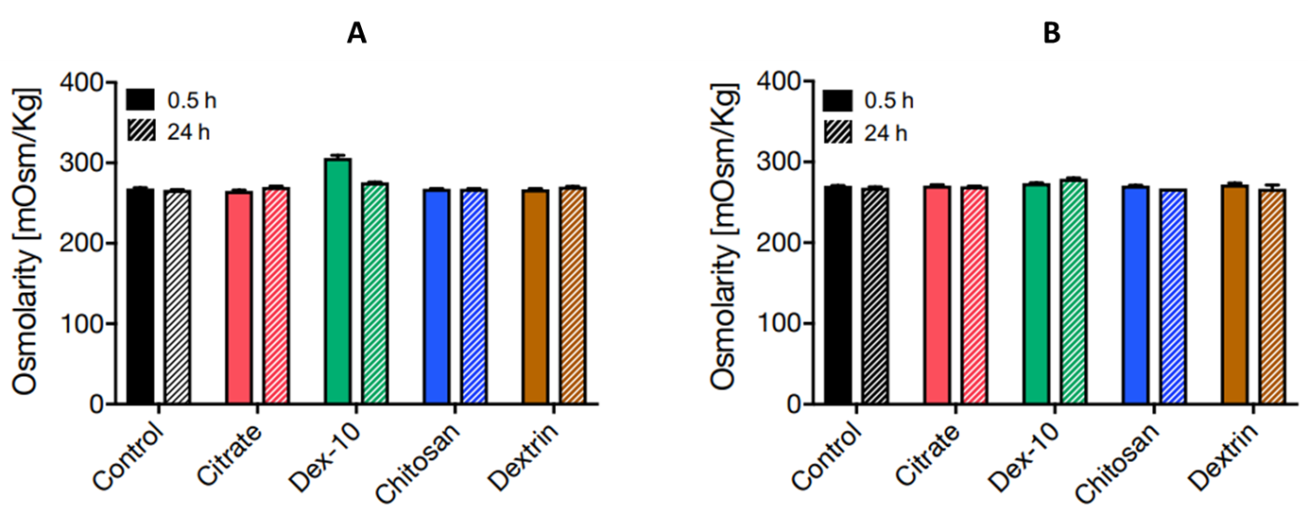
Figure S5. Osmolarity of protein poor (A) and protein rich (B) CCM after incubation with different surface-functionalized AuNPs for 0.5 h and 24 h at 37 ºC.

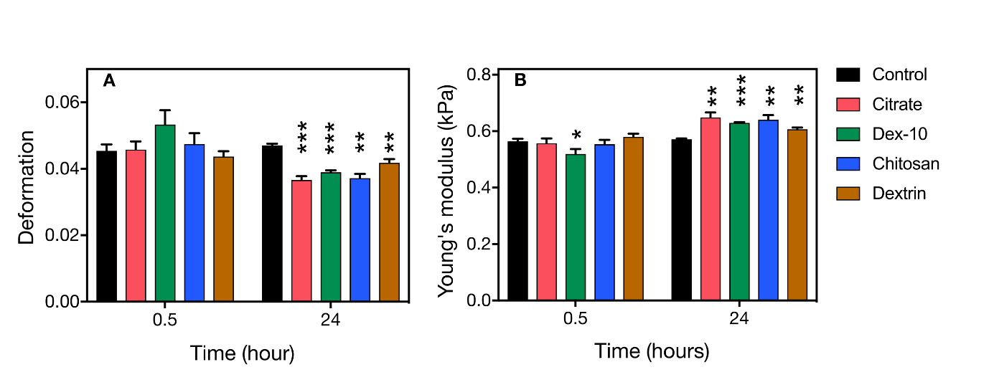
Figure S6. Time-dependent mechanical alterations of HL60 cells in presence of AuNPs (50 nM) in RPMI without FCS. Error bars correspond to the standard error of mean.

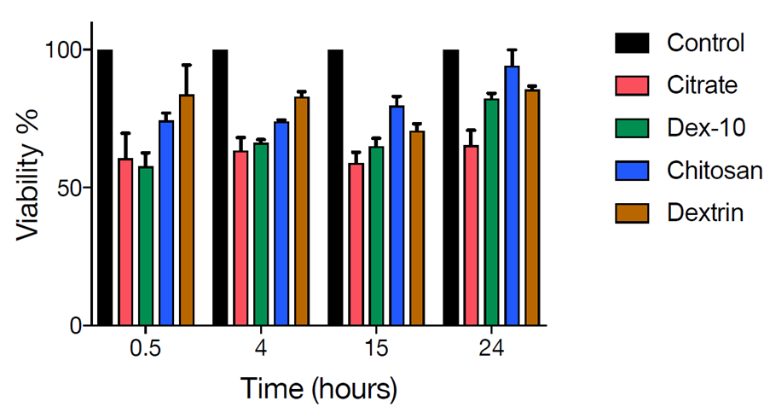
Figure S7. Time dependent cytotoxicity results of HL 60 cells in presence of different surface-functionalized AuNP (50 nM) in RPMI media without FCS. Error bars correspond to the standard deviation.

