Supplementary Information
Supplementary Figure 1: Matching of the two cohorts according to NT titers, age and sampling time points
Blue dots: Control cohort (n = 43, WT); red dots: omicron cohort (n = 37); a) Neutralizing activity of serum samples of the omicron cohort against BA.1, BA.2, Delta and an ancestral WT strain with the D614G mutation. b) Comparison of the WT-specific NT titer levels of the control cohort vs. the Omicron (BA.1/BA.2) NT titer levels. No significant difference in a two-tailed Mann Whitney U test (p = 0.42). c) Comparison of the age ofthe two cohorts at the time of PCR positivity (not significant, p = 0.32; Mann Whitney U test as above); d) Comparison of the time between disease onset (defined as the first positive PCR test) and the blood sampling of the two cohorts (not significant, p = 0.86; Mann Whitney U test as above); n.s.: not significant (p > 0.05)

Supplementary Figure 1a illustrates data from 29 convalescent Omicron infections already described in detail in Medits et al. 2022 (manuscript submitted, pre-print available: Medits I, et al. Human primary Omicron BA.1 and BA.2 infections result in sub-lineage-specific neutralization (PREPRINT (Version 1) available at Research Square [https://doi.org/10.21203/rs.3.rs-1536794/v1]. (2022).)

Supplementary Figure 2: Correlation of Virachip IgG microarray antibody levels with variant-specific NT titers in SARS-CoV-2 wildtype (WT) and Omicron primary infections
Graphical description of the correlation and the linear regression of the quantitative results by the Virachip IgG microarray in Virachip Units (VU) to the respective titers of variant-specific NTs (Omicron, WT; titer in log transformation). The Virachip IgG test assesses several target antigens simultaneously (S1, S2, RBD, RBD-Delta and NC). a) S1 vs. WT NT (blue) and S1 vs. Omicron NT (red) ). b) S2 vs. WT NT (blue) and S2 vs. Omicron NT (red) c) RBD vs. WT NT (blue) and RBD vs. Omicron NT (red) d) RBD-Delta vs. WT NT (blue) and RBD-Delta vs. Omicron NT (red) e) NC vs. WT NT (blue) and NC vs. Omicron NT (red). a-d: anti-S IgG assays; e: anti-NC IgG antibody assay. Dashed lines indicate the cutoff as recommended by the manufacturer. Blue dots: WT cohort (n = 43); red dots: Omicron cohort (n = 37). p-values, correlation coefficients r and R² were calculated using Pearson correlation (* p < 0.05; ** p < 0.01, *** p < 0.001).

Supplementary Figure 3: Correlation of recomLine SARS-COV-2 IgG immunoblot antibody levels with variant-specific NT titers in SARS-CoV-2 wildtype (WT) and Omicron primary infections
Graphical description of the correlation and the linear regression of the quantitative results by the recomLine IgG immunoblot as (cutoff-) Ratio to the respective titers of variant-specific NTs (Omicron, WT; both in log transformation). The recomLine IgG test assesses several target antigens simultaneously (S1, RBD, and NC). a) S1 vs. WT NT (blue) and S1 vs. Omicron NT (red) ). b) RBD vs. WT NT (blue) and RBD vs. Omicron NT (red) c) NC vs. WT NT (blue) and NC vs. Omicron NT (red) a and b: anti-S IgG assays; c: anti-NC IgG antibody assay. Dashed lines indicate the cutoff as recommended by the manufacturer. Blue dots: WT cohort (n = 43); red dots: Omicron cohort (n = 36). p-values, correlation coefficients r and R² were calculated using Pearson correlation (* p < 0.05; ** p < 0.01, *** p < 0.001).

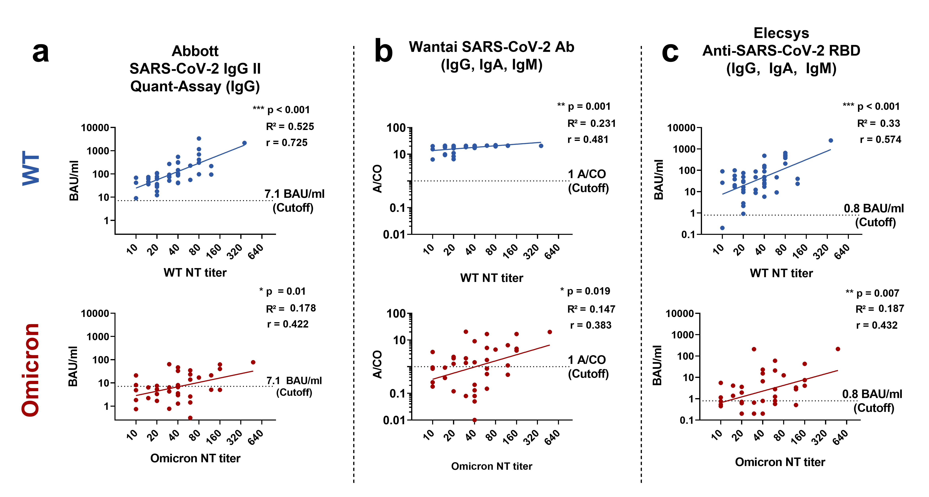

Supplementary Figure 4: Correlation of anti-Spike (S)- antibody levels with variant-specific NT titers in SARS-CoV-2 wildtype (WT) and Omicron primary infections
Graphical description of the correlation and the linear regression of the quantitative results of one Anti-IgG assay (Abbott) and two total antibody assays (Wantai, Elecsys) to the respective titers of variant-specific NTs (Omicron, WT; both in log transformation). a) SARS-CoV-2 IgG II Quant-Assay by Abbott (in BAU/ml) vs. WT NT (blue) and SARS-CoV-2 IgG II Quant-Assay vs. Omicron (red) b) Wantai SARS-CoV-2 Ab (in cutoff ratio (A/CO)) vs WT NT (blue) and Wantai SARS-CoV-2 Ab vs. Omicron NT (red) Dashed lines indicate the cutoff as recommended by the manufacturer. Blue dots: WT cohort (n = 43); red dots: Omicron cohort (n = 37), except for Abbott (panel a) where Omicron n = 36 (no sample material left for one sample). p-values, correlation coefficients r and R² were calculated using Pearson correlation (* p < 0.05; ** p < 0.01, *** p < 0.001).

Supplementary Figure 5: Correlation of Virachip IgM microarray antibody levels with variant-specific NT titers in SARS-CoV-2 wildtype (WT) and Omicron primary infections
Graphical description of the correlation and the linear regression of the quantitative results by the Virachip IgM microarray in Virachip Units (VU) to the respective titers of variant-specific NTs (Omicron, WT; titer in log transformation). The Virachip IgM test assesses several target antigens simultaneously (S1, S2, RBD, and NC). a) S1 vs. WT NT (blue) and S1 vs. Omicron NT (red) ). b) S2 vs. WT NT (blue) and S2 vs. Omicron NT (red) c) RBD vs. WT NT (blue) and RBD vs. Omicron NT (red) d) NC vs. WT NT (blue) and NC vs. Omicron NT (red). a-c: anti-S IgG assays; d: anti-NC IgG antibody assay. Dashed lines indicate the cutoff as recommended by the manufacturer. Blue dots: WT cohort (n = 43); red dots: Omicron cohort (n = 37). p-values, correlation coefficients r and R² were calculated using Pearson correlation (* p < 0.05; ** p < 0.01, *** p < 0.001).

Supplementary Figure 6: Correlation of anti-Spike (S)- and anti-RBD IgM antibody levels with variant-specific NT titers in SARS-CoV-2 wildtype (WT) and Omicron primary infections
Graphical description of the correlation and the linear regression of the quantitative results of three Anti-IgM assays to the respective titers of variant-specific NTs (Omicron, WT; both in log transformation). a) Liaison SARS-CoV-2 IgM by DiaSorin (as (cutoff-) index) vs. WT NT (blue) and Liaison SARS-CoV-2 IgM vs. Omicron (red) b) Wantai SARS-CoV-2 IgM (in cutoff ratio (A/CO)) vs WT NT (blue) and Wantai SARS-CoV-2 vs. Omicron NT (red) c) SARS-CoV-2-IgM by Abbott (as (cutoff-) index) vs WT NT (blue) and SARS-CoV-2-IgM vs. Omicron NT (red). Dashed lines indicate the cutoff as recommended by the manufacturer. Blue dots: WT cohort (n = 43); red dots: Omicron cohort (n = 37). p-values, correlation coefficients r and R² were calculated using Pearson correlation (* p < 0.05; ** p < 0.01, *** p < 0.001).

Supplementary Figure 7: Correlation of Virachip IgA microarray antibody levels with variant-specific NT titers in SARS-CoV-2 wildtype (WT) and Omicron primary infections
Graphical description of the correlation and the linear regression of the quantitative results by the Virachip IgA microarray in Virachip Units (VU) to the respective titers of variant-specific NTs (Omicron, WT; titer in log transformation). The Virachip IgA test assesses several target antigens simultaneously (S1, S2, RBD, and NC). a) S1 vs. WT NT (blue) and S1 vs. Omicron NT (red) ). b) S2 vs. WT NT (blue) and S2 vs. Omicron NT (red) c) RBD vs. WT NT (blue) and RBD vs. Omicron NT (red) d) NC vs. WT NT (blue) and NC vs. Omicron NT (red). a-c: anti-S IgG assays; d: anti-NC IgG antibody assay. Dashed lines indicate the cutoff as recommended by the manufacturer. Blue dots: WT cohort (n = 43); red dots: Omicron cohort (n = 37). p-values, correlation coefficients r and R² were calculated using Pearson correlation (* p < 0.05; ** p < 0.01, *** p < 0.001).

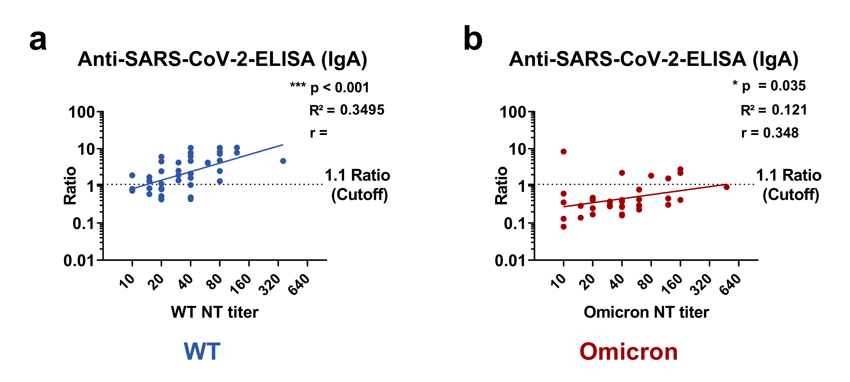

Supplementary Figure 8: Correlation of anti-Spike (S)-IgA antibody levels with variant-specific NT titers in SARS-CoV-2 wildtype (WT) and Omicron primary infections
Graphical description of the correlation and the linear regression of the quantitative results of the Anti-SARS-CoV-2-ELISA (IgA) by Euroimmun (in (cutoff-)ratio) to the respective titers of variant-specific NTs (Omicron, WT; both in log transformation). a) Anti-SARS-CoV-2-ELISA IgA vs. WT NT (blue) b) Anti-SARS-CoV-2-ELISA IgA vs. Omicron NT (red). Dashed lines indicate the cutoff as recommended by the manufacturer. Blue dots: WT cohort (n = 43); red dots: Omicron cohort (n = 37). p-values, correlation coefficients r and R² were calculated using Pearson correlation (* p < 0.05; ** p < 0.01, *** p < 0.001).

Supplementary Figure 9: Correlation of anti-Nucleocapid (NC)-antibody levels with variant-specific NT titers in SARS-CoV-2 wildtype (WT) and Omicron primary infections
Graphical description of the correlation and the linear regression of the quantitative results of three Anti-Nucleocapsid assays (as cutoff ratio expressed as COI, ratio or index) to the respective titers of variant-specific NTs (Omicron, WT; both in log transformation). a) Elecsys Anti-SARS-CoV-2 N by Roche vs. WT NT (blue) and Elecsys Anti-SARS-CoV-2 N vs Omicron NT (red) b) Anti-SARS-CoV-2-NCP-ELISA (IgM) by Euroimmun vs. WT NT (blue) and Anti-SARS-CoV-2-NCP-ELISA (IgM) vs Omicron NT (red). C) SARS-CoV-2 IgG (NC) by Abbott vs. WT NT (blue) and SARS-CoV-2 IgG (NC) by Abbott vs. Omicron NT (red). Dashed lines indicate the cutoff as recommended by the manufacturer. Blue dots: WT cohort (n = 43); red dots: Omicron cohort (n = 37). p-values, correlation coefficients r and R² were calculated using Pearson correlation (* p < 0.05; ** p < 0.01, *** p < 0.001).

Supplemental Table 1: Evaluated antibody assays and cutoffs
Abbott Laboratories, North Chicago, USA | SARS-CoV-2 IgG assay | CMIA | NC | Semi-Quant. | 1.4 Index
 | SARS-CoV-2 IgM | CMIA | S | Semi-Quant. | 1 Index
 | SARS-CoV-2 IgG II Quant-Assay | CMIA | S | Quant. | 7.1 BAU/ml
Beijing Wantai, Beijing, China | WANTAI SARS-CoV-2 Ab ELISA | ELISA | RBD | Semi-Quant. | 1 A/CO
 | WANTAI SARS-CoV-2 IgM ELISA | ELISA | RBD | Semi-Quant. | 1.1 A/CO
DiaSorin S.p.A, Saluggia, Italy | LIAISON® SARS-CoV-2 IgM | ELISA | S1 + RBD | Quant. | 1.1 Index
 | LIAISON® SARS-CoV-2 TrimericS IgG assay | ELISA | S | Quant. | 33.8 BAU/ml
EUROIMMUN Medizinische Labordiagnostika AG, Lübeck, Germany | Anti-SARS-CoV-2-QuantiVac-ELISA (IgG) | ELISA | S | Quant. | 35.2 BAU/ml
 | SARS-CoV-2-NeutraLISA | ELISA | RBD | Semi-Quant. | 35%
 | Anti-SARS-CoV-2-ELISA (IgA) | ELISA | S | Semi-Quant. | 1.1 Ratio
 | Anti-SARS-CoV-2-NCP-ELISA (IgG) | ELISA | NC | Semi-Quant. | 1.1 Ratio
 | Anti-SARS-CoV-2-NCP-ELISA (IgM) | ELISA | NC | Semi-Quant. | 1.1 Ratio
GenScript, New Jearsey, USA | cPass ® SARS-CoV-2 Neutralization Antibody Detection Kit | sVNT | RBD-ACE2 | Quant. | 30 % IH
MIKROGEN GMBH, Neuried, Germany | recomLine SARS-CoV-2 IgG | Immunoblot | S1, RBD, NC | Qual. | 1 signal ≥ 1Ratio
Roche Diagnostics GmbH, Mannheim, Germany | Elecsys Anti-SARS-CoV-2 N | ECLIA | NC | Semi-Quant. | 1 COI
 | Elecsys Anti-SARS-CoV-2 S | ECLIA | RBD | Quant. | 0.8 BAU/ml
TECOmedical AG, Sissach, Switzerland | TECO® SARS-CoV-2 Neutralization Antibody Assay | sVNT | RBD-ACE2 | Quant. | 20 % IH
Viramed Biotech AG, Planegg, Germany | SARS-CoV-2 ViraChip ® IgG | Microarray | S1, RBD, RBDd, S2, NC | Quant. | 1 signal ≥ 100 VU
 | SARS-CoV-2 ViraChip ® IgM | Microarray | S1, RBD, S2, NC | Quant. | 2 signals ≥100 VU
 | SARS-CoV-2 ViraChip ® IgA | Microarray | S1, RBD, S2, NC | Quant. | 2 signals ≥100 VU
sVNT surrogate virus neutralization test, ELISA enzyme-linked immunosorbent assay, CLIA chemiluminescence immunoassay, CMIA: chemiluminescence micro particle assay, ECLIA: electro-chemiluminescence immunoassay, % IH percent inhibition, VU Virachip Units, Quant. quantative; Semi-quant semi-quantiative, S1 / S2 subunits S1 and S2 of the Spike protein, S Spike, RBD receptor-binding domain, RBDd receptor-binding domain of the Delta variant, NC nucleocapid protein

Supplementary Table 2: Re-calculation: only variant-PCR confirmed Omicron infection

Target Antibodies |  | Test-Kit | Prin-ciple | Target Antigen(s) | WT |  | Omicron |  | Fisher
 |  |  |  |  | n | % | n | % | p-value
Anti-S- / Anti-RBD antibody assay | Surrogate Virus Neutralization Test (sVNT)
 | IgG/A/M | cPass SARS-CoV-2 Neutralization Antibody Detection Kit (GenScript) | sVNT | RBD-ACE2 Inhibition | 40/43 | 93% | 2/9 | 22% | < 0.0001
 |  | TECO SARS-CoV-2 Neutralization Antibody Assay (TECOmedical) | sVNT |  | 38/43 | 88% | 2/9 | 22% | 0.0002
 |  | SARS-CoV-2-NeutraLISA (Euroimmun) | sVNT |  | 30/43 | 70% | 1/9 | 11% | 0.0018
 | Anti-S-Total Antibody Tests
 | IgG/A/M | WANTAI SARS-CoV-2 Ab Elisa (Wantai) | ELISA | RBD | 43/43 | 100% | 5/9 | 56% | 0.0005
 |  | Elecsys Anti-SARS-CoV-2 S (Roche) | ECLIA |  | 42/43 | 98% | 6/9 | 67% | 0.0138
 | Anti-S-IgG / Anti-RBD-IgG
 | IgG | SARS-CoV-2 IgG II Quant-Assay (Abbott) | CMIA | S | 43/43 | 100% | 7/8 | 88% | 0.1568
 |  | SARS-CoV-2 Virachip IgG (Viramed) | MA | S1+S2+RBD +RBDd | 42/43 | 98% | 5/9 | 56% | 0.0228
 |  | LIAISON SARS-CoV-2  TrimericS IgG assay (DiaSorin) | CLIA | S | 41/43 | 95% | 6/9 | 67% | 0.0313
 |  | Anti-SARS-CoV-2-QuantiVac-ELISA (Euroimmun) | ELISA |  | 39/43 | 91% | 7/9 | 78% | 0.0739
 |  | recomLine SARS-CoV-2 IgG (Mikrogen) | IB | S1+RBD | 39/43 | 91% | 6/9 | 67% | < 0.0001
 | Anti-S-IgM / Anti-RBD-IgM
 | IgM | WANTAI SARS-CoV-2 IgM Elisa (Wantai) | ELISA | RBD | 37/43 | 86% | 0/9 | 0% | < 0.0001
 |  | SARS-CoV-2 IgM (Abbott) | CMIA | S | 33/43 | 77% | 0/9 | 0% | < 0.0001
 |  | SARS-CoV-2 Virachip IgM (Viramed) | MA | S1+S2+RBD | 27/43 | 63% | 2/9 | 22% | 0.061
 |  | LIAISON SARS-CoV-2 IgM (DiaSorin) | CLIA | RBD | 26/43 | 60% | 1/9 | 11% | < 0.0001
 | Anti-S-IgA / Anti-RBD-IgA
 | IgA | Anti-SARS-CoV-2-ELISA (IgA) (Euroimmun) | ELISA | S | 31/43 | 72% | 1/9 | 11% | 0.0011
 |  | SARS-CoV-2 Virachip IgA (Viramed) | MA | S1+S2+RBD | 20/43 | 47% | 0/9 | 0% | 0.0088
Anti-NC-antibody assay | Anti-NC-Antibody Assays (IgG, IgA, IgM)
 | IgG/A/M | Elecsys Anti-SARS-CoV-2 N (Roche) | ECLIA | NC | 39/43 | 91% | 9/9 | 100% | > 0.9999
 | IgG | SARS-CoV-2 IgG (Abbott) | CMIA |  | 38/43 | 88% | 9/9 | 100% | 0.5726
 |  | recomLine SARS-CoV-2 IgG (Mikrogen) | IB |  | 38/43 | 88% | 9/9 | 100% | 0.5726
 |  | Anti-SARS-CoV-2-NCP-ELISA (IgG) (Euroimmun) | ELISA |  | 35/43 | 81% | 9/9 | 100% | 0.323
 |  | SARS-CoV-2 Virachip IgG (Viramed) | MA |  | 29/43 | 67% | 9/9 | 100% | 0.092
 | IgM | SARS-CoV-2 Virachip IgM (Viramed) | MA |  | 16/43 | 37% | 4/9 | 44% | 0.7192
 |  | Anti-SARS-CoV-2-NCP-ELISA (IgM) (Euroimmun) | ELISA |  | 5/43 | 11% | 2/9 | 22% | 0.5899
 | IgA | SARS-CoV-2 Virachip IgA (Viramed) | MA |  | 11/43 | 26% | 1/9 | 11% | 0.6655
For this table, only Omicron samples were included in which a variant-specific RT-PCR was available (BA.1 n = 4; BA.2 n = 5) and compared to the WT cohort. N number of positive samples/ number of samples tested, % percent of positive samples, Fisher’s exact test (two-tailed, alpha level = 0.05), sVNT SARS-CoV-2 Surrogate Virus Neutralization Tests, ELISA enzyme-linked immunosorbent assay; CLIA chemiluminescence immunoassay; CMIA chemiluminescence micro particle assay; ECLIA electro-chemo luminescence immunoassay, IB immunoblot, S spike, S1/S2 subunit 1/2 of spike, RBD receptor-binding-domain; RBDd receptor binding domain of the Delta variant, NC nucleocapsid, MA: microarray. WT: n = 43; Omicron: n = 9; except for SARS-CoV-2 IgG II Quant-Assay (Abbott) where Omicron n = 8 (no sample material left in one sample). Significant p-values (p < 0.05): bold, underlined.
Supplementary Table 3: Re-analysis of the results comparing only samples with NT ≥ 20
Target Antibodies |  | Test-Kit | Prin-ciple | Target Antigen(s) | WT NT ≥ 20 |  | Omicron NT ≥ 20 |  | Fisher
 |  |  |  |  | n | % | n | % | p-value
Anti-S- / Anti-RBD antibody assay | Surrogate Virus Neutralization Test (sVNT)
 | IgG/A/M | cPass SARS-CoV-2 Neutralization Antibody Detection Kit (GenScript) | sVNT | RBD-ACE2 Inhibition | 32/35 | 91% | 2/30 | 5% | < 0.0001
 |  | TECO SARS-CoV-2 Neutralization Antibody Assay (TECOmedical) | sVNT |  | 30/35 | 86% | 2/30 | 7% | < 0.0001
 |  | SARS-CoV-2-NeutraLISA (Euroimmun) | sVNT |  | 24/35 | 69% | 1/30 | 3% | < 0.0001
 | Anti-S-Total Antibody Tests
 | IgG/A/M | WANTAI SARS-CoV-2 Ab Elisa (Wantai) | ELISA | RBD | 35/35 | 100% | 18/30 | 60% | < 0.0001
 |  | Elecsys Anti-SARS-CoV-2 S (Roche) | ECLIA |  | 34/35 | 97% | 17/30 | 57% | 0.0001
 | Anti-S-IgG / Anti-RBD-IgG
 | IgG | SARS-CoV-2 IgG II Quant-Assay (Abbott) | CMIA | S | 35/35 | 100% | 14/29 | 48% | < 0.0001
 |  | SARS-CoV-2 Virachip IgG (Viramed) | MA | S1+S2+RBD +RBDd | 35/35 | 100% | 16/30 | 53% | < 0.0001
 |  | LIAISON SARS-CoV-2  TrimericS IgG assay (DiaSorin) | CLIA | S | 22/35 | 63% | 3/30 | 10% | < 0.0001
 |  | Anti-SARS-CoV-2-QuantiVac-ELISA (Euroimmun) | ELISA |  | 32/35 | 91% | 8/30 | 27% | < 0.0001
 |  | recomLine SARS-CoV-2 IgG (Mikrogen) | IB | S1+RBD | 28/35 | 80% | 12/29 | 40% | 0.002
 | Anti-S-IgM / Anti-RBD-IgM
 | IgM | WANTAI SARS-CoV-2 IgM Elisa (Wantai) | ELISA | RBD | 29/35 | 83% | 2/30 | 7% | < 0.0001
 |  | SARS-CoV-2 IgM (Abbott) | CMIA | S | 29/35 | 83% | 3/30 | 10% | < 0.0001
 |  | SARS-CoV-2 Virachip IgM (Viramed) | MA | S1+S2+RBD | 23/35 | 66% | 8/30 | 27% | 0.0026
 |  | LIAISON SARS-CoV-2 IgM (DiaSorin) | CLIA | RBD | 21/35 | 60% | 3/30 | 10% | < 0.0001
 | Anti-S-IgA / Anti-RBD-IgA
 | IgA | Anti-SARS-CoV-2-ELISA (IgA) (Euroimmun) | ELISA | S | 18/35 | 51% | 2/30 | 7% | < 0.0001
 |  | SARS-CoV-2 Virachip IgA (Viramed) | MA | S1+S2+RBD | 26/35 | 74% | 5/30 | 17% | 0.0001
Anti-NC-antibody assay | Anti-NC-Antibody Assays (IgG, IgA, IgM)
 | IgG/A/M | Elecsys Anti-SARS-CoV-2 N (Roche) | ECLIA | NC | 32/35 | 91% | 29/30 | 97% | >0.9999
 | IgG | SARS-CoV-2 IgG (Abbott) | CMIA |  | 30/35 | 86% | 27/30 | 90% | 0.7157
 |  | recomLine SARS-CoV-2 IgG (Mikrogen) | IB |  | 28/35 | 80% | 27/29 | 93% | 0.166
 |  | Anti-SARS-CoV-2-NCP-ELISA (IgG) (Euroimmun) | ELISA |  | 29/35 | 83% | 27/30 | 90% | 0.4883
 |  | SARS-CoV-2 Virachip IgG (Viramed) | MA |  | 24/35 | 69% | 25/30 | 83% | 0.249
 | IgM | SARS-CoV-2 Virachip IgM (Viramed) | MA |  | 11/35 | 31% | 13/30 | 43% | 0.44
 |  | Anti-SARS-CoV-2-NCP-ELISA (IgM) (Euroimmun) | ELISA |  | 2/35 | 6% | 2/30 | 7% | >0.9999
 | IgA | SARS-CoV-2 Virachip IgA (Viramed) | MA |  | 9/35 | 26% | 5/30 | 17% | 0.5464
Comparison of detection rates in the Omicron vs. WT cohorts, only including samples with high NT titer (≥ 20). N number of positive samples/ number of samples tested, % percent of positive samples, Fisher’s exact test (two-tailed, alpha level = 0.05), sVNT SARS-CoV-2 Surrogate Virus Neutralization Tests, ELISA enzyme-linked immunosorbent assay; CLIA chemiluminescence immunoassay; CMIA chemiluminescence micro particle assay; ECLIA electro-chemo luminescence immunoassay, IB immunoblot, S spike, S1/S2 subunit 1/2 of spike, RBD receptor-binding-domain; RBDd receptor binding domain of the Delta variant, NC nucleocapsid, MA: microarray. WT: n = 35; Omicron: n = 30; except for recomLine SARS-CoV-2 IgG (Mikrogen) and SARS-CoV-2 IgG II Quant-Assay (Abbott) where Omicron n = 29 (sample technically invalid and no material left respectively). Significant p-values (p < 0.05): bold, underlined.

