Genome Wide Identification, Classification and Functional Characterization Analysis of IQD gene family in Diploid and Tetraploid Cotton (Gossypium)
Abdul Rehman^{1,2,3}, Zhen Peng², Hongge Li², Guangyong Qin¹, Yinhua Jia²，Zhaoe Pan²，Shoupu He^{1,2}, Abdul Qayyum³ and Xiongming Du^{1,2}*,
¹Zhengzhou Research Base, State Key Laboratory of Cotton Biology, Zhengzhou University, Zhengzhou 450000, China.
²State Key Laboratory of Cotton Biology, Institute of Cotton Research Chinese Academy of Agricultural Science, Anyang, 455000, Henan, China.
³Department of Plant Breeding and Genetics, Bahauddin Zakariya university, Multan-66000, Pakistan.
*Corresponding Author: duxiongming@caas.cn,

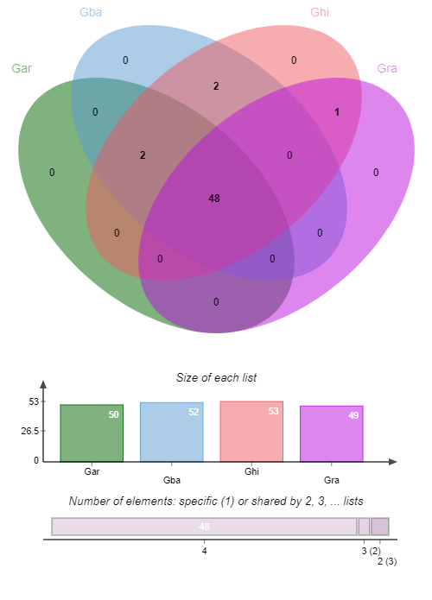
Supplementary Fig. 7a. Cluttering of orthologous genes analysis between G. arboreum, G. raimondii, G. barbadense and G. hirsutum
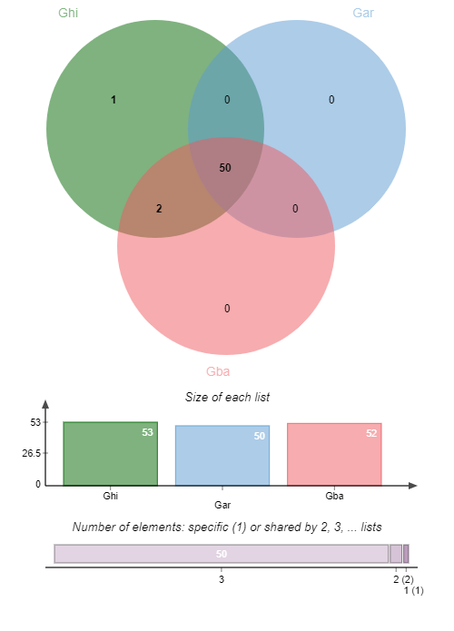
Supplementary Fig. 7b. Cluttering of orthologous genes analysis between G. arboreum, G. barbadense and G. hirsutum
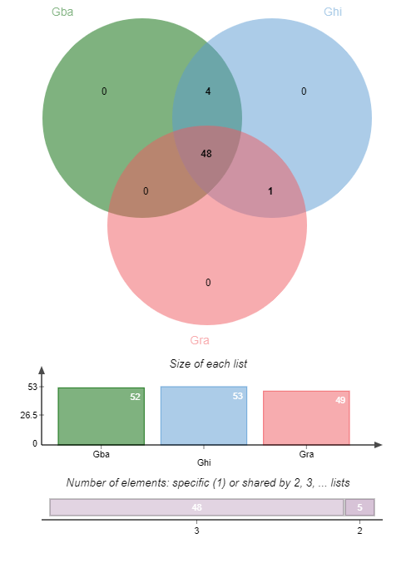
Supplementary Fig. 7c. Cluttering of orthologous genes analysis between G. barbadense, G. hirsutum 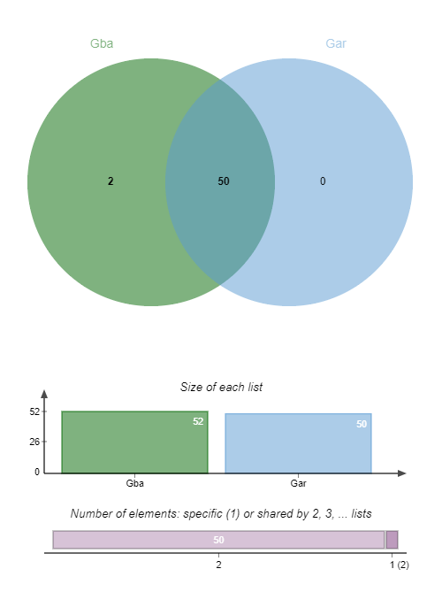and G. raimondii

Supplementary Fig. 7d. Cluttering of orthologous genes analysis between G. arboreum and G. barbadense

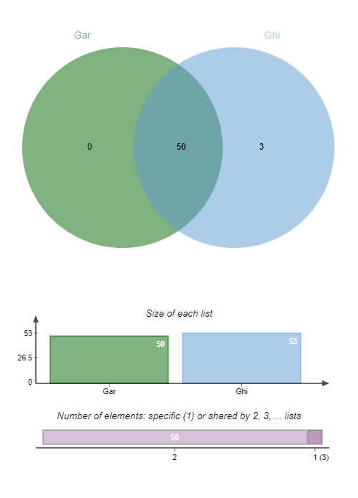
Supplementary Fig. 7e. Cluttering of orthologous genes analysis between G. arboreum and G. hirsutum
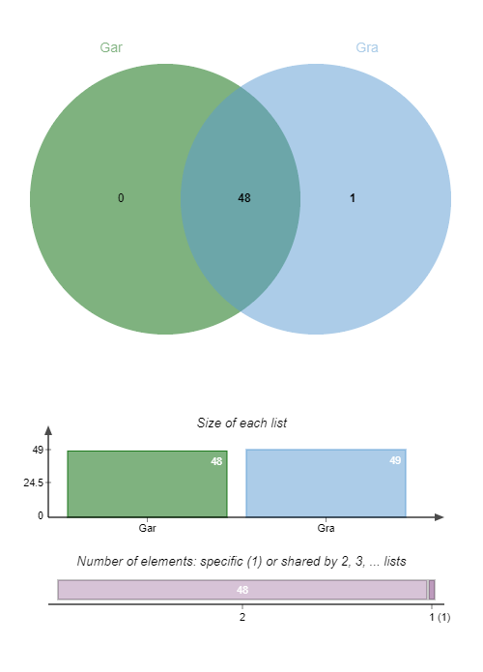
Supplementary Fig. 7f. Cluttering of orthologous genes analysis between G. arboreum and G. raimondii

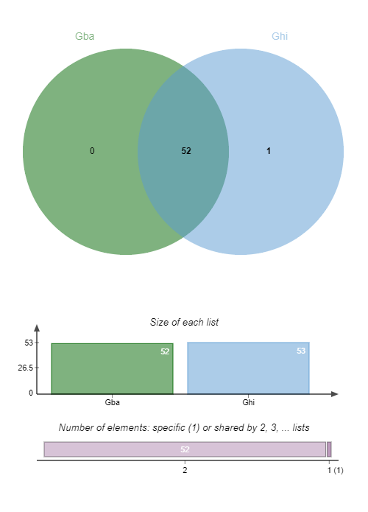
Supplementary Fig. 7g. Cluttering of orthologous genes analysis between G. hirsutum and G. barbadense
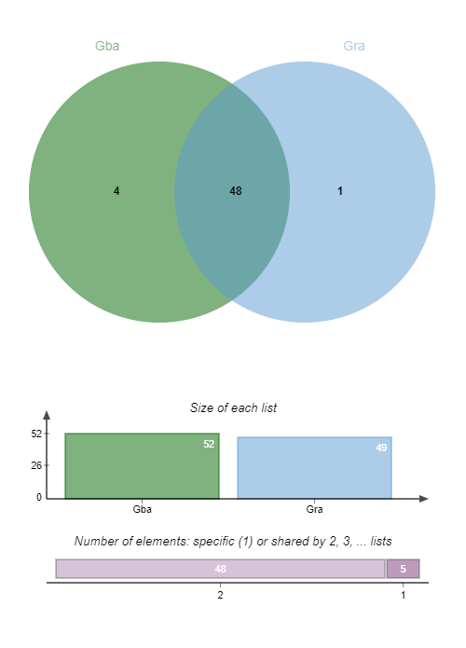
Supplementary Fig. 7h. Cluttering of orthologous genes analysis between G. raimondii and G. barbadense
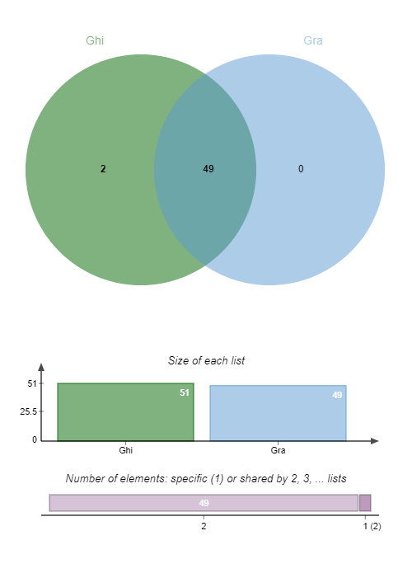
Supplementary Fig. 7i. Cluttering of orthologous genes analysis between G. hirsutum and G. raimondii

