Table 1. Parameters and Scores Used for Evaluation

Parameters | Scores | Description
The ICDAS II codes and criteria | 0 | 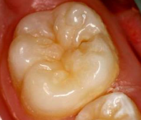 Sound.
 | 1 | 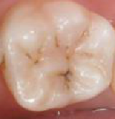 First visual change in enamel.
 | 2 | 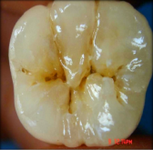 Distinct visual change in enamel.
 | 3 | 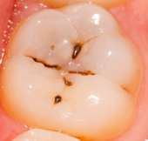 Localized enamel breakdown.
 | 4 | 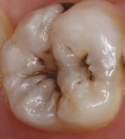 Underlying dark shadow.
 | 5 | 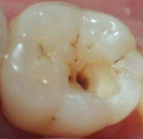Distinct cavity with visible dentin.
 | 6 | 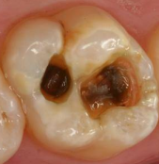Extensive distinct cavity with visible dentin.
Restoration and Sealant Codes | 0 | Not sealed or restored.
 | 1 | Sealant, partial.
 | 2 | Sealant, full.
 | 3 | Tooth colored restoration.
 | 4 | Amalgam restoration.
 | 5 | Stainless steel crown.
 | 6 | Porcelain, gold, FPM crown or veneer.
 | 7 | Lost or broken restoration.
 | 8 | Temporary restoration.
Scores for teeth loss | 97 | Tooth missing because of caries.
 | 98 | Tooth missing for reasons other than caries.
 | 99 | Not erupted.

