Supporting Information File
Experimental design modelling and optimization of triazine herbicides removal with reduced graphene oxide using response surface method

Authors: Martina Foschiª, Paola Capassoª, Maria Anna Maggi^{b}, Fabrizio Ruggieriª and Giulia Fioravanti^{a*}
a) University of L’Aquila, Department of Physical and Chemical Sciences, Via Vetoio, Coppito, L'Aquila 67100, Italy.
b) Hortus Novus, Via Aldo Moro 28 D, L'Aquila, 67100, Italy

*Corresponding authors
E-mail: giulia.fioravanti@univaq.it
Department of Physical and Chemical Sciences
University of L’Aquila
Via Vetoio – 67100 L’Aquila (AQ) – Italy
Tel. +39-0862-434244

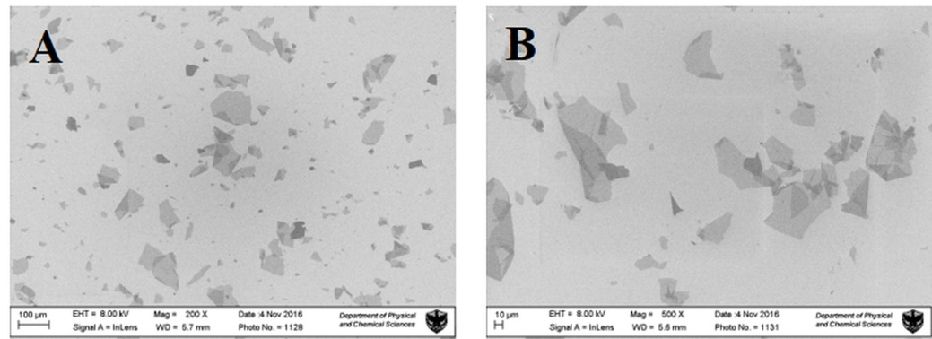
Figure S01 SEM images of GO sheets at different magnification

Figure S02 FTIR spectrum of pristine GO

Figure S03 XPS survey of GO (A) and C1s region (B)

