Supporting information

High-rate decoupled water electrolysis system integrated with α-MoO₃ as a redox mediator with fast anhydrous proton kinetics

Zihan Ma^{1,‡}, Xiaofei Lu^{1,‡}, Sunghyun Park¹, Tatsuya Shinagawa¹, Masashi Okubo², Kazuhiro Takanabe^{1,*}, Atsuo Yamada^{1,*}

1Department of Chemical System Engineering, School of Engineering, The University of Tokyo, Hongo 7-3-1, Bunkyo-ku, Tokyo 113-8656, Japan.
2Department of Electrical Engineering and Bioscience, School of Advanced Science and Engineering, Waseda University, Okubo 3-4-1, Shinjuku-ku, Tokyo 169-8555, Japan.

*e-mail address of corresponding authors:
takanabe@chemsys.t.u-tokyo.ac.jp,
yamada@chemsys.t.u-tokyo.ac.jp,
‡These authors contributed equally.

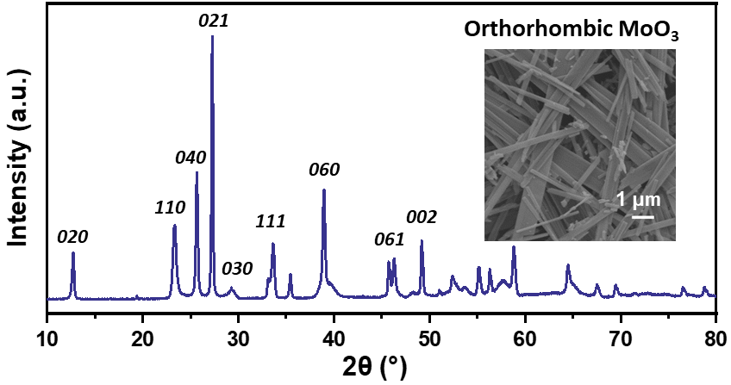
Figure S1. X-ray diffraction pattern of the as synthesized MoO₃. Inset: scanning electron microscopy image of as-synthesize MoO₃.

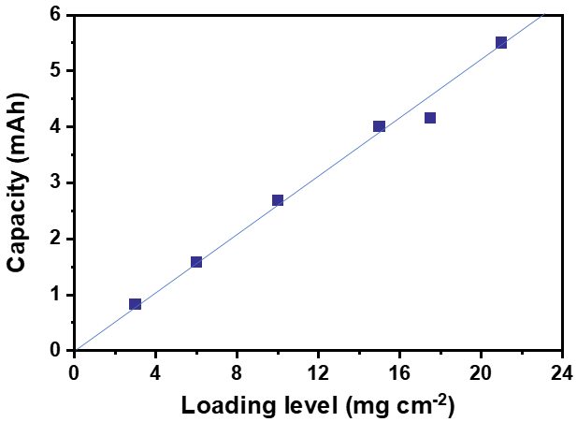
Figure S2. loading level optimization of MoO₃ in a 10 M H₃PO₄ aqueous electrolyte. The capacity of the MoO₃ electrode is almost linear to the loading level when the loading is < 20 mg cm⁻², we chose a loading level of 10 mg cm⁻² to match the maximum current output of the electrochemical workstation (1 A) to enable a maximum current density of 100 A g⁻¹ with an electrode of 1 cm².

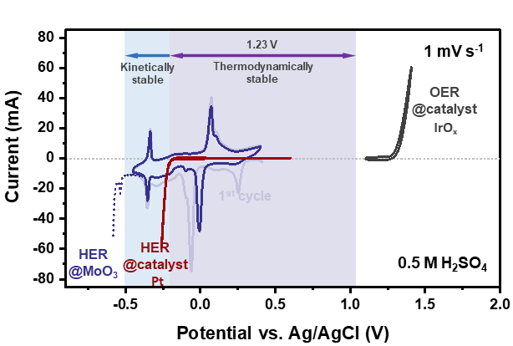
Figure S3. Electrochemical characterization of MoO₃. Cyclic voltammograms (CVs) over MoO₃ supported on the carbon cloth, Pt platinized Pt mesh, and IrO_{x}/Ti felt were recorded at a scan rate of 1 mV s^{–1} and a temperature of 25 °C in 0.5 M H₂SO₄ aqueous solution.

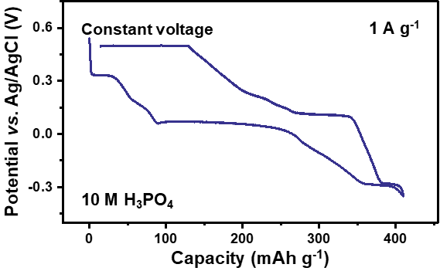
Figure S4. Constant current- constant voltage (CC-CV) deprotonation of MoO₃ in 10 M H₃PO₄ aqueous solution. With a constant current (CC) deprotonation mode, only part of the proton inserted could be extracted. When a constant voltage (CV) at 0.5 V vs. Ag/AgCl of 3 h is applied after constant current deprotonation (CC-CV mode), almost all inserted proton can be extracted. This phenomena can be explained by the deceleration of proton kinetics at the end of CC deprotonation.

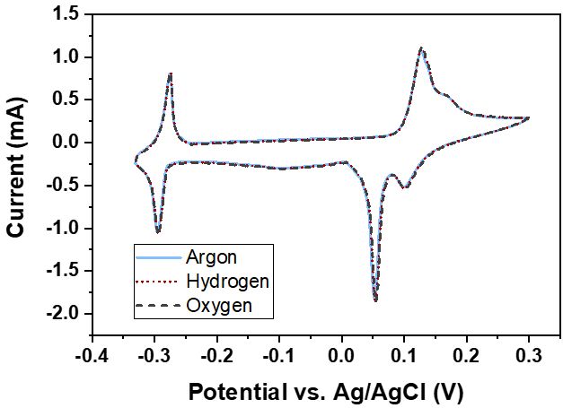
Figure S5. Electrochemical characterization of MoO₃ in different atmospheres. Cyclic voltammograms (CVs) over MoO₃ supported on the carbon cloth were recorded at a scan rate of 1 mV s^{–1} and a temperature of 25 °C in Ar, H₂, and O₂ saturated 0.5 M H₂SO₄ aqueous solution, respectively. The MoO₃ electrode was cycled under each atmosphere for 5 cycles and the last cycle for each is shown.

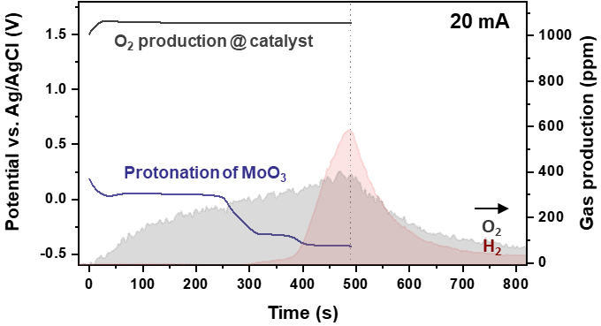
Figure S6. Parasitic hydrogen evolution reaction (HER) of MoO₃ upon over protonation in 10 M H₃PO₄ aqueous solution. According to theoretical calculation, MoO₃ can only accommodate 2.5 H⁺ to form H_{2.5}MoO₃. The over protonation would lead to structural decomposition and parasitic hydrogen evolution at low potential.

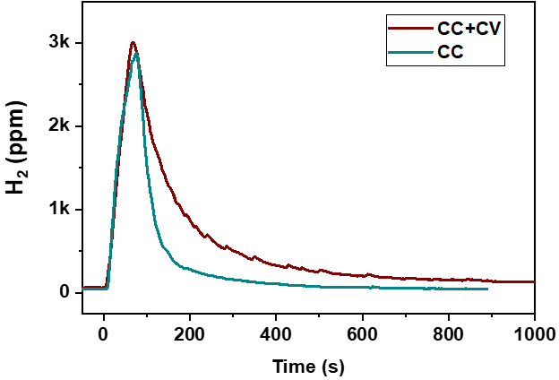
Figure S7. The additional hydrogen production using a constant current- constant voltage (CC-CV) deprotonation mode of MoO₃ in 10 M H₃PO₄ aqueous solution . When a constant voltage (CV) at 0.5 V vs. Ag/AgCl is applied after constant current deprotonation (CC-CV mode), additional ~50% of hydrogen can be produced, indicting the “trapped” proton in MoO₃ was releasaed.

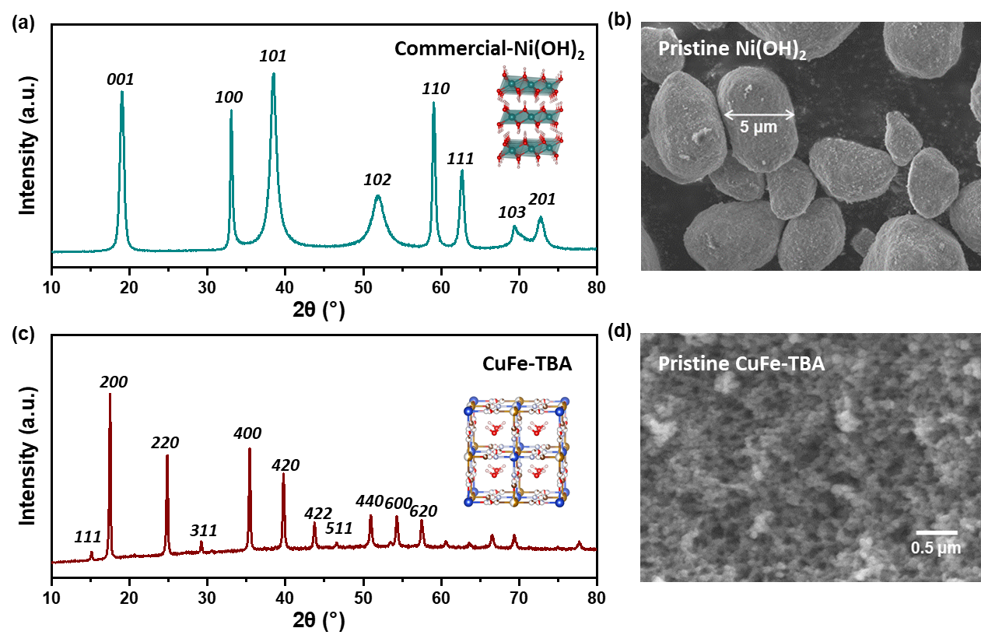
Figure S8. The X-ray diffraction p patterns and scanning electron microscopy images of commercial (a, c) Ni(OH)₂ and (b, d) CuFe-TBA.

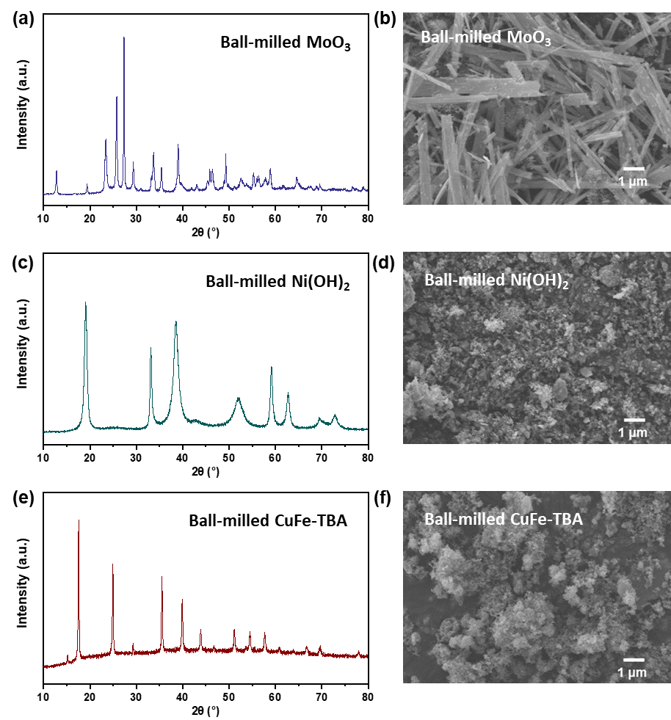
Figure S9. The X-ray diffraction (XRD) patterns and scanning electron microscopy (SEM) images of ball-milled MoO₃, Ni(OH)₂ and CuFe-TBA. XRD patterns of samples ball-milled with 20 wt% carbon addictives for 30 min: (a) MoO₃, (c) Ni(OH)₂ and (e) CuFe-TBA and the corresponding SEM images (b) MoO₃, (d) Ni(OH)₂ and (f) CuFe-TBA.

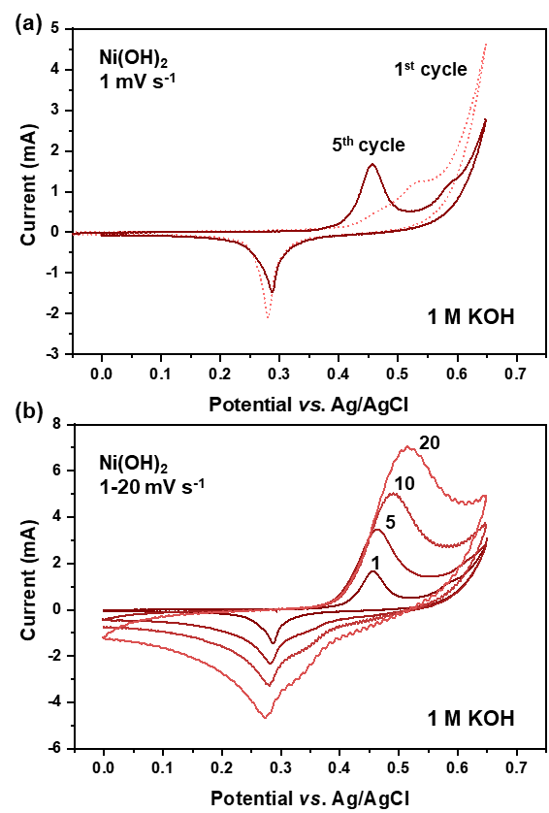
Figure S10. Electrochemical characterization of Ni(OH)₂. Cyclic voltammograms (CVs) over Ni(OH)₂ supported on the carbon cloth were recorded at various scan rates and a temperature of 25 °C in Ar saturated 1 M KOH aqueous solution, respectively: (a) the first and fifth CV cycles and (b) the CV cycles with different scan rates of Ni(OH)₂ in a 1 M KOH aqueous electrolyte.

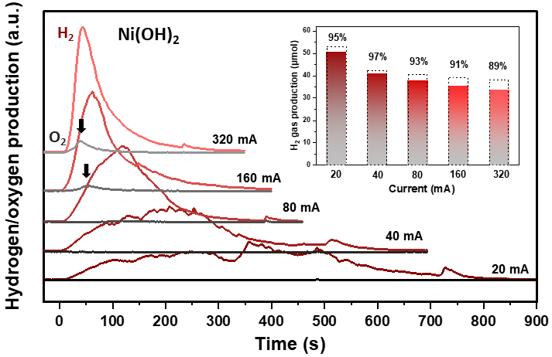
Figure S11. Gas production using Ni(OH)₂ as a redox mediator. The qualification of generated H₂ and O₂ gas using mass spectroscopy. Inset: theoretical H₂ gas amount (red solid bars) and detected gas amount (dash squares), the corresponding Faradic efficiency was marked at the top of each bar. Remarkable parasitic oxygen evolution can be observed at current rates of > 160 mA (marked with black arrows).

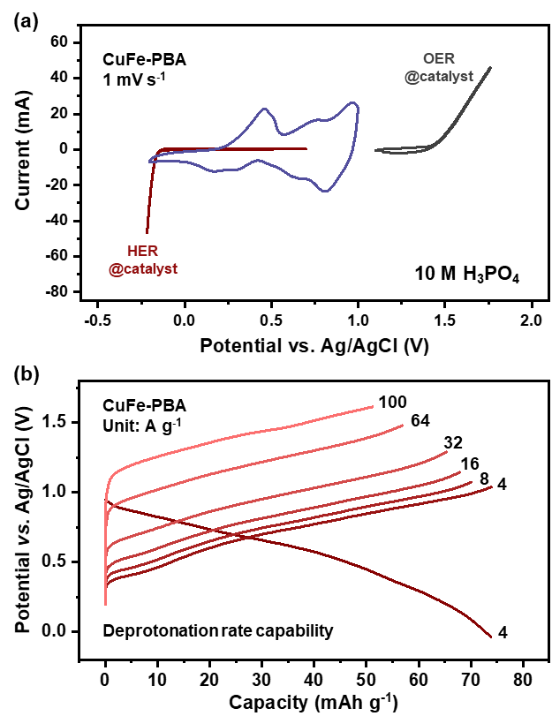
Figure S12. Proton storage properties of CuFe-TBA as a redox mediator. (a) Cyclic voltammograms (CVs) over CuFe-TBA supported on the carbon cloth, Pt platinized Pt mesh, and IrO_{x}/Ti felt were recorded at a scan rate of 1 mV s^{–1} and a temperature of 25 °C in 10 M H₃PO₄ aqueous solution.. (b) The potential curves of CuFe-TBA upon deprotonation at rates from 4 A g⁻¹ to 100 A g⁻¹.

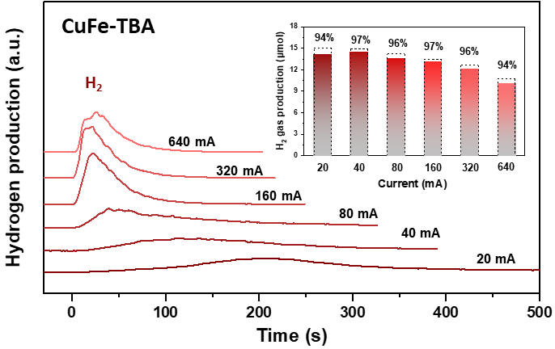
Figure S13. Gas production using CuFe-TBA as a redox mediator. The qualification of generated H₂ gas using mass spectroscopy. Inset: theoretical hydrogen gas amount (red solid bars) and detected gas amount (dash squares), the corresponding Faradic efficiency was marked at the top of each bar.

