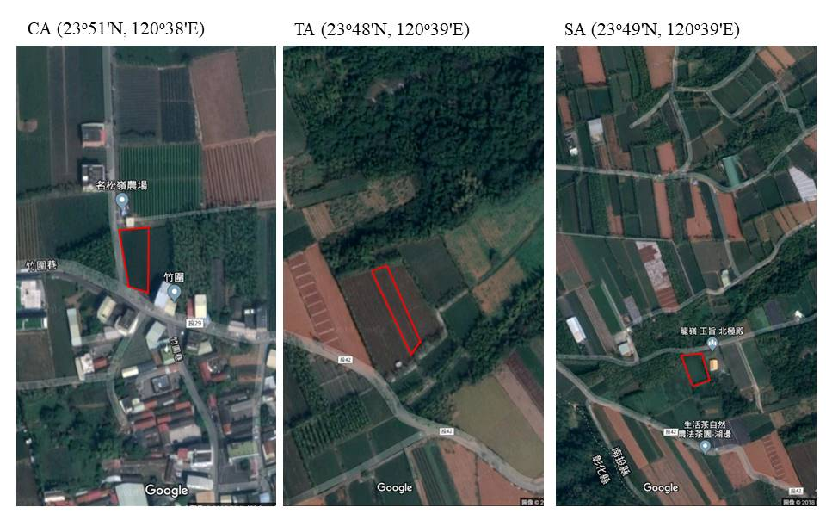
Fig. S1. Geographical maps of three tea plantations including CA, TA, and SA managements. The red frames indicate the experimental fields. The maps were obtained from the Google map.

