**Improvement of water resistance by photoelectrical catalysts Fe2O3/TiO2 for formaldehyde removal: Experimental and theoretical investigation**

**Supplementary Materials**

Dong Jing1, Li Qing1, Lv Bihong1, Xia Wenjie2, Jing Guohua1, Shen Huazhen1*, Yuan Chung-shin3*

1 College of Chemical Engineering, Huaqiao University, Xiamen, Fujian, China

2Department of Civil and Environmental Engineering, North Dakota State University, Fargo, ND 58108, USA

3 Institute of Environmental Engineering, National Sun Yat-Sen University,

No. 70, Lian-Hai Road, Kaohsiung 804, Taiwan

* To whom all correspondence should be addressed

Tel: +86-15260231263

Tel: +886-7-5252000 Ext. 4409; Fax: 886-7-52524409;

E-mail: hzhshen@hotmail.com

ycsngi@mail.nsysu.edu.tw

**Table Captions**

Table S-1 XRD parameters of (101), (200), and (004) peaks for TiO2 and Fe2O3/TiO2s.

Table S-1 XRD parameters of (101), (200), and (004) peaks for TiO2 and Fe2O3/TiO2s.

|  |  |  |  |  |  |  |  |  |  |  |  |  |  |
| --- | --- | --- | --- | --- | --- | --- | --- | --- | --- | --- | --- | --- | --- |
|  | (101) | | | (200) | | | (004) | | | X(200)/X(101) | | X(004)/X(101) | |
|  | area | peak height | FWHM | area | peak height | FWHM | area | peak height | FWHM | area ratio | height ratio | area ratio | height ratio |
| TiO2 | 50505 | 1298 | 0.661 | 15940 | 422 | 0.642 | 9470 | 219 | 0.735 | 0.315 | 0.325 | 0.187 | 0.168 |
| 0.5%Fe2O3 | 63655 | 2127 | 0509 | 22013 | 664 | 0.564 | 4365 | 122 | 0.608 | 0.345 | 0.312 | 0.0685 | 0.0573 |
| 3%Fe2O3 | 61958 | 2038 | 0.517 | 20058 | 584 | 0.584 | 6988 | 141 | 0.843 | 0.323 | 0.286 | 0.112 | 0.0691 |
| 5%Fe2O3 | 78949 | 2759 | 0.486 | 25600 | 792 | 0.549 | 8127 | 155 | 0.891 | 0.324 | 0.287 | 0.102 | 0.0561 |

**Figure captions**

Figure S-1. Structured optimized TiO2(010) and Fe2O3/TiO2(010).

Figure S-2. Adsorption energy of CHOH on (a) TiO2 and (b) Fe2O3/TiO2.

Figure S-3. Photo- and Photoelectrical catalytic removal efficiency of TiO2 and Fe2O3/TiO2 at different R.H. (%).



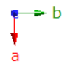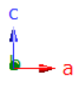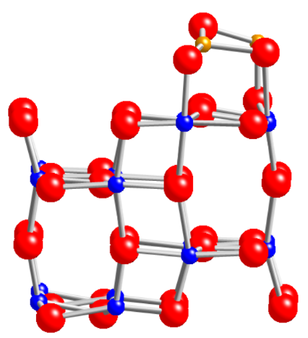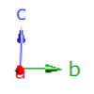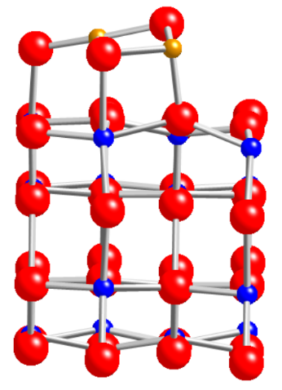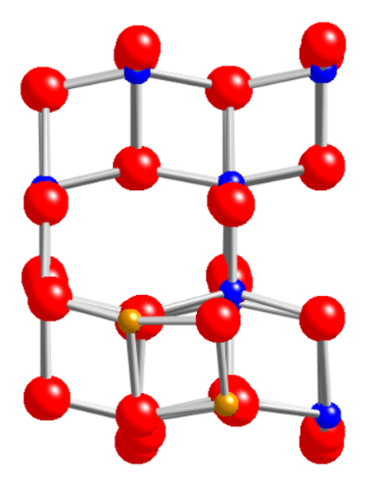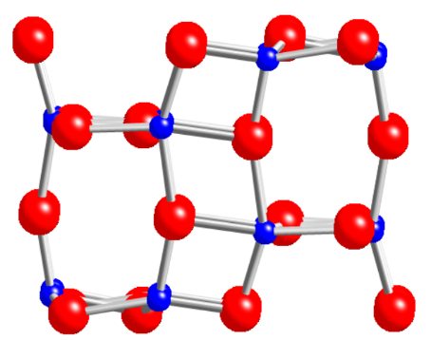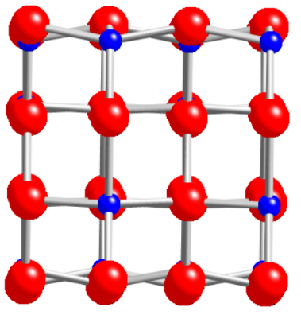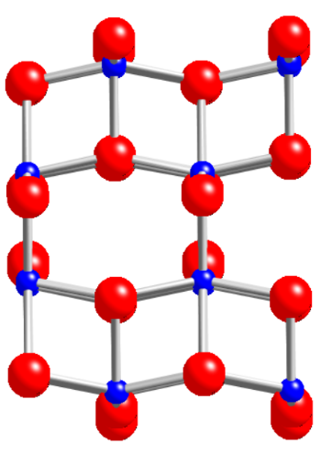

(a)

(b)

(c)

(d)

(e)

(f)

Fe

O



Ti

Figure S-1. The structure optimized TiO2(010) (a) front view, (b) side view, (c) top view, and Fe2O3/TiO2 (d) front view, (e) side view, (f) top view.

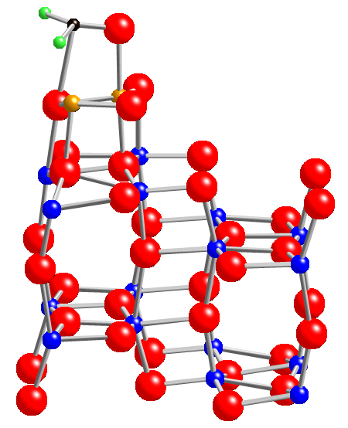

2.007 Å

2.184 Å

△E = -1.491 eV

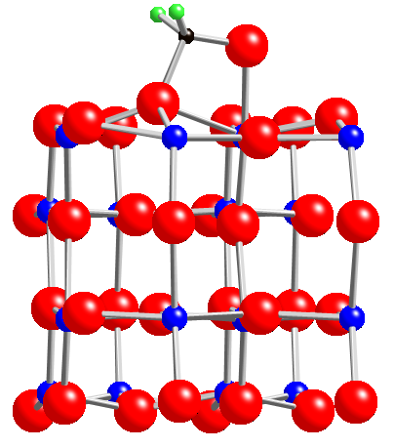

1.824 Å

1.989 Å

△E = -1.089 eV

Fe

Ti

O

H

Figure S-2. Adsorption energy of CHOH on (a) TiO2 and (b) Fe2O3/TiO2.

1.  (b)

Figure S-2. Photo- and Photoelectrical catalytic removal efficiency of TiO2 and Fe2O3/TiO2 at different R.H. (%).