SUPPLEMENTARY MATERIAL
Environmental Science and Pollution Research
ASSESSMENT OF THE COMBINED USE OF BASIC OXYGEN FURNACE SLUDGE AND HYDROGEN PEROXIDE IN THE TREATMENT OF ACID MINE DRAINAGE
Sandrine F. Araujo¹; Cláudia L. Caldeira ²; Virgínia S.T. Ciminelli^{2,3} ; Ricardo P. Borba⁴; Joanna P. Rodrigues¹;Gustavo F. Simões^{1*}
¹Department of Sanitary and Environmental Engineering, Universidade Federal de Minas Gerais, UFMG, Av. Antônio Carlos, 6627, Belo Horizonte – MG, Brazil, 31270-901.
²Department of Metallurgical and Materials Engineering, Universidade Federal de Minas Gerais, UFMG. Brazil.
³National Institute of Science and Technology: INCT- Acqua, Brazil.
⁴Department of Geology and Natural Resources. Universidade Estadual de Campinas, UNICAMP. Brazil.
* Corresponding author e-mail: gustavo@desa.ufmg.br phone: +55 31 3409-1792. Fax: +55 31 3409-1879.

- Sample preparation and analyses
Concentration of extractable metals in acid medium in the BOFS samples was determined after digestion with HNO₃/HCl (3:1) using a microwave assisted digestion procedure (Ethos, Milestone, EUA) (USEPA 1998). The following day and after reaching room temperature (~ 25ºC), the extracted solutions were transferred to FalconTM tubes and filled to 50 mL with 18 MΩ cm deionized water. The vessels were washed at least three times with deionized water to ensure complete recovery of the extracted solution. The resulting solutions were stored at 4 ºC until further analysis.
The solutions were then analyzed by Inductively Coupled Plasma Optical Emission Spectrometry (ICP-OES) (Perkin Elmer Optima 7300DV) according to the conditions described in Table S1. As a guarantee and quality control, two standard reference materials (NIST SRM 2710a and CANMET / CCRMP Till 3) were analyzed together with each batch of 10 samples. Lutetium (1 mg L⁻¹) was used as an internal standard element to monitor the effects of the matrix and the sensitivity deviations of the ICP-OES instrument.
Table S1: Microwave digestion conditions
Step | Time (min) | Temperature (ºC) | Power (W)
Ramp | 5.5 | RT¹– 175 | 1500
Hold | 4.5 | 175 | 1500
Cooling | 30 | 175 – 80 | ----
Total run | 40
Pressure: 9.2x 10⁵ N/m²; ¹RT: room temperature
Table S2: Instrumental conditions (ICP-OES)
Parameter | Condition
Radiofrequency (W) | 1300
Nebulizer | Burgener MiraMist
Nebulizer flow (L min⁻¹) | 0.8
Alumina injector (mm) | 2.0
Plasma flow (L min⁻¹) | 15
Auxiliary gas (L min⁻¹) | 0.8
Pump flow (mL min⁻¹) | 1.30
Internal standard (1 mg L⁻¹) | Lutetium

Table S3: Chemical composition deionized water by ICP-OES.
% (p/p)
Samples | Al | As | B | Ba | Ca | Cd | Co | Cr | Cu |  | Fe |  | Hg | K | La | Li | Mg | Mn
A1 | 0.112 | <5.0 | <0.1 | 0.004 | 3.920 | 0.006 | <0.1 | 0.011 | 0.006 |  | 88.83 |  | <0.1 | 0.004 | <0.1 | <0.1 | 0.604 | 0.360
A2 | 0.136 | <5.0 | <0.1 | 0.004 | 4.318 | 0.006 | <0.1 | 0.011 | 0.006 |  | 88.06 |  | <0.1 | 0.005 | <0.1 | <0.1 | 0.763 | 0.459
Average ± SD | 0.124±0.012 |  |  | 0.004± 0.0002 | 4.11± 0.199 | 0.006± 0.0002 |  | 0.011± 0.0002 | 0.006± 0.000 |  | 88.45± 0.3852 |  |  | 0.005± 0.000 |  |  | 0.684± 0.080 | 0.410± 0.050
Samples | Mo | Na | Ni | P | Pb | S | Sb | Sc | Se |  | Sn |  | Sr | Ti | U | V | Y | Zn
A1 | <0.1 | 0.028 | 0.005 | 0.449 | 0.003 | <2.5 | <0.1 | <0.1 | <0.1 |  | <0.1 |  | 0.005 | 0.036 | 0.041 | 0.010 | <0.1 | 0.065
A2 | <0.1 | 0.031 | 0.005 | 0.476 | 0.003 | <2.5 | <0.1 | <0.1 | <0.1 |  | <0.1 |  | 0.006 | 0.047 | 0.046 | 0.011 | <0.1 | 0.071
Average ± SD |  | 0.030± 0.0002 | 0.005± 0.0002 | 0.463± 0.0002 | 0.003± 0.0002 |  |  |  |  |  |  |  | 0.005± 0.0002 | 0.042± 0.0002 | 0.044± 0.0002 | 0.0103± 0.0002 |  | 0.068± 0.0002
 |  | 0.002 | 0.000 | 0.014 | 0.000 |  |  |  |  |  |  |  | 0.001 | 0.006 | 0.002 | 0.001 |  | 0.003

Table S4: ` Hyperfine parameters of the paramagnetic sites of the Mossbauer spectra adjustments for the samples of crude BOFS and BOFS resulting from the studied systems.
Sample | Oxidation State | δ (mm/s) ±  (0.05 mm/s) | Δ/ε (mm/s) ±  (0.05 mm/s) | B_{HF} (T) ±  (0.5 T) | Relative Area  ±(1 %)
BOFS | Fe⁰  Fe²⁺  Fe³⁺ | 0.0  1.06  0.20 | 0.0  0.83  0.47 | 33.1  -  - | 48  41  11
S1  (BOFS + H₂O pH 2.5) | Fe⁰  Fe²⁺  Fe³⁺ | 0.0  1.04  0.35 | 0.0  0.93  0.69 | 33.1  -  - | 22  20  58
S3  (BOFS + AMD pH 2.5) | Fe⁰  Fe²⁺  Fe³⁺  α-Fe₂O₃¹ | 0.0  0.94  0.36  0.34 | 0.0  0.96  0.7  -0.16 | 33.1  -  -  48.8 | 31  33  25  11
S5  (BOFS + AMD pH 2.5 + H₂O₂ 1 Mm) | Fe⁰  Fe²⁺  Fe³⁺  α-Fe₂O₃¹ | 0.0  0.97  0.36  0.36 | 0.0  0.64  0.67  -0.16 | 33.1  -  -  48.7 | 32  39  21  8
¹Hematite

Figure S1: Grain curve and passing percentage.
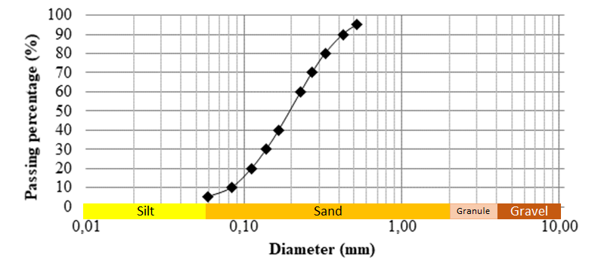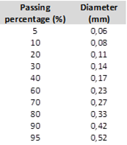

Figure S2 - Mösbauer spectrum at room temperature and BOFS hyperfine parameters.
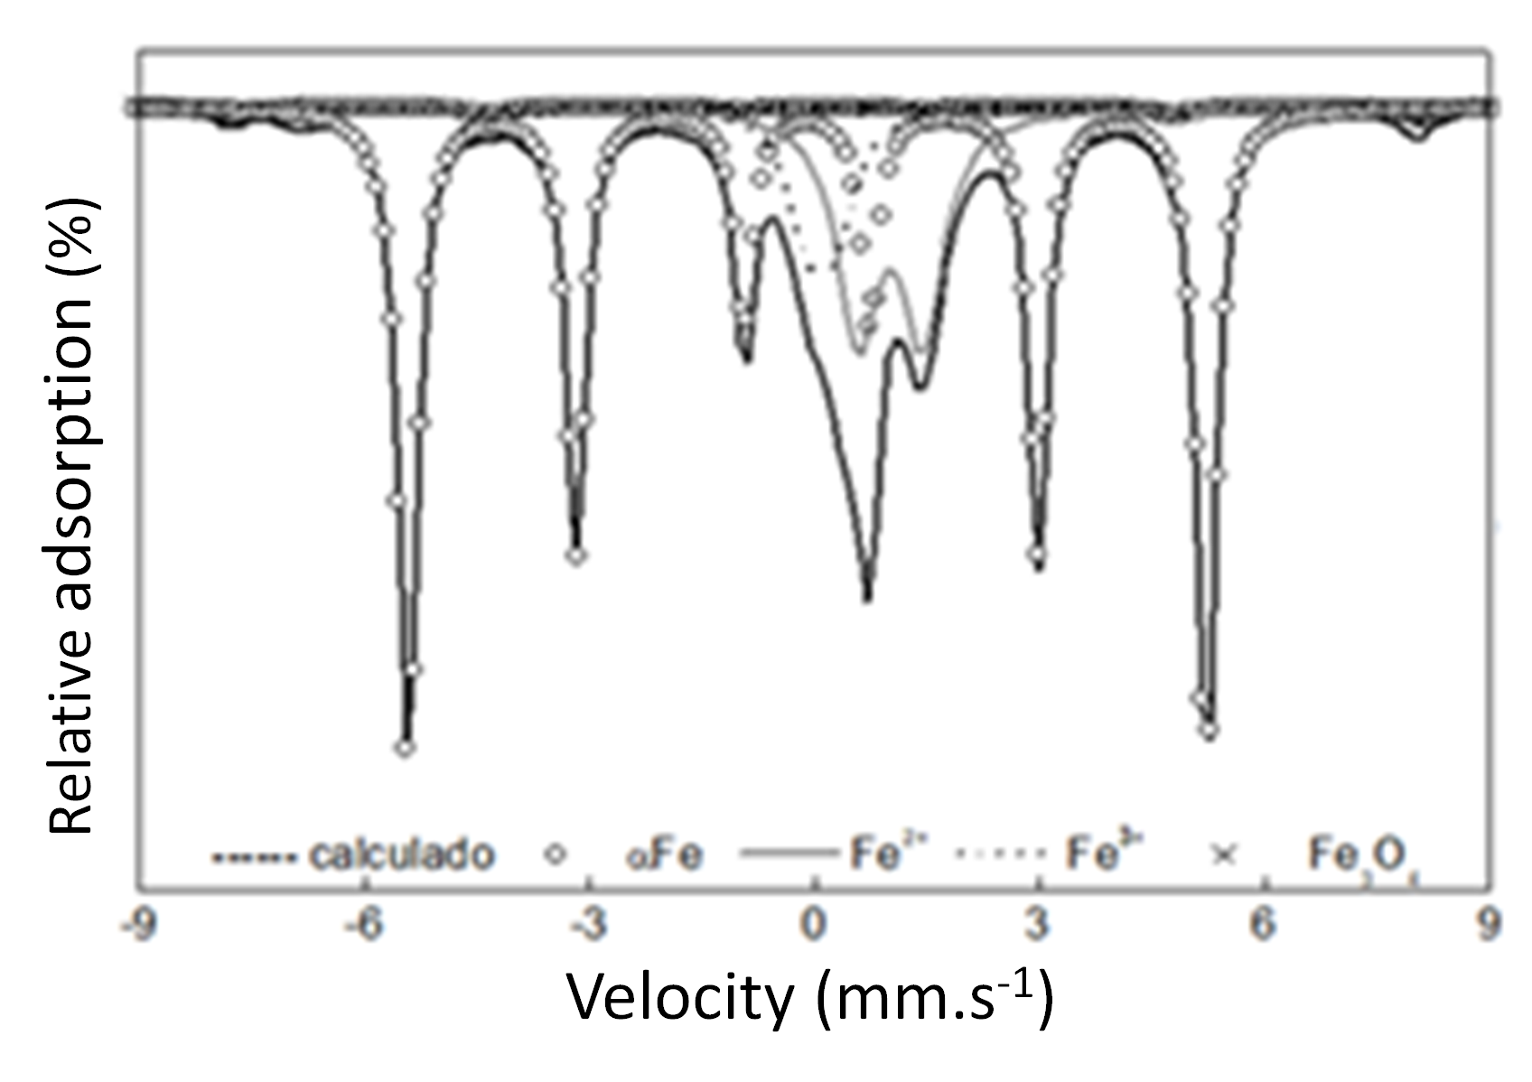

Figure S3 – (A-B colums) Morphological properties of raw BOFS, (C) AMD-reacted BOFS and (D) AMD/H₂O₂-reacted BOFS.

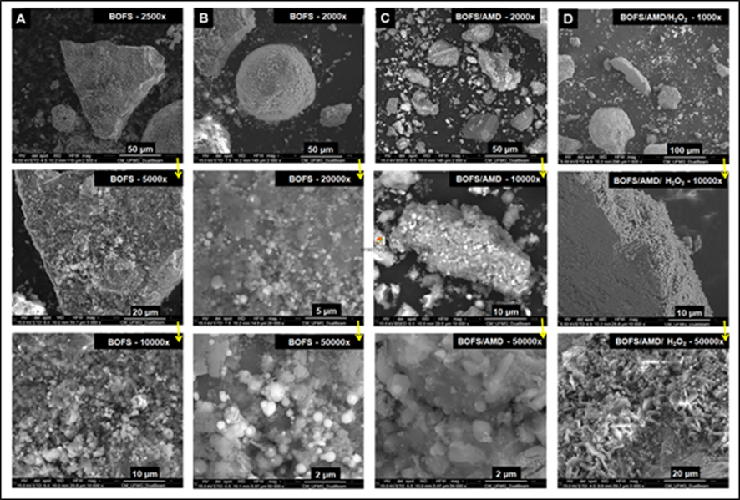

NBR 10004 - Solid Waste - Classification (ABNT, 2004), aims to classify solid waste according to its potential risks to the environment and public health, so that they can be properly managed. For this purpose, this standard proposes to carry out leaching and solubilization tests (NBR 10005 - Procedure for obtaining leachate extract from solid waste and NBR 10006 - Procedure for obtaining solubilized extract from solid waste). The results of these procedures provide an estimate of the behavior and solubility of metals in the short term, indicating the release of metals and semimetals based on the solubility of compounds in solution, when the process is dominated by simple dissolution.
The classification proposed by NBR 10004/04 is as follows:
- Class I - Harzadous: These are those that present substantial real or potential dangerousness to human health or living organisms and that are characterized by lethality, non-degradability and diverse cumulative effects, or even by one of the following characteristics: flammability, corrosivity, reactivity, toxicity and pathogenicity.
- Class IIA – Non-Inert: These are those that do not fit the classifications of Class I - Hazardous waste, or Class IIB - Inert waste. These residues have properties such as: combustibility, biodegradability or solubility in water.
- Class IIB - Inert: These are residues that, when sampled in a representative manner and subjected to static or dynamic contact with deionized distilled water, at room temperature, had none of their constituents solubilized at concentrations above water potability standards. , except for aspects of color, turbidity and flavor..

References:
ABNT. Associação Brasileira de Normas Técnicas. Solo: Análise Granulométrica. Rio de Janeiro,. NBR 7181/82: 13 p. 1984.

______. Associação Brasileira de Normas Técnicas. Procedimento para obtenção de extrato lixiviado de resíduos sólidos. Rio de Janeiro. NBR 10005, : 16 p. 2004a.

______. Associação Brasileira de Normas Técnicas. Resíduos sólidos - Classificação. Rio de Janeiro. NBR 10004,: 71 p. 2004b.

USEPA (1998): Method 3051a - Microwave assisted acid digestion of sediments, sludges, soils, and oils. . ‹http://www.epa.gov/epawaste/hazard/testmethods/sw846/pdfs/3051a.pdf›, pp. 30

