Supplementary material

Title: Responsiveness and convergent validity of QLU-C10D and EQ-5D-3L in assessing short-term quality of life following esophagectomy

Comparing demographics and quality of life outcomes for excluded respondents
The analysis in this paper only included patients with both baseline (pre-operative) and follow-up (post-operative) quality of life scores on all instruments. Tables A1 and A2 show differences in demographic characteristics and quality of life outcomes for patients included and those excluded from the analysis.

Table A1 Comparing Demographic characteristics for excluded respondents
Characteristic | Total sample | Complete QoL data (n=164) | Incomplete QoL data | p-value
Continuous variables [Mean (sd)]
Age | 63.5 (8.7) | 62.9 (7.9) | 64.4 (9.6) | 0.06
Hospital length of stay (days) | 18.7 (17.1) | 17 (15) | 21.8 (20.1) | 0.08
ICU length of stay (days) | 4.7 (8) | 4 (4) | 5.8 (11.7) | 0.66
Blood loss (ml) | 263.4 (244.9) | 268.1 (256.1) | 255.5 (225.9) | 0.89
Blood transfusion (units) | 0.28 (1.61) | 0.31 (1.98) | 0.22 (0.81) | 0.89
Tumour length (cm) | 3.62 (2.62) | 3.86 (2.66) | 3.24 (2.52) | 0.14
Total pack years | 17.9 (20.2) | 16 (18) | 20.1 (23.4) | 0.50
Categorical variables | N (%)
Male Gender | 223 (81) | 133 (81) | 90 (80) | 0.88
Hospital length of stay > 10 days | 213 (81) | 133 (81) | 80 (80) | 0.83
Tumour length >3cm | 87 (47) | 58 (51) | 29 (40) | 0.16
Co-morbidities
Hypertension | 105 (39) | 62 (38) | 43 (41) | 0.61
Diabetes | 35 (13) | 21 (13) | 14 (13) | 0.92
Respiratory | 61 (22.6) | 33 (20) | 28 (26) | 0.23
Cardiac | 52 (19) | 27 (17) | 25 (24) | 0.15
Alcohol | 164 (62) | 106 (66) | 58 (56) | 0.1
Smoking | 36 (13) | 22 (13) | 14 (13) | 0.96
Preoperative Radiotherapy | 112 (41) | 67 (41) | 45 (42) | 0.8
Preoperative Chemotherapy | 211 (78) | 129 (79) | 82 (77) | 0.80
ASA score
1 or 2 | 178 (67) | 111 (68) | 67 (66) | 0.77
3 | 86 (33) | 52 (32) | 34 (34)
Pathological T staging
0/1/1a/1b/Tis | 112 (43) | 72 (44) | 40 (41) | 0.67
2/3 | 149 (57) | 92 (56) | 57 (59)
TNM staging
0/IA/IB | 112 (43) | 75 (46) | 37 (37) | 0.01
II/IIB/IIIA/IIIB | 130 (49) | 82 (50) | 48 (48)
IIIC/4 | 21 (8) | 7 (4) | 14 (14)
Procedure type
Open chest and abdominal approach | 108 (42) | 76 (46) | 32 33.68 | 0.05
Hybrid (thoracoscopic) | 151 58.30 | 88 (54) | 63 66.32

Table A2 Comparing Quality of life outcomes for excluded respondents¹
Quality of life measure | Total sample | Complete QoL data | Incomplete QoL data | p-value
Baseline (7 days before esophagectomy)
EQ-5D-3L | 0.85 (0.15) | 0.85 (0.15) | 0.84 (0.15) | 0.71
QLU-C10D | 0.80 (0.17) | 0.81 (0.16) | 0.80 (0.18) | 0.90
EORTC summary score | 84.3 (12.7) | 84.3 (13.1) | 84.6 (11.9) | 0.90
Follow – up (42 days after esophagectomy)
EQ-5D-3L | 0.69 (0.18) | 0.69 (0.16) | 0.69 (0.24) | 0.15
QLU-C10D | 0.52 (0.22) | 0.52 (0.22) | 0.53 (0.24) | 0.50
EORTC summary score | 62.4 (18.5) | 62.5 (17.9) | 61.9 (21.0) | 0.83

¹The analysis in this paper only included patients with both baseline (pre-operative) and follow-up (post-operative) quality of life scores on all instruments. This table shows differences in quality of life for patients included and those excluded from the analysis. There were no differences in quality of life between the two groups

Additional files on Complete case analysis

Distribution of QoL scores for each instrument (complete cases)

Fig A1 Baseline QoL (7 days before esophagectomy)
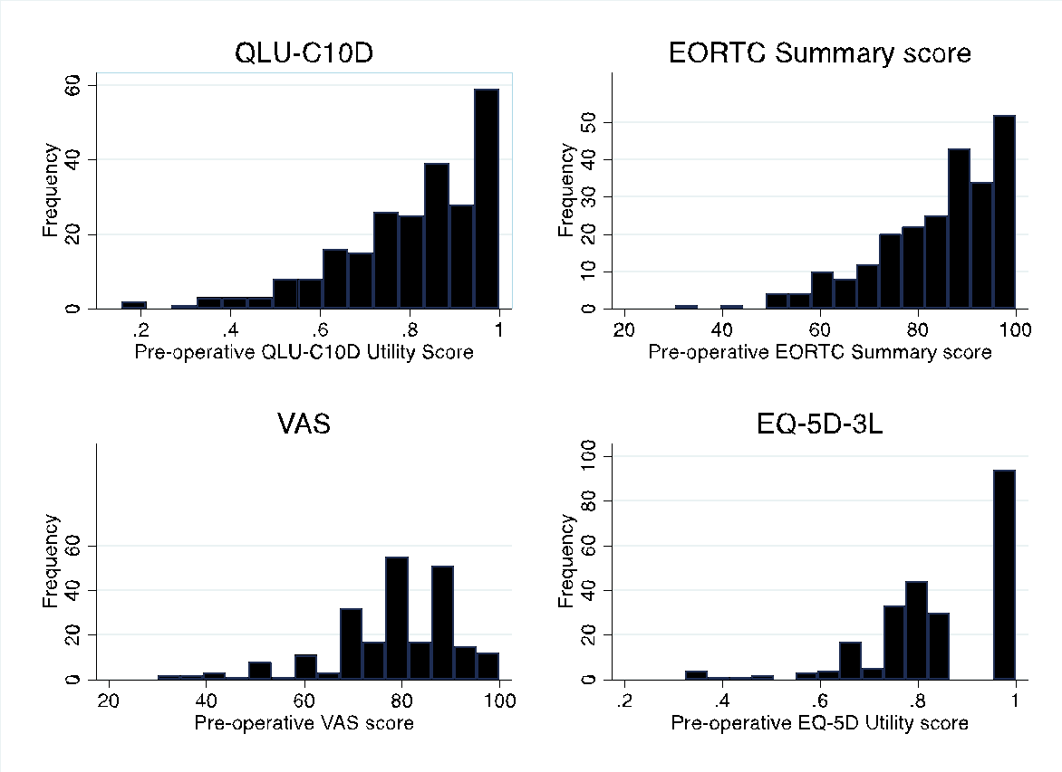

Fig A2 Follow-up QoL (42 days after esophagectomy)
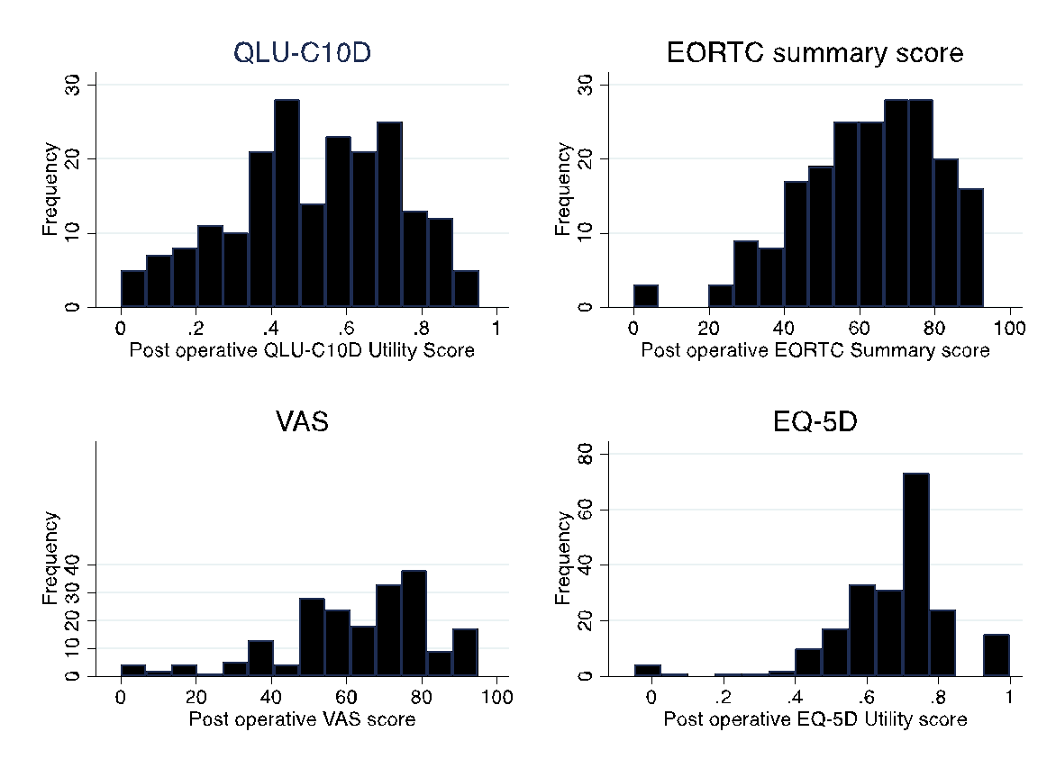

Fig A3 Distribution of the mean difference in QoL scores for each instrument
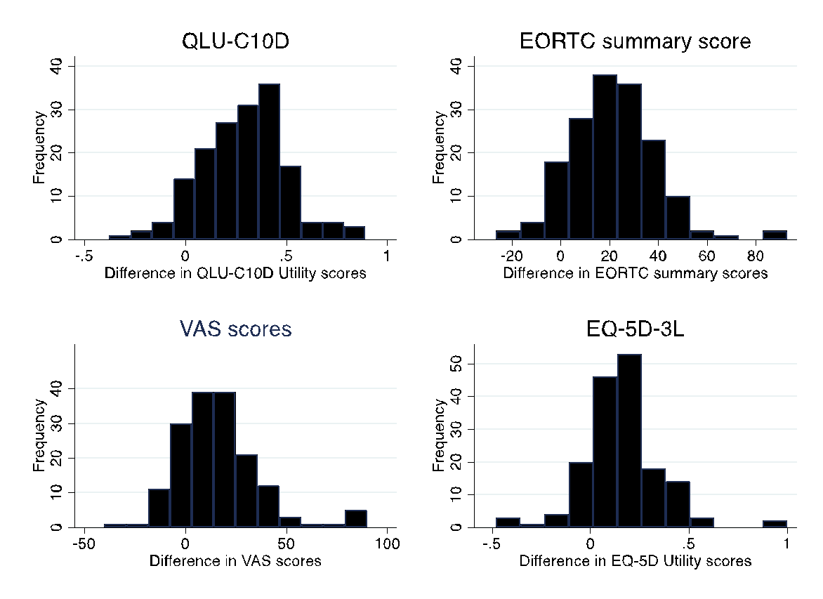

Table A3 Correlation (significant) between QLQ-C30 and EQ-5D-3L domains at follow-up (42 days after esophagectomy)
 | EQ-5D utility score | Mobility | Personal care | Usual activities | Pain/discomfort | Anxiety/depression
EORTC total score | 0.7060 | -0.4217 | -0.2622 | -0.5656 | -0.2145 | -0.5238
Global health score | 0.5469 | -0.3222 |  | -0.5245 | -0.1599 | -0.3803
QLQ-C30 Functional scales
Physical function | 0.6630 | -0.5970 | -0.3891 | -0.6068 |  | -0.3346
Role function | 0.6500 | -0.4355 | -0.2613 | -0.6716 | -0.1716 | -0.3255
Emotional function | 0.6787 | -0.3047 | -0.1863 | -0.4392 |  | -0.7170
Social function | 0.5831 | -0.3311 | -0.2786 | -0.5563 | -0.1914 | -0.3600
Cognitive function | 0.4623 | -0.2863 | -0.1952 | -0.3894 |  | 0.3807
QLQ-C30 Symptoms
Fatigue | -0.5572 | 0.3723 | 0.2344 | 0.4642 |  | 0.3786
Nausea and vomiting | -0.3845 | 0.1809 |  | 0.2469 | 0.1821 | 0.3524
Pain | -0.4445 | 0.2446 |  | 0.3310 | 0.5548 | 0.1846
Insomnia | -0.3385 | 0.2567 | 0.1926 | 0.2763 |  | 0.3241
Appetite loss | -0.3470 | 0.2106 |  | 0.2769 |  | 0.3235
Dypnoea | -0.3473 | 0.3627 | 0.2285 | 0.3114 |  | 0.1968
Diarrhoea |  |  |  |  |  | 0.2082
Constipation |  |  |  |  |  | 0.1846
Financial problems | -0.2465 |  |  | 0.3281 |  | 0.1856
OES symptom scales
Dysphagia | -0.2992 | 0.2608 | 0.1713 | 0.2373 |  | 0.2502
Eating difficulties | -0.4121 | 0.2647 |  | 0.2815 |  | 0.3353
Reflux
Pain |  |  |  |  | 0.2476
Swallowing saliva
Choking and swallowing
Dry mouth | -0.2660 |  |  | 0.2192 |  | 0.2157
Taste | -0.1882 | 0.1758
Coughing |  |  |  | 0.1881 |  | 0.2238
Talking | -0.1735 |  |  |  |  | 0.2138

