Supplement
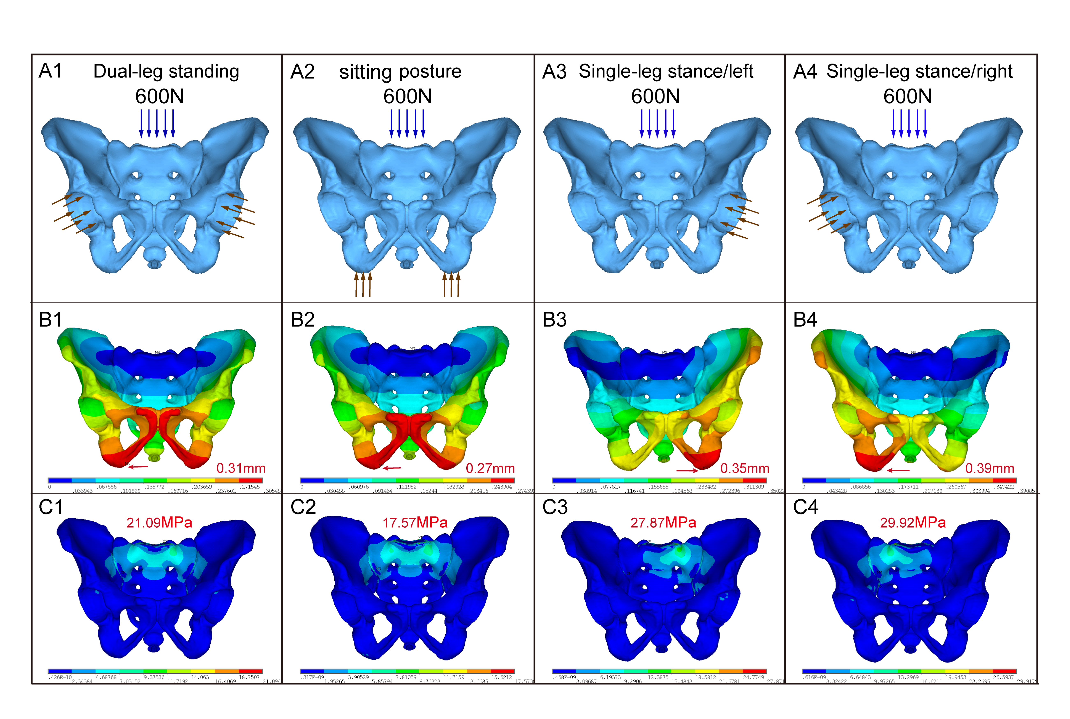 Supplement figure 1. FE intact model under four posture. A: geometries for model with different loading stress. B: The displacement of the intact pelvis. C: The Von Mises stresses distribution applied to the intact pelvis.

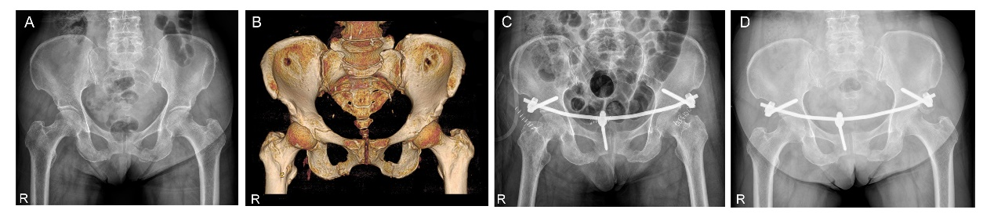
Supplement figure 2. A 48-year-old female patient with anterior pelvic ring fracture. A and B. Preoperative X-ray film and 3D CT image showed bilateral displaced pubic ramus fracture. C. Postoperative pelvic AP view, the X-ray film showed satisfactory reduction with the modified three-screw fixation. D. the Pelvic AP view of X-ray film showed bone union at six months’ follow-up, postoperatively.

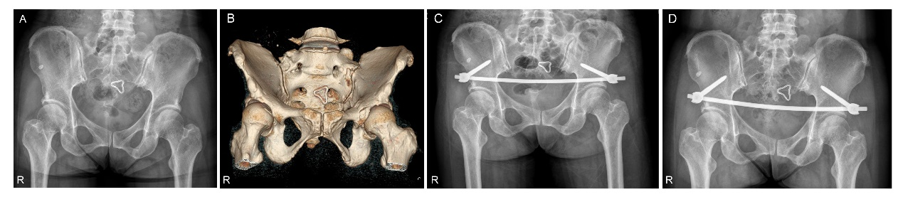
Supplement figure 3. A 45-year-old female patient with anterior pelvic fracture. A and B Preoperative X-ray film and 3D CT image showed left pubic ramus fracture. C. Postoperative pelvic AP view, the X-ray film showed satisfactory reduction with the conventional two-screw fixation. D. Pelvic AP view of X-ray film showed bone union at seven months’ follow-up, postoperatively.

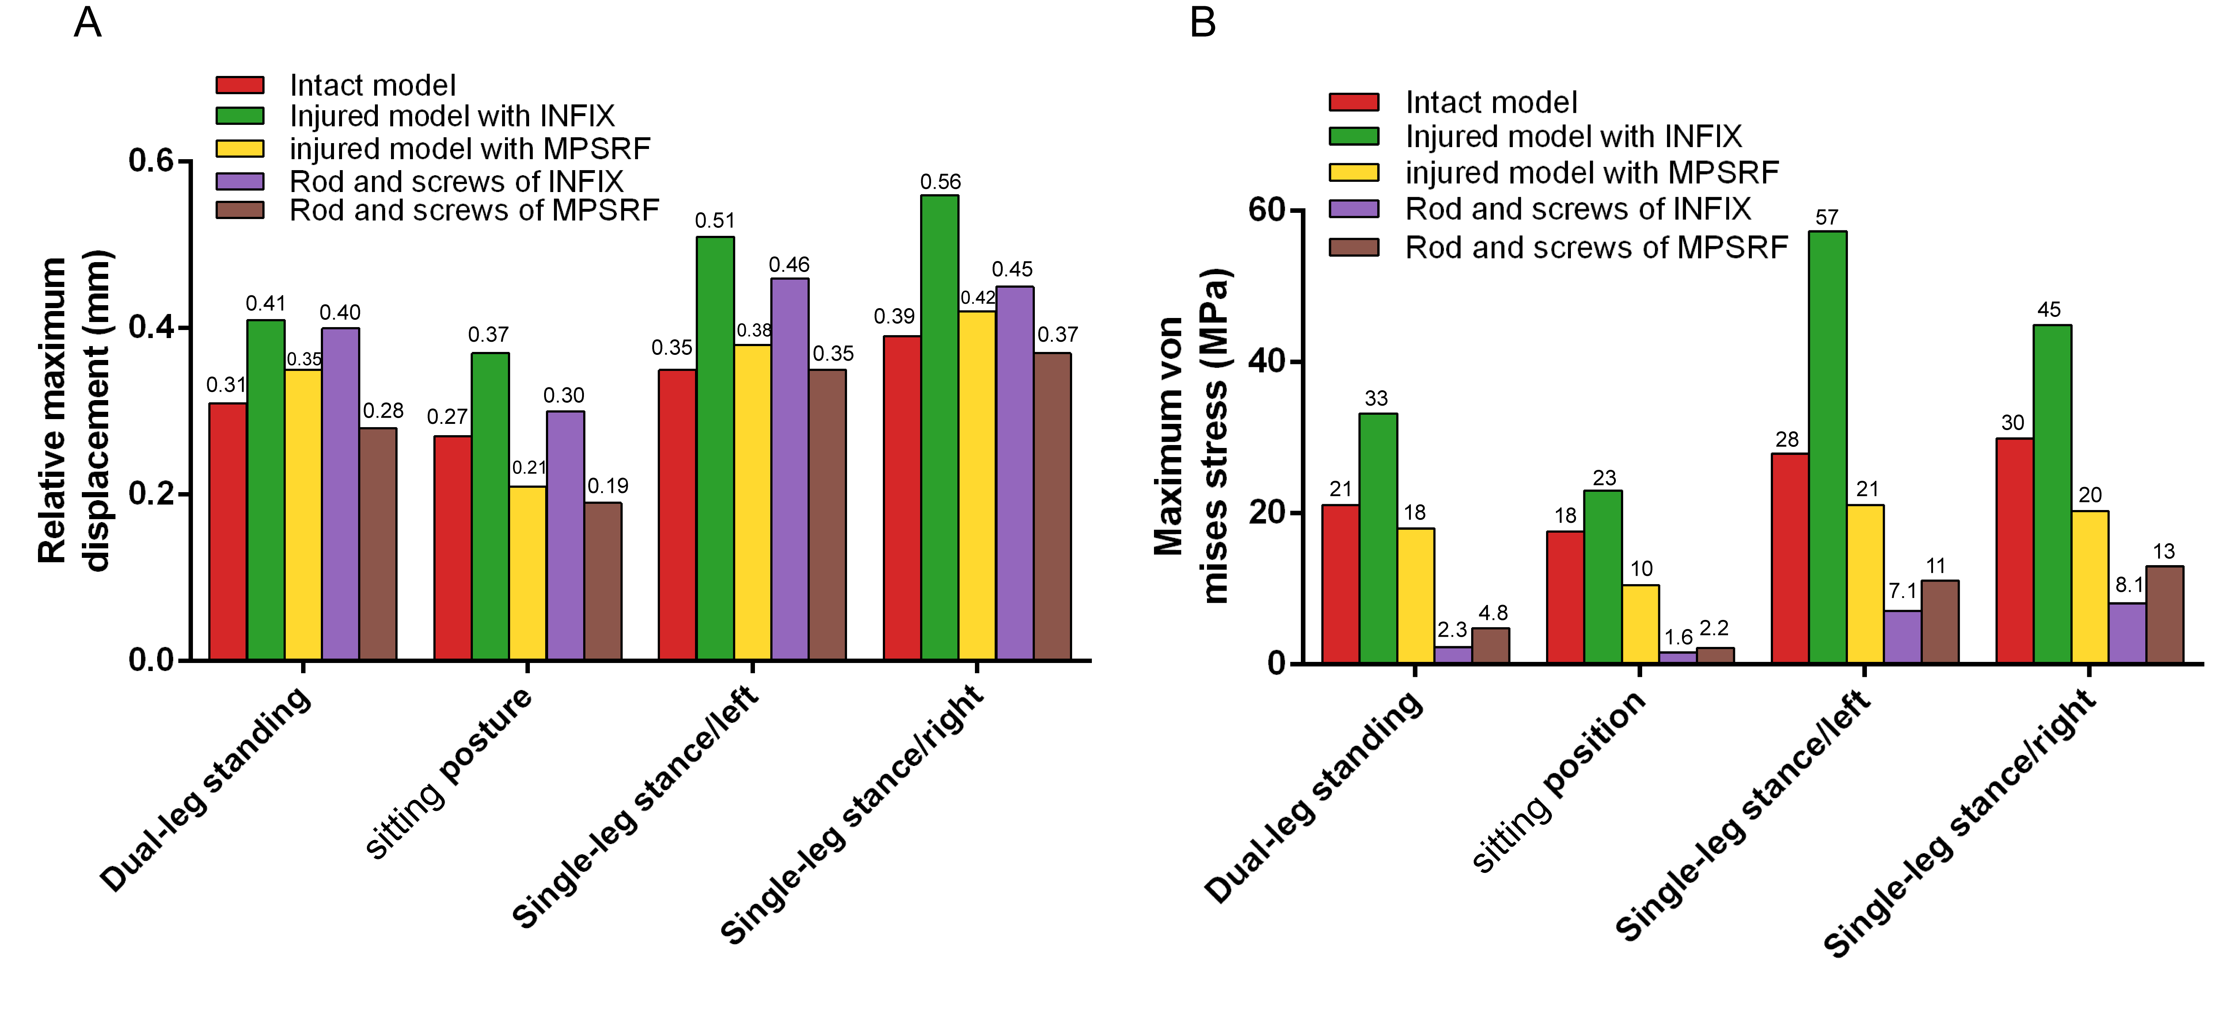
Supplement figure 4. Comparison of fixation stability in intact model and injured model with INFIX/MPSRF under four postures. including the dual-leg standing, sitting posture and single-leg stance(left/right). A: the maximum displacement of pelvis and implant devices. B: maximum Von Mises stresses of pelvis and implant devices.

