Additional file 1 - Design and baseline description of an observational population-based cohort study into COVID-19 vaccine effectiveness in the Netherlands - The VAccine Study COvid-19 (VASCO)

Figure S1. Timeline examples participants

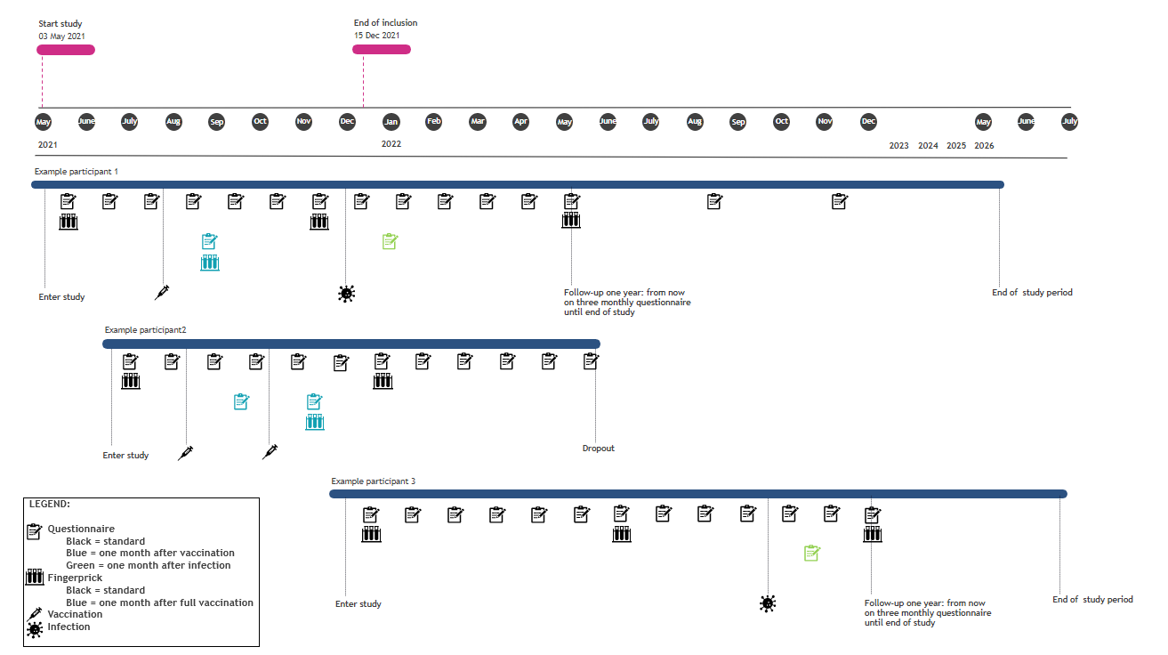
Figure S2. Number of inclusions over time with recruitment actions
