Supporting Information

**Light controlled liquefactions of non-photoresponsive crystals**

Weibin Dong, Shuai Tan, Jie Luo, Junyi Ji, Yong Wu, Caihong Wang*, Masayoshi Watanabe

**Table of Contents**

1Experimental Section S3

* 1. Materials S3
  2. Characterization S3
  3. Synthesis S3
  4. Preparation of mixed Azo-C12VIM[X]. S4
  5. Electrochemical Measurements of mixed Azo-C12VIM[Br] S5

1. Molecular Dynamics Simulation S6
2. Supplementary Fig 1-Supplementary Fig 17 S7-17
3. Supplementary Table 1-2 S18-19
4. Other Supplementary Materials for this manuscript:

Supplementary Movie 1-2

1. **Experimental Section**

**1.1 Materials.** 1-vinylimidazole and bromododecane were purchased from Aladdin. 1-Dodecyl-3-vinylimidazolium-based ionic crystals were synthesized by reaction of 1-vinylimidazole with an alkyl halide and followed by ion exchange. Azobenzene was purchased from Chengdu HuaXia Chemical Reagent Co. Ltd. Other chemical reagents were used as received unless otherwise noted.

**1.2 Characterization.** 1HNMR was carried out on a Bruker Avance-III 400 spectrometer. Elemental analysis (EIS) measurements were performed on an Agilent ICP-OES730 with an Elementar Vario EL cube. High resolution mass spectra (HRMS) were conducted on a TSQ Quantum Ultra in negative modes. Differential scanning calorimetry (DSC) data were collected on a TA Q2000 (TA Instruments, New Castle, DE) at a scanning rate of 10 °C/min with a nitrogen flow of 50 mL/min using aluminum pans as sample holder. Polarized optical microscopy (Weitu XPL-30TF) was equipped with a WT- 3000 hotstage to control temperatures. Powder X-ray diffraction (XRD) measurements were carried out on an Anton Paar GmbH (Graz, Austria) with a temperature controller, using Cu-Kα radiation at 40 kV and 50 mA before and after UV irradiation at a certain temperature (UV light, 365 nm, 200 mW∙cm−2). UV-Vis spectra were performed on a UV-Vis spectrometer (Metash UV-5500). FT-IR spectra were acquired using a Cary 630 FT-IR spectrometer (Agilent Technologies, Santa Clara, CA). Electrochemical impedance spectroscopy (EIS) measurements were recorded on an electrochemical workstation (VersaSTAT3, Princeton). The electrochemical charging/discharging of a capacitor was recorded on Chenghua B14663b in presence/absence of UV light. A portable light-emitting diode (LED) light source (Beijing Newbetter Optics Technology Co.) was utilized to provide photoirradiation with selective intensity and wavelength (UV: 365 nm；Vis: 450 nm).

* 1. **Synthesis**

**Synthesis of 1-vinyl-3-dodecyl imidazole bromide (C12VIM[Br]).**

The detailed synthesis was referred to the reported literature.1,2 1-vinylimidazole (3.29 g，35 mmol) was dropped into bromododecane (10 g，40 mmol) in a 100 mL eggplant-shaped flask. The mixture was stirred at room temperature for 10 min, then heated at 70 °C for 5 h. After cooling to room temperature, the crude product was recrystallized several times by ethyl acetate. White needle-like crystals were collected after filtration, yield 92%. 1HNMR (ppm, DMSO): δ 0.86 (t, 3H, -CH3), 1.24-1.27 (m, 18H, -CH2), 1.82 (m, 2H, -CH2), 4.2 (t, 2H, N-CH2), 5.41-5.8 (m, 2H, =CH2), 7.26-7.3 (q, H, N-CH=), 7.94 (s, 1H, CH-N of rings), 8.21 (s, 1H, N-CH of rings), 9.51 (s, 1H, N-CH-N of rings). HRMS for C17H31N2Br (calculated at 263.00): found *m/z* = 263.25 ([M-H]+). Elemental analysis for C17H31N2Br, Calc.: C, 59.47; H, 9.32; N, 8.16; Br, 33.05. Found: C, 59.13; H, 9.25; N, 7.97; Br, 33.65.

**Synthesis of 1-vinyl-3-dodecylimidazole tetrafluoroborate (C12VIM[BF4]).** C12VIM[Br] (5.15 g，15 mmol) and NH4BF4 (1.89 g，18 mmol) were dissolved in a mixture of MeOH-H2O (20 : 80 v/v), and magnetically stirred at room temperature for 24 h. The precipitates separated by filtration were washed several times with a large amount of MeOH-H2O (20: 80 v/v) and then dried to obtain C12VIM[BF4] in a yield of 78%. 1HNMR (ppm, DMSO): δ 0.90-0.94 (t, 3H, -CH3), 1.32 (m, 18H, -CH2), 1.83-1.92 (m, 2H, -CH2), 4.22-4.28 (t, 2H, N-CH2), 5.5-6.0 (m, 2H, =CH2), 7.3-7.4 (q, H, N-CH=), 8.0 (s, 1H, CH-N of rings), 8.26 (s, 1H, N-CH of rings), 9.53 (s, 1H, N-CH-N of rings). HRMS for C17H31N2BF4 (calculated at 349.80): found *m/z* =350.24 ([M-H]+). Elemental analysis for C17H31N2, Calc.: C, 58.32; H, 8.86; N, 8.00. Found: C, 58.23; H, 8.67; N, 7.78.

**Synthesis of 1-vinyl-3-dodecylimidazole hexafluorophosphate (C12VIM[PF6]).** C12VIM[Br] (5.15 g，15 mmol) and NH4PF6 (2.93 g，18 mmol) were dissolved in mixed MeOH–H2O (15:85 v/v) solutions, and magnetically stirred at room temperature for 24 h. The precipitates were separated by filtration and washed several times by mixed MeOH–H2O (15: 85 v/v) solvents. C12VIM[PF6] was obtained in a yield of 82%. 1HNMR (ppm, DMSO): δ 0.88-0.92 (t, 3H, -CH3), 1.3 (m, 18H, -CH2), 1.85-1.91 (m, 2H, -CH2), 4.23-4.26 (t, 2H, N-CH2), 5.4-6.2 (m, 2H, =CH2), 7.32-7.37 (q, H, N-CH=), 7.98 (s, 1H, CH-N of rings), 8.25 (s, 1H, N-CH of rings), 9.52 (s, 1H, N-CH-N of rings). HRMS for C17H31N2PF6 (calculated at 408.06): found *m/z* = 408.20 ([M-H]+). Elemental analysis for C17H31N2, Calc.: C, 50.00; H, 7.60; N, 6.86. Found: C, 50.08; H, 7.55; N, 6.84.

**Synthesis of 1-vinyl-3-dodecylimidazole carbonate ([C12VIM]2[CO3]).**

A solution of (NH4)2CO3 (0.85 g，9 mmol) in water (30 mL) was added dropwise into a mixture of C12VIM[Br] (5.15 g，15 mmol) in water (200 mL) at 45°C. After stirring for 24 h, chloroform was used for extracting [C12VIM]2[CO3] product from water, yield 74%. 1HNMR (ppm, DMSO): δ 0.85-0.88 (t, 3H, -CH3), 1.25(m, 18H, -CH2), 1.77-1.82 (m, 2H, -CH2), 4.12-4.22 (t, 2H, N-CH2), 5.44-5.95 (m, 2H, =CH2), 7.25-7.35 (q, H, N-CH=), 7.92 (s, 1H, CH-N of rings), 8.21 (s, 1H, N-CH of rings), 9.49 (s, 1H, N-CH-N of rings). HRMS for C35H62N4O3 (calculated at 263.00): found *m/z* = 263.24 ([M-H]+). Elemental analysis for C35H62N4O3, Calc.: C, 71.43; H, 10.54; N, 9.52; O, 8.51. Found: C, 71.35; H, 10.57; N, 9.48; O, 8.60.

**Synthesis of 1-vinyl-3-dodecylimidazole thiocyanate (C12VIM[SCN]).**

C12VIM[Br] (5.15 g，15 mmol) and NaSCN (1.46 g，18 mmol) were dissolved in acetone, and magnetically stirred at room temperature for 24 h. Removing the white precipitate by filtration helped to obtain a colorless transparent viscous liquid, which was washed by chloroform for several times, and the purified compound was vacuum-dried for 24 h to obtain the final product, yield 75%. 1HNMR (ppm, DMSO): δ 0.85-0.90 (t, 3H, -CH3), 1.25 (m, 18H, -CH2), 1.78-1.85 (m, 2H, -CH2), 4.15-4.21 (t, 2H, N-CH2), 5.43-5.94 (m, 2H, =CH2), 7.26-7.33 (q, H, N-CH=), 7.94 (s, 1H, CH-N of rings), 8.21 (s, 1H, N-CH of rings), 9.47 (s, 1H, N-CH-N of rings). HRMS for C18H31N3S (calculated at 321.07): found *m/z* = 321.22 ([M-H]+). Elemental analysis for C18H31N3S, Calc.: C, 67.29; H, 9.66; N, 13.08; S, 9.97. Found: C, 67.33; H, 9.59; N, 13.05; S, 10.03.

**Synthesis of 1-vinyl-3-dodecylimidazole perchlorate (C12VIM[ClO4])**

C12VIM[Br] (5.15 g，15 mmol) and AgClO4 (3.73 g，18 mmol) were dissolved in water, and magnetically stirred at room temperature for 24 h. Then chloroform was used for extracting the crude product from water to obtain C12VIM[ClO4], yield 71%. 1HNMR (ppm, DMSO): δ 0.84-0.86 (t, 3H, -CH3), 1.24 (m, 18H, -CH2), 1.78-1.83 (m, 2H, -CH2), 4.16-4.2 (t, 2H, N-CH2), 5.4-6.0 (m, 2H, =CH2), 7.25-7.31 (q, H, N-CH=), 7.93 (s, 1H, CH-N of rings), 8.2 (s, 1H, N-CH of rings), 9.46 (s, 1H, N-CH-N of rings). HRMS for C17H31N2O4Cl (calculated at 263.00): found *m/z* = 263.24 ([M-H]+). Elemental analysis for C17H31N2O4Cl, Calc.: C, 56.28; H, 8.55; N, 7.72; O, 17.66; Cl, 9.79. Found: C, 56.17; H, 8.52; N, 7.68; O, 17.76; Cl, 9.77.

* 1. **Preparation of mixed Azo-C12VIM[X]**.

The mixed weight ratio of Azo/C12VIM[X] was 5/95. Taken Azo-C12VIM[Br] as an example, proper weight portions of C12VIM[Br] and Azo were mixed in acetone with strong stirring for 24 h. Then the acetone was removed under vacuum at 40 °C for 8 h to obtain Azo-C12VIM[Br].

**1.5 Electrochemical Measurements of mixed Azo-C12VIM[Br]**

The samples were sandwiched by Indium Tin Oxide (ITO) glass plates with a spacer in a fixed thickness of 1 mm. EIS measurements were conducted over a frequency range of 1 MHz to 0.1 Hz at an amplitude of 10 mV. The IC-based capacitor was assembled using ITO glasses as electrodes with Azo-C12VIM[Br] as an electrolyte. Cyclic voltammetry and galvanostatic charge-discharge tests were conducted to characterize electrochemical performances of the capacitor in presence/absence of UV light.

1. **Molecular Dynamics Simulation**

All simulations were performed with the GROMACS 5.0.2 suite using OPLS all-atom force field for Azo-C12VIM[BF4] after the initial model has been constructed on the Packmol software. The simple point charge extended (SPC/E) water model was used upon the OPLS all-atom force field, and periodic boundary conditions were employed in X, Y and Z dimensions. Before initiating the Molecular Dynamics (MD) simulations, an energy minimization was performed to relax the system. Leapfrog algorithm MD was employed in all simulations with 2 fs time step. All bonds were constrained with the LINCS algorithm. In each simulation, a time step of 2 fs was applied with SHAKE constraints on covalent bonds. The particle mesh Ewald (PME) method was used to treat long-range electrostatic interactions with a cutoff of 12 Å. The number of particles (N), and the simulation box volume (V) are maintained constant during our simulations. The temperature was kept at 300 K using a stochastic term (v-rescale modified Berendsen) with a collision frequency of 1.0 ps-1. All simulations were conducted for 10 ns. The systems are visualized using VMD 1.9.1.48.

1. **Figures**

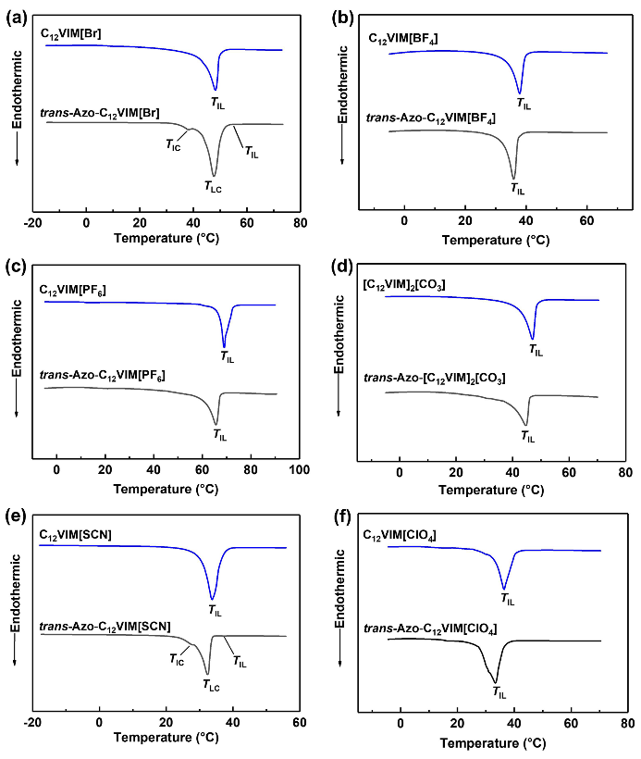

**Supplementary Fig 1** DSC curves of C12VIM[X] and *trans*-Azo-C12VIM[X] upon heating process at a rate of 10 ºC/min: C12VIM[Br] and *trans*-Azo-C12VIM[Br](a), C12VIM[BF4] and *trans*-Azo-C12VIM[BF4] (b), C12VIM[PF6] and *trans*-Azo-C12VIM[PF6] (c), [C12VIM]2[CO3] and *trans*-Azo-[C12VIM]2[CO3] (d), C12VIM[SCN] and *trans*-Azo-C12VIM[SCN] (e), C12VIM[ClO4] and *trans*-Azo-C12VIM[ClO4] (f).

The melting temperatures (*T*ILs) of *trans*-Azo-C12VIM[X] mixtures mostly shifted to low temperatures compared with those of C12VIM[X], as depicted from DSC curves (Table S1 and Supplementary Fig 1). It was understandable that an addition of Azo could interrupt closely packed ionic crystal lattices, resulting in a reduction of *T*ILs. Only *T*ILs of Azo-C12VIM[Br] and Azo-C12VIM[SCN] slightly shifted to high temperatures due to an appearance of liquid crystal mesophase.

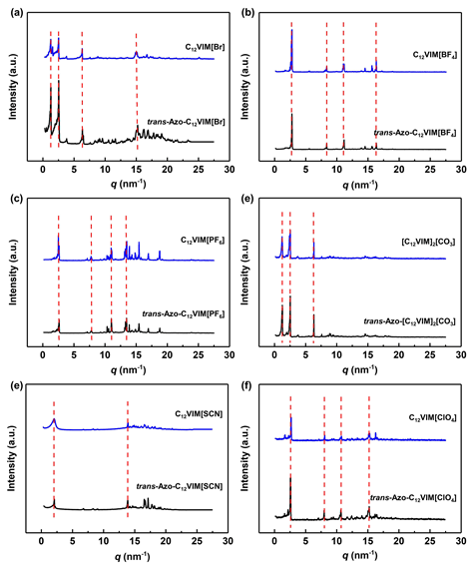

**Supplementary Fig 2** Powder-XRD of C12VIM[X] and Azo-C12VIM[X] at room temperature: C12VIM[Br] and Azo-C12VIM[Br](a); C12VIM[BF4] and Azo-C12VIM[BF4] (b); C12VIM[PF6] and Azo-C12VIM[PF6] (c); [C12VIM]2[CO3] and Azo-[C12VIM]2[CO3] (d); C12VIM[SCN] and Azo-C12VIM[SCN] (e); C12VIM[ClO4] and Azo-C12VIM[ClO4] (f).

As shown in Supplementary Fig 2, crystalline structure of the IC compounds did not greatly change in presence of Azo, as shown by few changes in peak patterns. Various anions of ICs have different layer structures as reported.1 Taken Azo-C12VIM[Br] as an example, with the addition of Azo, the crystalline structures of *trans*-Azo-C12VIM[Br] barely changed. The layer spacing *d* of *trans*-Azo-C12VIM[Br] was almost double for the single chain length of C12VIM[Br] based on the (001) reflection, and such double layer order character is similar to the structure of the neat C12VIM[Br] compound.1,2 Therefore, Azo addition less altered crystal nanostructures of C12VIM[X].

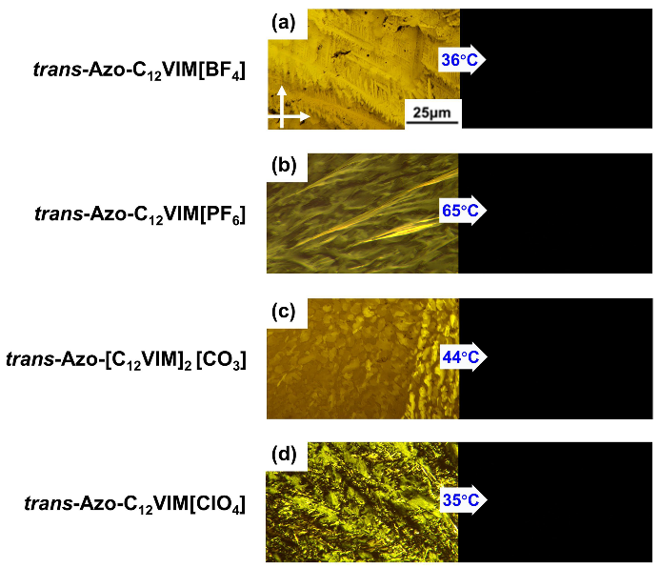

**Supplementary Fig 3** Thermoinduced solid-liquid transitions of Azo-C12VIM[X] upon heating process under POM observations: Azo-C12VIM[BF4] at 36 °C (a), Azo-C12VIM[PF6] at 65 °C (b), Azo-[C12VIM]2[CO3] at 44 °C (c), Azo-C12VIM[ClO4] at 35 °C (d).



**Supplementary Fig 4** POM observed thermo-induced solid-liquid transitions of C12VIM[Br] birefringence of crystal phase at 25 °C (a) and isotropic IL phase at 45 °C (b) and thermo-induced solid-liquid crystal-isotropic liquid transitions of *trans*-Azo-C12VIM[Br]: crystalline at 25 °C(c); conical texture of LC phase at 38 °C (d) and IL phase at 60 °C (e) upon heating process.

Taken Azo-C12VIM[Br] as an example, C12VIM[Br] showed birefringence of at 25 °C and melted at 45 °C according to polarizing optical microscopic (POM) observations (Supplementary Fig 4). With the addition of Azo (as *trans*-Azo-C12VIM[Br]), the characteristic conical texture of a smectic LC phase appeared, followed by a change to a homogeneous liquid phase (Supplementary Fig 4c, d and e). The appearance of LC mesophases suggested a supramolecular character of the Azo-C12VIM[X] block. It was assumed that the affinity and π-conjugated stacking between vinyl imidazolium and *trans*-Azo enabled the *trans*-Azo to be well inserted in nanolayered ionic regions.3 Consequently, sandwiched supramolecular cores with reduced rigidity were able to induce an ordered lamellar LC mesophase, since the balance of rigidity and flexibility is important to induce LC mesophases. It was the first time to report the LC phase for ICs induced by an addition of Azo, which is meaningful for exploring supramolecular IL materials.

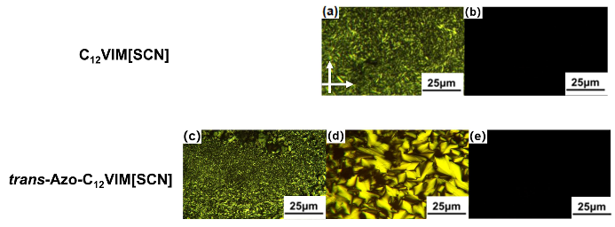

**Supplementary Fig 5** POM observations of C12VIM[SCN] upon heating process: crystalline phase at 25 °C (a) and isotropic phase at 33 °C (b); and POM observations of *trans*-Azo-C12VIM[SCN]: crystalline phase at 5 °C (c), smectic phase at 28 °C(d) and isotropic phase at 38 °C (e).

Upon heating process, there was only one phase transition observed for C12VIM[SCN], as shown in Supplementary Fig 5a and S5b. But after adding Azo, there was one mesophase appeared, liquid crystal phase, before a phase transition to the isotropic liquid phase (Supplementary Fig 5c, d and e). It seemed that *trans*-Azo could properly alter rigidity of the ionic cores of C12VIM[SCN] to induce an appearance of LC mesophase. Such behavipr was similar to Azo-C12VIM[Br] as shown in Supplementary Fig 4.

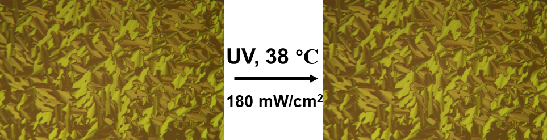

**Supplementary Fig 6** No phase transitions occurred for *trans*-Azo-C12VIM[Br] at 38 °C under UV irradiation for 1 h.



**Supplementary Fig 7** Reversible liquid crystal-isotropic liquid transitions of Azo-C12VIM[Br] detected by powder-XRD at 40 °C before UV irradiation, followed by under UV and then Vis light irradiation.



**Supplementary Fig 8** UV-Vis spectra of Azo-C12Py[Cl] under UV irradiation.

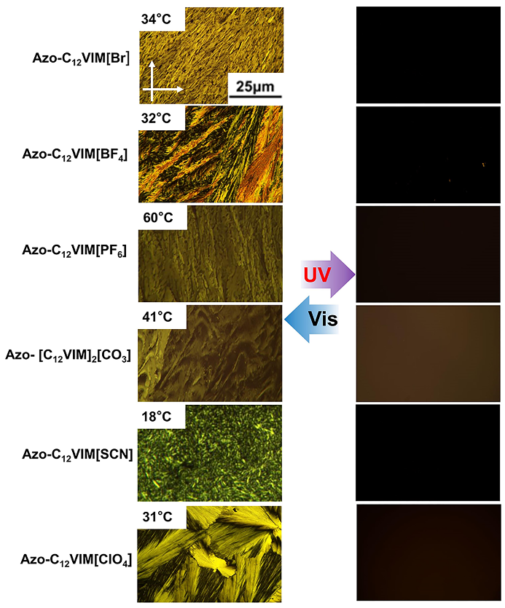

**Supplementary Fig 9** Light switchable solid-liquid transitions under UV and Vis light irradiations for Azo-C12VIM[X] under POM observations: Azo-C12VIM[Br] at 20 °C; Azo-C12VIM[BF4] at 32 °C; Azo-C12VIM[PF6] at 60 °C; Azo-[C12VIM]2[CO3] at 41 °C; Azo-C12VIM[SCN] at 18 °C; Azo-C12VIM[ClO4] at 31 °C.

Azo-C12VIM[X] demonstrated lightswitchable solid-liquid transitions. Different anions variously altered the switchable temperatures. High transition temperatures accelerated the phase transitions speed. But even for Azo-C12VIM[SCN], one reversible solid-liquid transition cycle at 18 °C took 2 min. It was attractive to use Azo to construct photoliquefaction compounds.4 Besides, it needs to be pointed out that photoisomerization of free Azo were no longer constrained by high glass temperatures of Azo compounds, yet decided by the environmental ionic components.

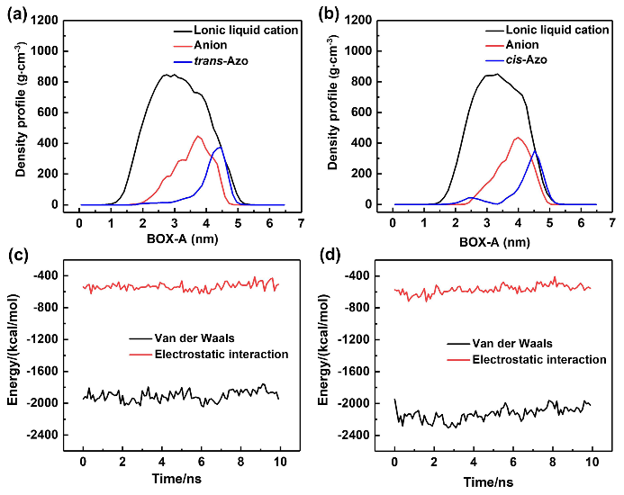

**Supplementary Fig 10** Density curves and energy curves between C12VIM[BF4] (cation and anion) and *trans*-Azo (a)(c) /*cis*- Azo (b)(d).

An initial system model of 4.6 × 4.6 × 6.12 nm3 composed of 100 ICs and 25 Azo was used to modulate interaction between Azo and ICs. The density curves represent the change of the density number (spatial concentration) of the statistical molecular distribution along the simulated box direction; while the energy curves are the energy (van der Waals force and electrostatic interaction) change of the various parts of the system self-assembly along the simulation time, that is, the energy of the self-assembly dynamics evolution over time. The energy in the simulation system was among all molecules, divided into van der Waals energy and electrostatic energy. Through detailed comparative analysis of density curves between *trans*-/*cis*-Azo-C12VIM[BF4] systems, it was found out that the peaks of *trans-/cis*-Azo were mainly scattered between the cation and anion density peaks (Supplementary Fig 10a and Supplementary Fig 10b), supporting that either *trans-/cis*-Azo was distributed in ionic regions, which were mainly caused by van der Waals and electrostatic interaction. As shown in Supplementary Fig 10c and Supplementary Fig 10d, van der Waals energy was much more negative in *cis*-Azo-C12VIM[BF4] system, as an indication of enhanced van der Waals interactions between *cis*-Azo and C12VIM[BF4] in the system. The ionic region in ICs, where Azo was settled in, offered enough space and flexibility forAzo isomerization and interaction with Azo.

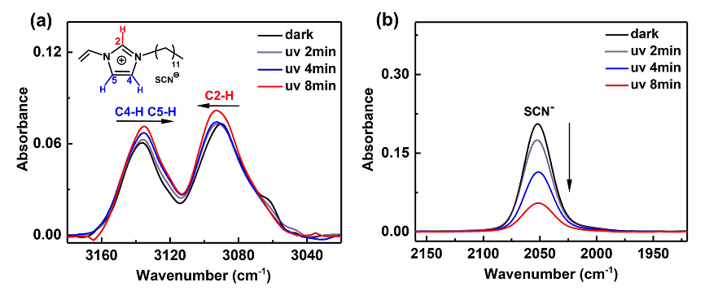

**Supplementary Fig 11** FT-IR spectra for Azo-C12VIM[SCN] under UV irradiations at room temperature.

Azo-C12VIM[SCN] was taken as an example to show FT-IR spectra because of the presence of a characteristic anion peak at 2053 cm-1. Under UV irradiation, the most positively charged acidic C2-H presented a blue shift while C4, 5-H of imidazolium ring showed a red shift at 3160-3040 regions (Supplementary Fig 11a). Upon Azo isomerization in the ionic region, a change in the interaction between the imidazolium cation and Azo might induce the vibrational change. The characteristic vibration peak of [SCN] anion located at 2053 cm-1 demonstrated an obvious reduction in intensity under UV irradiation (Supplementary Fig 11b). This great change would also support the incorporation of Azo in the ionic region, and also the interactions among Azo/imidazolium cation/[SCN] anion were altered by photoisomerization of Azo.

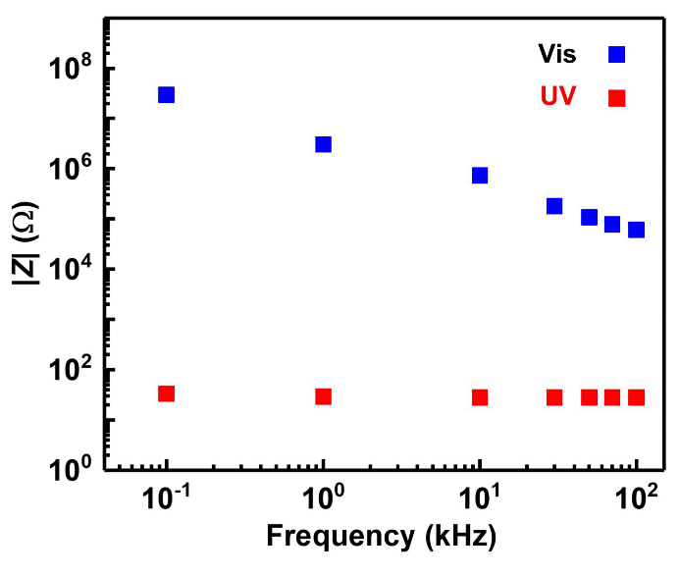

**Supplementary Fig 12** Frequency dependence of |*Z*| values of Azo-C12VIM[Br] under UV and Vis light irradiation at 15 °C.

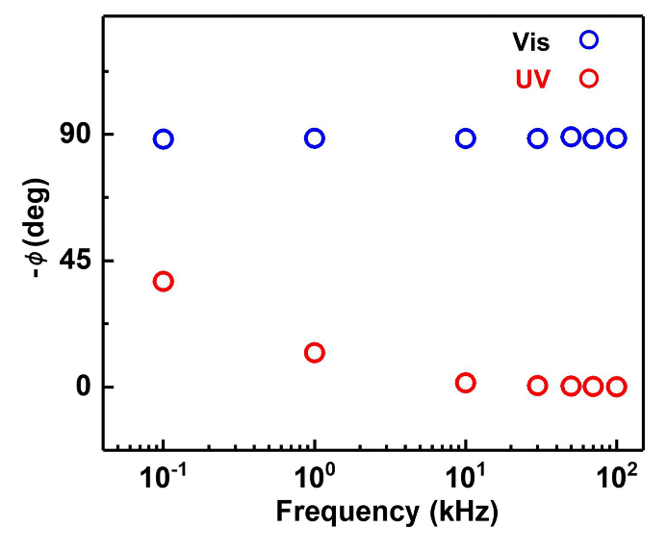

**Supplementary Fig 13** Frequency dependence of -*ϕ* values of Azo-C12VIM[Br] under UV and Vis light irradiation at 15 °C.

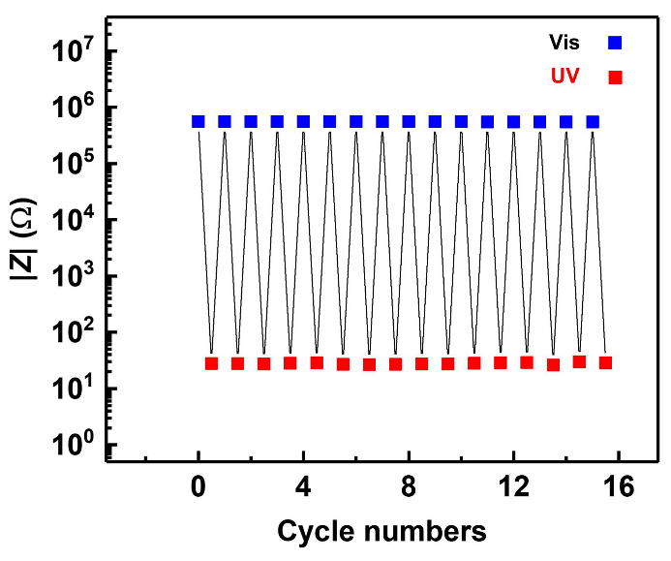

**Supplementary Fig 14** Light controlled reversible |*Z*| changes of Azo-C12VIM[Br] under UV (red square) and Vis (blue square) light irradiation at a frequency of 100 kHz at 15 °C.

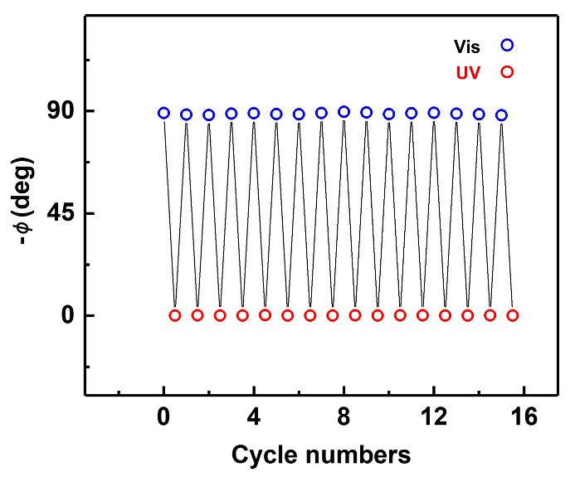

**Supplementary Fig 15** Light controlled reversible -*ϕ* changes of Azo-C12VIM[Br] under UV (red circle) and Vis (blue circle) light irradiation at a frequency of 100 kHz at 15 °C.



**Supplementary Fig 16** Electrochemical measurements of a *trans-*Azo-C12VIM[Br]-based capacitance: galvanostatic charge-discharge tests at 15 °C in absence of UV light.

In the charge-discharge curve, charging and discharging were completed within 0.02 s, which showed that capacitance of the cell is quite low. Combined with CV curves at different scan rates, that the current density was always close to zero, these behaviors indicated that almost no charge was stored in the *trans-*Azo-C12VIM[Br]-based capacitor.



**Supplementary Fig 17** Electrochemical measurements of a *cis-*Azo-C12VIM[Br]-based capacitance: galvanostatic charge-discharge tests at 15 °C under UV light irradiation.

The charge-discharge curves at different current densities showed charging and discharging profiles of the electric double layers ofa *cis*-Azo-C12VIM[Br]-based capacitor. The response differences between Supplementary Fig 16 and 17 were remarkable. Therefore, mobile ions allow the capacitance to store energy while frozen ions were unchargeable.

**Supplementary Table 1** Phase transition temperatures of C12VIM[X] and Azo-C12VIM[X] determined by DSC curves upon heating process. IC: ionic crystal; LC: liquid crystal; IL: isotropic liquid. The numerals in the table represent transition temperatures in °C.

|  |  |  |
| --- | --- | --- |
| X | C12VIM[X] | Azo-C12VIM[X] |
| Br- | IC 47.8 IL | IC 47.1 LC 54.7 IL |
| BF4- | IC 37.7 IL | IC 35.5 IL |
| PF6- | IC 68.7 IL | IC 65.6 IL |
| CO3- | IC 47.4 IL | IC 44.3 IL |
| SCN- | IC 33.5 IL | IC 32.2 LC 38.7 IL |
| ClO4- | IC 35.9 IL | IC 33.4 IL |

**Supplementary Table 2** Structure effect of various cations on photoliquefactions.

|  |  |  |
| --- | --- | --- |
| Name | Chemical structure of host ionic crystals | photoliquefactions |
| Azo-C16Amin[Br] |  | No |
| Azo-C12Amin[Br] |  | No |
| Azo-C12Py[Cl] |  | No |
| Azo-C4Py[Br] |  | No |
| Azo-C2VIM[Br] |  | Yes |
| Azo-C4VIM[Br] |  | Yes |
| Azo-C6VIM[Br] |  | Yes |
| Azo-C10VIM[Br] |  | Yes |
| Azo-C12VIM[Br] |  | Yes |
| Azo-C14VIM[Br] |  | Yes |
| Azo-C16VIM[Br] |  | Yes |
| Azo-C12MIm[Br] |  | Yes |

**Reference**

1. Nelyubina, Y. V., Shaplov, A. S., Lozinskaya, E. I., Buzin, M. I. & Vygodskii, Y. S. A New Volume-Based Approach for Predicting Thermophysical Behavior of Ionic Liquids and Ionic Liquid Crystals. *J. Am. Chem. Soc.* **138**, 10076–10079 (2016).

2. Luo, S. C. *et al.* Ionic liquids and ionic liquid crystals of vinyl functionalized imidazolium salts. *J. Mater. Chem.* **21**, 1866–1873 (2011).

3. Gao, N. *et al.* Crystal-confined freestanding ionic liquids for reconfigurable and repairable electronics. *Nat. Commun.* **10**, 1–11 (2019).

4. Yamamoto, T., Norikane, Y. & Akiyama, H. Photochemical liquefaction and softening in molecular materials, polymers, and related compounds. *Polym. J.* **50**, 551–562 (2018).