Supplementary material
Figure S1. S. rolfsii inoculation, sample collection, and the peanut phenotype before and after inoculation. a). S. rolfsii inoculation on peanut base using infected oats. b). Peanut stems at the infection part were collected for total RNA extraction. c). The phenotype of peanut before and 7 days after inoculation. DAI, days after inoculation.
Figure S2. The annotation distribution of the total sRNA in each sample.
Table S1. Clean reads and mapping rates of each sample.
Table S2. The expression level of detected miRNAs.
Table S3. List of predicted target genes from DEMs.

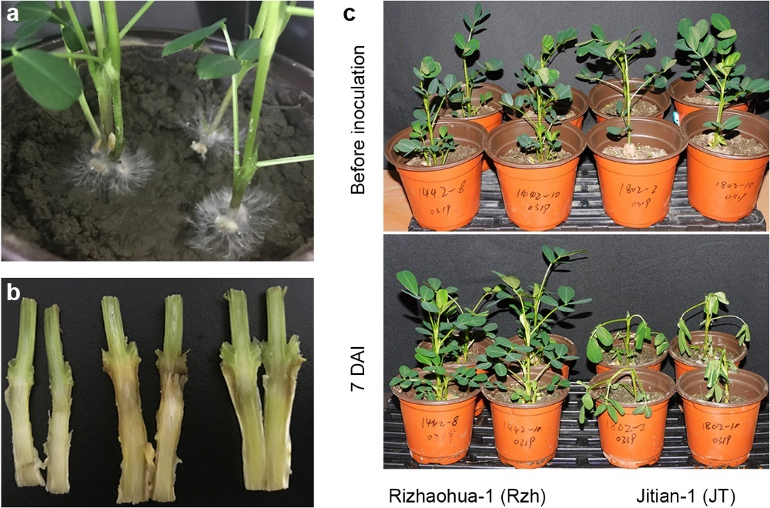
Figure S1. S. rolfsii inoculation, sample collection, and the peanut phenotype before and after inoculation. a). S. rolfsii inoculation on peanut base using infected oats. b). Peanut stems at the infection part were collected for total RNA extraction. c). The phenotype of peanut before and 7 days after inoculation. DAI, days after inoculation.
Figure S2. The annotation distribution of the total sRNA in each sample.

