Appendix Figures
Figure S1. Flow chart of sample restrictions

12,427 participants
2,214 with less than two rounds of cognitive impairment
4,892 participants
7,535 without diagnosis of cognitive impairment
Exclude individuals with less than three-round data for assessment-based physical functioning (737 obs) and individuals with less than three-round data for general health status (357 obs)
2,378 participants
1,641 participants with physical functioning and 2,021 participants with general health status
300 with less than three rounds of data
2,678 participants

Figure S2. Baseline distributions of physical functioning and general health status
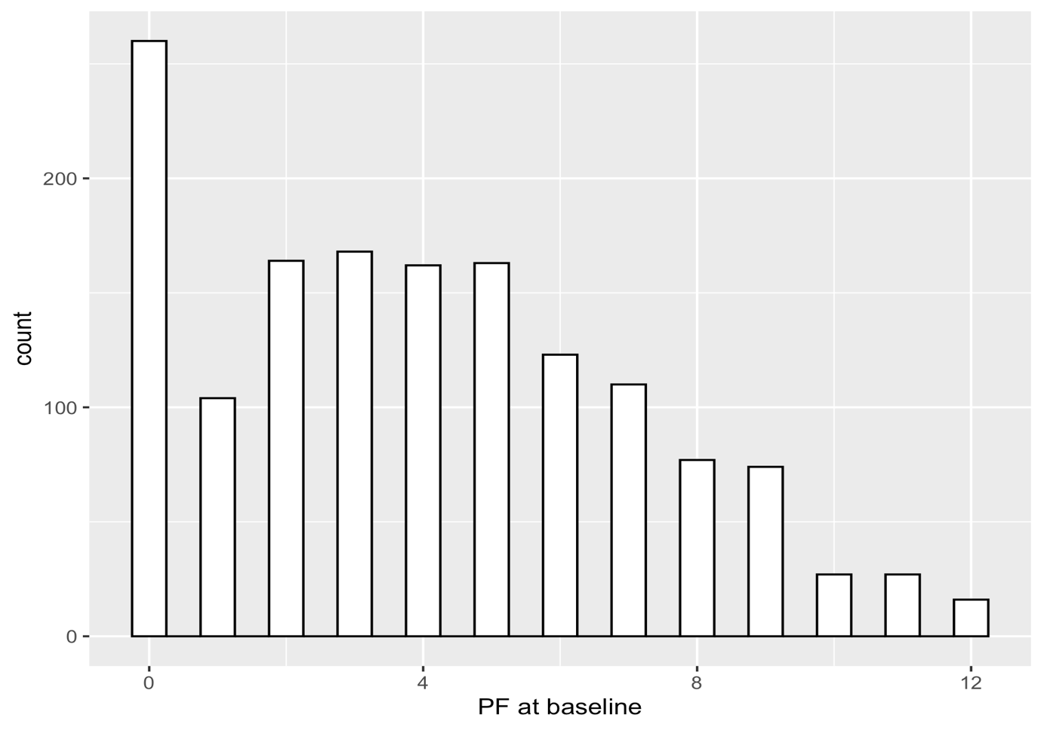
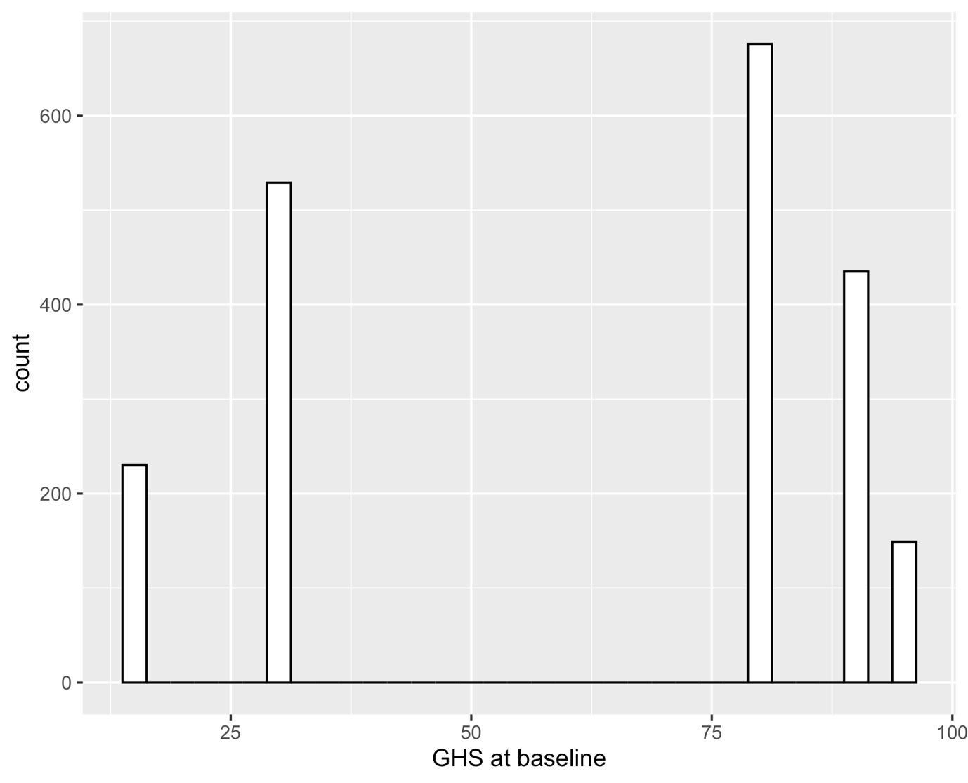

Appendix Tables

Table S1. Model selection of assessment-based physical functioning and general health status trajectories models

Health outcomes |  | Functional form |  |  |  |  |  | Log likelihood | BIC
PH | Group 1 |  | Group 2 | Group 3 | Group 4 | Group 5 | Group 6
 | 1 |  | 1 |  |  |  |  | -15894.38 | -15912.89
 | 1 |  | 1 | 2 |  |  |  | -14957.00 | -14990.32
 | 1 |  | 1 | 1 | 1 |  |  | -14635.20 | -14675.92
 | 1 |  | 1 | 1 | 2 | 1 |  | -14547.16 | -14614.05
 | 1 |  | 2 | 2 | 1 | 2 | 1 | -14397.85 | -14488.50
GHS | 1 |  | 1 |  |  |  |  | -40678.69 | -40651.10
 | 1 |  | 1 | 1 |  |  |  | -40480.94 | -40522.32
 | 1 |  | 2 | 2 | 1 |  |  | -40329.25 | -40393.61
 | 1 |  | 2 | 2 | 1 | 1 |  | -40310.22 | -40388.38
 | 1 |  | 2 | 2 | 2 | 1 | 1 | -40237.26 | -40333.81
Source: National Health and Aging Trends Study (NHATS), 2011-2018
Notes: BIC = log(L)-0.5*log(n)*k. The numbers 1, 2 and 3 for a certain group indicate whether the functional form of the health trajectory is linear, quadratic or cubic; All combinations of linear, quadratic, and cubic functional forms were tested. Due to page limits, we only report the best fitted model for each number of groups here. A BIC closer to 0 or a larger log likelihood indicates a better fit. For GHS, although 5 and 6 groups have better BICs, we chose 4 groups as the best model because some groups were not well-populated (i.e., with below 2% individuals) when we had 5 or 6 groups.

Table S2. Assessment-based physical functioning and general health status model diagnosis
Group | Mean posterior probabilities (AvePP) | Median posterior probabilities | Actual group size (%) | Predicted group size (%) | Odds of correct classification (OCC)
PH
1 | 0.86 | 0.93 | 8.39% | 7.27% | 68.81
2 | 0.78 | 0.79 | 22.22% | 22.30% | 12.21
3 | 0.78 | 0.80 | 27.66% | 28.21% | 9.28
4 | 0.68 | 0.68 | 6.03% | 6.34% | 32.66
5 | 0.82 | 0.88 | 22.01% | 21.51% | 16.64
6 | 0.91 | 0.98 | 13.68% | 14.26% | 65.46
GHS
1 | 0.92 | 0.99 | 44.79% | 45.37% | 14.19
2 | 0.77 | 0.79 | 18.82% | 19.45% | 14.14
3 | 0.77 | 0.80 | 14.05% | 12.96% | 20.73
4 | 0.90 | 0.96 | 22.33% | 22.22% | 31.99
Notes: OCC = [AvePP/(1 - AvePP)]/[$\hat{π}/(1-\hat{π})$], $\hat{π}$ is the estimated posterior probability. An AvePP greater than 0.7 and an OCC greater than 5 are indicative of good model fit. Median posterior probabilities are an alternative statistic to AvePP. Actual group size and predicted group size indicate the observed and precited percentages of individuals in the sample belonging to each latent group. Following previous studies, each latent group should have at least 2% of individuals.

Table S3. Risk factors of physical functioning trajectories for physical functioning (Odds Ratios and 95% Confidence Interval), without multiple imputation
 | Model 1 | Model 2
Group membership (Ref. Group 1)
Group 2 | 5.04** | 4.20**
 | (1.98, 12.82) | (1.59, 11.14)
Group 3 | 8.73*** | 6.49***
 | (3.49, 21.87) | (2.46, 17.13)
Group 4 | 28.88*** | 25.11***
 | (10.90, 76.50) | (8.52, 74.00)
Group 5 | 14.84*** | 11.29***
 | (5.91, 37.25) | (4.21, 30.22)
Group 6 | 21.48*** | 17.85***
 | (8.47, 54.50) | (6.49, 49.10)
Female |  | 0.57**
 |  | (0.40, 0.79)
Age |  | 1.09
 |  | (0.75, 1.58)
Age squared |  | 1.00
 |  | (1.00, 1.00)
Race/Ethnicity (Ref. White)
Black |  | 0.68*
 |  | (0.48, 0.96)
Other |  | 0.73
 |  | (0.33, 1.61)
Hispanic |  | 0.65
 |  | (0.38, 1.10)
Educational attainment (Ref. < High school)
High school |  | 1.25
 |  | (0.87, 1.80)
> High school |  | 1.33
 |  | (0.93, 1.89)
# of siblings (Ref. 0)
1-3 |  | 1.07
 |  | (0.77, 1.48)
4+ |  | 0.75
 |  | (0.49, 1.15)
# of children (Ref. 0)
1-3 |  | 1.33
 |  | (0.77, 2.31)
4+ |  | 1.07
 |  | (0.61, 1.89)
Medicare |  | 1.04
 |  | (0.78, 1.40)
Medicaid |  | 0.96
 |  | (0.67, 1.37)
Tricare |  | 1.59
 |  | (0.84, 3.03)
Comorbidity (Ref. 0)
1-3 |  | 1.04
 |  | (0.61, 1.77)
4+ |  | 1.44
 |  | (0.81, 2.55)
Marital status (Ref. Never married)
Married/live with a partner |  | 1.01
 |  | (0.44, 2.31)
Separated, divorced, widowed |  | 0.94
 |  | (0.42, 2.10)
Smoke regularly |  | 1.36*
 |  | (1.01, 1.82)
MCI |  | 0.59***
 |  | (0.44, 0.79)
Note: * p<0.05; ** p<0.01; *** p<0.001. N=1,164. Odds Ratios were reported.
Table S4. Risk factors of general health status trajectories (Odds Ratios and 95% Confidence Interval), without multiple imputation
 | Model 1 | Model 2
Group membership (Ref. Group 1)
Group 2 | 1.79*** | 2.39***
 | (1.40, 2.30) | (1.71, 3.34)
Group 3 | 1.19 | 1.66*
 | (0.88, 1.61) | (1.13, 2.44)
Group 4 | 1.74*** | 2.92***
 | (1.37, 2.20) | (2.06, 4.15)
Female |  | 0.84
 |  | (0.63, 1.13)
Age |  | 1.10
 |  | (0.79, 1.53)
Age squared |  | 1.00
 |  | (1.00, 1.00)
Race/Ethnicity (Ref. White)
Black |  | 0.73*
 |  | (0.53, 0.99)
Other |  | 0.51
 |  | (0.25, 1.05)
Hispanic |  | 0.56*
 |  | (0.35, 0.91)
Educational attainment (Ref. < High school)
High school |  | 1.19
 |  | (0.86, 1.66)
> High school |  | 1.30
 |  | (0.95, 1.79)
# of siblings (Ref. 0)
1-3 |  | 1.06
 |  | (0.79, 1.41)
4+ |  | 0.72
 |  | (0.49, 1.05)
# of children (Ref. 0)
1-3 |  | 0.95
 |  | (0.61, 1.49)
4+ |  | 0.81
 |  | (0.50, 1.29)
Medicare |  | 0.99
 |  | (0.76, 1.29)
Medicaid |  | 1.00
 |  | (0.72, 1.38)
Tricare |  | 1.26
 |  | (0.69, 2.30)
Comorbidity (Ref. 0)
1-3 |  | 1.26
 |  | (0.78, 2.03)
4+ |  | 1.58
 |  | (0.94, 2.65)
Marital status (Ref. Never married)
Married/live with a partner |  | 1.02
 |  | (0.53, 1.97)
Separated, divorced, widowed |  | 0.87
 |  | (0.46, 1.66)
Smoke regularly |  | 1.54**
 |  | (1.19, 1.99)
Self-report |  | 0.52**
 |  | (0.36, 0.75)
MCI |  | 0.57***
 |  | (0.44, 0.75)
Note: * p<0.05; ** p<0.01; *** p<0.001. N = 1,393. Reference group is Group 1 (High start, slight decrease.
Table S5. Group-based assessment-based trajectory model of physical functioning
Group | Parameter | Estimate | Standard Error | T for H0:  Parameter=0 | Prob>|T|
1 | Intercept | 2.24 | 0.03 | 75.39 | 0.00
 | Linear | -0.02 | 0.01 | -2.47 | 0.01
2 | Intercept | 1.89 | 0.04 | 43.33 | 0.00
 | Linear | -0.00 | 0.02 | -0.10 | 0.92
 | Quadratic | -0.01 | 0.00 | -2.41 | 0.02
3 | Intercept | 1.61 | 0.04 | 42.74 | 0.00
 | Linear | -0.11 | 0.01 | -10.23 | 0.00
4 | Intercept | -0.76 | 1.00 | -0.76 | 0.45
 | Linear | 3.08 | 1.48 | 2.08 | 0.04
 | Quadratic | -1.22 | 0.48 | -2.53 | 0.01
5 | Intercept | 0.84 | 0.10 | 8.74 | 0.00
 | Linear | -0.09 | 0.06 | -1.44 | 0.15
 | Quadratic | -0.02 | 0.01 | -2.06 | 0.04
6 | Intercept | -1.32 | 0.35 | -3.78 | 0.00
 | Linear | -0.50 | 0.14 | -3.54 | 0.00

Table S6. Baseline sample characteristics by trajectory group of physical functioning
 | High start, moderate decrease | High-medium start, moderate decrease | Medium start, moderate decrease | Medium-low start, early fast decrease | Medium-low start, moderate decrease | Low start, stable
Female | 36.07% | 47.96% | 59.35% | 59.05% | 69.69% | 76.50%
Age | 73.98 (5.75) | 78.41 (6.82) | 80.86 (6.66) | 82.68 (8.11) | 83.04 (7.39) | 83.48 (7.80)
Race/Ethnicity
White | 63.93% | 56.16% | 58.15% | 58.82% | 56.07% | 44.93%
Black | 20.49% | 28.49% | 28.41% | 26.47% | 29.77% | 42.29%
Other | 9.84% | 3.56% | 3.08% | 3.92% | 3.75% | 3.96%
Hispanic | 5.74% | 11.78% | 10.35% | 10.78% | 10.40% | 8.81%
Educational attainment
< high school | 21.49% | 36.26% | 44.81% | 37.50% | 48.41% | 46.61%
High school | 19.01% | 30.22% | 24.72% | 29.81% | 22.61% | 22.62%
> high school | 59.50% | 33.52% | 30.46% | 32.69% | 28.99% | 30.77%
Number of siblings
0 | 12.40% | 21.15% | 27.95% | 35.24% | 27.56% | 31.88%
1-3 | 58.68% | 50.00% | 54.37% | 46.67% | 51.70% | 48.03%
4+ | 28.93% | 28.85% | 17.69% | 18.10% | 20.74% | 20.09%
Number of children
0 | 9.84% | 6.54% | 8.26% | 8.57% | 9.63% | 11.54%
1-3 | 59.84% | 53.68% | 53.48% | 53.33% | 55.52% | 48.29%
4+ | 30.33% | 39.78% | 38.26% | 38.10% | 34.84% | 40.17%
Medicare drug coverage | 66.94% | 68.97% | 71.23% | 63.54% | 67.31% | 69.34%
Medicaid | 21.49% | 22.56% | 26.92% | 25.25% | 30.42% | 41.86%
Tricare | 8.26% | 6.08% | 4.46% | 5.94% | 4.09% | 3.17%
Number of Comorbidities
0 | 15.70% | 12.43% | 7.05% | 11.88% | 4.93% | 3.07%
1-3 | 71.90% | 68.78% | 65.42% | 53.47% | 57.97% | 6.87%
4+ | 12.40% | 18.78% | 27.53% | 34.65% | 37.10% | 36.40%
Marital status
Never married | 4.96% | 3.55% | 4.13% | 4.76% | 5.95% | 6.87%
Married/live with a partner | 63.64% | 47.54% | 36.96% | 39.05% | 30.59% | 28.76%
Separated, divorced, widowed | 31.40% | 48.91% | 58.91% | 56.19% | 63.46% | 64.38%
Vigorous activity | 50.00% | 29.43% | 24.84% | 19.05% | 14.73% | 8.58%
Smoking regularly | 44.90% | 51.34% | 47.62% | 48.75% | 37.83% | 34.41%
MCI | 63.11% | 57.22% | 42.61% | 20.00% | 35.13% | 14.10%
Sample size | 122 | 367 | 460 | 105 | 353 | 234
Note: Mean (SD) for continuous variables and % for categorical variables.

Table S7. Group-based assessment-based trajectory model of general health status
Group | Parameter | Estimate | Standard Error | T for H0:  Parameter=0 | Prob>|T|
1 | Intercept | 86.83 | 0.85 | 101.64 | 0.00
 | Linear | -0.85 | 0.21 | -3.97 | 0.00
2 | Intercept | 102.13 | 3.31 | 30.84 | 0.00
 | Linear | -26.72 | 2.27 | -11.77 | 0.00
 | Quadratic | 2.70 | 0.30 | 9.09 | 0.00
3 | Intercept | 13.34 | 3.88 | 3.44 | 0.00
 | Linear | 23.83 | 2.08 | 11.44 | 0.00
 | Quadratic | -2.53 | 0.25 | -10.29 | 0.00
4 | Intercept | 22.17 | 1.39 | 15.94 | 0.00
 | Linear | 0.53 | 0.36 | 1.46 | 0.14

Table S8. Baseline sample characteristics by trajectory group of general health status
 | High start, slight decrease | High start, convex | Low start, concave | Low start, slight increase
Female | 61.94% | 58.02% | 59.92% | 57.91%
Age | 81.61 (7.66) | 81.64 (7.82) | 80.20 (7.16) | 79.86 (7.34)
Race/Ethnicity
White | 65.67% | 54.38% | 46.92% | 42.76%
Black | 25.36% | 29.64% | 36.54% | 36.32%
Other | 3.65% | 3.09% | 5.77% | 4.37%
Hispanic | 5.32% | 12.89% | 10.77% | 16.55%
Educational attainment
< high school | 31.62% | 41.86% | 55.00% | 60.69%
High school | 26.70% | 25.32% | 27.31% | 18.62%
> high school | 41.68% | 32.82% | 17.69% | 20.69%
Number of siblings
0 | 26.84% | 29.56% | 25.48% | 22.92%
1-3 | 54.90% | 50.90% | 46.33% | 49.44%
4+ | 18.26% | 19.54% | 28.19% | 27.64%
Number of children
0 | 10.58% | 8.14% | 10.31% | 8.46%
1-3 | 54.42% | 57.00% | 52.67% | 49.44%
4+ | 35.01% | 34.86% | 37.02% | 42.09%
Medicare drug coverage | 68.70% | 66.85% | 70.33% | 72.20%
Medicaid | 20.46% | 28.38% | 30.04% | 40.28%
Tricare | 5.62% | 3.90% | 3.50% | 3.26%
Number of Comorbidities
0 | 11.50% | 9.69% | 3.11% | 2.96%
1-3 | 73.01% | 62.30% | 59.14% | 48.06%
4+ | 15.49% | 28.01% | 37.74% | 48.97%
Marital status
Never married | 5.24% | 4.62% | 6.11% | 5.35%
Married/live with a partner | 37.99% | 36.67% | 38.55% | 38.31%
Separated, divorced, widowed | 56.77% | 58.72% | 55.34% | 56.35%
Vigorous activity | 28.93% | 21.74% | 16.03% | 12.03%
Smoking regularly | 43.29% | 44.92% | 44.29% | 51.99%
MCI | 43.84% | 33.84% | 35.88% | 34.08%
Sample size | 917 | 393 | 262 | 449
Note: Mean (SD) for continuous variables and % for categorical variables.

Table S9. Comparison of the samples before and after excluding individuals with at least three rounds of data for physical functioning and general health status
 | Physical functioning | General health status
Female | 0.01 | -0.09
 | (-0.26, 0.28) | (-0.45, 0.26)
Age | 0.11 | 0.27
 | (-0.17, 0.40) | (-0.11, 0.68)
Age squared | -0.00 | -0.00
 | (-0.00, 0.00) | (-0.00, 0.00)
Race/Ethnicity (Ref. White)
Black | -0.02 | -0.02
 | (-0.31, 0.26) | (-0.39, 0.34)
Other | -0.71 | -0.98
 | (-1.58, 0.04) | (-2.43, 0.10)
Hispanic | -0.24 | -0.61
 | (-0.71, 0.21) | (-1.35, 0.05)
Educational attainment (Ref. < High school)
High school | -0.32* | -0.02
 | (-0.62, -0.02) | (-0.40, 0.36)
> High school | -0.41** | -0.21
 | (-0.70, -0.13) | (-0.58, 0.15)
# siblings (Ref. 0)
1-3 | -0.13 | -0.21
 | (-0.39, 0.14) | (-0.53, 0.11)
4+ | -0.25 | -0.58*
 | (-0.60, 0.11) | (-1.09, 0.10)
# children (Ref. 0)
1-3 | -0.21 | 0.21
 | (-0.61, 0.20) | (-0.33, 0.79)
4+ | -0.45* | -0.14
 | (-0.88, -0.02) | (-0.71, 0.46)
Medicare drug coverage | -0.31* | -0.38*
 | (-0.56, -0.05) | (-0.72, -0.05)
Medicaid | 0.24 | 0.00
 | (-0.06, 0.54) | (-0.38, 0.40)
Tricare | 0.25 | -0.29
 | (-0.06, 0.54) | (-0.99, 0.51)
Comorbidity (Ref. 0)
1-3 | 0.38 | 0.49
 | (-0.09, 0.88) | (-0.16, 1.25)
4+ | 0.53* | 0.80*
 | (0.04, 1.06) | (0.12, 1.57)
Marital status (Ref. Never married)
Married/live with a partner | -0.49 | -0.08
 | (-1.07, 0.11) | (-0.90, 0.82)
Separated, divorced, widowed | -0.47 | -0.09
 | (-1.04, 0.10) | (-0.87, 0.79)
Smoking regularly | -0.21 | -0.17
 | (-0.45, 0.03) | (-0.48, 0.13)
MCI | -0.78*** | -1.09***
 | (-1.04, -0.53) | (-1.47, -0.72)
Note: * p<0.05; ** p<0.01; *** p<0.001. N = 1,634. Because of missing control variables, two models have the same sample sizes.

