Supplementary material

Nitrogen and carbon stable isotope ratios analysis sheds light on trophic competition between two syntopic land iguana species from Galápagos
Marco Gargano¹, Giuliano Colosimo^{2,*}, Paolo Gratton², Silvio Marta³, Mauro Brilli⁴, Francesca Giustini⁴, Christian Sevilla⁵ & Gabriele Gentile²

¹PhD Program in Evolutionary Biology and Ecology, Department of Biology, University
of Rome Tor Vergata
²Department of Biology, University of Rome Tor Vergata, Via della ricerca scientifica, snc - 00133 Rome, Italy
³Department of Environmental Science and Policy, Università degli Studi di Milano, via Celoria 10, 20133 Milano, Italy
⁴Italian National Research Council, Institute of Environmental Geology and Geoengineering IGAG - CNR, Area della Ricerca di Roma1, Via Salaria km 29.300, I-00015 Monterotondo Stazione, Rome, Italy
⁵Galápagos National Park Directorate, Av. Charles Darwin - 200102 Puerto Ayora, Is. Santa Cruz, Galápagos, Ecuador

*Corresponding author: Giuliano Colosimo, giuliano.colosimo@uniroma2.it

ORCID:
Marco Gargano: 0000-0003-0073-9094
Giuliano Colosimo: 0000-0002-0485-9758
Paolo Gratton: 0000-0001-8464-4062
Silvio Marta: 0000-0001-8850-610X
Gabriele Gentile: 0000-0002-1045-6816
Mauro Brilli: 0000-0002-2536-5714
Francesca Giustini: 0000-0002-7159-469X
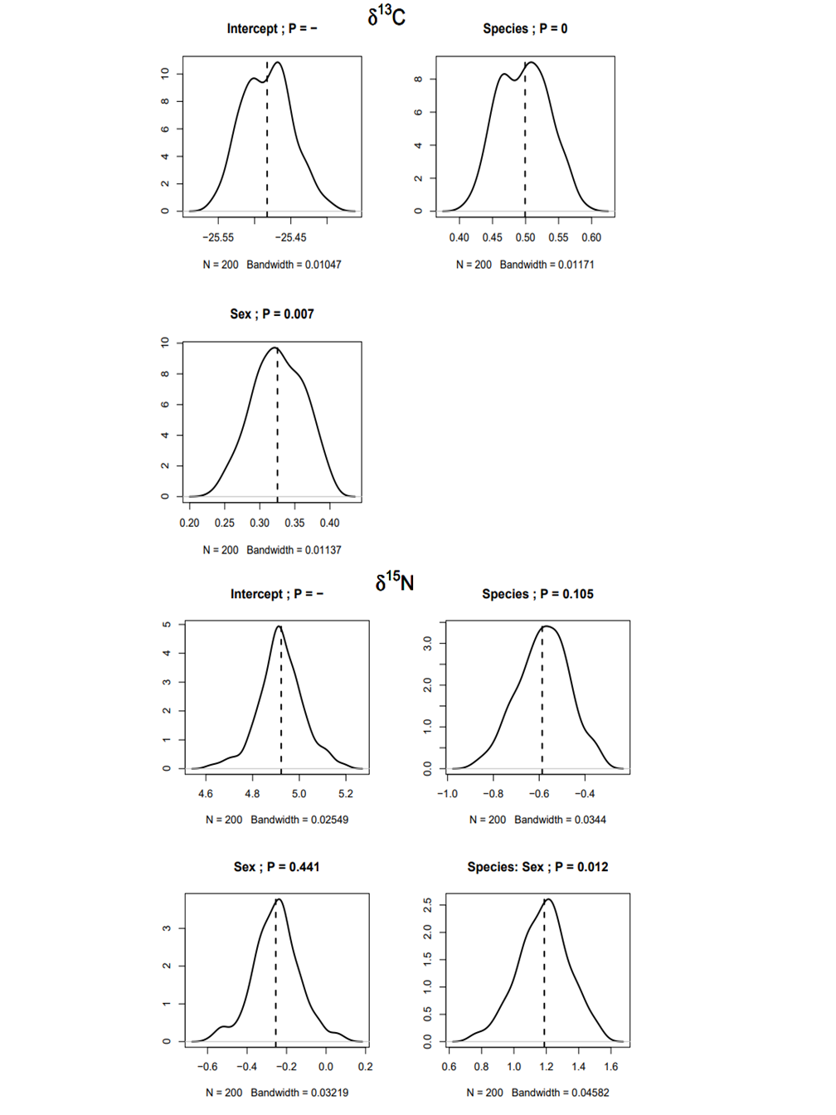

SM Figure 1 Result of stability procedure for bivariate linear model with δ¹³C and δ¹⁵N as response variables and species and sex as predictors. The figure shows the distribution of the coefficients obtained after re-fitting the model 200 times on random sub-samples with 90% of the data. Dashed line indicates the coefficient obtained with the full model. The title of each graph shows the variable considered and the corresponding P-value in the full model.
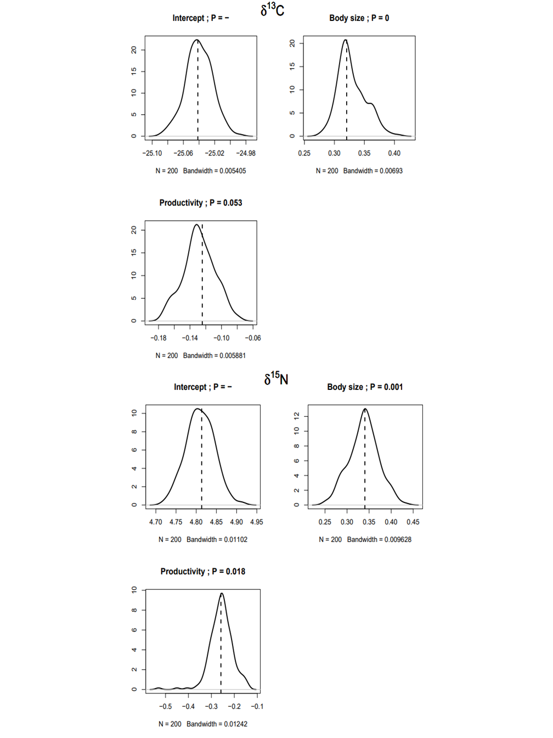
SM Figure 2 Result of stability procedure for generalized additive model with δ¹³C and δ¹⁵N as response variables and body size and productivity as predictors. The figure shows the distribution of the coefficients obtained after re-fitting the model 200 times on random sub-samples with 90% of the data. Dashed line indicates the coefficient obtained with the full model. The title of each graph shows the variable considered and the corresponding P-value in the full model.
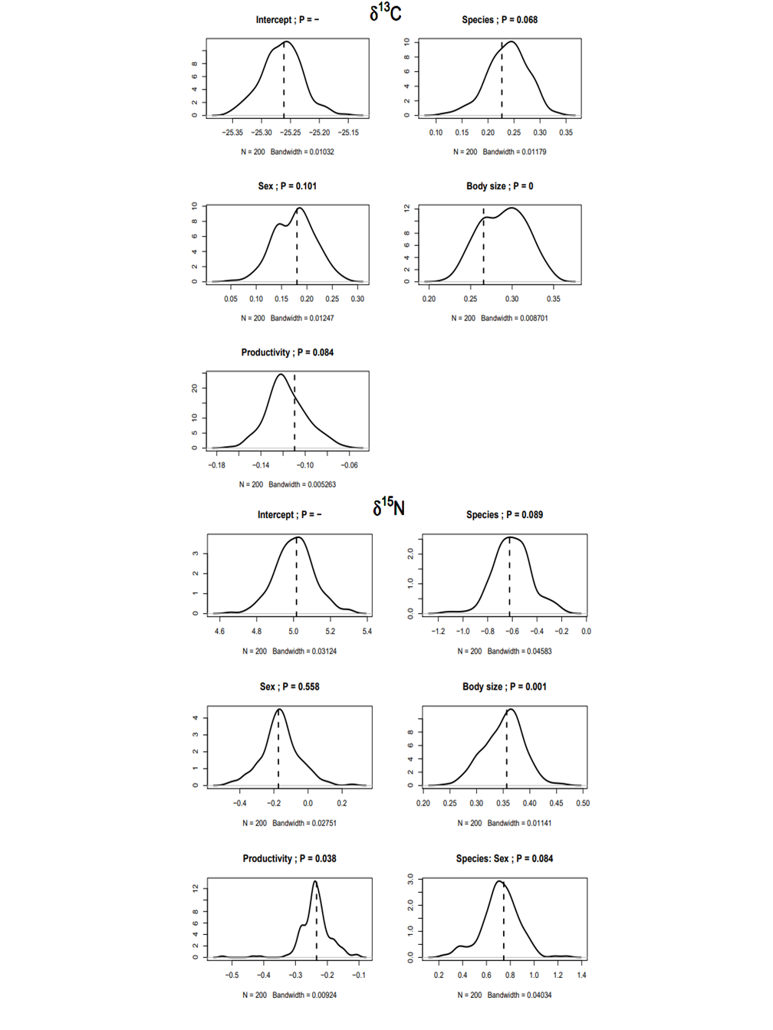

SM Figure 3 Result of stability procedure for generalized additive model with δ¹³C and δ¹⁵N as response variables and species, sex, body size and productivity as predictors. The figure shows the distribution of the coefficients obtained after re-fitting the model 200 times on random sub-samples with 90% of the data. Dashed line indicates the coefficient obtained with the full model. The title of each graph shows the variable considered and the corresponding P-value in the full model.

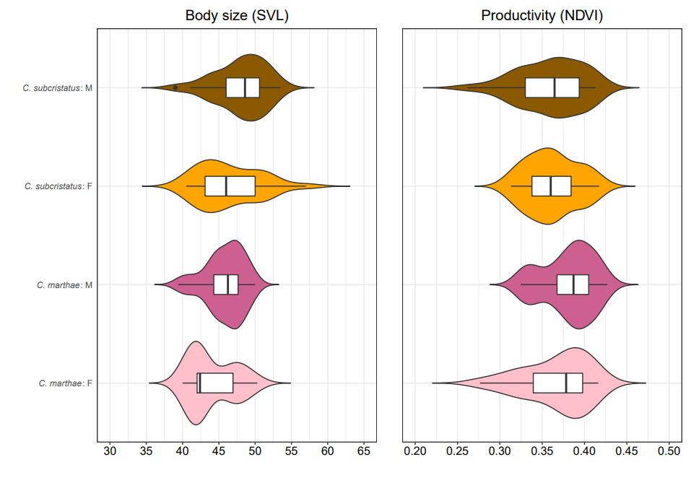

SM Figure 4 Violin plots for body size and productivity of the capture points between and within the species. This figure shows the differences in body size (expressed as snout-to-vent-length, SVL, in cm) and productivity of the capture points (expressed as Normalized Difference Vegetation Index, NDVI) between sex classes of each species (Conolophus subcristatus and Conolophus marthae).

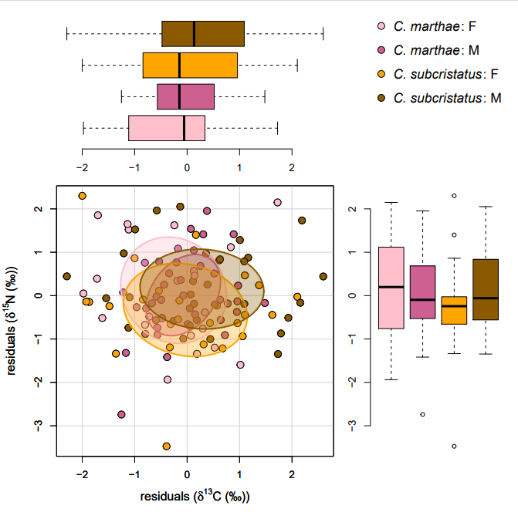
SM Figure 5 δ¹³C, δ¹⁵N residuals biplot illustrating the isotopic niche of C. subcristatus and C. marthae males and females after the effects of body size, productivity and space were removed. Each dot represents a single individual. Solid lines enclose standard ellipse areas with sample size correction (SEA_{c}). Marginal boxplots show the distribution of δ ¹³C and δ ¹⁵N residuals for each combination of sex and species. Color codes are shown in the top right corner.

