Thermal decomposition mechanisms of energetic CL-20-based co-crystals: quantum molecular dynamics simulation

Li Tang · Weihua Zhu¹

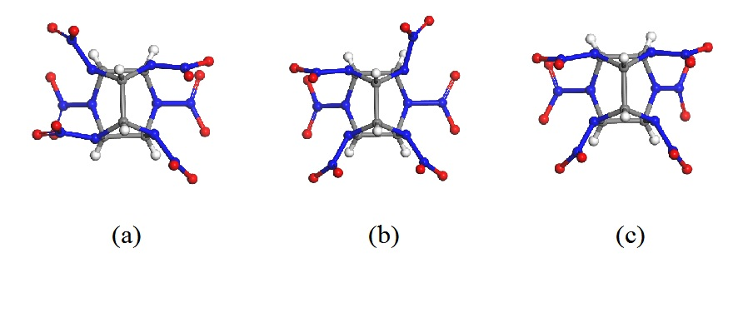
Fig. S1 Molecular conformations and crystal structures of (a) β-CL-20, (b) γ-CL-20 and (c) ε-CL-20

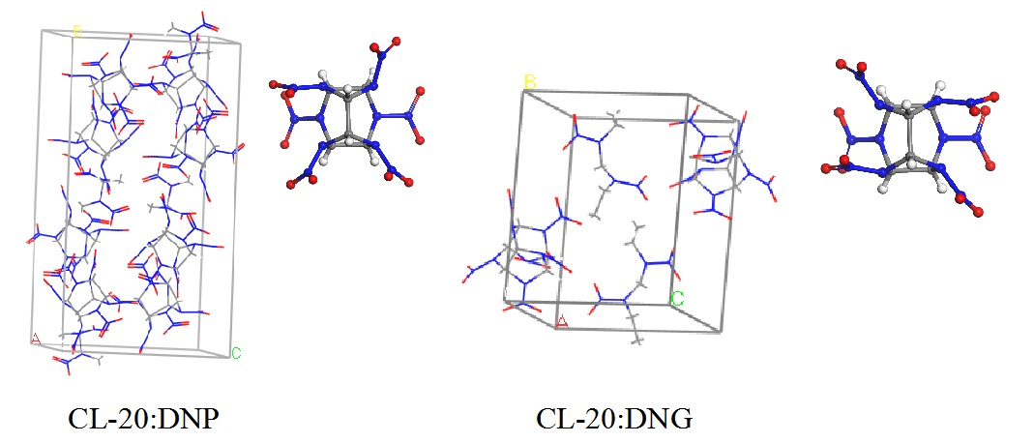
Fig. S2 Crystal structures and phases of CL-20 in CL-20:DNP and CL-20:DNG co-crystals

Table S1 Bond type and bond cutoff radius in the fragment analysis of the DFTB-MD trajectory
Bond type | Cutoff radius(Å) | Bond type | Cutoff radius(Å)
C−C | 2.31 | H−O | 1.50
C−H | 1.63 | H−N | 1.61
C−O | 2.15 | O−O | 2.22
C−N | 2.20 | O−N | 2.10
H−H | 1.11 | N−N | 2.17

Corresponding author: Wei-hua Zhu, zhuwh@njust.edu.cn Institute for Computation in Molecular and Materials Science, School of Chemistry and Chemical Engineering, Nanjing University of Science and Technology, Nanjing 210094, China

