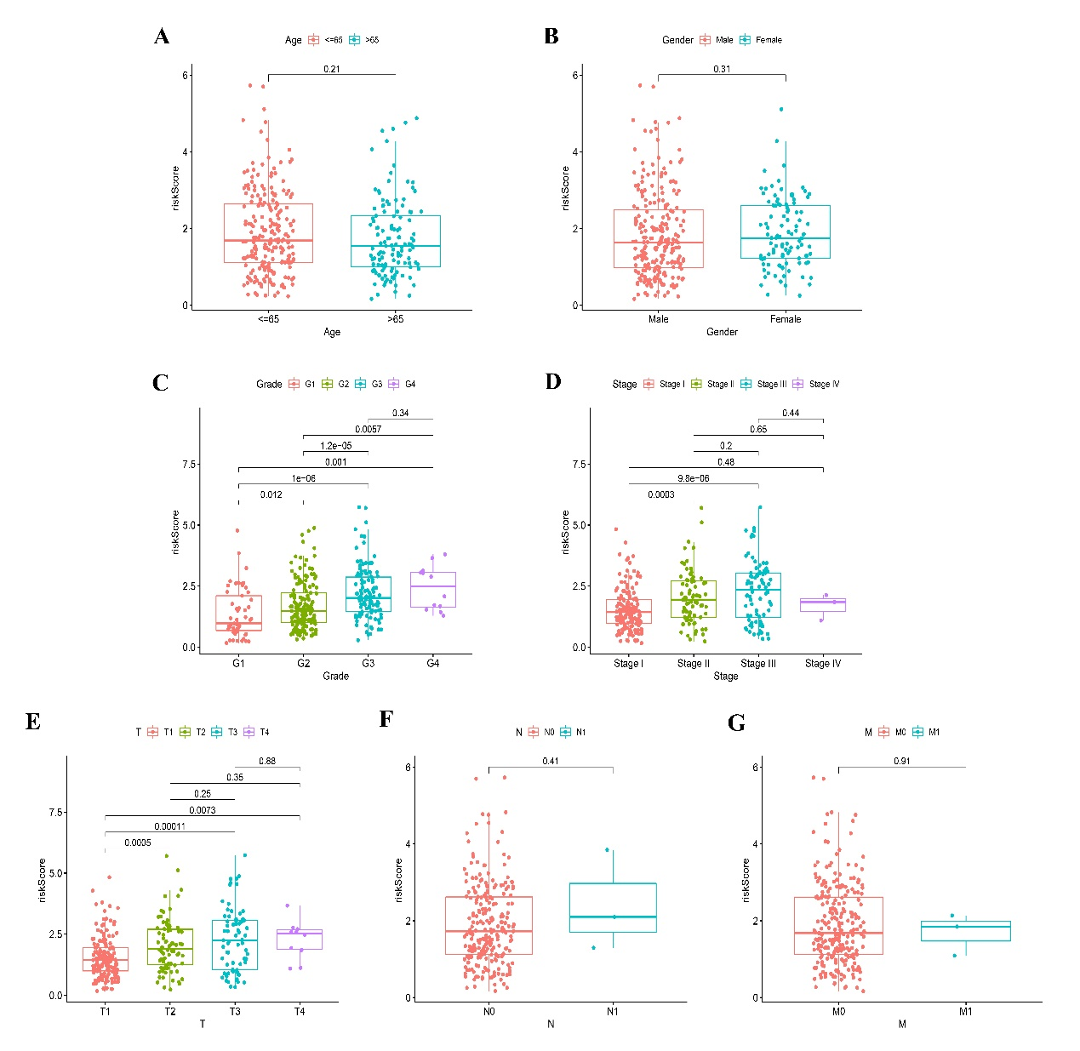
Figure S3 | The differences in risk scores across clinical features. (A) Age. (B) Gender. (C) Grade. (D) Stage. (E) T stage. (F) N stage. (G) M stage.

