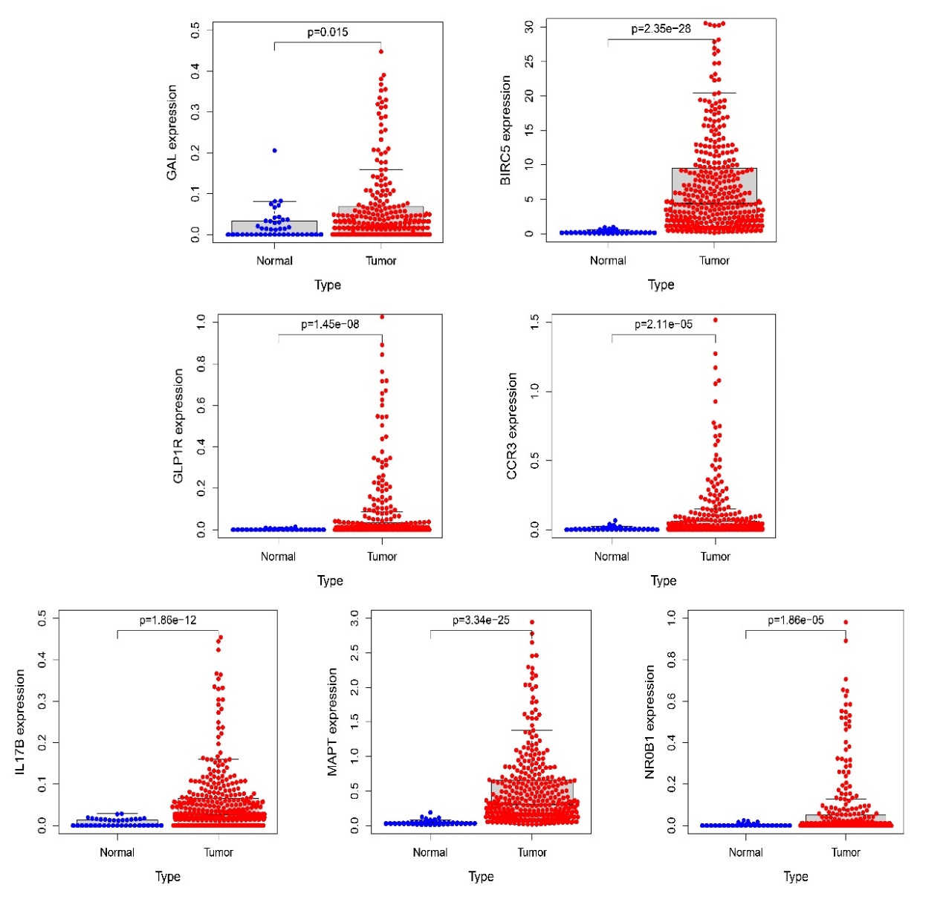
Figure S1 | The expression of seven IRSS genes between normal and tumor.

