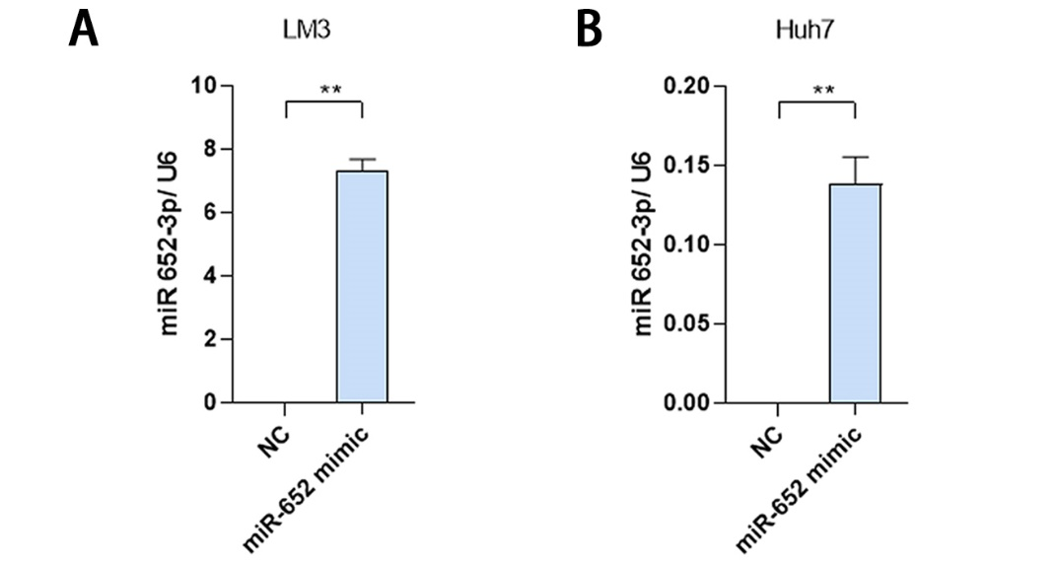
Figure S1. MiR-652-3p was overexpressed in HCC cells.
The expression level of miR-652-3p was significantly increased in HCC-LM3 (A) and Huh7 cells (B) after transfecting miR-652-3p mimics. **P <0.01.

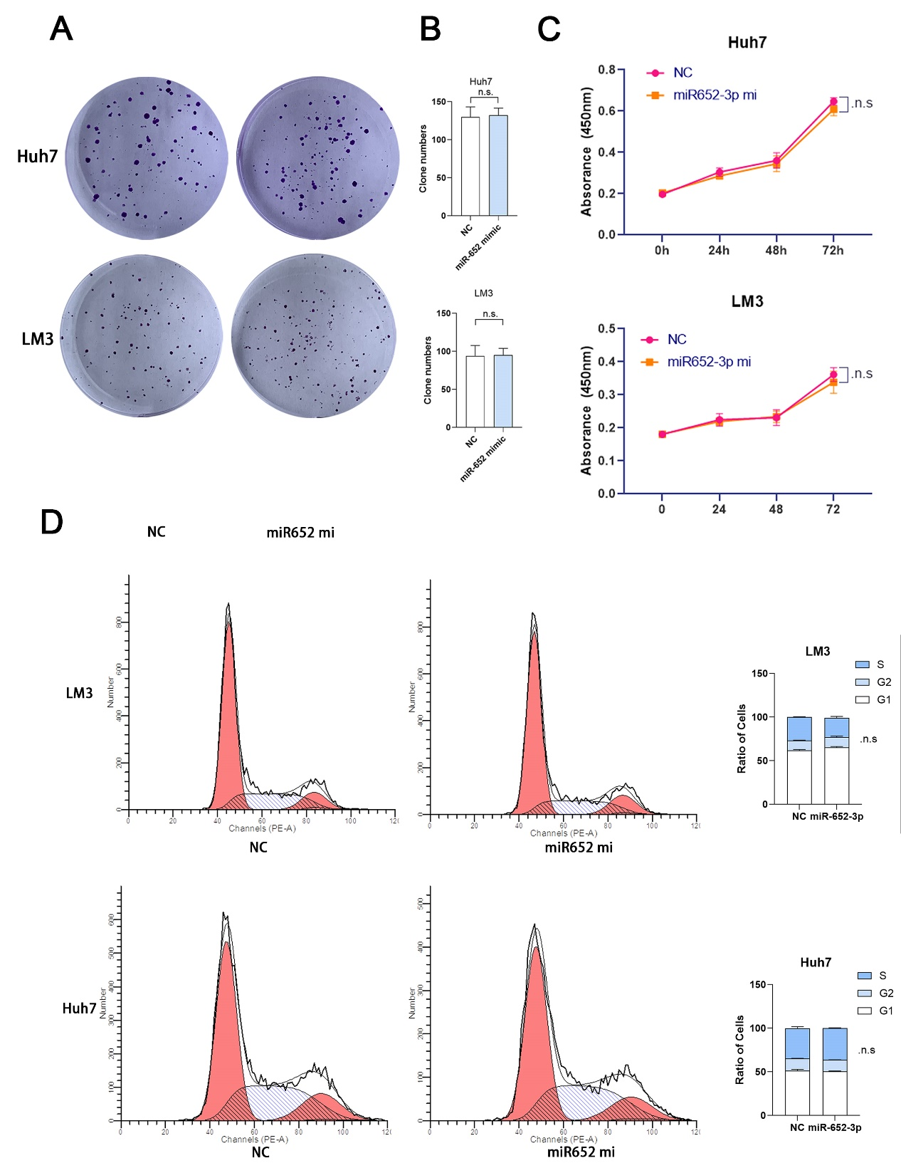
Figure S2. MiR-652-3p had no impact on proliferation ability in HCC cells.
The colony formation ability was compared between the miR-652-3p mimics group and NC group in Huh7 and LM3 cells (A, B). The results of the CCK8 assay in miR-652-3p mimics group and NC group in Huh7 and LM3 cells were shown (C). And there is no significant change in the results of the flow cytometry assay between the miR-652-3p mimics group and NC group in Huh7 and LM3 cells (D). n.s.: no significance.

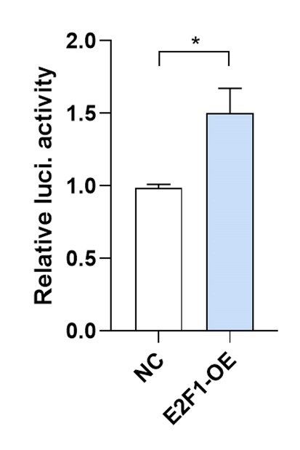
Figure S3. Transcription factor E2F1 promoted the expression of miR-652-3p in Huh7 cells.
Quantified data of relative luciferase activity in Huh7 cells after co-transfection of NC or overexpression plasmid and miR-652-promoter-luciferase plasmid was shown. *P <0.05.

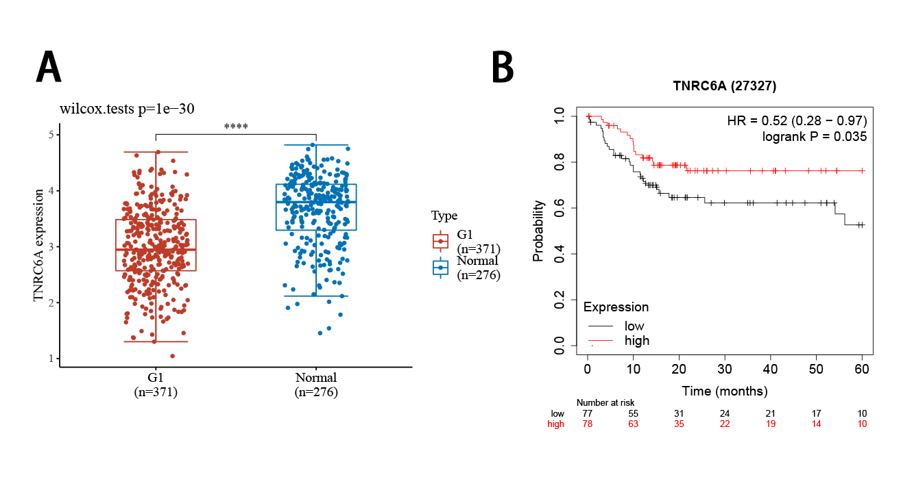
Figure S4. Low expression of TNRC6A was correlated with poor survival in Asian HCC patients.
From the results of TCGA data, low expression of TNRC6A was found in the tumor tissues of HCC patients (A). And the low expression of TNRC6A was correlated with poor overall survival rate in Asian HCC patients (B).

