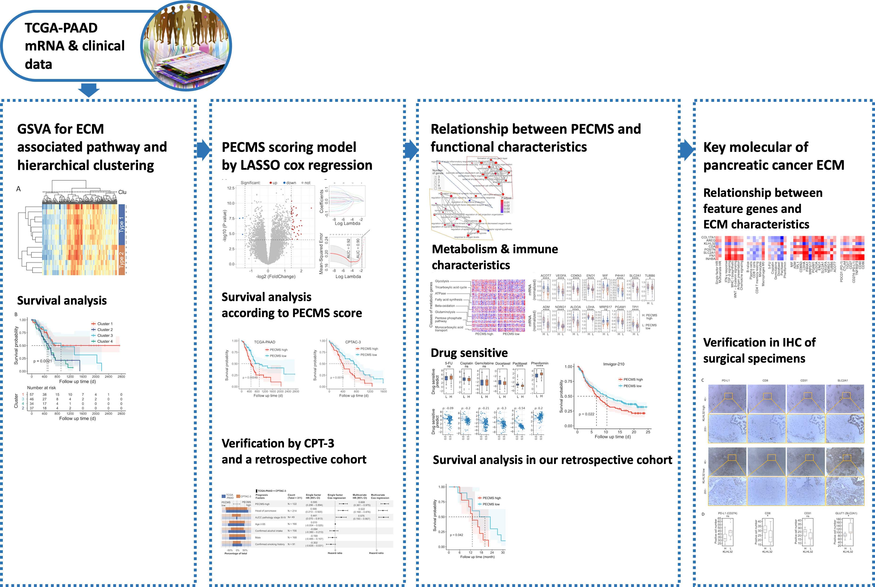
Supplementary Fig. S1 Flowchart of this study

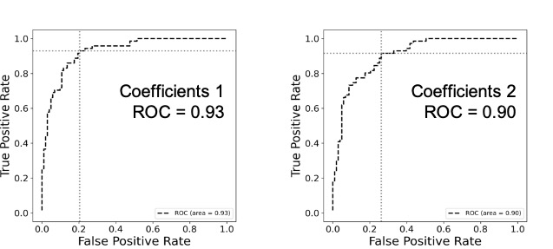
Supplementary Fig. S2 ROC curve of the Lasso model (Coefficient 1 was obtained at the minimum MSE, and coefficient 2 was obtained at 1 SE MSE. Cutoff values were obtained based on the Youden index)
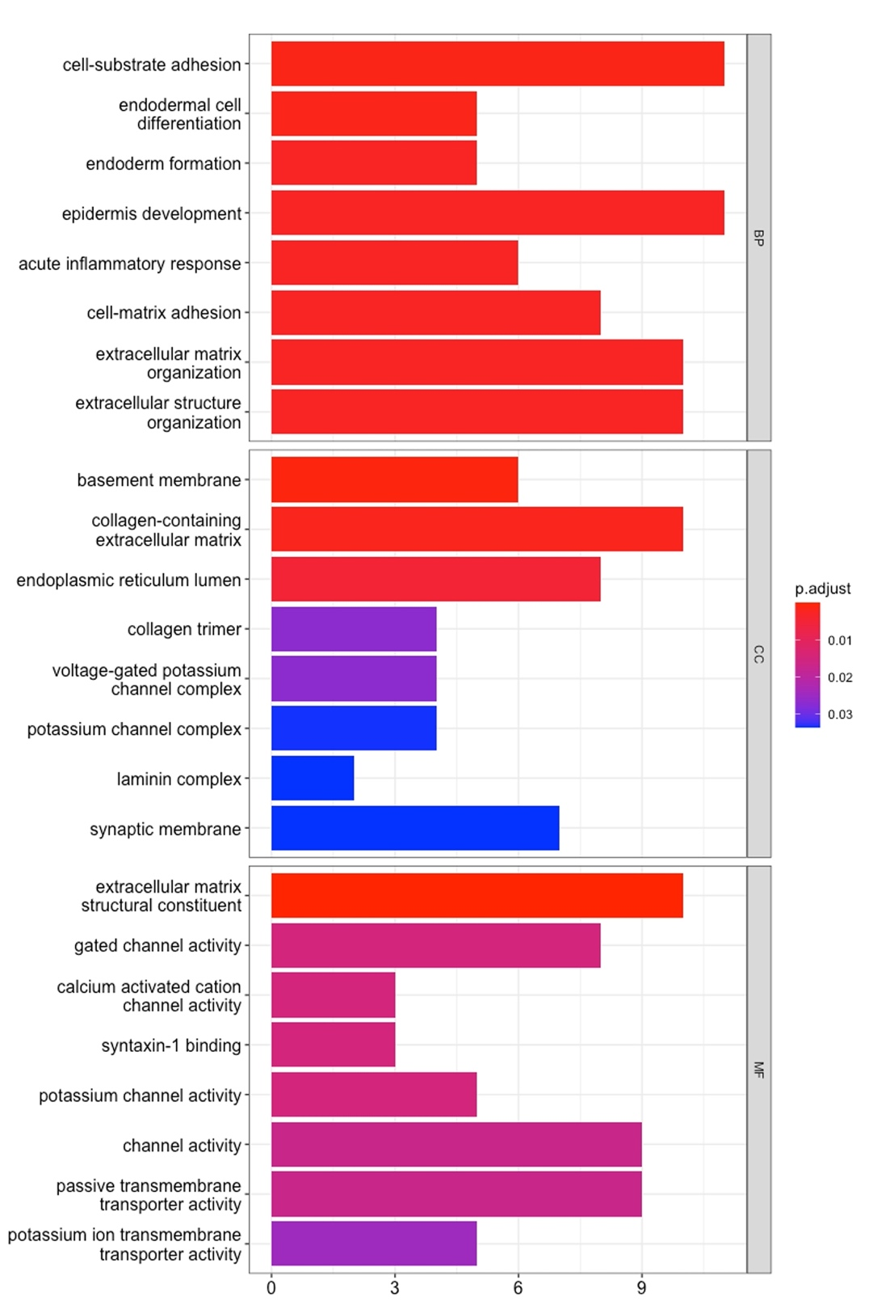
Supplementary Fig. S3 GO enrichment analysis between PECMS groups
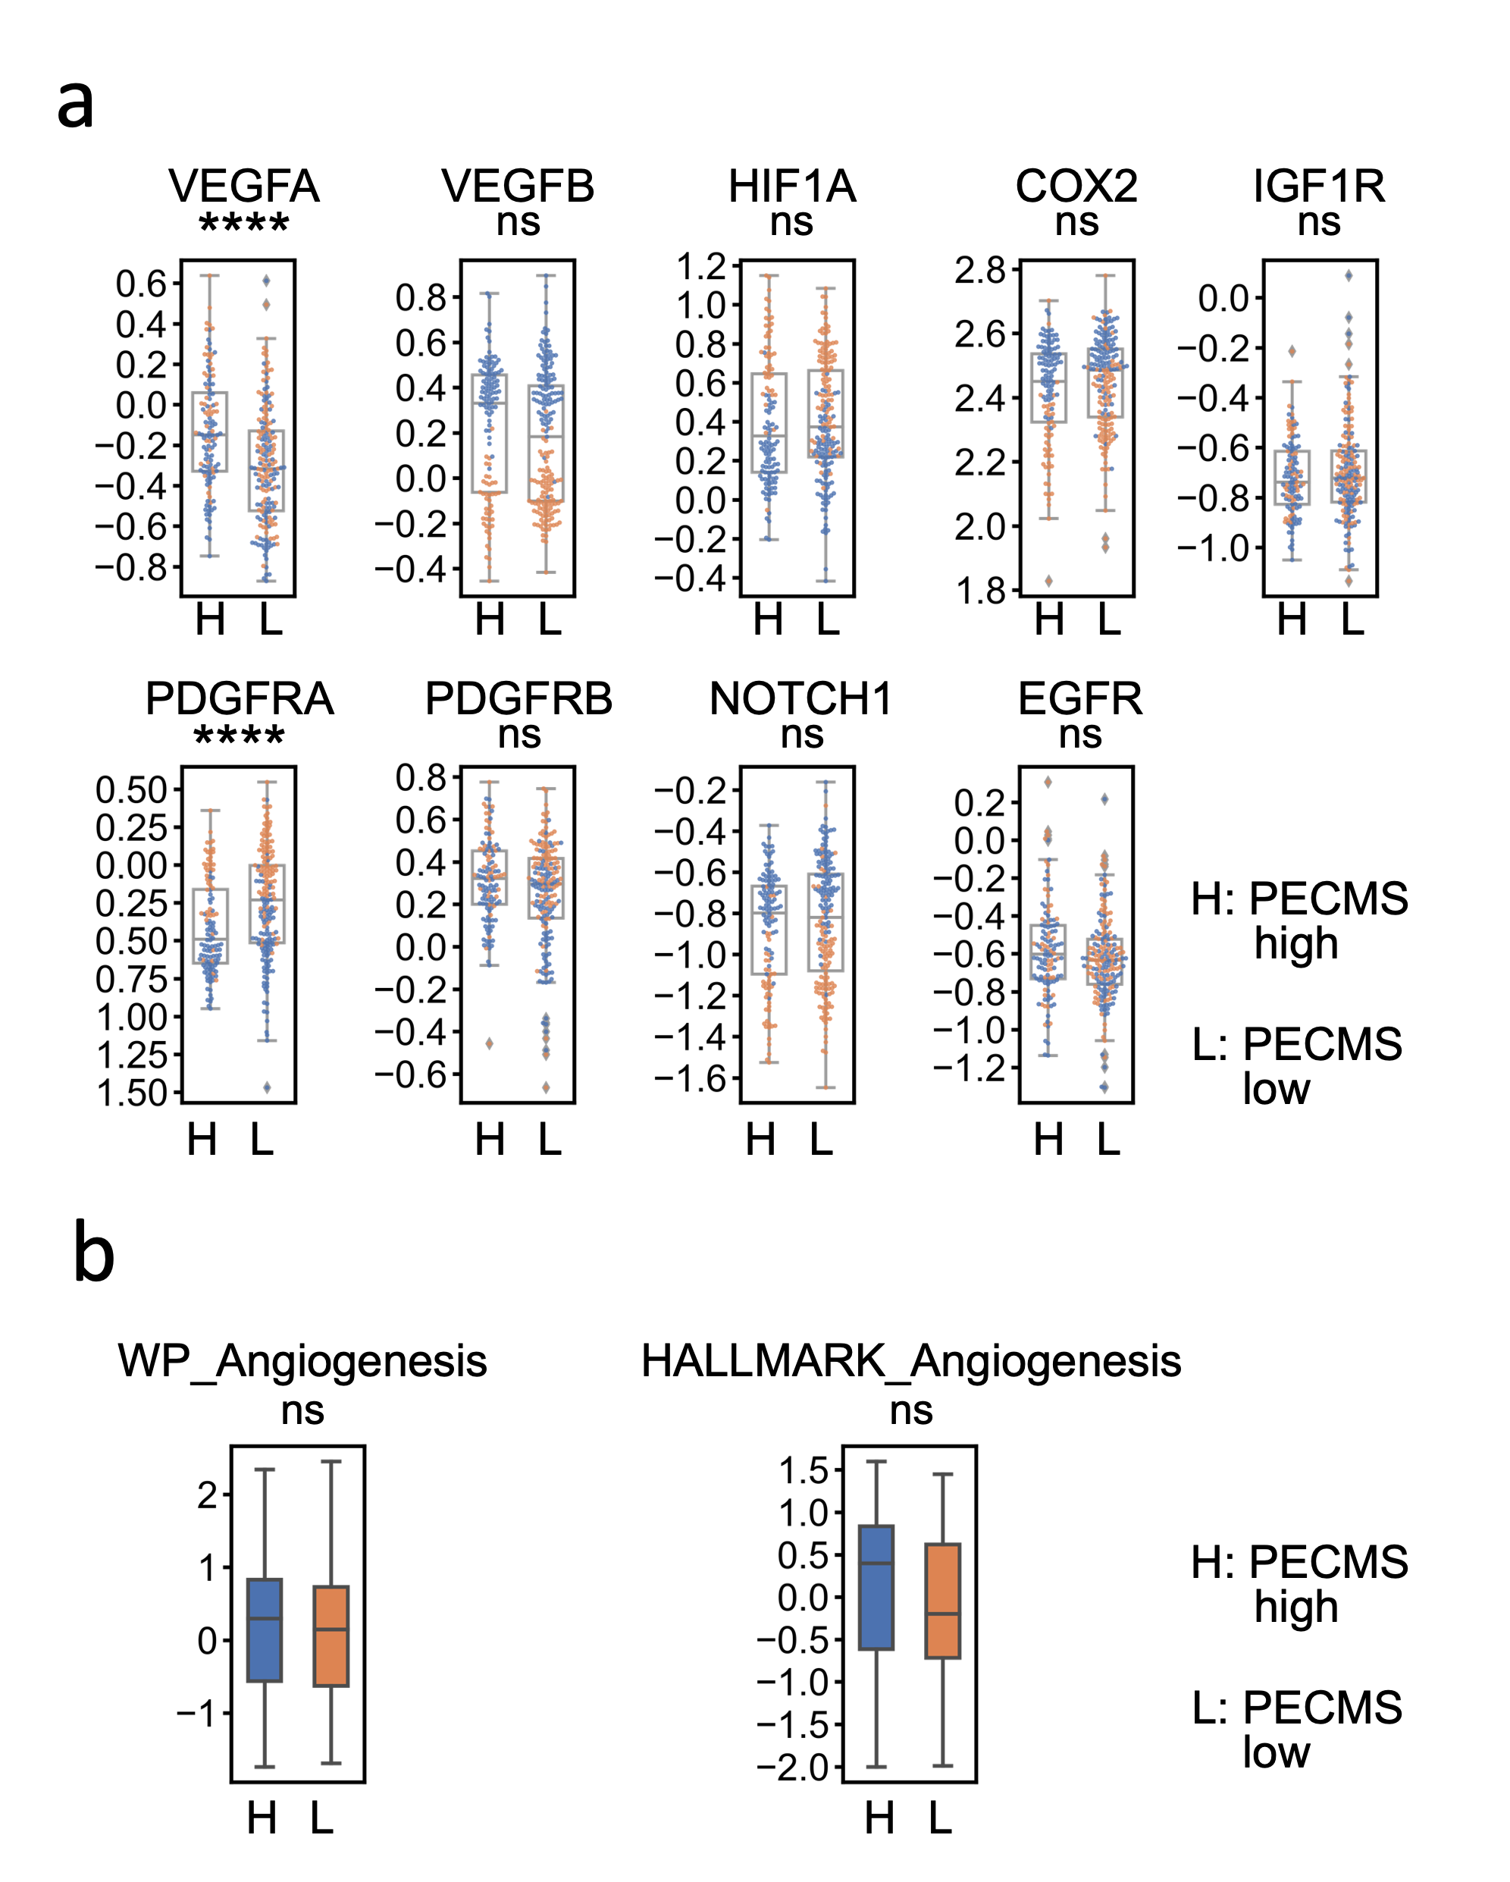
Supplementary Fig. S4 Level of angiogenesis marker genes and pathway GSVA scores between PECMS groups (ns: no significant difference; *: P<0.05; **: P<0.005; ***: P<0.0005; ****: P<0.00005)
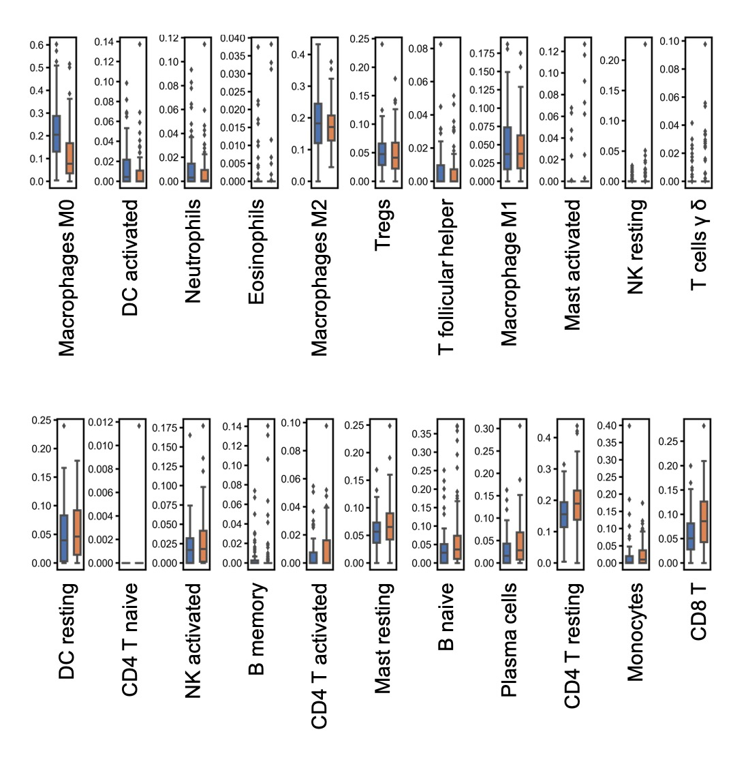
Supplementary Fig. S5 CIBERSORT score value of different infiltrating immune cells between PECMS groups
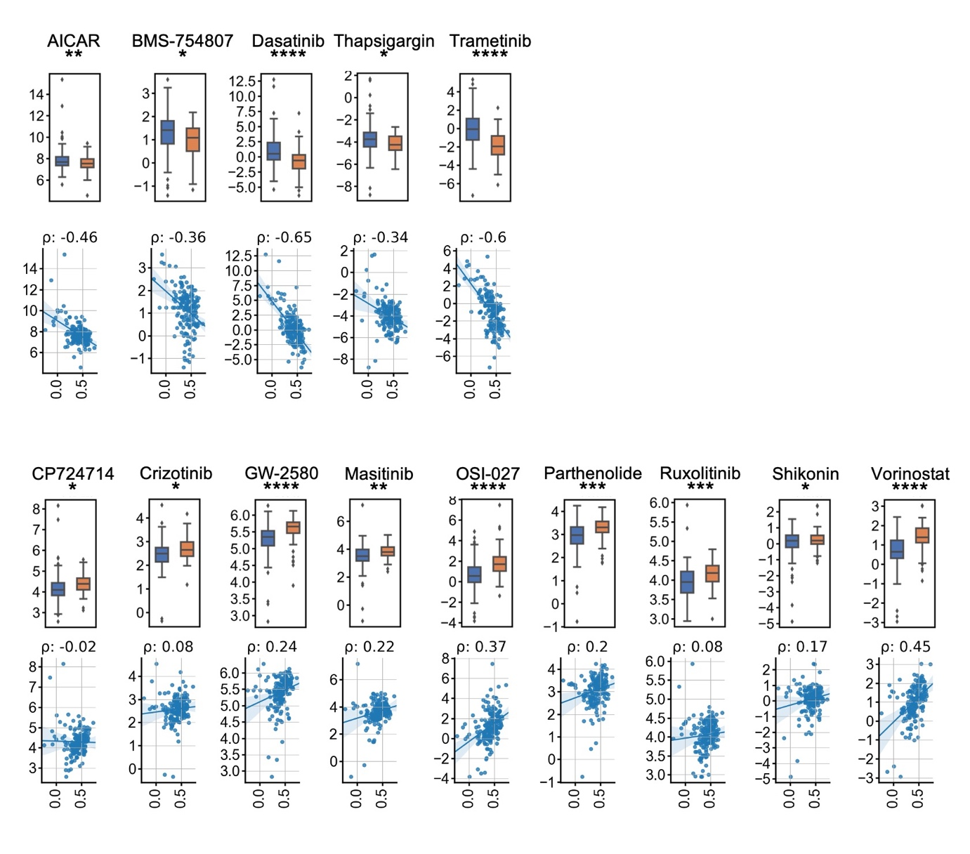
Supplementary Fig. S6 Predictive value of molecular targeted drugs between PECMS groups (ns: no significant difference; *: P<0.05; **: P<0.005; ***: P<0.0005; ****: P<0.00005)
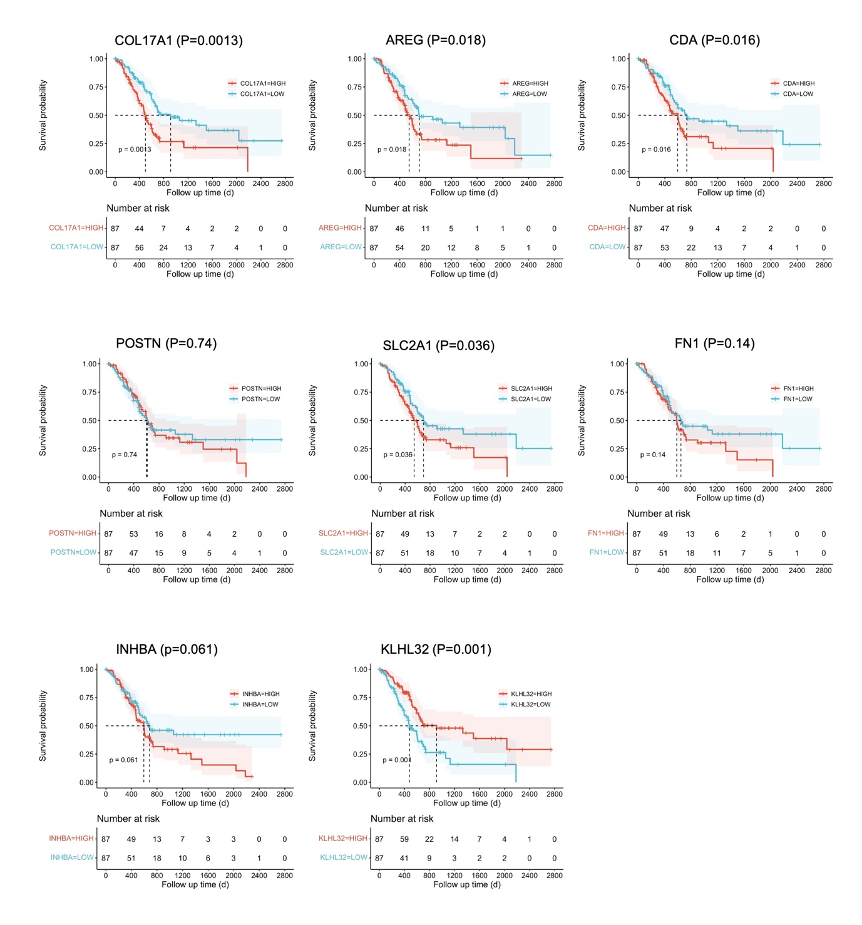
Supplementary Fig. S7 Survival curve of TCGA-PAAD. The patients were divided by the median value of PECMS feature gene mRNA levels
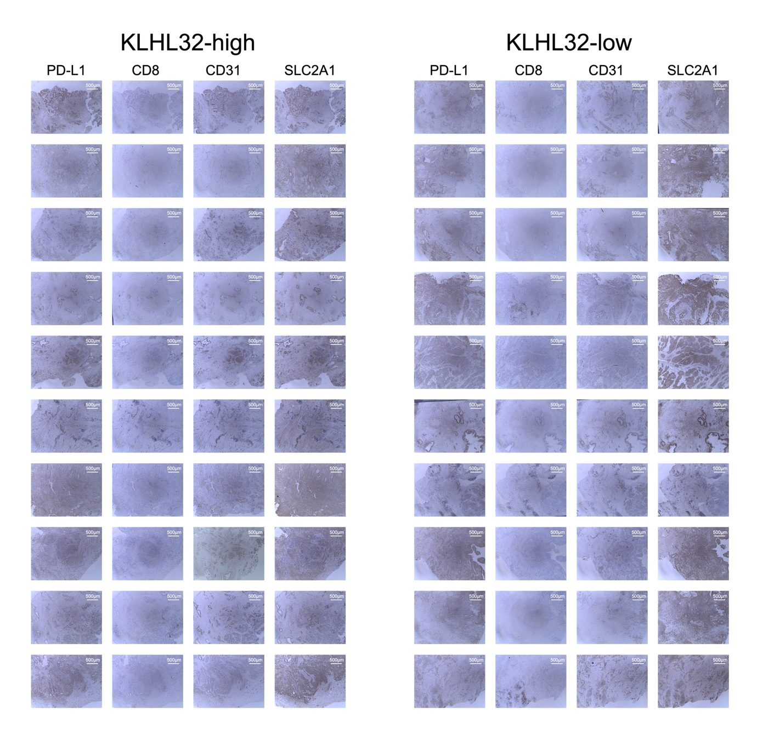
Supplementary Fig. S8 IHC of PD-L1, CD8, CD31, and SLC2A1 in our single-center retrospective cohort (The patients were grouped by the level of KLHL32)

