Supplementary Data

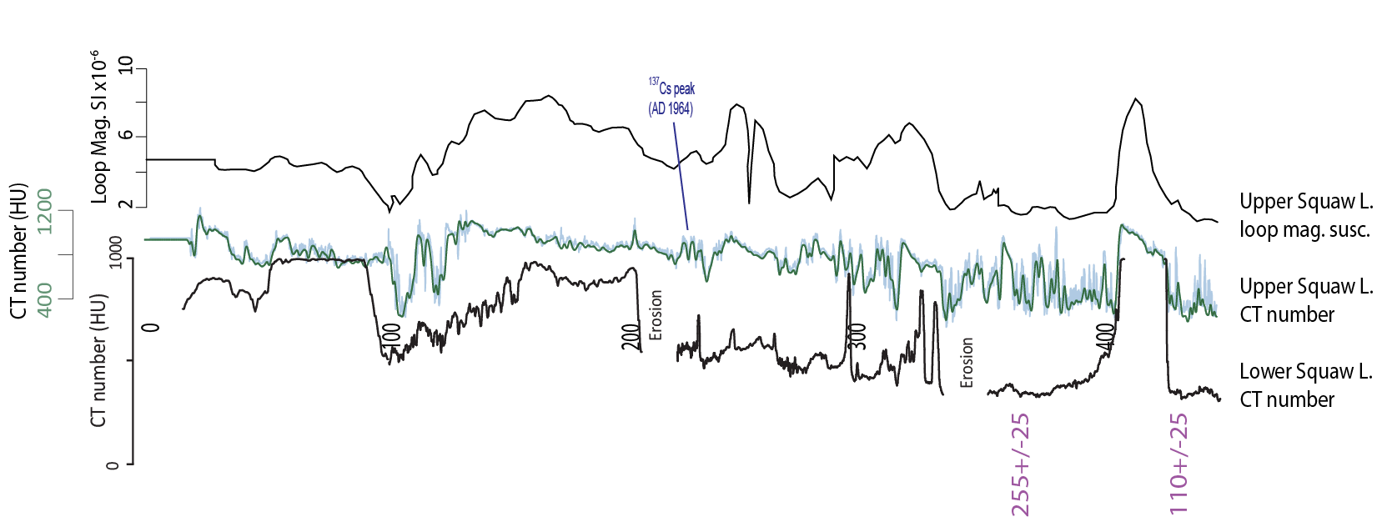
- Comparison between Upper Squaw Lake and Lower Squaw Lake for the identification of a horizon representing 1964.

- XRD Data
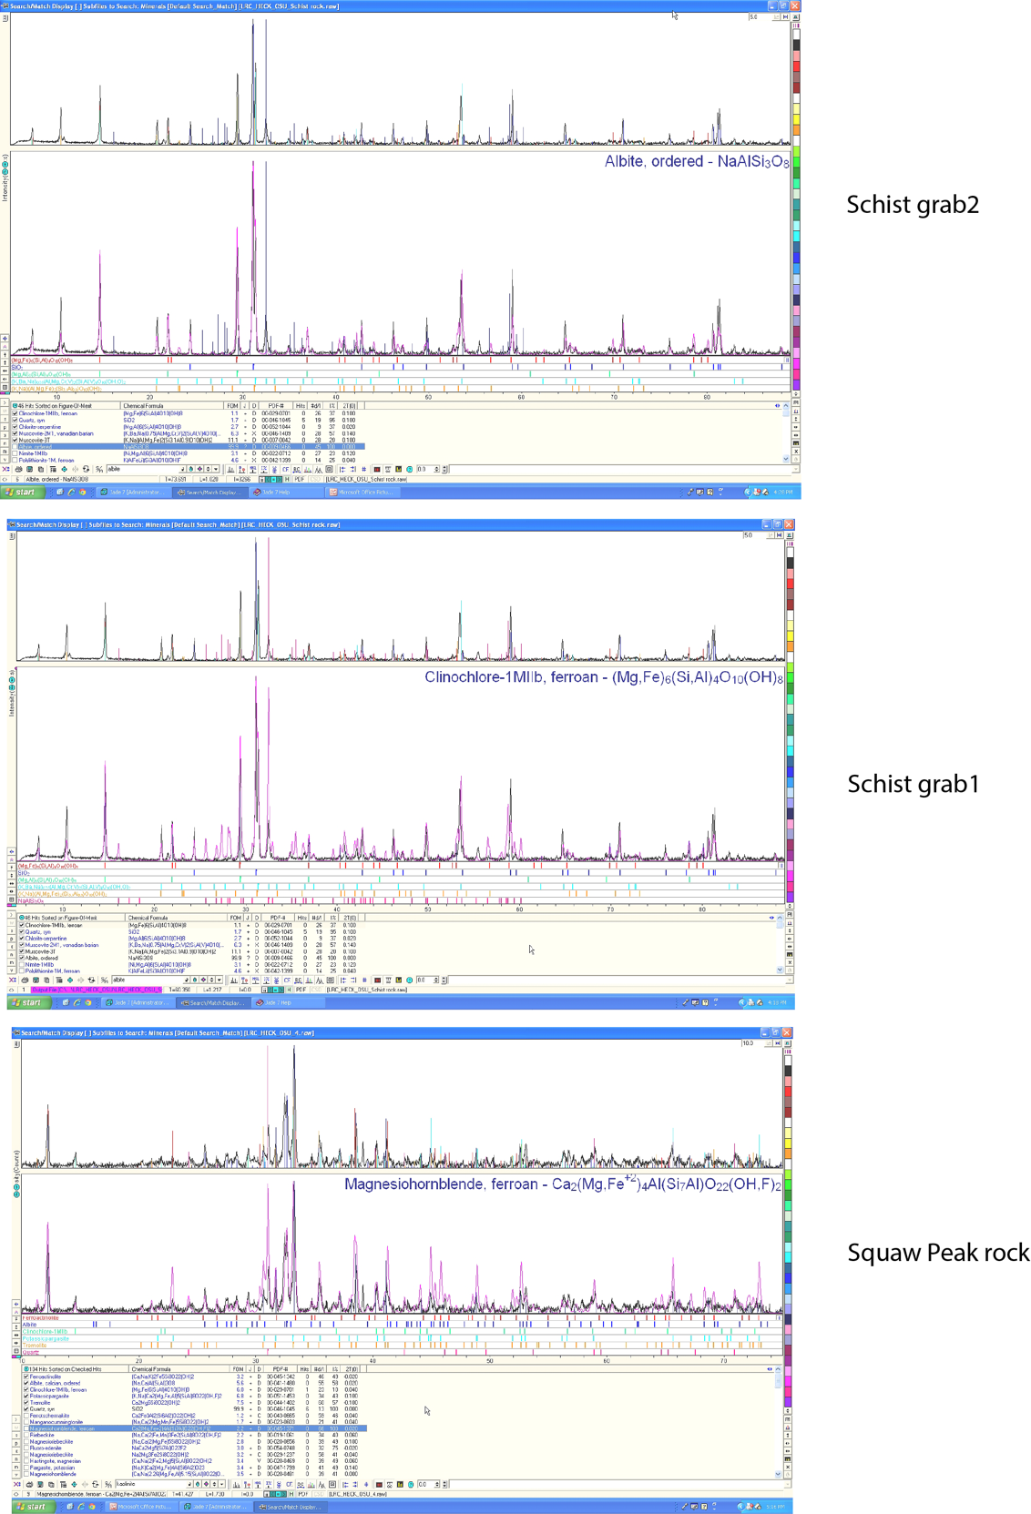
- JADE software output:

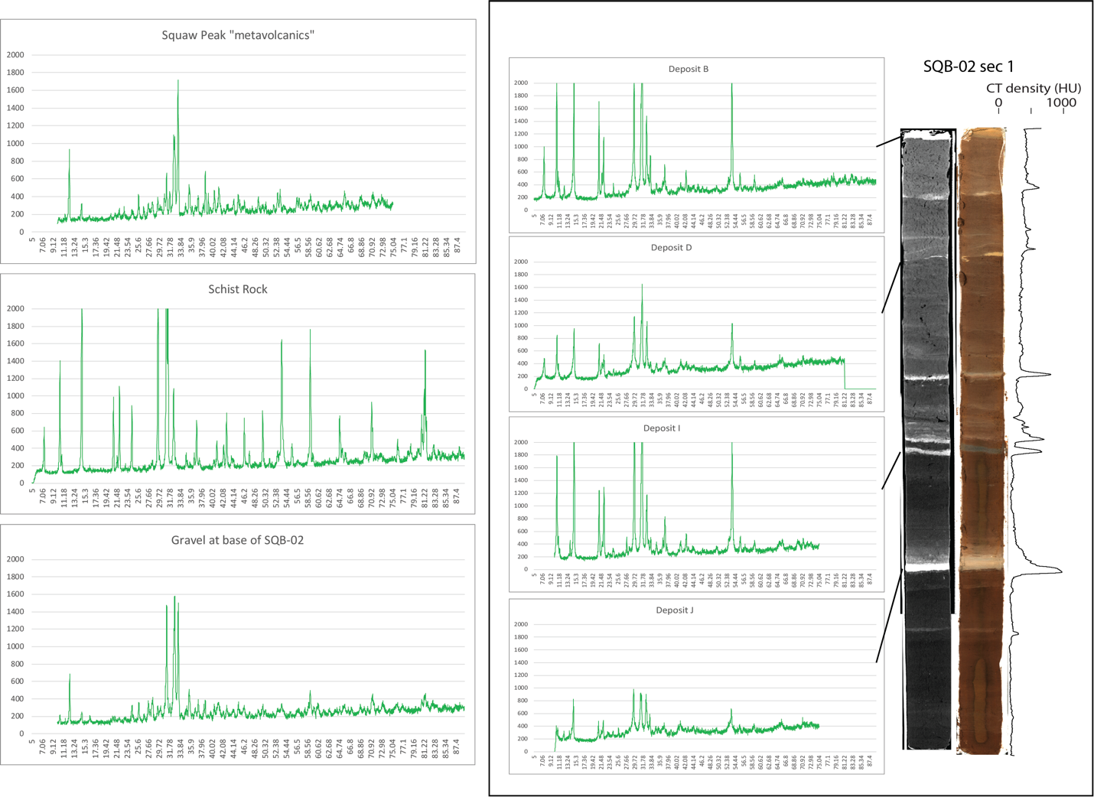
b. Graphs of actual data from sediment core samples:

- Data:

 |  |  | SQB-02
2Theta | Deposit B | Deposit D | Deposit I | Deposit J | basal gravel | Schist | Squaw Peak
5 | 172 | 5 |  |  |  | 1
5.02 | 180 | 2 |  |  |  | 4
5.04 | 176 | 5 |  |  |  | 1
5.06 | 166 | 4 |  |  |  | 4
5.08 | 189 | 5 |  |  |  | 1
5.1 | 162 | 2 |  |  |  | 2
5.12 | 164 | 10 |  |  |  | 0
5.14 | 155 | 6 |  |  |  | 1
5.16 | 171 | 12 |  |  |  | 5
5.18 | 163 | 16 |  |  |  | 2
5.2 | 173 | 21 |  |  |  | 1
5.22 | 166 | 38 |  |  |  | 5
5.24 | 188 | 34 |  |  |  | 1
5.26 | 191 | 42 |  |  |  | 1
5.28 | 176 | 40 |  |  |  | 13
5.3 | 158 | 45 |  |  |  | 8
5.32 | 169 | 39 |  |  |  | 13
5.34 | 175 | 57 |  |  |  | 20
5.36 | 173 | 54 |  |  |  | 24
5.38 | 179 | 56 |  |  |  | 27
5.4 | 175 | 70 |  |  |  | 28
5.42 | 180 | 69 |  |  |  | 38
5.44 | 182 | 89 |  |  |  | 47
5.46 | 175 | 70 |  |  |  | 39
5.48 | 188 | 110 |  |  |  | 39
5.5 | 198 | 88 |  |  |  | 54
5.52 | 179 | 98 |  |  |  | 61
5.54 | 162 | 101 |  |  |  | 56
5.56 | 163 | 126 |  |  |  | 54
5.58 | 165 | 123 |  |  |  | 77
5.6 | 181 | 117 |  |  |  | 83
5.62 | 141 | 114 |  |  |  | 73
5.64 | 158 | 116 |  |  |  | 78
5.66 | 167 | 146 |  |  |  | 95
5.68 | 185 | 135 |  |  |  | 88
5.7 | 180 | 127 |  |  |  | 88
5.72 | 170 | 166 |  |  |  | 104
5.74 | 178 | 156 |  |  |  | 121
5.76 | 167 | 143 |  |  |  | 100
5.78 | 166 | 169 |  |  |  | 109
5.8 | 183 | 155 |  |  |  | 110
5.82 | 183 | 158 |  |  |  | 115
5.84 | 175 | 150 |  |  |  | 121
5.86 | 183 | 176 |  |  |  | 125
5.88 | 189 | 127 |  |  |  | 136
5.9 | 176 | 160 |  |  |  | 138
5.92 | 159 | 174 |  |  |  | 151
5.94 | 177 | 164 |  |  |  | 136
5.96 | 165 | 144 |  |  |  | 126
5.98 | 180 | 158 |  |  |  | 126
6 | 182 | 159 |  |  |  | 151
6.02 | 178 | 162 |  |  |  | 115
6.04 | 195 | 156 |  |  |  | 124
6.06 | 184 | 164 |  |  |  | 138
6.08 | 180 | 167 |  |  |  | 137
6.1 | 191 | 178 |  |  |  | 135
6.12 | 188 | 137 |  |  |  | 125
6.14 | 198 | 182 |  |  |  | 155
6.16 | 194 | 146 |  |  |  | 149
6.18 | 180 | 174 |  |  |  | 145
6.2 | 165 | 186 |  |  |  | 144
6.22 | 172 | 139 |  |  |  | 151
6.24 | 170 | 153 |  |  |  | 156
6.26 | 224 | 166 |  |  |  | 143
6.28 | 212 | 177 |  |  |  | 147
6.3 | 186 | 173 |  |  |  | 136
6.32 | 211 | 162 |  |  |  | 142
6.34 | 179 | 172 |  |  |  | 157
6.36 | 192 | 163 |  |  |  | 124
6.38 | 203 | 159 |  |  |  | 146
6.4 | 200 | 160 |  |  |  | 133
6.42 | 197 | 147 |  |  |  | 144
6.44 | 186 | 169 |  |  |  | 148
6.46 | 211 | 147 |  |  |  | 135
6.48 | 196 | 191 |  |  |  | 168
6.5 | 207 | 161 |  |  |  | 135
6.52 | 199 | 188 |  |  |  | 165
6.54 | 201 | 184 |  |  |  | 147
6.56 | 213 | 167 |  |  |  | 156
6.58 | 216 | 173 |  |  |  | 148
6.6 | 202 | 168 |  |  |  | 131
6.62 | 219 | 200 |  |  |  | 143
6.64 | 204 | 177 |  |  |  | 162
6.66 | 194 | 164 |  |  |  | 130
6.68 | 221 | 157 |  |  |  | 154
6.7 | 194 | 189 |  |  |  | 157
6.72 | 228 | 180 |  |  |  | 166
6.74 | 227 | 189 |  |  |  | 134
6.76 | 188 | 176 |  |  |  | 160
6.78 | 199 | 185 |  |  |  | 145
6.8 | 221 | 211 |  |  |  | 144
6.82 | 210 | 182 |  |  |  | 140
6.84 | 244 | 182 |  |  |  | 136
6.86 | 226 | 197 |  |  |  | 152
6.88 | 206 | 211 |  |  |  | 146
6.9 | 244 | 184 |  |  |  | 134
6.92 | 230 | 210 |  |  |  | 154
6.94 | 229 | 207 |  |  |  | 158
6.96 | 226 | 207 |  |  |  | 155
6.98 | 239 | 232 |  |  |  | 168
7 | 256 | 231 |  |  |  | 184
7.02 | 263 | 238 |  |  |  | 159
7.04 | 283 | 224 |  |  |  | 168
7.06 | 285 | 219 |  |  |  | 162
7.08 | 276 | 201 |  |  |  | 189
7.1 | 300 | 225 |  |  |  | 215
7.12 | 335 | 272 |  |  |  | 199
7.14 | 289 | 247 |  |  |  | 190
7.16 | 341 | 270 |  |  |  | 184
7.18 | 366 | 277 |  |  |  | 252
7.2 | 345 | 287 |  |  |  | 247
7.22 | 402 | 258 |  |  |  | 256
7.24 | 436 | 265 |  |  |  | 310
7.26 | 477 | 292 |  |  |  | 329
7.28 | 445 | 301 |  |  |  | 347
7.3 | 523 | 284 |  |  |  | 435
7.32 | 545 | 347 |  |  |  | 495
7.34 | 582 | 347 |  |  |  | 549
7.36 | 674 | 392 |  |  |  | 641
7.38 | 682 | 381 |  |  |  | 581
7.4 | 804 | 385 |  |  |  | 603
7.42 | 774 | 411 |  |  |  | 510
7.44 | 863 | 401 |  |  |  | 390
7.46 | 924 | 441 |  |  |  | 290
7.48 | 888 | 431 |  |  |  | 229
7.5 | 1001 | 482 |  |  |  | 183
7.52 | 903 | 452 |  |  |  | 137
7.54 | 778 | 449 |  |  |  | 128
7.56 | 720 | 476 |  |  |  | 149
7.58 | 576 | 443 |  |  |  | 139
7.6 | 449 | 416 |  |  |  | 148
7.62 | 330 | 374 |  |  |  | 118
7.64 | 343 | 361 |  |  |  | 132
7.66 | 299 | 296 |  |  |  | 133
7.68 | 285 | 257 |  |  |  | 125
7.7 | 272 | 263 |  |  |  | 160
7.72 | 261 | 211 |  |  |  | 140
7.74 | 240 | 237 |  |  |  | 130
7.76 | 246 | 230 |  |  |  | 138
7.78 | 243 | 208 |  |  |  | 134
7.8 | 251 | 204 |  |  |  | 124
7.82 | 247 | 201 |  |  |  | 144
7.84 | 242 | 187 |  |  |  | 128
7.86 | 265 | 220 |  |  |  | 124
7.88 | 205 | 198 |  |  |  | 117
7.9 | 227 | 208 |  |  |  | 106
7.92 | 208 | 192 |  |  |  | 111
7.94 | 212 | 189 |  |  |  | 126
7.96 | 224 | 182 |  |  |  | 136
7.98 | 228 | 176 |  |  |  | 122
8 | 247 | 181 |  |  |  | 138
8.02 | 222 | 207 |  |  |  | 132
8.04 | 205 | 178 |  |  |  | 130
8.06 | 222 | 203 |  |  |  | 123
8.08 | 193 | 196 |  |  |  | 143
8.1 | 232 | 169 |  |  |  | 127
8.12 | 232 | 201 |  |  |  | 126
8.14 | 209 | 197 |  |  |  | 120
8.16 | 207 | 168 |  |  |  | 122
8.18 | 196 | 187 |  |  |  | 109
8.2 | 189 | 198 |  |  |  | 119
8.22 | 196 | 182 |  |  |  | 122
8.24 | 206 | 212 |  |  |  | 123
8.26 | 229 | 173 |  |  |  | 122
8.28 | 206 | 179 |  |  |  | 116
8.3 | 231 | 173 |  |  |  | 115
8.32 | 215 | 216 |  |  |  | 132
8.34 | 206 | 183 |  |  |  | 141
8.36 | 202 | 194 |  |  |  | 137
8.38 | 200 | 174 |  |  |  | 102
8.4 | 183 | 155 |  |  |  | 109
8.42 | 204 | 157 |  |  |  | 109
8.44 | 221 | 171 |  |  |  | 126
8.46 | 203 | 185 |  |  |  | 124
8.48 | 198 | 168 |  |  |  | 144
8.5 | 209 | 193 |  |  |  | 104
8.52 | 211 | 170 |  |  |  | 113
8.54 | 193 | 174 |  |  |  | 115
8.56 | 224 | 168 |  |  |  | 120
8.58 | 209 | 171 |  |  |  | 115
8.6 | 195 | 176 |  |  |  | 124
8.62 | 204 | 176 |  |  |  | 112
8.64 | 206 | 184 |  |  |  | 121
8.66 | 205 | 156 |  |  |  | 115
8.68 | 207 | 190 |  |  |  | 117
8.7 | 206 | 196 |  |  |  | 101
8.72 | 209 | 186 |  |  |  | 116
8.74 | 195 | 206 |  |  |  | 108
8.76 | 222 | 171 |  |  |  | 118
8.78 | 181 | 166 |  |  |  | 125
8.8 | 191 | 160 |  |  |  | 124
8.82 | 186 | 178 |  |  |  | 125
8.84 | 192 | 161 |  |  |  | 119
8.86 | 203 | 156 |  |  |  | 120
8.88 | 216 | 174 |  |  |  | 140
8.9 | 198 | 174 |  |  |  | 109
8.92 | 173 | 178 |  |  |  | 102
8.94 | 183 | 169 |  |  |  | 120
8.96 | 186 | 175 |  |  |  | 108
8.98 | 202 | 173 |  |  |  | 131
9 | 184 | 181 |  |  |  | 118
9.02 | 199 | 187 |  |  |  | 115
9.04 | 202 | 181 |  |  |  | 137
9.06 | 206 | 189 |  |  |  | 123
9.08 | 175 | 154 |  |  |  | 109
9.1 | 201 | 181 |  |  |  | 106
9.12 | 180 | 170 |  |  |  | 130
9.14 | 216 | 152 |  |  |  | 114
9.16 | 197 | 181 |  |  |  | 119
9.18 | 178 | 164 |  |  |  | 135
9.2 | 218 | 191 |  |  |  | 114
9.22 | 200 | 157 |  |  |  | 118
9.24 | 211 | 188 |  |  |  | 109
9.26 | 210 | 164 |  |  |  | 132
9.28 | 227 | 180 |  |  |  | 137
9.3 | 213 | 186 |  |  |  | 122
9.32 | 196 | 169 |  |  |  | 126
9.34 | 213 | 169 |  |  |  | 121
9.36 | 216 | 179 |  |  |  | 120
9.38 | 209 | 187 |  |  |  | 122
9.4 | 201 | 196 |  |  |  | 131
9.42 | 205 | 149 |  |  |  | 136
9.44 | 211 | 174 |  |  |  | 125
9.46 | 193 | 165 |  |  |  | 127
9.48 | 203 | 158 |  |  |  | 142
9.5 | 218 | 195 |  |  |  | 138
9.52 | 213 | 172 |  |  |  | 113
9.54 | 223 | 168 |  |  |  | 140
9.56 | 224 | 156 |  |  |  | 121
9.58 | 244 | 192 |  |  |  | 104
9.6 | 250 | 204 |  |  |  | 125
9.62 | 219 | 185 |  |  |  | 138
9.64 | 235 | 205 |  |  |  | 114
9.66 | 214 | 165 |  |  |  | 130
9.68 | 206 | 203 |  |  |  | 117
9.7 | 230 | 172 |  |  |  | 110
9.72 | 218 | 170 |  |  |  | 117
9.74 | 218 | 177 |  |  |  | 122
9.76 | 218 | 189 |  |  |  | 125
9.78 | 223 | 183 |  |  |  | 146
9.8 | 192 | 192 |  |  |  | 112
9.82 | 220 | 191 |  |  |  | 136
9.84 | 203 | 215 |  |  |  | 114
9.86 | 213 | 205 |  |  |  | 129
9.88 | 227 | 194 |  |  |  | 115
9.9 | 242 | 194 |  |  |  | 142
9.92 | 233 | 200 |  |  |  | 125
9.94 | 219 | 190 |  |  |  | 140
9.96 | 232 | 177 |  |  |  | 131
9.98 | 280 | 211 |  |  |  | 150
10 | 252 | 199 | 229 | 1 | 130 | 139 | 94
10.02 | 232 | 170 | 195 | 5 | 111 | 160 | 123
10.04 | 235 | 199 | 257 | 2 | 123 | 165 | 109
10.06 | 234 | 191 | 230 | 4 | 122 | 171 | 128
10.08 | 219 | 187 | 210 | 6 | 138 | 167 | 121
10.1 | 232 | 202 | 237 | 12 | 112 | 153 | 142
10.12 | 256 | 212 | 270 | 23 | 124 | 208 | 141
10.14 | 233 | 232 | 237 | 31 | 116 | 156 | 136
10.16 | 293 | 235 | 255 | 46 | 139 | 196 | 133
10.18 | 267 | 234 | 242 | 51 | 138 | 235 | 143
10.2 | 271 | 219 | 293 | 66 | 142 | 244 | 150
10.22 | 300 | 250 | 280 | 75 | 142 | 304 | 163
10.24 | 324 | 225 | 272 | 108 | 124 | 274 | 148
10.26 | 350 | 238 | 322 | 111 | 136 | 334 | 133
10.28 | 345 | 250 | 332 | 119 | 150 | 376 | 137
10.3 | 379 | 256 | 338 | 127 | 145 | 399 | 136
10.32 | 436 | 244 | 395 | 159 | 134 | 520 | 150
10.34 | 458 | 289 | 374 | 187 | 139 | 631 | 160
10.36 | 480 | 329 | 422 | 209 | 157 | 769 | 137
10.38 | 515 | 329 | 475 | 231 | 164 | 910 | 166
10.4 | 595 | 319 | 513 | 306 | 178 | 1146 | 140
10.42 | 664 | 390 | 535 | 321 | 204 | 1294 | 135
10.44 | 725 | 406 | 637 | 348 | 208 | 1404 | 143
10.46 | 846 | 410 | 729 | 389 | 208 | 1345 | 123
10.48 | 1069 | 458 | 803 | 397 | 217 | 1155 | 125
10.5 | 1228 | 486 | 916 | 405 | 199 | 918 | 131
10.52 | 1524 | 531 | 1093 | 379 | 192 | 628 | 128
10.54 | 1908 | 554 | 1207 | 298 | 177 | 380 | 137
10.56 | 2259 | 601 | 1412 | 300 | 178 | 296 | 134
10.58 | 2353 | 640 | 1581 | 290 | 159 | 226 | 115
10.6 | 2272 | 764 | 1719 | 273 | 142 | 190 | 139
10.62 | 1881 | 795 | 1790 | 285 | 153 | 221 | 134
10.64 | 1547 | 847 | 1768 | 247 | 109 | 203 | 130
10.66 | 1138 | 815 | 1639 | 266 | 127 | 244 | 119
10.68 | 754 | 774 | 1617 | 278 | 126 | 260 | 153
10.7 | 567 | 667 | 1365 | 310 | 115 | 234 | 128
10.72 | 446 | 577 | 1106 | 278 | 142 | 281 | 122
10.74 | 407 | 461 | 810 | 312 | 125 | 310 | 134
10.76 | 408 | 360 | 656 | 352 | 111 | 317 | 115
10.78 | 396 | 342 | 507 | 345 | 123 | 330 | 139
10.8 | 405 | 325 | 395 | 322 | 110 | 297 | 130
10.82 | 368 | 331 | 386 | 373 | 126 | 274 | 123
10.84 | 433 | 331 | 409 | 326 | 128 | 249 | 101
10.86 | 486 | 297 | 420 | 342 | 117 | 226 | 118
10.88 | 578 | 299 | 457 | 303 | 123 | 181 | 129
10.9 | 594 | 325 | 434 | 301 | 132 | 151 | 132
10.92 | 617 | 308 | 454 | 262 | 142 | 150 | 138
10.94 | 556 | 351 | 481 | 258 | 115 | 143 | 119
10.96 | 541 | 395 | 511 | 224 | 109 | 125 | 130
10.98 | 494 | 386 | 465 | 222 | 113 | 143 | 140
11 | 414 | 397 | 522 | 205 | 112 | 148 | 112
11.02 | 343 | 328 | 460 | 229 | 133 | 119 | 129
11.04 | 280 | 355 | 431 | 230 | 132 | 144 | 133
11.06 | 289 | 285 | 385 | 204 | 127 | 128 | 158
11.08 | 318 | 243 | 362 | 249 | 131 | 124 | 131
11.1 | 299 | 236 | 301 | 200 | 117 | 142 | 156
11.12 | 320 | 205 | 263 | 214 | 134 | 120 | 124
11.14 | 340 | 227 | 250 | 223 | 115 | 138 | 127
11.16 | 340 | 212 | 285 | 225 | 127 | 119 | 156
11.18 | 390 | 209 | 266 | 208 | 122 | 114 | 158
11.2 | 433 | 220 | 265 | 240 | 135 | 116 | 160
11.22 | 459 | 222 | 284 | 208 | 125 | 127 | 109
11.24 | 413 | 233 | 292 | 173 | 139 | 126 | 145
11.26 | 401 | 227 | 314 | 199 | 119 | 133 | 147
11.28 | 356 | 265 | 334 | 206 | 132 | 131 | 125
11.3 | 318 | 221 | 331 | 192 | 123 | 121 | 150
11.32 | 266 | 227 | 326 | 200 | 134 | 106 | 147
11.34 | 244 | 232 | 302 | 194 | 140 | 123 | 138
11.36 | 218 | 205 | 308 | 184 | 133 | 108 | 144
11.38 | 194 | 203 | 276 | 216 | 106 | 110 | 182
11.4 | 230 | 191 | 218 | 202 | 133 | 123 | 168
11.42 | 217 | 199 | 192 | 180 | 129 | 114 | 199
11.44 | 202 | 159 | 229 | 191 | 131 | 120 | 207
11.46 | 218 | 176 | 181 | 184 | 133 | 113 | 194
11.48 | 205 | 188 | 195 | 198 | 180 | 118 | 174
11.5 | 235 | 176 | 197 | 187 | 141 | 127 | 159
11.52 | 220 | 174 | 187 | 203 | 153 | 130 | 163
11.54 | 207 | 190 | 181 | 210 | 149 | 107 | 132
11.56 | 210 | 182 | 173 | 181 | 135 | 128 | 128
11.58 | 204 | 168 | 209 | 178 | 121 | 123 | 126
11.6 | 183 | 161 | 190 | 195 | 119 | 135 | 137
11.62 | 215 | 172 | 182 | 182 | 108 | 110 | 113
11.64 | 205 | 197 | 205 | 212 | 128 | 128 | 159
11.66 | 181 | 174 | 192 | 194 | 108 | 131 | 139
11.68 | 195 | 154 | 176 | 209 | 123 | 125 | 121
11.7 | 204 | 162 | 187 | 162 | 121 | 131 | 130
11.72 | 199 | 178 | 186 | 205 | 117 | 122 | 129
11.74 | 221 | 157 | 167 | 186 | 118 | 123 | 164
11.76 | 185 | 168 | 166 | 180 | 105 | 139 | 147
11.78 | 204 | 184 | 158 | 213 | 146 | 133 | 163
11.8 | 197 | 167 | 184 | 203 | 124 | 122 | 166
11.82 | 190 | 163 | 170 | 199 | 116 | 112 | 141
11.84 | 188 | 147 | 171 | 176 | 133 | 108 | 163
11.86 | 155 | 146 | 175 | 166 | 124 | 120 | 161
11.88 | 189 | 159 | 175 | 199 | 124 | 133 | 162
11.9 | 175 | 164 | 167 | 198 | 125 | 124 | 197
11.92 | 167 | 184 | 188 | 205 | 127 | 134 | 193
11.94 | 188 | 148 | 189 | 177 | 141 | 113 | 199
11.96 | 207 | 158 | 167 | 207 | 141 | 143 | 194
11.98 | 167 | 176 | 172 | 199 | 147 | 126 | 201
12 | 163 | 140 | 182 | 182 | 150 | 137 | 211
12.02 | 182 | 163 | 182 | 204 | 132 | 108 | 239
12.04 | 189 | 170 | 170 | 202 | 161 | 115 | 260
12.06 | 244 | 181 | 168 | 215 | 181 | 130 | 309
12.08 | 190 | 160 | 182 | 211 | 152 | 132 | 346
12.1 | 212 | 166 | 169 | 210 | 181 | 141 | 380
12.12 | 203 | 183 | 170 | 212 | 174 | 116 | 380
12.14 | 215 | 185 | 162 | 225 | 171 | 142 | 430
12.16 | 249 | 164 | 162 | 249 | 180 | 116 | 471
12.18 | 217 | 163 | 189 | 250 | 206 | 121 | 551
12.2 | 226 | 152 | 181 | 235 | 201 | 132 | 658
12.22 | 252 | 143 | 186 | 237 | 254 | 114 | 736
12.24 | 235 | 165 | 194 | 233 | 265 | 107 | 852
12.26 | 225 | 176 | 158 | 255 | 328 | 134 | 935
12.28 | 246 | 167 | 164 | 274 | 386 | 114 | 851
12.3 | 250 | 166 | 178 | 281 | 487 | 129 | 767
12.32 | 269 | 187 | 152 | 302 | 567 | 118 | 668
12.34 | 291 | 184 | 172 | 322 | 633 | 134 | 482
12.36 | 307 | 205 | 199 | 307 | 686 | 138 | 345
12.38 | 328 | 208 | 165 | 324 | 667 | 126 | 235
12.4 | 331 | 201 | 166 | 287 | 610 | 147 | 184
12.42 | 384 | 218 | 203 | 264 | 505 | 137 | 174
12.44 | 378 | 194 | 199 | 245 | 412 | 132 | 158
12.46 | 351 | 180 | 179 | 218 | 276 | 108 | 135
12.48 | 359 | 210 | 148 | 174 | 211 | 131 | 162
12.5 | 348 | 221 | 178 | 195 | 188 | 128 | 146
12.52 | 291 | 207 | 178 | 193 | 154 | 122 | 160
12.54 | 242 | 183 | 154 | 200 | 143 | 124 | 155
12.56 | 198 | 195 | 172 | 192 | 159 | 120 | 137
12.58 | 204 | 178 | 179 | 187 | 155 | 128 | 149
12.6 | 222 | 170 | 186 | 205 | 116 | 115 | 143
12.62 | 201 | 180 | 200 | 189 | 129 | 134 | 140
12.64 | 181 | 175 | 166 | 183 | 126 | 119 | 130
12.66 | 208 | 162 | 173 | 199 | 145 | 117 | 140
12.68 | 198 | 183 | 190 | 199 | 121 | 124 | 141
12.7 | 208 | 190 | 199 | 180 | 125 | 139 | 122
12.72 | 204 | 182 | 178 | 196 | 145 | 125 | 152
12.74 | 225 | 178 | 180 | 180 | 149 | 136 | 137
12.76 | 225 | 176 | 183 | 199 | 131 | 125 | 115
12.78 | 192 | 162 | 188 | 199 | 116 | 141 | 142
12.8 | 205 | 151 | 192 | 212 | 145 | 125 | 131
12.82 | 206 | 184 | 175 | 202 | 129 | 134 | 124
12.84 | 212 | 189 | 188 | 200 | 118 | 120 | 125
12.86 | 216 | 161 | 155 | 208 | 124 | 109 | 139
12.88 | 206 | 177 | 149 | 213 | 128 | 123 | 164
12.9 | 201 | 192 | 182 | 166 | 141 | 124 | 133
12.92 | 199 | 156 | 172 | 208 | 133 | 140 | 139
12.94 | 204 | 153 | 184 | 223 | 140 | 129 | 138
12.96 | 190 | 184 | 200 | 221 | 124 | 122 | 148
12.98 | 186 | 162 | 190 | 212 | 139 | 147 | 160
13 | 238 | 187 | 177 | 203 | 134 | 112 | 125
13.02 | 175 | 191 | 170 | 198 | 131 | 135 | 122
13.04 | 212 | 158 | 175 | 199 | 100 | 124 | 146
13.06 | 191 | 169 | 167 | 210 | 146 | 110 | 127
13.08 | 203 | 187 | 174 | 207 | 134 | 119 | 129
13.1 | 206 | 190 | 178 | 184 | 136 | 141 | 132
13.12 | 192 | 183 | 189 | 215 | 154 | 130 | 160
13.14 | 224 | 164 | 183 | 229 | 137 | 145 | 150
13.16 | 205 | 193 | 168 | 221 | 117 | 158 | 126
13.18 | 213 | 214 | 177 | 229 | 135 | 148 | 136
13.2 | 221 | 177 | 206 | 200 | 126 | 151 | 139
13.22 | 244 | 182 | 193 | 227 | 136 | 139 | 154
13.24 | 209 | 192 | 197 | 227 | 144 | 160 | 168
13.26 | 230 | 192 | 203 | 219 | 136 | 141 | 154
13.28 | 224 | 195 | 194 | 218 | 130 | 148 | 150
13.3 | 236 | 184 | 181 | 210 | 126 | 143 | 136
13.32 | 218 | 188 | 206 | 226 | 113 | 157 | 112
13.34 | 211 | 194 | 189 | 209 | 138 | 140 | 143
13.36 | 220 | 218 | 193 | 239 | 123 | 169 | 150
13.38 | 231 | 203 | 215 | 197 | 125 | 142 | 152
13.4 | 249 | 198 | 209 | 219 | 137 | 134 | 138
13.42 | 254 | 201 | 216 | 219 | 128 | 134 | 146
13.44 | 208 | 197 | 216 | 219 | 121 | 134 | 148
13.46 | 239 | 214 | 210 | 242 | 154 | 134 | 137
13.48 | 239 | 187 | 220 | 215 | 139 | 145 | 131
13.5 | 255 | 185 | 232 | 227 | 136 | 141 | 139
13.52 | 234 | 193 | 210 | 223 | 129 | 129 | 156
13.54 | 239 | 177 | 223 | 202 | 114 | 164 | 140
13.56 | 258 | 215 | 233 | 244 | 128 | 136 | 143
13.58 | 265 | 189 | 253 | 231 | 134 | 148 | 146
13.6 | 241 | 234 | 250 | 250 | 126 | 140 | 142
13.62 | 230 | 203 | 231 | 274 | 116 | 145 | 144
13.64 | 238 | 209 | 222 | 277 | 135 | 124 | 134
13.66 | 257 | 199 | 229 | 291 | 123 | 131 | 139
13.68 | 213 | 188 | 239 | 328 | 143 | 139 | 141
13.7 | 240 | 216 | 224 | 288 | 117 | 152 | 146
13.72 | 231 | 213 | 231 | 308 | 141 | 142 | 131
13.74 | 263 | 235 | 214 | 277 | 123 | 139 | 152
13.76 | 253 | 249 | 275 | 241 | 126 | 160 | 144
13.78 | 218 | 231 | 264 | 277 | 133 | 150 | 138
13.8 | 243 | 236 | 300 | 242 | 112 | 119 | 147
13.82 | 222 | 246 | 306 | 265 | 110 | 118 | 145
13.84 | 249 | 216 | 383 | 224 | 127 | 152 | 136
13.86 | 245 | 253 | 447 | 220 | 143 | 140 | 125
13.88 | 271 | 221 | 406 | 223 | 128 | 160 | 151
13.9 | 275 | 238 | 460 | 196 | 142 | 150 | 134
13.92 | 276 | 235 | 437 | 220 | 121 | 139 | 145
13.94 | 256 | 240 | 344 | 190 | 133 | 133 | 168
13.96 | 289 | 243 | 318 | 238 | 132 | 160 | 171
13.98 | 286 | 227 | 244 | 245 | 145 | 168 | 141
14 | 293 | 227 | 249 | 271 | 126 | 143 | 158
14.02 | 272 | 230 | 227 | 262 | 128 | 148 | 151
14.04 | 283 | 266 | 218 | 277 | 136 | 148 | 156
14.06 | 305 | 249 | 218 | 267 | 125 | 150 | 176
14.08 | 288 | 248 | 222 | 275 | 150 | 158 | 159
14.1 | 307 | 258 | 204 | 279 | 145 | 167 | 144
14.12 | 331 | 279 | 219 | 270 | 123 | 168 | 154
14.14 | 284 | 274 | 236 | 267 | 136 | 170 | 143
14.16 | 311 | 275 | 258 | 271 | 155 | 176 | 169
14.18 | 328 | 241 | 240 | 283 | 125 | 169 | 173
14.2 | 348 | 258 | 211 | 307 | 139 | 191 | 162
14.22 | 331 | 285 | 251 | 319 | 155 | 204 | 169
14.24 | 342 | 281 | 255 | 313 | 137 | 187 | 142
14.26 | 363 | 299 | 233 | 360 | 151 | 201 | 166
14.28 | 362 | 314 | 258 | 371 | 133 | 206 | 151
14.3 | 384 | 318 | 263 | 365 | 149 | 236 | 175
14.32 | 400 | 313 | 273 | 373 | 163 | 225 | 174
14.34 | 427 | 329 | 261 | 353 | 148 | 252 | 176
14.36 | 405 | 354 | 271 | 358 | 155 | 254 | 179
14.38 | 468 | 354 | 315 | 328 | 147 | 279 | 127
14.4 | 441 | 371 | 315 | 384 | 155 | 303 | 198
14.42 | 481 | 338 | 354 | 389 | 170 | 364 | 170
14.44 | 468 | 376 | 337 | 360 | 163 | 404 | 203
14.46 | 549 | 416 | 362 | 370 | 152 | 441 | 217
14.48 | 574 | 416 | 364 | 424 | 178 | 456 | 202
14.5 | 544 | 413 | 430 | 419 | 166 | 599 | 236
14.52 | 582 | 404 | 416 | 472 | 160 | 657 | 247
14.54 | 588 | 417 | 442 | 503 | 170 | 729 | 260
14.56 | 659 | 420 | 465 | 533 | 167 | 950 | 258
14.58 | 764 | 475 | 510 | 537 | 168 | 1201 | 307
14.6 | 769 | 444 | 548 | 600 | 205 | 1437 | 305
14.62 | 843 | 490 | 619 | 668 | 208 | 1748 | 315
14.64 | 873 | 502 | 721 | 694 | 225 | 2124 | 308
14.66 | 1006 | 525 | 784 | 754 | 228 | 2233 | 320
14.68 | 1169 | 587 | 860 | 791 | 242 | 2192 | 280
14.7 | 1279 | 665 | 1043 | 826 | 251 | 2082 | 197
14.72 | 1557 | 646 | 1194 | 714 | 243 | 1835 | 189
14.74 | 1805 | 652 | 1435 | 710 | 242 | 1259 | 154
14.76 | 2133 | 767 | 1674 | 577 | 227 | 856 | 159
14.78 | 2403 | 817 | 1984 | 448 | 172 | 569 | 153
14.8 | 2400 | 867 | 2227 | 398 | 188 | 371 | 156
14.82 | 2398 | 878 | 2414 | 311 | 142 | 286 | 156
14.84 | 1998 | 951 | 2587 | 261 | 125 | 233 | 159
14.86 | 1551 | 878 | 2655 | 275 | 136 | 218 | 137
14.88 | 1121 | 923 | 2561 | 272 | 135 | 215 | 152
14.9 | 708 | 931 | 2419 | 228 | 117 | 203 | 145
14.92 | 550 | 805 | 2134 | 215 | 131 | 183 | 143
14.94 | 432 | 669 | 1810 | 208 | 131 | 191 | 140
14.96 | 380 | 497 | 1355 | 226 | 138 | 188 | 170
14.98 | 344 | 402 | 934 | 203 | 120 | 186 | 125
15 | 326 | 326 | 669 | 206 | 130 | 170 | 152
15.02 | 312 | 292 | 416 | 203 | 128 | 171 | 156
15.04 | 293 | 287 | 369 | 216 | 133 | 186 | 150
15.06 | 264 | 229 | 314 | 206 | 127 | 145 | 136
15.08 | 272 | 243 | 304 | 196 | 121 | 153 | 152
15.1 | 298 | 235 | 289 | 206 | 129 | 163 | 143
15.12 | 281 | 209 | 278 | 196 | 100 | 150 | 125
15.14 | 271 | 279 | 258 | 198 | 114 | 177 | 156
15.16 | 221 | 255 | 265 | 201 | 127 | 151 | 120
15.18 | 276 | 179 | 243 | 182 | 134 | 146 | 135
15.2 | 228 | 239 | 235 | 197 | 155 | 140 | 135
15.22 | 233 | 203 | 246 | 187 | 129 | 171 | 135
15.24 | 250 | 229 | 264 | 190 | 110 | 149 | 133
15.26 | 225 | 171 | 199 | 190 | 135 | 145 | 135
15.28 | 230 | 190 | 233 | 190 | 130 | 141 | 155
15.3 | 229 | 187 | 212 | 176 | 116 | 173 | 129
15.32 | 222 | 183 | 205 | 181 | 130 | 147 | 148
15.34 | 186 | 206 | 204 | 171 | 150 | 153 | 135
15.36 | 203 | 184 | 206 | 216 | 135 | 162 | 130
15.38 | 208 | 180 | 236 | 195 | 132 | 145 | 152
15.4 | 208 | 177 | 209 | 181 | 137 | 137 | 143
15.42 | 220 | 157 | 209 | 188 | 125 | 135 | 164
15.44 | 189 | 178 | 189 | 188 | 122 | 134 | 153
15.46 | 176 | 175 | 183 | 164 | 134 | 157 | 147
15.48 | 195 | 178 | 220 | 170 | 136 | 143 | 141
15.5 | 236 | 191 | 174 | 186 | 139 | 148 | 167
15.52 | 189 | 192 | 178 | 187 | 120 | 150 | 128
15.54 | 179 | 178 | 181 | 196 | 128 | 142 | 146
15.56 | 197 | 165 | 201 | 191 | 140 | 133 | 141
15.58 | 190 | 171 | 196 | 195 | 141 | 130 | 137
15.6 | 197 | 180 | 187 | 197 | 110 | 138 | 116
15.62 | 172 | 184 | 184 | 182 | 130 | 136 | 153
15.64 | 193 | 184 | 185 | 174 | 112 | 152 | 152

