Supplementary Material

Supplementary Figures
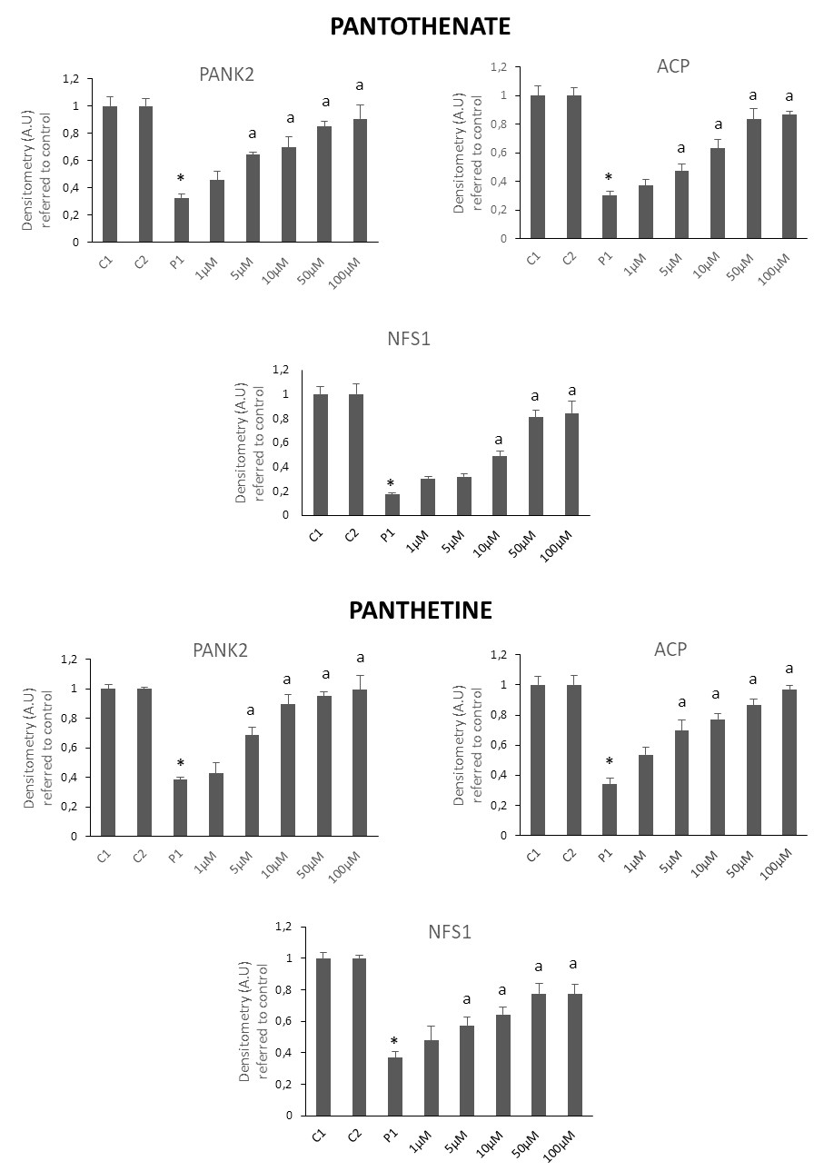
Supplementary Figure 1.
Densitometry Westerns Figure 3. Data represent the mean±SD of three separate experiments. *p<0.01 between PKAN patients and controls. ªp<0.01 between untreated and treated fibroblasts. A.U., arbitrary units.

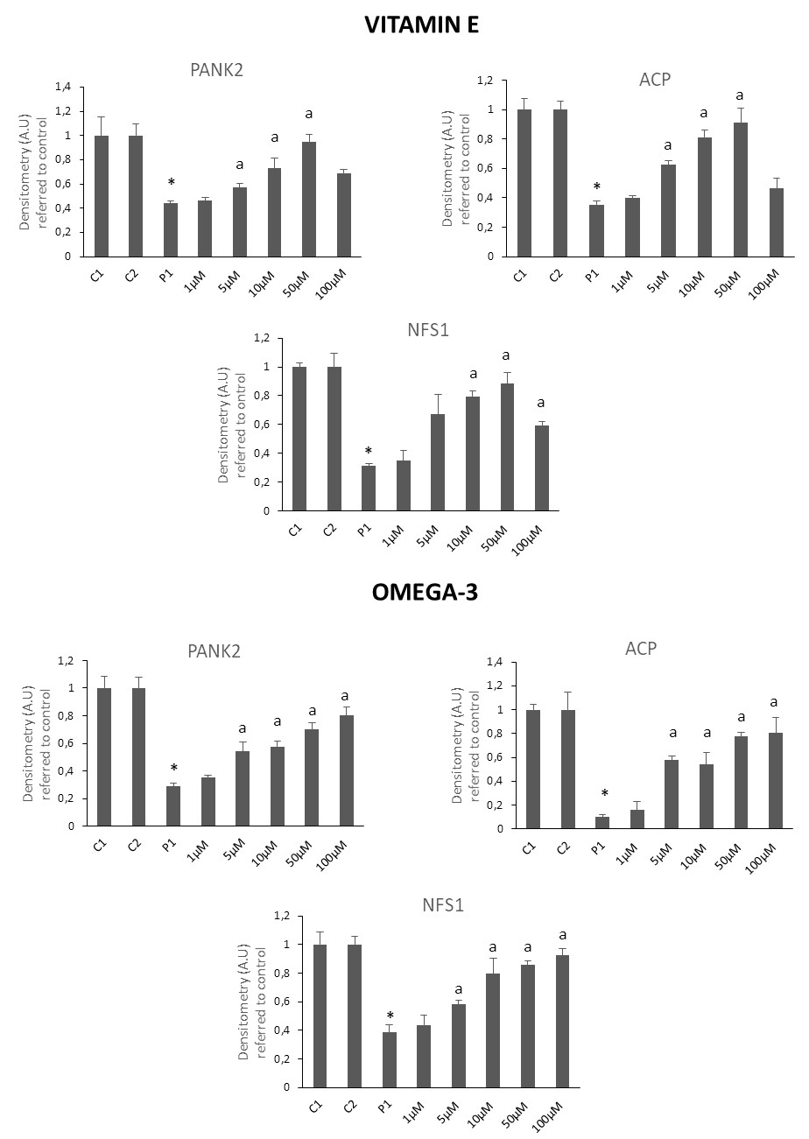

Supplementary Figure 2.
Densitometry Westerns Figure 4. Data represent the mean±SD of three separate experiments. *p<0.01 between PKAN patients and controls. ªp<0.01 between untreated and treated fibroblasts. A.U., arbitrary units.
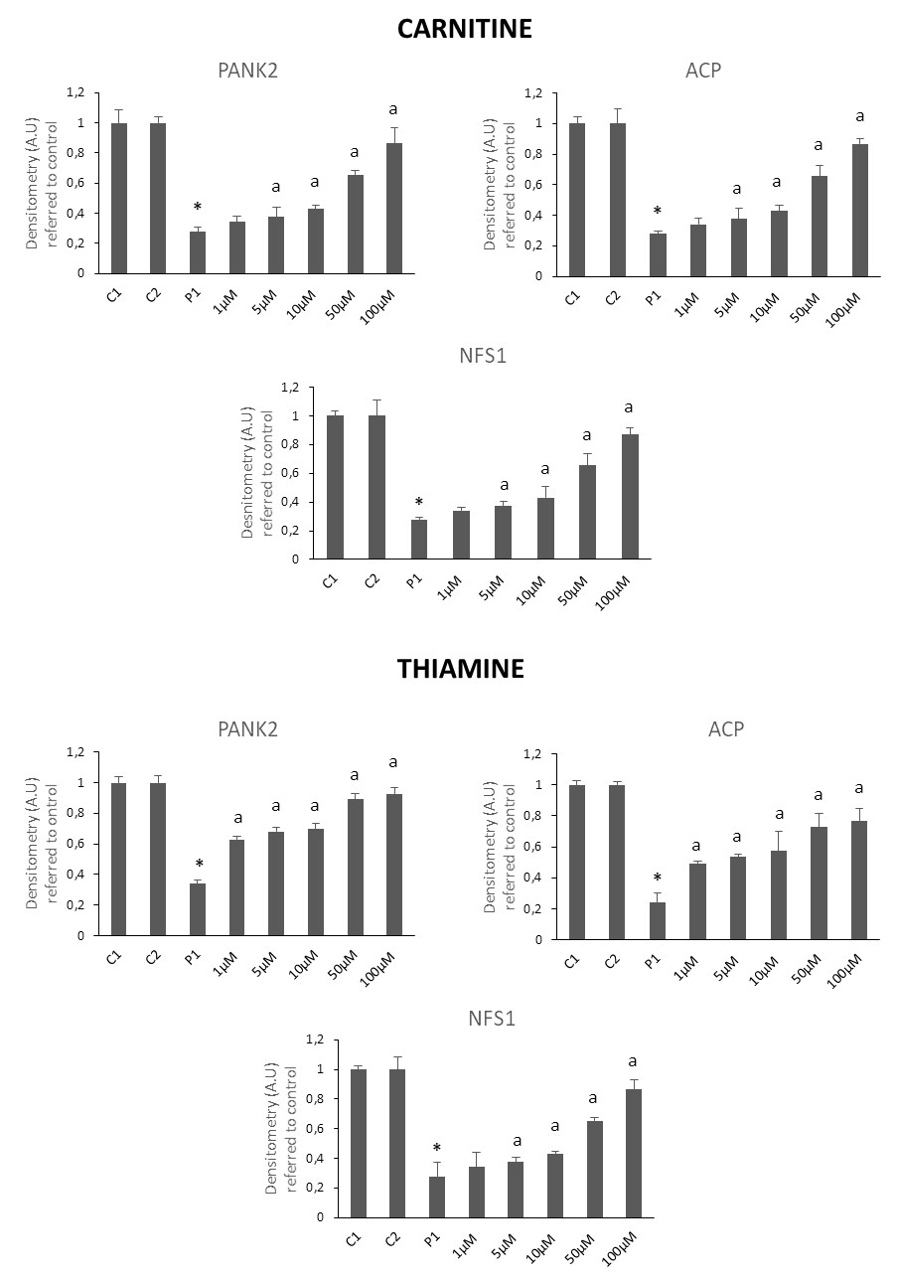

Supplementary Figure 3.
Densitometry Westerns Figure 5. Data represent the mean±SD of three separate experiments. *p<0.01 between PKAN patients and controls. ªp<0.01 between untreated and treated fibroblasts. A.U., arbitrary units.
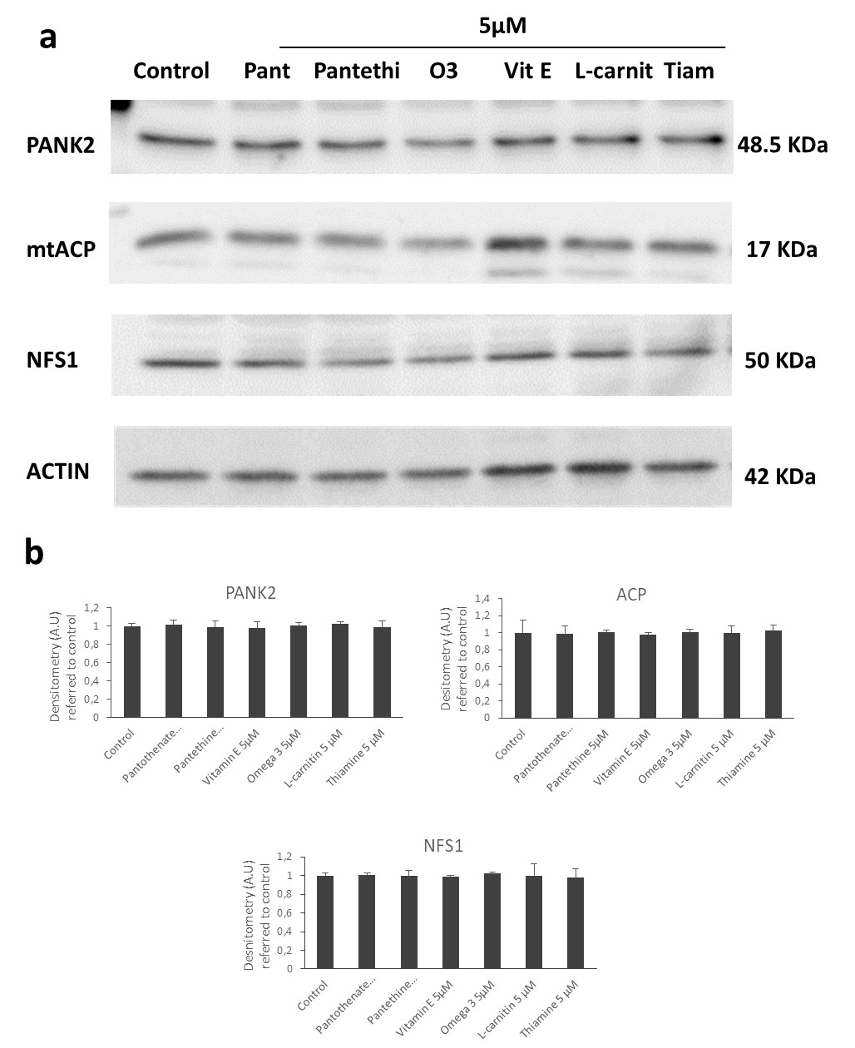
Supplementary Figure 4.
(a) Control cells were treated with pantothenate (Pant), pantethine (Pantethi), vitamin E (Vit E), omega 3 (O3), L-carnitine (L-carnit) or thiamine (Tiam) at 5 μM for 20 days. Protein extracts (50 μg) were separated on a SDS polyacrylamide gel and immunostained with antibodies against PANK2, mtACP and NFS1. Actin was used as a loading control. (b). Densitometry of the Western blotting of PANK2. Data represent the mean±SD of three separate experiments. *p<0.01 between PKAN patients and controls. ªp<0.01 between untreated and treated fibroblasts. A.U., arbitrary units.
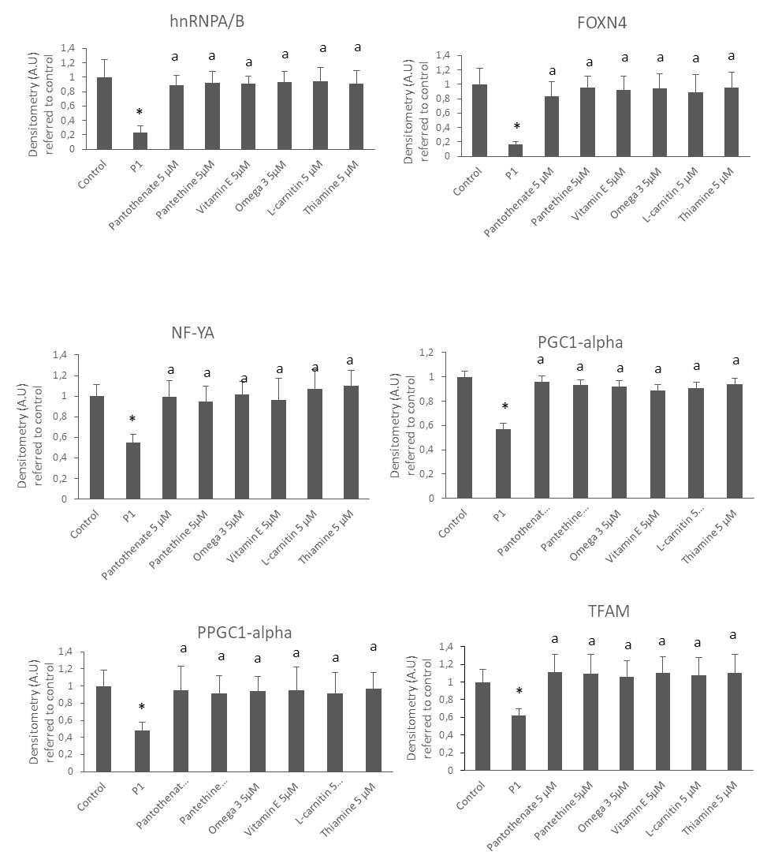

Supplementary Figure 5. Densitometry Westerns Figure 6b. Data represent the mean±SD of three separate experiments. *p<0.01 between PKAN patients and controls. ªp<0.01 between untreated and treated fibroblasts. A.U., arbitrary units.

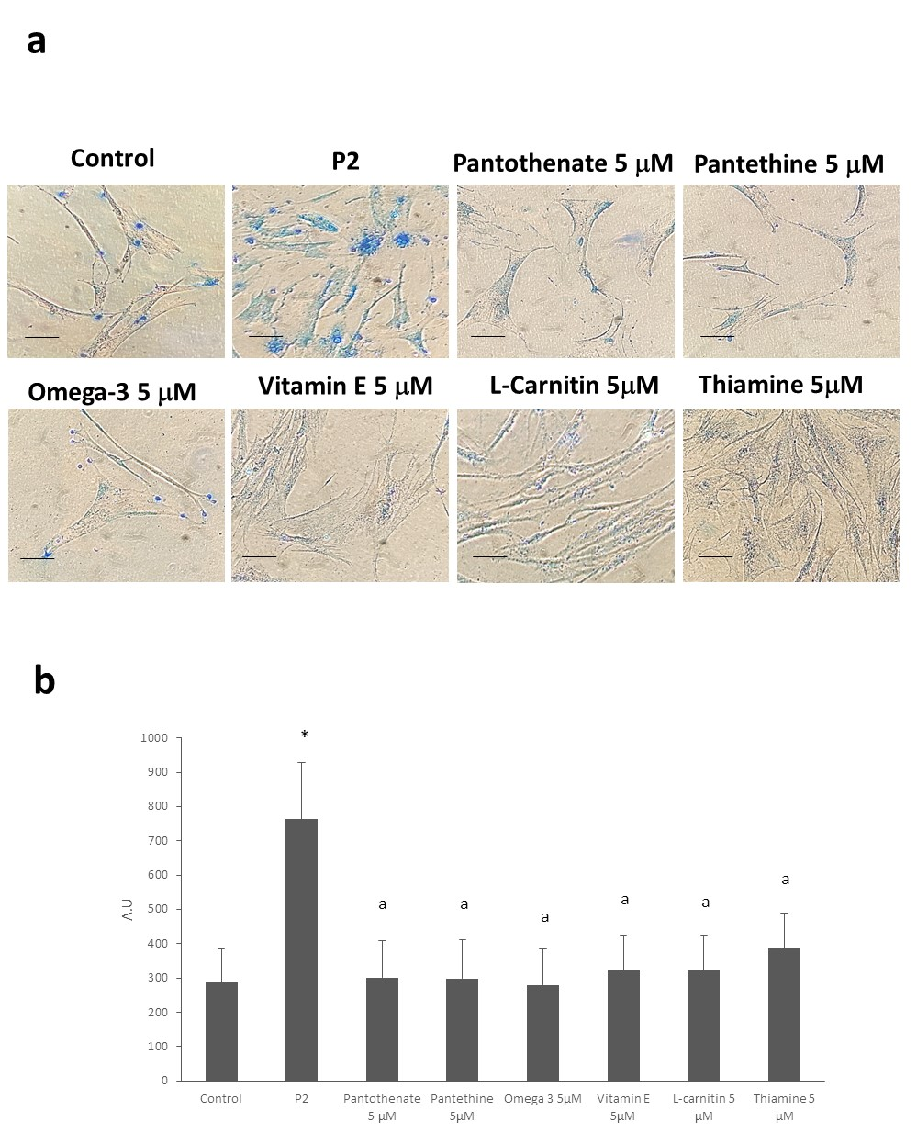

Supplementary Figure 6. (a) Control (C1) and PKAN fibroblasts (P2) were treated with pantothenate, pantethine, vitamin E, omega 3, L-carnitine or thiamine at 5 μM for 20 days. Then, cells were stained with Prussian Blue as described in material and Methods and examined by bright-field microscopy. Scale bar= 15 μm. (b) Quantification of Prussian Blue staining. Images were analyzed by the Image J software. *p<0.01 between Control and PKAN fibroblasts. ªp<0.01 between untreated and treated fibroblasts. A.U., arbitrary units.

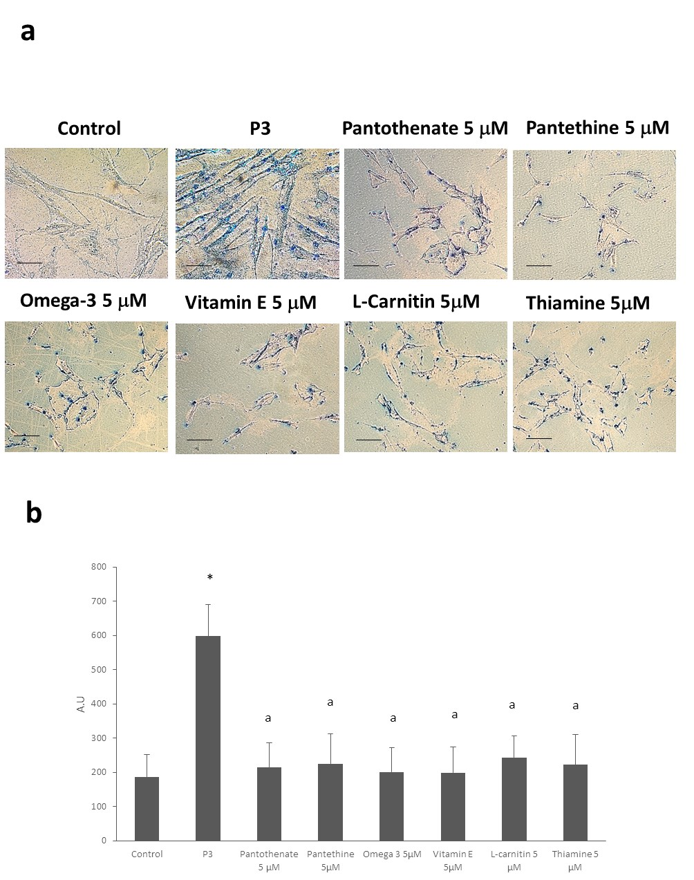

Supplementary Figure 7. (a) Control (C1) and PKAN fibroblasts (P3) were treated with pantothenate, pantethine, vitamin E, omega 3, L-carnitine or thiamine at 5 μM for 20 days. Then, cells were stained with Prussian Blue as described in material and Methods and examined by bright-field microscopy. Scale bar= 15 μm. (b) Quantification of Prussian Blue staining. Images were analyzed by the Image J software. *p<0.01 between Control and PKAN fibroblasts. ªp<0.01 between untreated and treated fibroblasts. A.U., arbitrary units.

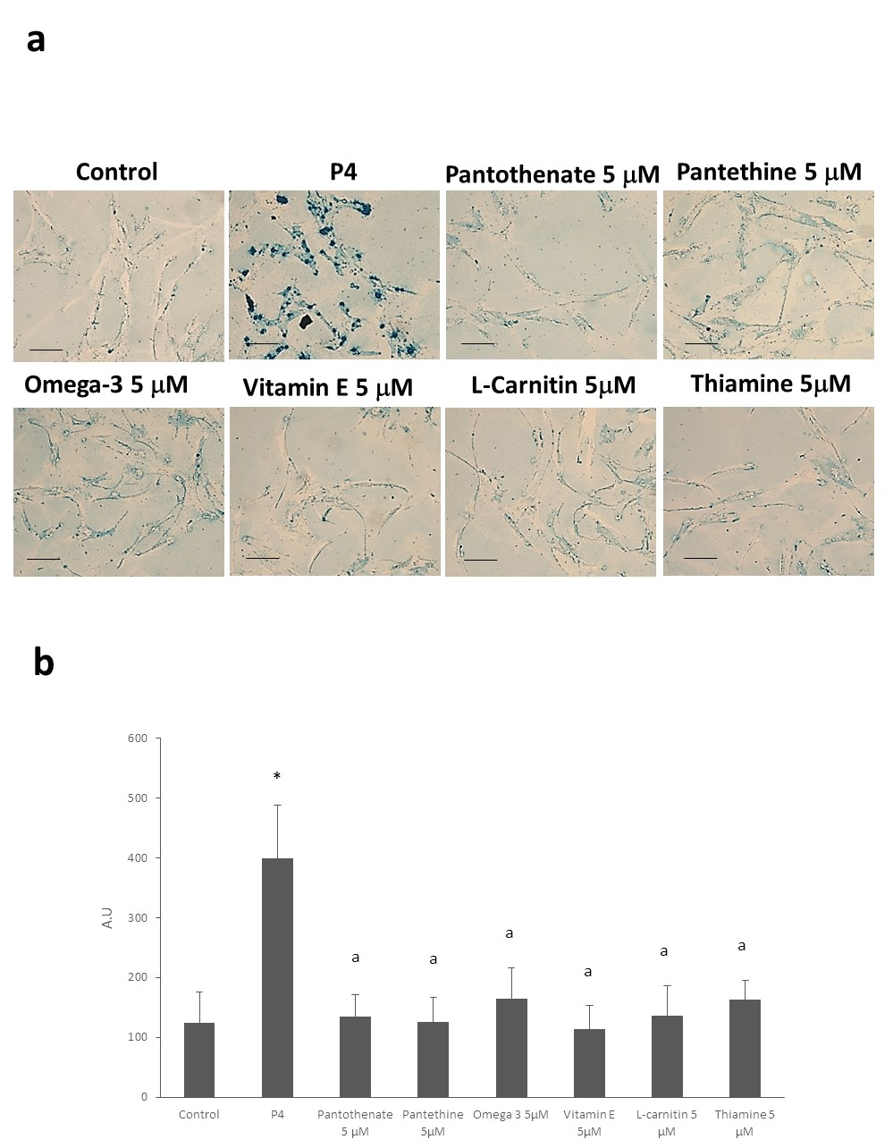

Supplementary Figure 8. (a) Control (C1) and PKAN fibroblasts (P4) were treated with pantothenate, pantethine, vitamin E, omega 3, L-carnitine or thiamine at 5 μM for 20 days. Then, cells were stained with Prussian Blue as described in material and Methods and examined by bright-field microscopy. Scale bar= 15 μm. (b) Quantification of Prussian Blue staining. Images were analyzed by the Image J software. *p<0.01 between Control and PKAN fibroblasts. ªp<0.01 between untreated and treated fibroblasts. A.U., arbitrary units.

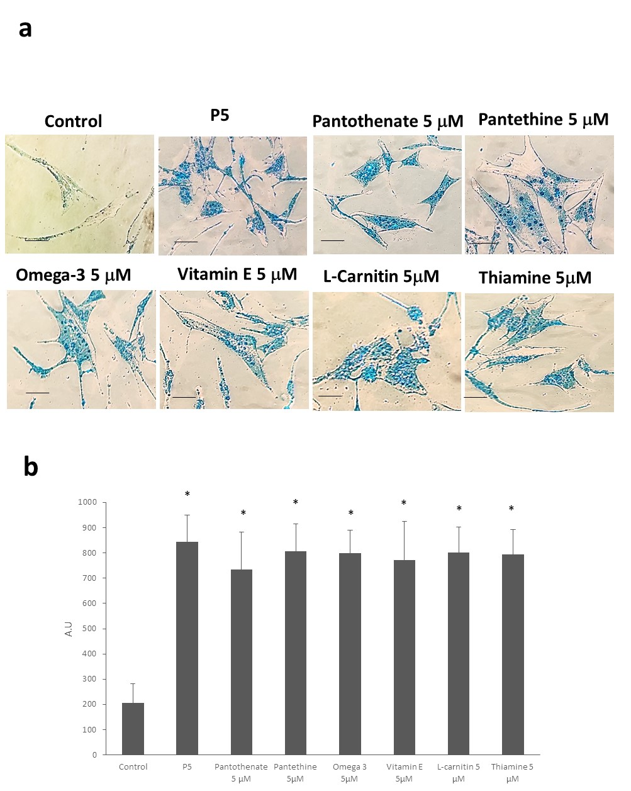

Supplementary Figure 9. (a) Control (C1) and PKAN fibroblasts (P5) were treated with pantothenate, pantethine, vitamin E, omega 3, L-carnitine or thiamine at 5 μM for 20 days. Then, cells were stained with Prussian Blue as described in material and Methods and examined by bright-field microscopy. Scale bar= 15 μm. (b) Quantification of Prussian Blue staining. Images were analyzed by the Image J software. *p<0.01 between Control and PKAN fibroblasts. ªp<0.01 between untreated and treated fibroblasts. A.U., arbitrary units.

