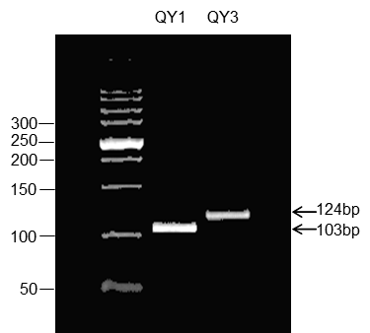
Figure S1 Development of the marker HTpros for amplifying the two different alleles of HTMYB2 (QY1 and QY3). The fragments yielded by the marker were either 124bp or 103 bp, which were indicative of promoter in QY1 and QY3, respectively.

