Supplementary Table S1: Primers used in this study.
Primers | 5’ 3’
OsCYP2 promoter FP | CGCGGATCCAACCGTAAAAAAGCCATGAT
OsCYP2 promoter RP | GGAAGATCTCTAGGGTTTTGCGAATTTC
p62 sense strand for Y1H | AGCTTCACGTGC
p62 antisense strand for Y1H | TCGAGCACGTGA
p63 sense strand for Y1H | AGCTTCTCGCGC
p63 antisense strand for Y1H | TCGAGCGCGAGA
p62 sense strand for EMSA | GGGTCACGTGCATC
p62 antisense strand for EMSA | GATGCACGTGACCC
p63 sense strand for EMSA | GGGTCTCGCGCATC
p63 antisense strand for EMSA | GATGCGCGAGACCC
Myc2-like FP for EMSA | CGGAATTCATGAACCTTTGGACGGACGA
Myc2-like RP for EMSA | CCAAGCTTCCGGGCGGCGGTGCCAGGCT
Myc2-like FP for overexpression | TCACCCGGGATGAACCTTTGGACGGACGA
Myc2-like RP for overexpression | TCACCCGGGTAGAGTTGAGTTACCGGGCG
Actin FP | GACCTTGCTGGGCGTGAT
Actin RP | GTCATAGTCCAGGGCGATGT
Myc2-like FP for qPCR | AGTGGTTCTTCCTCGTCTCC
Myc2-like RP for qPCR | AGGTTGAAGAGGGCGCGGAT
Note: The underlines indicate restriction enzyme site

Supplementary Table S2: Predicted cis-elements of OsCYP2 promoter.
Types | Elements | No. | Core sequence | Position ^{c}
CE ª | TATA box | 1 | TATAAAT | -736 (－)
 |  | 1 | TATATAA | -790 (＋)
 |  | 4 | TTATTT | -751 (＋), -813 (＋), -866 (＋), -1035 (－)
 |  | 1 | TATTTAA | -34 (＋)
 | CAAT box | 5 | CAAT | -204 (－), -669 (－), -711(－), -843 (－), -938 (－)
 | GATA box | 8 | GATA | -401 (－), -520 (－), -543 (－), -836 (＋), -985 (－), -1026 (－), -1050 (－), -1055 (＋)
IE ^{b} | ABRE | 2 | CACGTG | -86 (＋), -182 (＋)
 | MYBR | 3 | TAACCA | -110 (－), -142 (－), -153 (＋)，
 |  | 5 | CGGTT | -25 (－), -331 (－), -526 (－), -893 (＋), -1068 (－)
 |  | 3 | CCAACC | -45 (－), -337 (＋), -391 (＋)
ª CE: core elements; ^{b} IE: inducible elements; ^{c} Position of the cis-elements relative to the putative transcription start site. Strands are indicated as: (＋), forward; (－), complement

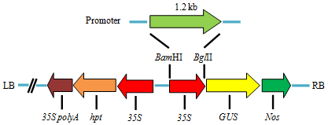

Supplementary Figure S1: Schematic diagram of pOsCYP2:GUS based on pCAMBIA1301 framework.

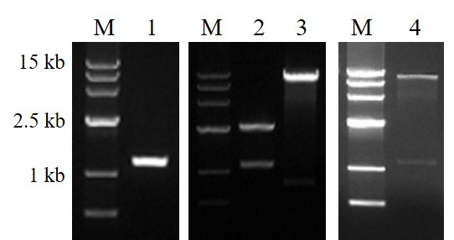
Supplementary Figure S2: Construction of pOsCYP2:GUS vector. M: Wide Range 500-15000 marker; 1: Fragment of promoter; 2 and 3: Digested pMD19-T + promoter and pCAMBIA1301, respectively; 4: Identification of recombined pOsCYP2:GUS vector.

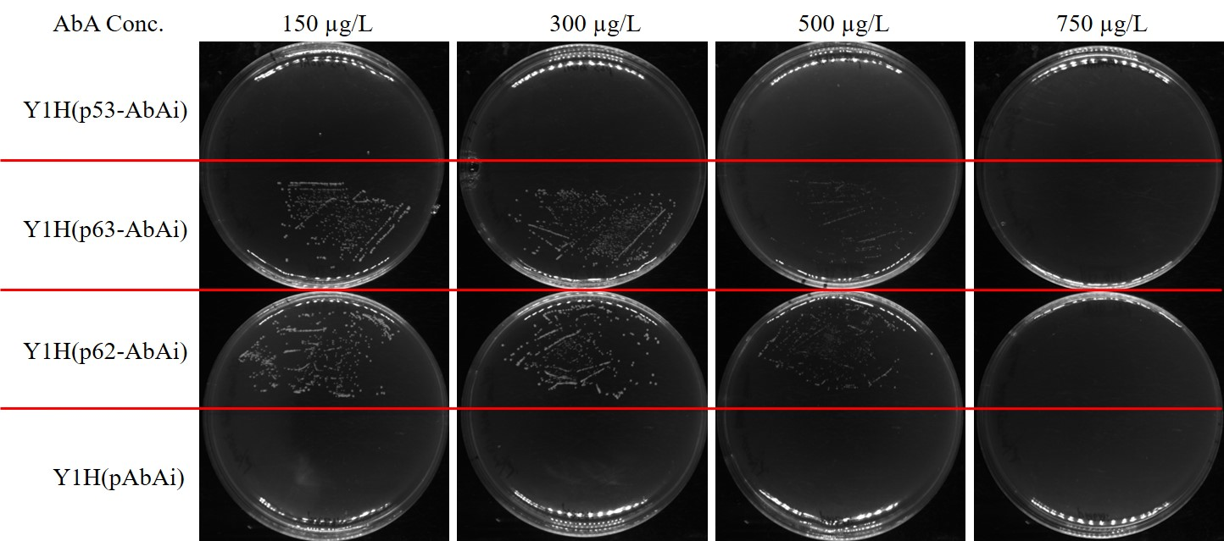
Supplementary Figure S3: Determine minimal inhibitory concentration of AbA for bait strain. Y1H (p53-AbAi), Y1H (pAbAi), Y1H (p62-AbAi), Y1H (p63-AbAi) represent positive, negative, bait and mutant bait strains respectively.

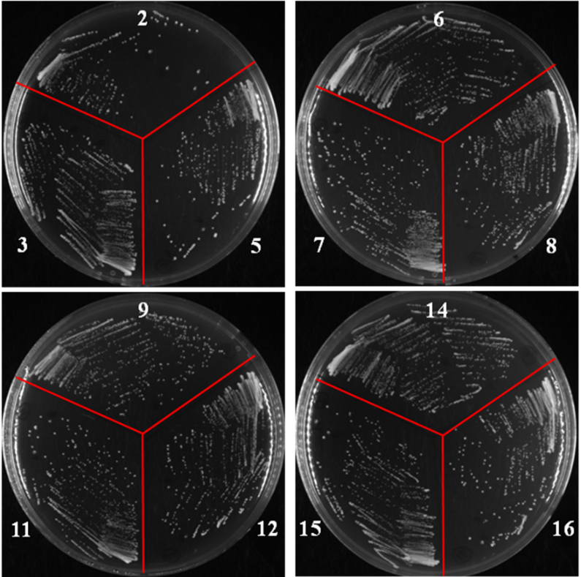
Supplementary Figure S4: Partial colonies were restreaked onto SD/-Leu/AbA media plates.

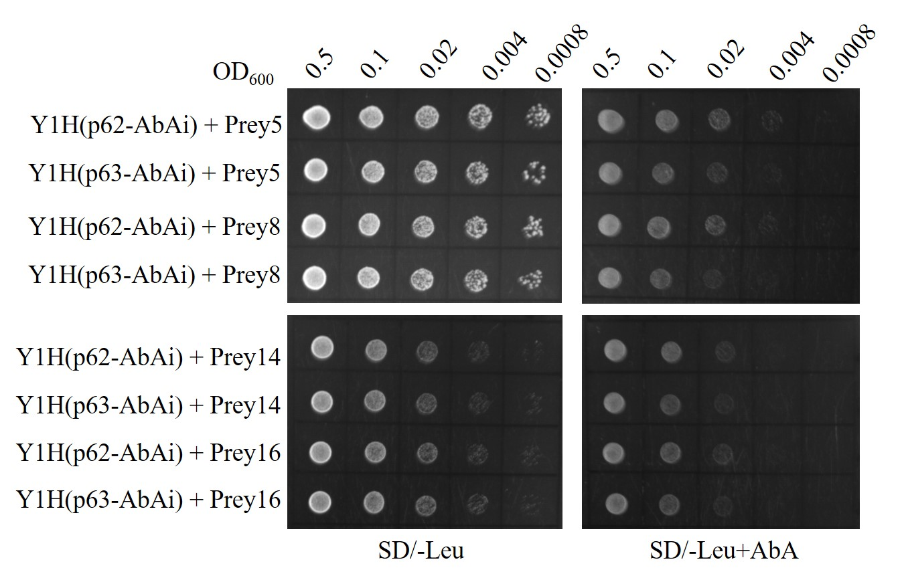
Supplementary Figure S5: Cotransformation and serial diluted (1:5) with the initial optical density OD600) of 0.5 on selective media to verify interactions of candidate interaction transcription factors. SD/-Leu: synthetically defined medium with dropout leucine, SD/-Leu+AbA: synthetically defined medium with dropout leucine and plus 750 μg/L Aureobasidin A; Y1H (p62-AbAi): bait strain, Y1H (p63-AbAi): mutant bait strain.

Supplementary Figure S6: Detection of recombinant Myc2-like with His tag by SDS-PAGE and stained using Coomassie brilliant blue R-250. M: Pre-stained protein marker RM013; 1: Myc2-like with His tag.

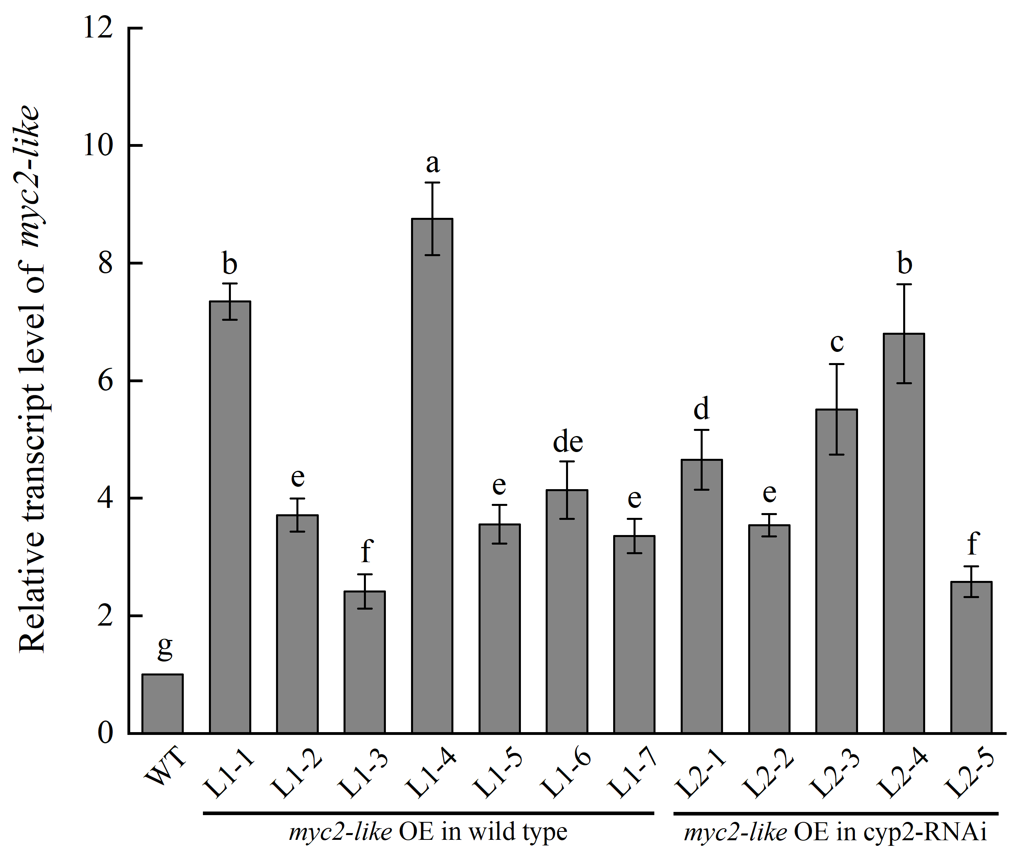
Supplementary Figure S7: Relative transcript level of myc2-like in the wild type, myc2-like overexpression in wild type and myc2-like overexpression in cyp2 RNAi. WT: wild type; L1-1, L1-2, L1-3, L1-4, L1-5, L1-6, L1-7: myc2-like overexpression (OE) in wild type; L2-1, L2-2, L2-3, L2-4, L2-5: Independent myc2-like overexpression (OE) in cyp2- RNAi. Values represent means and followed by different letters are significantly different (P≤0.05) by the least significant difference test. Error bars represent SD.

