Supplemental information

**Utilization of aminoguanidine prevents cytotoxic effects of semen**

Mirja Harms1, Pascal von Maltitz1, Benjamin Mayer2, Miriam Deniz3, Janis Müller1,4, Jan Münch1*

1Institute of Molecular Virology, University Ulm Medical Center, 89081 Ulm, Germany

2Institute for Epidemiology and Medical Biometry, Ulm University, Ulm, 89075, Germany.

3Department of Gynaecology and Obstetrics, Ulm University Hospital, 89075 Ulm, Germany

4Institute of Virology, Philipps University of Marburg, 35043, Marburg, Germany

*Corresponding author: [jan.muench@uni-ulm.de](mailto:jan.muench@uni-ulm.de)



**Figure S1: Spermine detection in pooled human seminal plasma.** Polyamine concentration was determined in pooled seminal plasma of 50 individual donors using SPE-LC-MS/MS according to Magnes et al. (2014).35

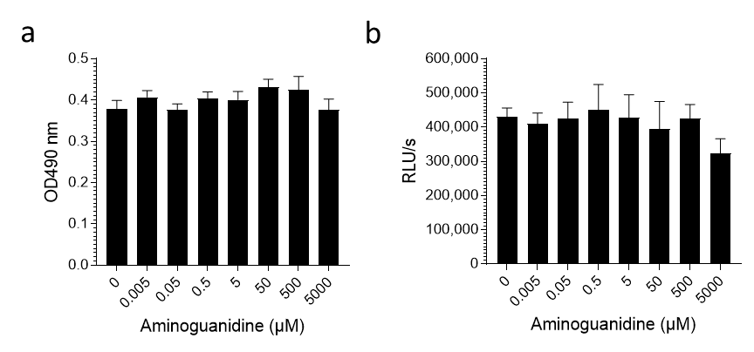

**Figure S2: Aminoguanidine is not cytotoxic.** TZM-bl cells (a) or isolated human PBMCs (b) were treated with indicated AG concentrations for two days. Viability was determined by MTT assay (a) or CellTiterGlo assay (b). Shown are data derived from triplicate treatment ± SD. RLU/s relative light units per second.

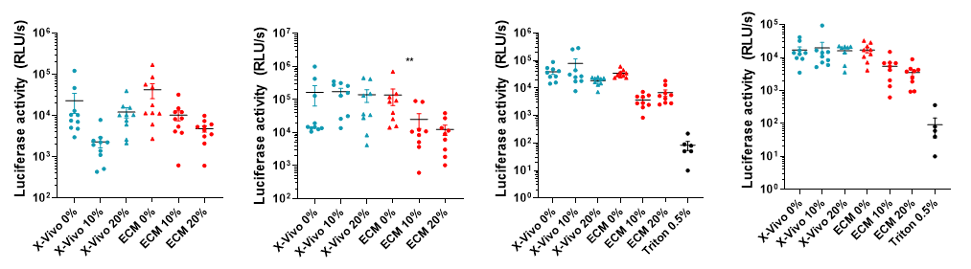

**Figure S3. AG in serum-free medium strongly reduces seminal plasma-derived cytotoxic effects in primary vaginal tissue.** 2 x 2 x 1 mm3 vaginal tissue blocks derived from 4 individual donors were incubated with 10% or 20% seminal plasma (or buffer) in the presence of chemically defined, serum free medium (Xvivo15) supplemented with 0.05 mM AG or in the presence of ECM growth medium supplemented with 10% FCS. After 3 days the individual blocks were washed twice with PBS and analyzed using CellTiterGlo viability assay. 0.5% triton was used as toxic control. Black lines indicate averages, RLU/s relative light units per second.