Supplementary materials

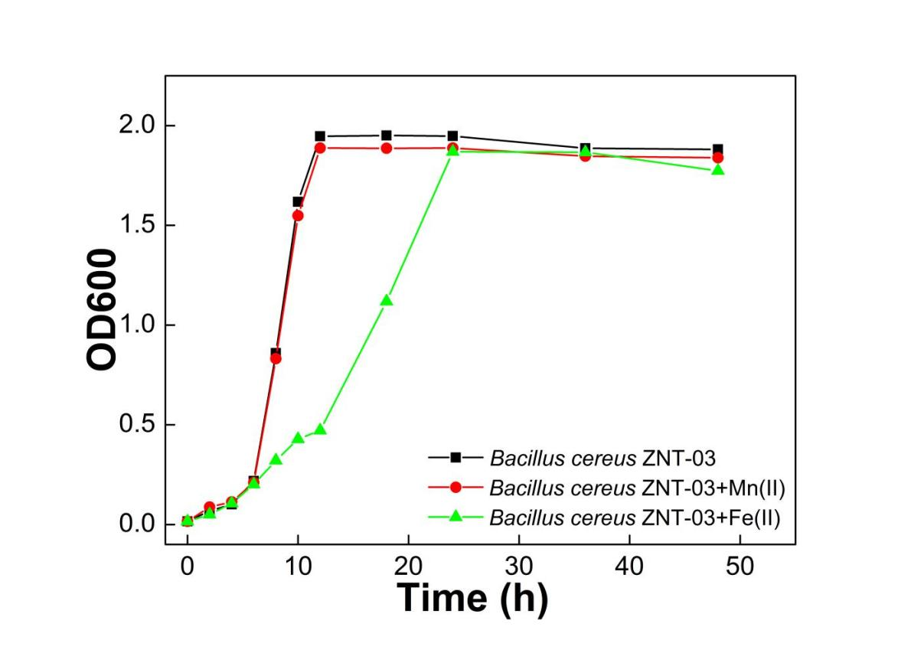
Fig. S1 Growth curves of Bacillus cereus ZNT-03

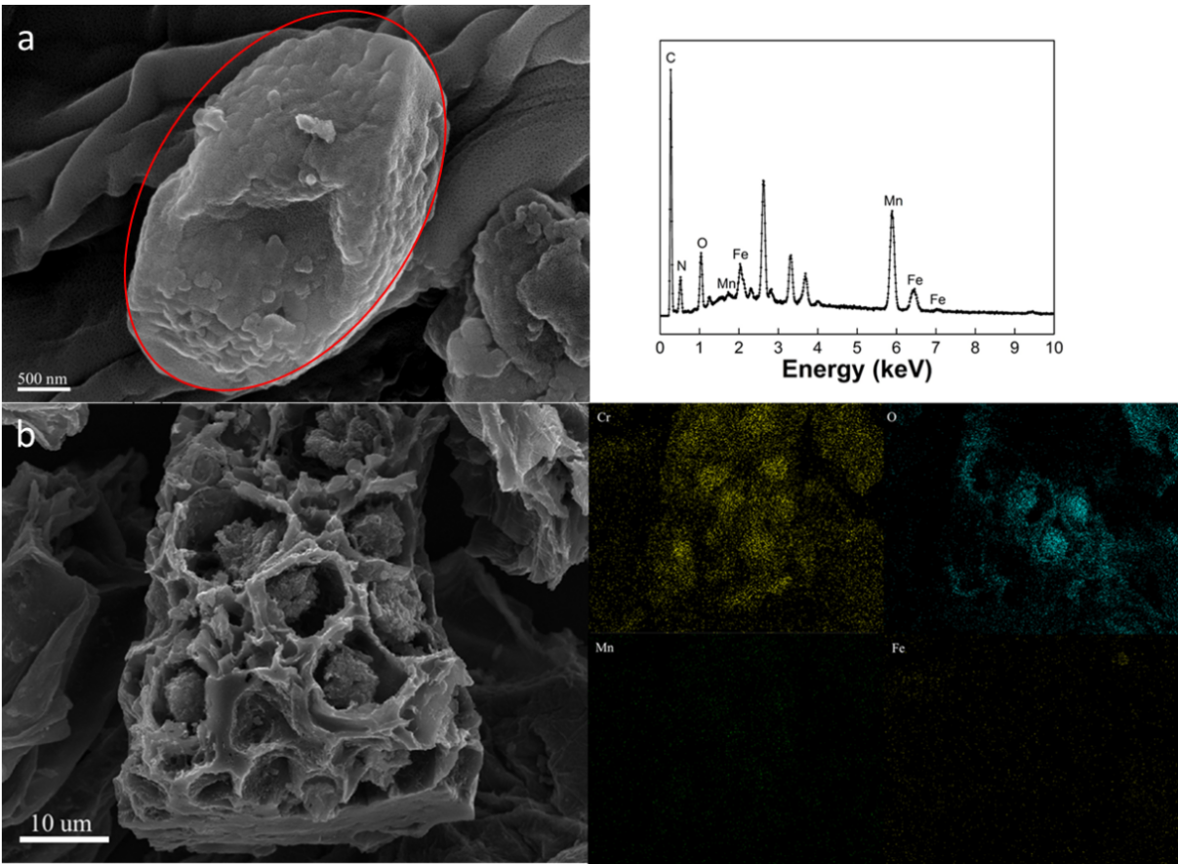
Fig. S2 SEM of FMBC before and after Cr(VI) adsorption (a) SEM-EDS of FMBC before Cr(VI) adsorption, and (b) SEM mapping of FMBC after Cr(VI) adsorption

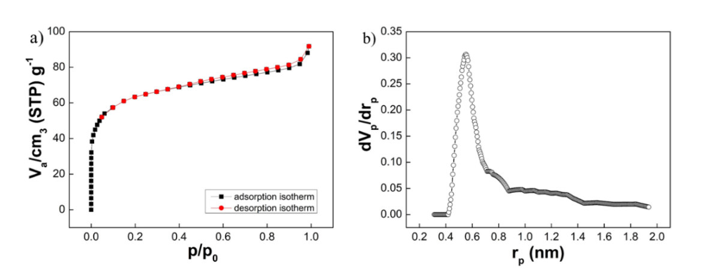
Fig. S3 (a) N₂ adsorption-desorption isotherm of FMBC; (b) pore size distribution of FMBC

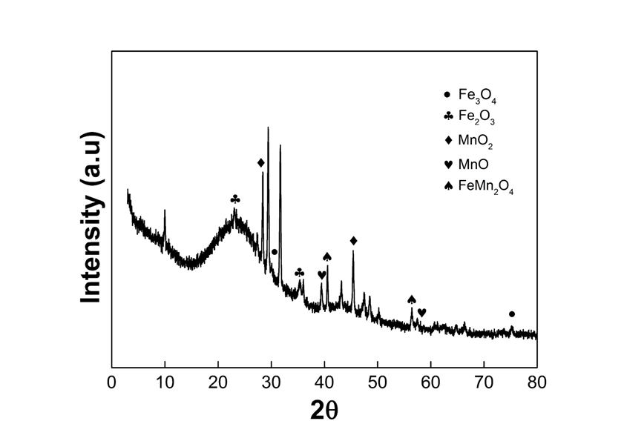
Fig. S4 XRD patterns of FMBC

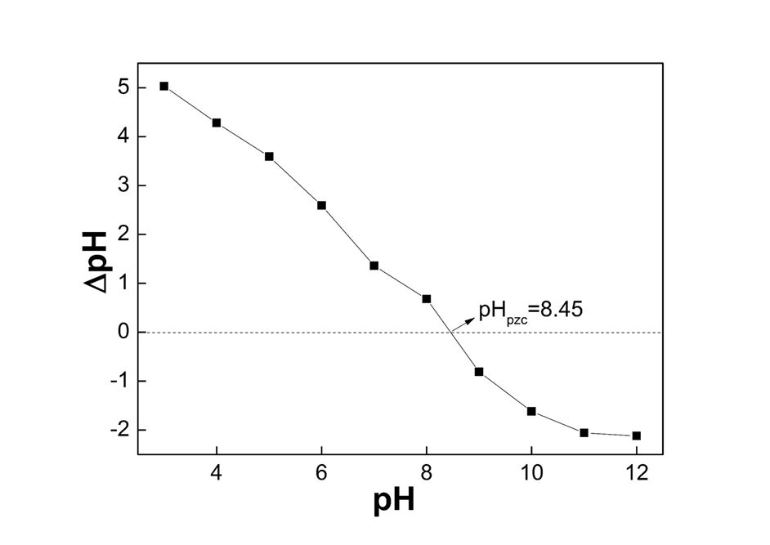
Fig. S5 pH_{zpc} of FMBC

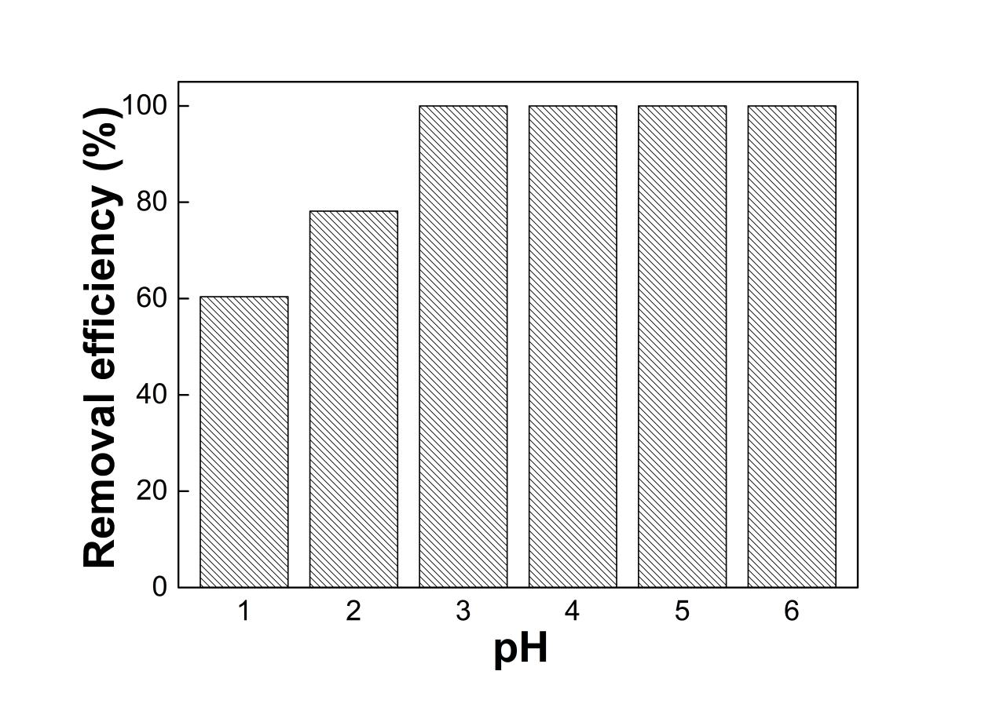
Fig. S6 The removal efficiency of Cr(III) using FMBC under different pH conditions (C₀ =27 mg L⁻¹; dosage = 1 g L⁻¹; T = 298 K)

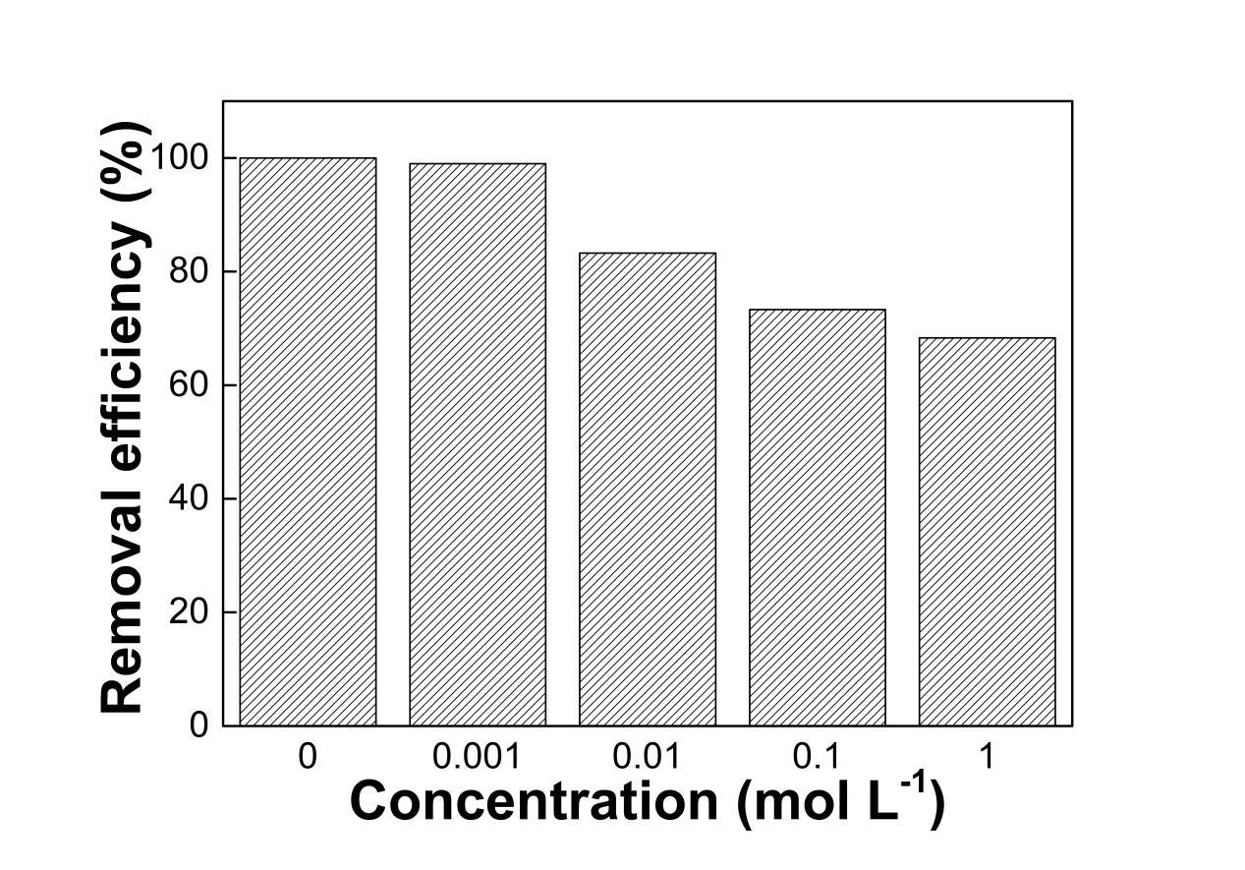
Fig. S7 Effects of coexisting ions (NaCl) on Cr(VI) removal by FMBC ( C₀ =17 mg L⁻¹; dosage = 1 g L⁻¹; T = 298 K; pH = 1.5)

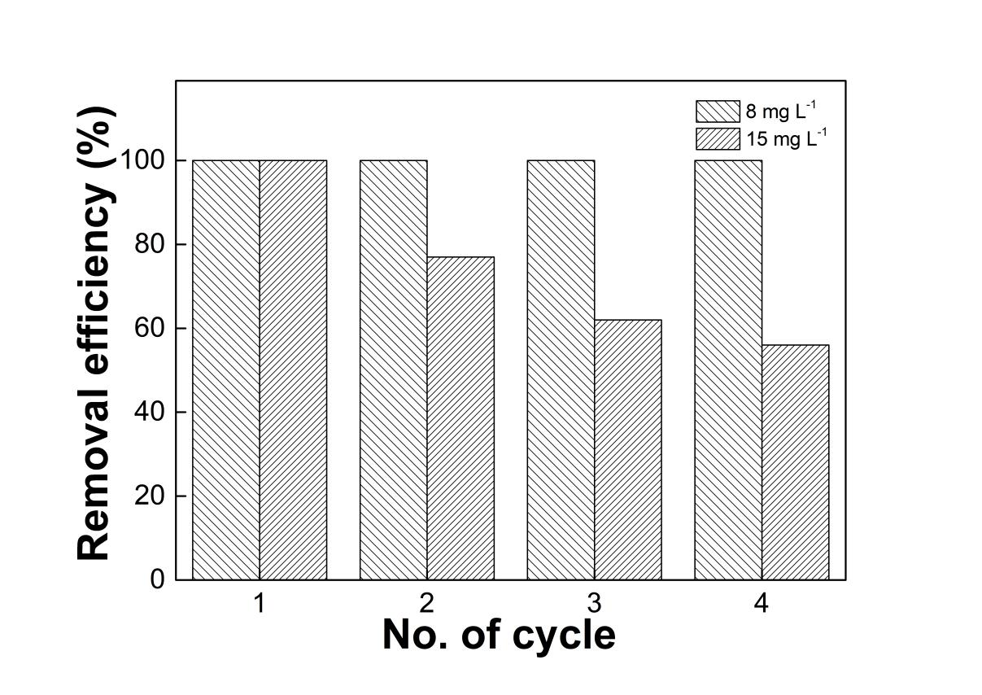
Fig. S8 Regeneration of FMBC ( dosage = 1 g L⁻¹; T = 298 K; pH = 1.5)
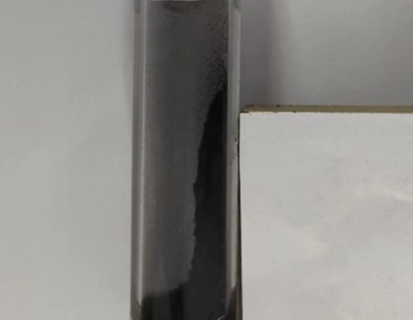
Fig. S9 Magnetism of FMBC after acidic soaking for 180 days

Table S1 The physical and chemical properties of FMBC
Properties | Average value
N (%) | 3.04
C (%) | 66.22
H (%) | 2.38
Fe (mg g⁻¹)) | 3.07
Mn (mg g⁻¹) | 2.56
BET surface area (m² g⁻¹) | 165.204
Total pore volume (cm³ g⁻¹) | 0.142

Table S2 Parameters for kinetic models of Cr(VI) adsorption using FMBC
Models | Parameters
Pseudo-first-order | q_{e} (mg g⁻¹)  K₁(min)  R²  q_{e} (mg g⁻¹)  K₂ (g mg⁻¹ min⁻¹)  R² | 10.46  5.27  0.97  10.71  1.48  0.98
10mg L⁻¹
Pseudo-second-order
10mg L⁻¹
Pseudo-first-order | q_{e} (mg g⁻¹)  K₁(min)  R²  q_{e} (mg g⁻¹)  K₂ (g mg⁻¹ min⁻¹)  R² | 14.65  3.80  0.95  15.28  0.51  0.97
20mg L⁻¹
Pseudo-second-order
20mg L⁻¹
Pseudo-first-order | q_{e} (mg g⁻¹)  K₁(min)  R²  q_{e} (mg g⁻¹)  K₂ (g mg⁻¹ min⁻¹)  R² | 17.23  1.60  0.98  19.00  0.13  0.98
30mg L⁻¹
Pseudo-second-order
30mg L⁻¹
Pseudo-first-order | q_{e} (mg g⁻¹)  K₁(min)  R²  q_{e} (mg g⁻¹)  K₂ (g mg⁻¹ min⁻¹)  R² | 25.61  1.70  0.94  27.35  0.11  0.97
40mg L⁻¹
Pseudo-second-order
40mg L⁻¹
The pseudo-first-order model (Eq. (1)) and pseudo-second-order model (Eq. (2)) are as follows (Chen et al., 2018):
$$q_{t}=q_{e}\left(1-e^{{-k}_{1}t}\right) (1)$$
$$q_{t}=q_{e}\left(1-\frac{1}{1+q_{e}k_{2}t}\right) (2)$$
Q_{e} and q_{t} (mg g⁻¹) are the adsorption amounts of Cr (VI) by adsorbents at equilibrium and time, respectively; k₁ (min⁻¹) and k₂ (g (mg·min)⁻¹) are the rate constants, respectively.

Table S3 Isotherm models parameters and correlation coefficients of Cr(VI) adsorption using FMBC
Temperature | Langmuir model |  | Freundlich model
278 K | q_{max} | 16.97 | K_{F} | 3.00
 | K_{L} | 0.10 | n | 2.35
 | R² | 0.97 | R² | 0.97
288 K | q_{max} | 18.54 | K_{F} | 8.50
 | K_{L} | 0.38 | n | 4.79
 | R² | 0.97 | R² | 0.91
298 K | q_{max} | 21.25 | K_{F} | 15.11
 | K_{L} | 1.94 | n | 9.35
 | R² | 0.93 | R² | 0.92
308 K | q_{max} | 17.84 | K_{F} | 14.48
 | K_{L} | 5.97 | n | 14.33
 | R² | 0.90 | R² | 0.86
Langmuir (Eq. (3)) and Freundlich (Eq. (4)) as follows (Xiao et al., 2018):
$$q_{e}=\frac{q_{max}C_{e}}{K_{L}^{-1}+C_{e}} (3)$$
$${q_{e}=K}_{F}C_{e}^{\frac{1}{n}} (4)$$
C_{e} (mg L⁻¹) is the equilibrium concentration, q_{e} and q_{m} (mg g⁻¹) are the equilibrium adsorption amounts and maximum adsorption capacity, respectively. K_{L} and K_{F} (L mg⁻¹) are the parameters. And n is the adsorption intensity.
Table S4 The XPS data of FMBC before and after Cr(VI) adsorption
 | Before adsorption | Binding Energy | Atomic | After adsorption | Binding Energy | Atomic
C 1s | C=C | 283.4 eV | 57.71% | C=C | 283.8 eV | 76.09%
 | C-C | 284.5 eV | 31.68% | C-C | 285.4 eV | 15.50%
 | C=O | 288.2 eV | 10.61% | C=O | 287.7 eV | 8.41%
O 1s | O²⁻ | 530.0 eV | 33.18% | O²⁻ | 529.8 eV | 1.63%
 | C=O | 531.2 eV | 3.48% | C=O | 530.7 eV | 16.61%
 | Fe-OH | 531.7 eV | 58.00% | Fe-OH | 530.9 eV | 62.48%
 | -OH | 534.9 eV | 5.34% | -OH | 532.6 eV | 19.28%
N 1s | Pyrrolic-N | 399.4 eV | 89. 40% | Pyrrolic-N | 398.9 eV | 100.0%
 | Fe-N_{x} | 397.4 eV | 7.25%
 | Pyridinic-N | 396.4 eV | 3.35%
Fe 2p | Fe (II) | 729.4 eV | 19.19% | Fe(II) | 731.5 eV | 23.99%
 | Fe (II) | 716.6 eV | 19.00% | Fe(II) | 718.7 eV | 23.75%
 | Fe (III) | 724.2 eV | 31.07% | Fe(III) | 723.8 eV | 26.27%
 | Fe (III) | 710.4 eV | 30.74% | Fe(III) | 710.0 eV | 25.99%
Mn 2p | Mn (II) | 644.2 eV | 17.73% | Mn(II) | 643.8 eV | 12.18%
 | Mn (II) | 655.9 eV | 17.83% | Mn(II) | 650.2 eV | 11.66%
 | Mn (VI) | 640.5 eV | 32.09% | Mn(VI) | 636.5 eV | 37.92%
 | Mn (VI) | 651.3 eV | 32.34% | Mn(VI) | 647.4 eV | 38.25%
Cr 2p |  |  |  | Cr(III) | 576.3 eV | 37.97%
 |  |  |  | Cr(III) | 586.6 eV | 34.28%
 |  |  |  | Cr(VI) | 577.5 eV | 23.75%
 |  |  |  | Cr(VI) | 589.2 eV | 4.00%

Table S5 Comparison of the maximum adsorption capacities of Cr(VI) on FMBC with other adsorbents
Experimental conditions
Absorbents | Q_{max} | pH | Treatment | Reference
 | (mg g⁻¹) |  | Time (h)
Wheat straw biochar | 21.34 | 1 | 5 | Wang et al. (2010)
Citrobacter freundii biochar | 19.43 | 2 | 12 | Simranjeet et al. (2022)
Tamarindus indica bark biochar | 21.00 | 2 | - | Goyal et al. (2016)
Core Shell adsorbents | 15.60 | 2.5 | 0.5 | Campos et al. (2019)
Pineapple peel biochar | 7.44 | 4 | 35 | Wang et al. (2016)
Magnetic carbon | 3.74 | 7 | 0.25 | Zhu et al. (2014)

References
Campos AFC, De Oliveira HAL, Da Silva FN, Da Silva FG, Coppola P, Aquino R, Mezzi A, Depeyrot J (2019) Core-Shell bimagnetic nanoadsorbents for hexavalent chromium removal from aqueous solutions. J Hazard Mater 362:82-91
Chen YY, Wang BY, Xin J, Sun P, Wu D (2018) Adsorption behavior and mechanism of Cr(VI) by modified biochar derived from Enteromorpha prolifera. Ecotoxicol Environ saf 164:440-447
Goyal S, Goyal Va (2016) Cr(VI) removal from synthetic textile effluent using Tamarindus indica bark: a kinetic and thermodynamic study on JSTOR. Curr Sci 110:392-398
Simranjeet S, Amith GA, Sunil Kumar TSN, Basavaraju U, Sutripto K, Bidisha N, Vineet K, Subramanian S, Joginder S, Praveen CR (2022) Mechanism and kinetics of Cr(VI) adsorption on biochar derived from Citrobacter freundii under different pyrolysis temperatures. Journal of Water Process Engineering 47:102723
Xiao R, Wang JJ, Li RH, Park J, Meng YH, Zhou B, Pensky S, Zhang ZQ (2018) Enhanced sorption of hexavalent chromium [Cr(VI)] from aqueous solutions by diluted sulfuric acid-assisted MgO-coated biochar composite. Chemosphere 208:408-416
Wang CH, Gu LF, Liu XY, Zhang XY, Cao LY, Hu XX (2016) Sorption behavior of Cr(VI) on pineapple-peel-derived biochar and the influence of coexisting pyrene. Int Biodeterior Biodegrad 111:78-84
Wang XS, Chen LF, Li FY, Chen KL, Wan WY, Tang YJ (2010) Removal of Cr (VI) with wheat-residue derived black carbon: reaction mechanism and adsorption performance. J Hazard Mater 175:816-822
Zhu JH, Gu HB, Guo J, Chen MJ, Wei HG, Luo ZP, Colorado HA, Yerra N, Ding DW, Ho TC, Haldolaarachchige N, Hopper J, Young DP, Guo ZH, Wei SY (2014) Mesoporous magnetic carbon nanocomposite fabrics for highly efficient Cr(VI) removal. J Mater Chem A 2:2256-2265

