Supplementary Table 1. Univariate and multivariate analyses for predictive factors of strong antibody response at each time point
 | Anti-S IgG at T1 |  | p-value | Adjusted OR (95% CI) | Anti-S IgG at T2 |  | p-value | Adjusted OR (95% CI)
 | <250 U/mL  (n=134) | ≥250 U/mL  (n=43) |  |  | <5400 U/mL  (n=111) | ≥5400 U/mL  (n=60)
Age, year (SD) | 25.2 (3.6) | 25.9 (4.5) | 0.322 | 1.036 (0.953-1.127)ª | 25.3 (2.7) | 25.5 (5.4) | 0.759 | 1.009 (0.931-1.094)ª
 |  |  |  |  |  |  |  | 1.023 (0.944-1.110)^{b}
Male | 39 (29.1%) | 14 (32.6%) | 0.667 | 1.223 (0.522-2.867)ª | 72 (64.9%) | 46 (76.7%) | 0.111 | 1.525 (0.674-3.449)ª
 |  |  |  |  |  |  |  | 1.716 (0.718-4.102)^{b}
BMI, kg/m² (SD) | 21.3 (2.8) | 22.1 (3.0) | 0.103 | 1.108 (0.970-1.266)ª | 21.8 (2.9) | 21.2 (2.9) | 0.212 | 0.969 (0.854-1.100)ª
 |  |  |  |  |  |  |  | 0.982 (0.863-1.116)^{b}
AE after dose 1
Any AE | 134 (100%) | 42 (97.7%) | 0.243 |  | 110 (99.1%) | 60 (100%) | 0.461
Any local AE | 132 (98.5%) | 42 (97.7%) | 0.568 |  | 108 (97.3%) | 60 (100%) | 0.271
pain | 130 (97%) | 40 (93%) | 0.226 | 0.471 (0.097-2.288)ª | 105 (94.6%) | 59 (98.3%) | 0.227 | 2.638 (0.297-23.399)ª
swelling | 23 (17.2%) | 4 (9.3%) | 0.212 |  | 18 (16.2%) | 9 (15.0%) | 0.835
Motion limitation | 119 (88.8%) | 39 (90.7%) | 0.490 |  | 95 (85.6%) | 57 (95.0%) | 0.062
Any systemic AE | 118 (88.1%) | 37 (86.0%) | 0.728 |  | 96 (86.5%) | 53 (88.3%) | 0.731
fever | 28 (20.9%) | 10 (23.3%) | 0.743 |  | 19 (17.1%) | 16 (26.7%) | 0.140
chill | 30 (22.4%) | 7 (16.3%) | 0.391 |  | 23 (20.7%) | 11 (18.3%) | 0.709
headache | 40 (29.9%) | 16 (37.2%) | 0.367 |  | 32 (28.8%) | 22 (36.7%) | 0.293
Muscle pain | 98 (73.1%) | 32 (74.4%) | 0.868 |  | 77 (69.4%) | 48 (80.0%) | 0.135
Fatigue | 78 (58.2%) | 26 (60.5%) | 0.794 |  | 66 (59.5%) | 33 (55.0%) | 0.573
arthralgia | 13 (9.7%) | 4 (9.3%) | 0.602 |  | 10 (9.0%) | 6 (10.0%) | 0.832
vomiting | 3 (2.2%) | 0 (0.0%) | 0.432 |  | 3 (2.7%) | 0 (0.0%) | 0.271
Rash | 10 (7.5%) | 3 (7.0%) | 0.609 |  | 10 (9.0%) | 3 (5.0%) | 0.267
dyspnea | 4 (3.0%) | 1 (2.3%) | 0.648 |  | 4 (3.6%) | 1 (1.7%) | 0.424
flushing | 4 (3.0%) | 1 (2.3%) | 0.648 |  | 4 (3.6%) | 1(1.7%) | 0.424
Facial palsy | 4 (3.0%) | 1 (2.3%) | 0.648 |  | 4 (3.6%) | 1(1.7%) | 0.424
paresthesia | 14 (10.4%) | 1 (2.3%) | 0.080 |  | 12 (10.8%) | 3 (5.0%) | 0.200
Antipyretic use | 81 (60.4%) | 26 (60.5%) | 0.998 | 1.009 (0.491-2.073)ª | 58 (52.3%) | 43 (71.7%) | 0.014 | 2.202 (1.110-4.367)ª
AE after dose 2
Any AE |  |  |  |  | 108 (97.3%) | 60 (100%) | 0.271
Any local AE |  |  |  |  | 107 (96.4%) | 57 (95.0%) | 0.470
pain |  |  |  |  | 104 (93.7%) | 57 (95.0%) | 0.510 | 0.511 (0.098-2.652)^{b}
swelling |  |  |  |  | 21 (18.9%) | 17 (28.3%) | 0.158
Motion limitation |  |  |  |  | 98 (88.3%) | 54 (90.0%) | 0.734
Any systemic AE |  |  |  |  | 104 (93.7%) | 59 (98.3%) | 0.161
fever |  |  |  |  | 76 (68.5%) | 49 (81.7%) | 0.063
chill |  |  |  |  | 73 (65.8%) | 48 (80.0%) | 0.051
headache |  |  |  |  | 76 (68.5%) | 44 (73.3%) | 0.507
Muscle pain |  |  |  |  | 89 (80.2%) | 52 (86.7%) | 0.287
Fatigue |  |  |  |  | 86 (77.5%) | 48 (80.0%) | 0.702
arthralgia |  |  |  |  | 29 (26.1%) | 16 (26.7%) | 0.939
vomiting |  |  |  |  | 12 (10.8%) | 4 (6.7%) | 0.375
Rash |  |  |  |  | 6 (5.4%) | 5 (8.3%) | 0.330
dyspnea |  |  |  |  | 6 (5.4%) | 0 (0.0%) | 0.071
flushing |  |  |  |  | 1 (0.9%) | 0 (0.0%) | 0.649
Facial palsy |  |  |  |  | 1 (0.9%) | 0 (0.0%) | 0.649
paresthesia |  |  |  |  | 5 (4.5%) | 3 (5.0%) | 0.578
Antipyretic use |  |  |  |  | 96 (86.5%) | 59 (98.3%) | 0.011 | 10.033 (1.185-84.924)^{b}

OR, odds ratio; SD, standard deviation; BMI, body mass index; AE, adverse event
ª Adjusted for age, sex, BMI, injection site pain after dose 1, and antipyretic use after dose 1
^{b} Adjusted for age, sex, BMI, injection site pain after dose 2, and antipyretic use after dose 2

Supplementary Figure 1. Solicited adverse events after each dose.
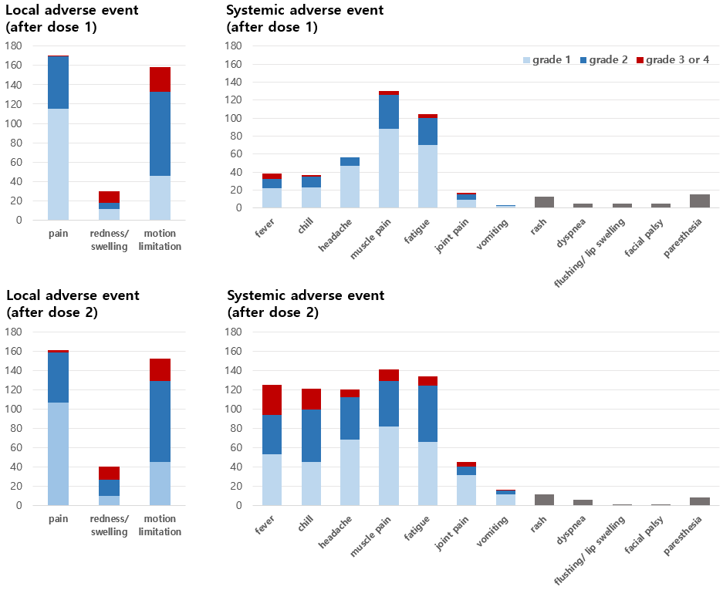

Supplementary Figure 2. Correlation between anti-SARS-CoV-2 S IgG and neutralizing antibody titer at each time point: (A) Four weeks and (B) Eight weeks after first injection.

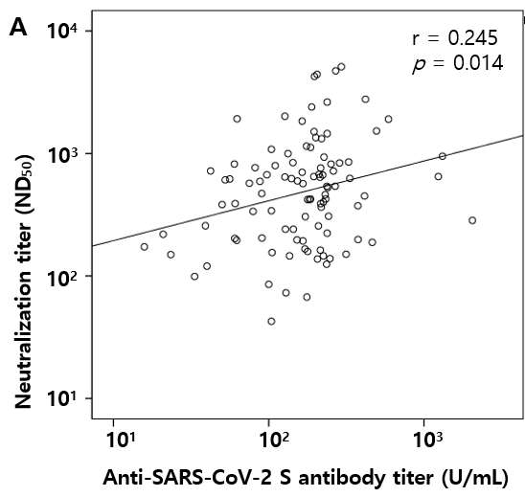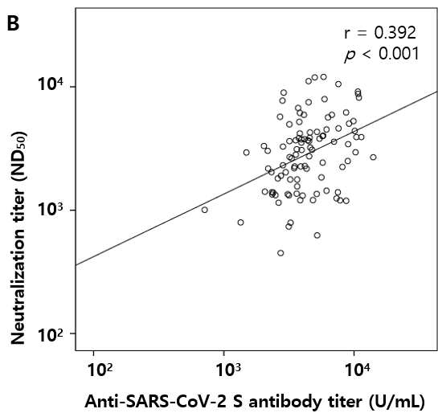
Supplementary Figure 3. Relationship of immune response with (A) highest severity of all adverse events, (B) highest severity of local adverse events, and (C) highest severity of systemic adverse events at each time point. Immune responses are presented as geometric mean titer.

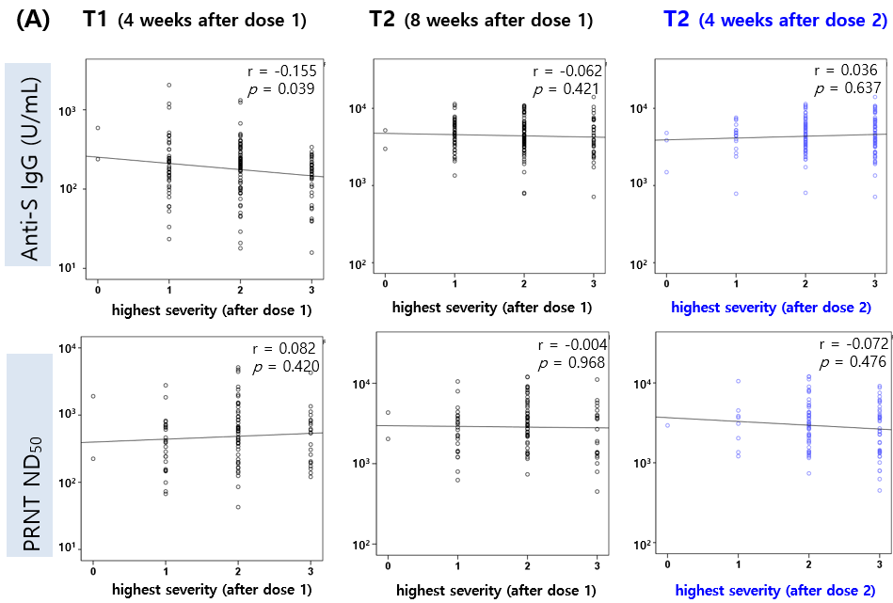
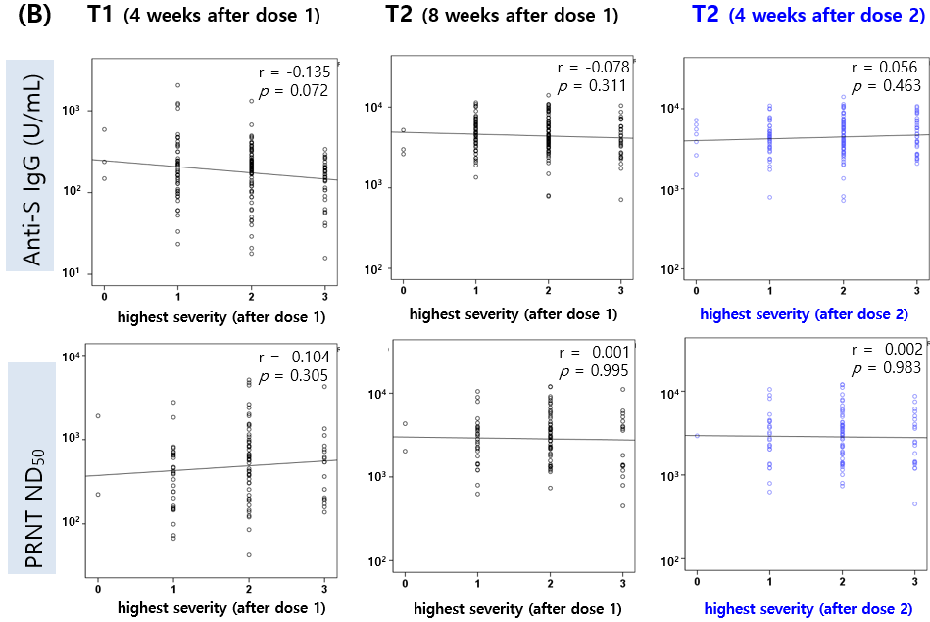
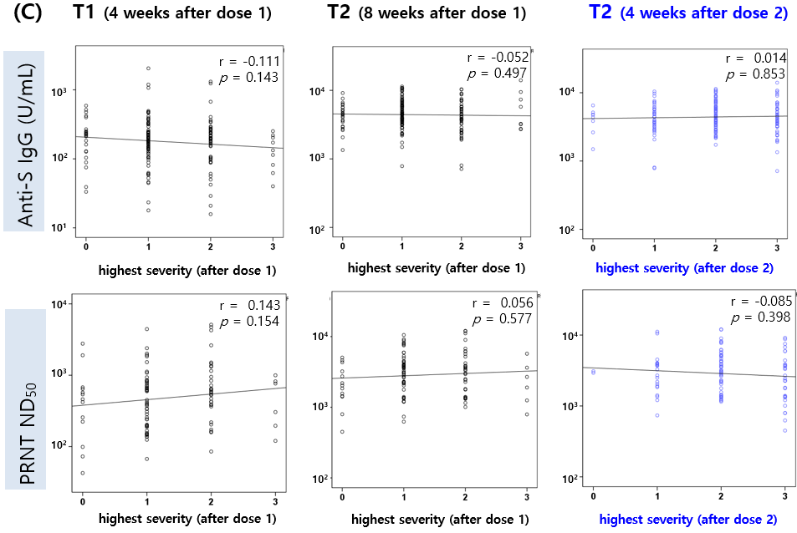

Supplementary Figure 4. Relationship of anti-SARS-CoV-2 S antibody response with (A) systemic SUM and SOM, and (B) localized SUM and SOM at each time point. SUM, sum of the severity scores; SoM, sum of multiplying each symptoms' severity by the duration of symptoms
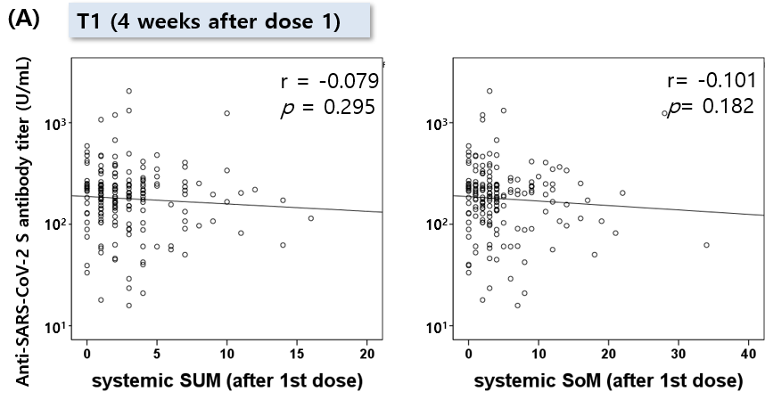
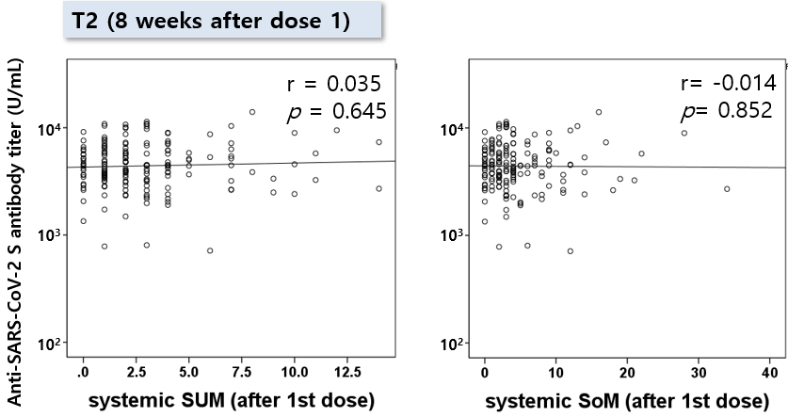
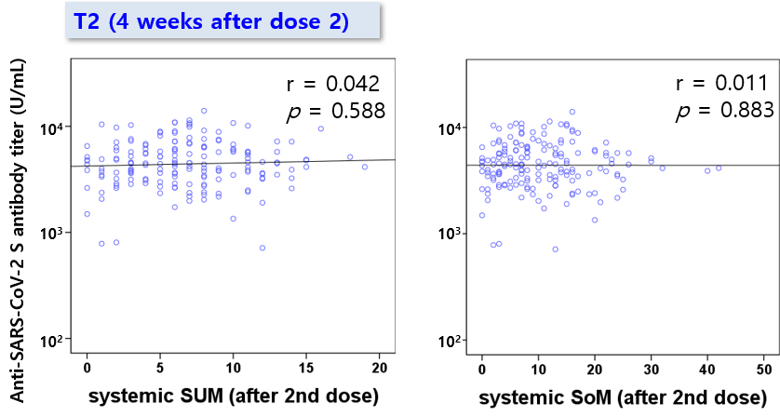
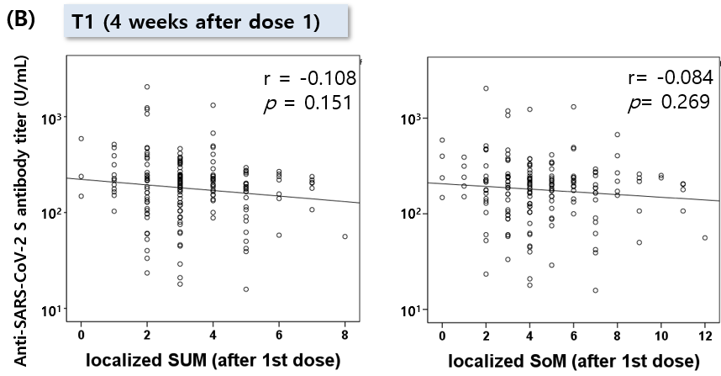
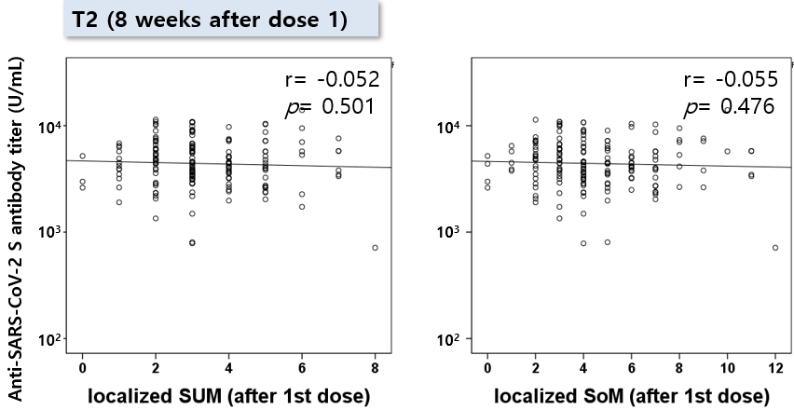
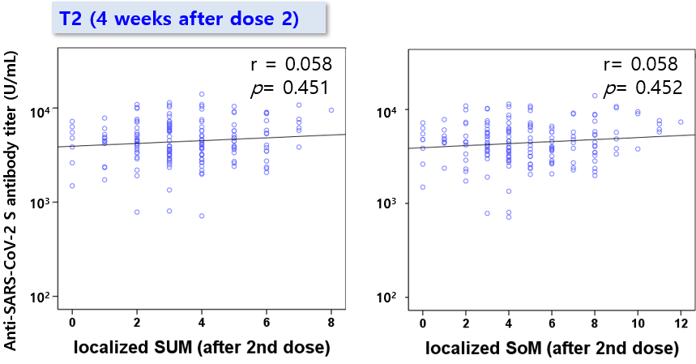

Supplementary Figure 5. Relationship of neutralizing antibody response (PRNT ND₅₀) with (A) systemic SUM and SoM, and (B) localized SUM and SoM at each time point. PRNT, plaque reduction neutralization test; SUM, sum of the severity scores; SoM, sum of multiplying each symptoms' severity by the duration of symptoms

