Supplementary Materials: Automated and stable LED array illumination system for multiwell plate cell culture photodynamic therapy experiments
Kai Zhang, Sudip Timilsina, Matthew Waguespack, Eric M. Kercher, and Bryan Q. Spring

S1. Well plate layout

Fig. 2b shows a typical layout to measure the light-dose response for two different treatment groups. The cells of the groups are in the same plate during the culturing, drug application, and viability measurement processes to minimize the error due to the environmental difference.

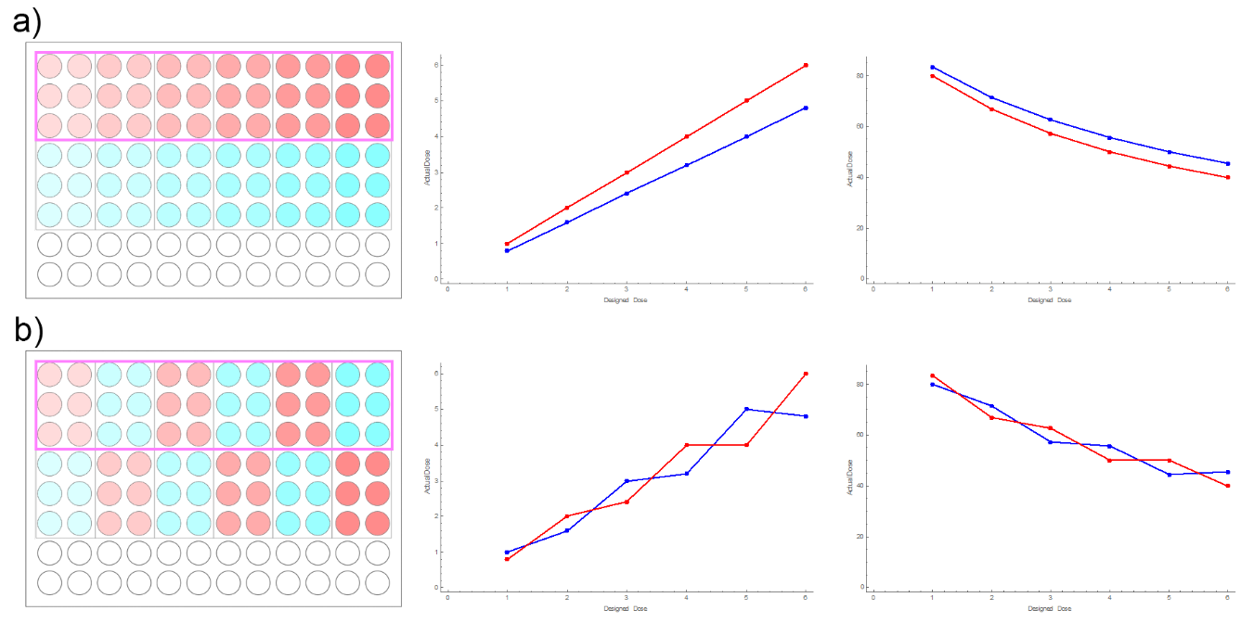
Fig. S1 The chessboard pattern is used to detect the misalignment caused by the robot arms. (a) In a rare case that the wrong calibration profile was used, the misalignment could happen to a row of treatment group with the same amount. Therefore, wells in this misaligned row (assume the wells highlighted by magenta rectangles) would receive a proportionally different light dose than the experimental design (middle). This could be misinterpreted as a different EC₅₀ in the light dose response curve. If the checker pattern was used as show in (b), light dose applied to the groups in the same set would change differently, resulting an easy-to-detect saw-tooth-like pattern in the light-dose response curve, indicating a bad alignment. The data in the plots here are for demonstration purposes only.

S2. Derivation of LED spectral efficiency

Define $I_{L} and I_{D}$ as the actual intensity of the laser and the LED, respectively. Define $S_{L}\left(λ\right) and S_{D}\left(λ\right)$ as the spectrum of the laser and the LED, respectively; i.e., $\int{S{}_{i\left(λ\right)}dλ}=I_{i}$, where the subscript i is L for laser and D for LED.
Define $A_{P}\left(λ\right) and A_{S}\left(λ\right)$ as the absorption spectrum (extinction coefficient spectrum) of the power meter and the photosensitizer, respectively. The overlap integral of the light source output and the photosensitizer absorption gives the power absorption of the photosensitizer, $R_{S,i}=I_{i}∫S_{i}(λ)×A_{S}(λ) dλ$, while the rest of the photons are transmitted and eventually become heat. The reading of the power meter $R_{P,i}=I_{i}\int{S_{i}\left(λ\right)}×A_{P}\left(λ\right) dλ$
The ratio of the powermeter reading of the LED and the laser can be expressed by the actual power ratio:
$$\frac{R_{P,D}}{R_{P,L}}=\frac{I_{D}\int{S_{D}\left(λ\right)}×A_{P}\left(λ\right)dλ}{I_{L}\int{S_{L}\left(λ\right)}×S_{P}\left(λ\right)dλ}$$
Therefore,
$$\frac{I_{D}}{I_{L}}=\frac{R_{P,D}}{R_{P,L}}\frac{\int{S_{L}\left(λ\right)}×S_{P}\left(λ\right)dλ}{\int{S_{D}\left(λ\right)}×A_{P}\left(λ\right)dλ}$$
The ratio of the photosensitizer photon absorption between the LED and the laser is:
$$\frac{R_{S,D}}{R_{S,L}}=\frac{I_{D}\int{S_{D}\left(λ\right)}×A_{S}\left(λ\right)dλ}{I_{L}\int{S_{L}\left(λ\right)}×A_{S}\left(λ\right)dλ}$$
$$=\frac{R_{P,D}}{R_{P,L}} \frac{\int{S_{L}\left(λ\right)}×S_{P}\left(λ\right)dλ}{\int{S_{D}\left(λ\right)}×A_{P}\left(λ\right)dλ} \frac{\int{S_{D}\left(λ\right)}×A_{S}\left(λ\right)dλ}{\int{S_{L}\left(λ\right)}×A_{S}\left(λ\right)dλ}$$
While the LED and the laser spectra can be measured by a spectrometer, the power meter (S132C, Thorlabs) response and the absorption spectrum of VPF are available^{35,36}. The numerical value of the four integrals can be calculated by programming with a discrete Reiman Sum technique. Note that absolute values and normalizations of the spectra are not required as these factors cancel out of the relative ratio.

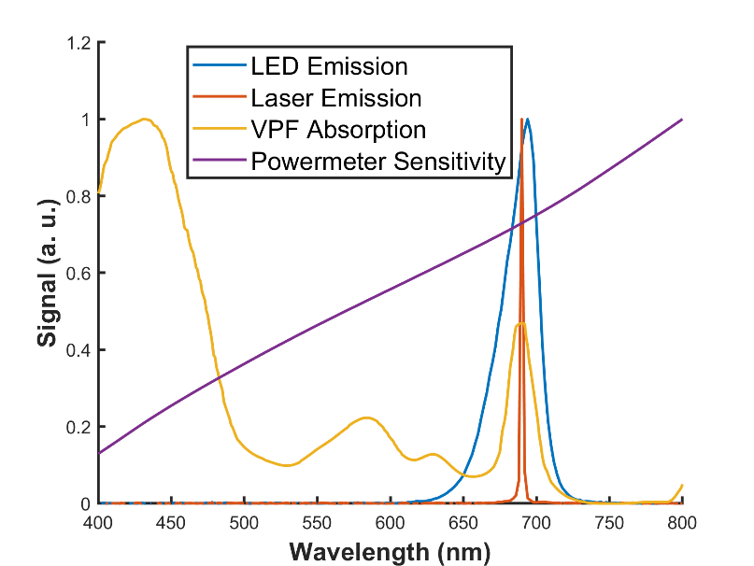
Fig. S2 The normalized spectra of the LED (blue) and the laser (orange), the absorption spectrum of VPF (yellow), and the spectral response of the powermeter sensor (purple).

List of materials
Table S1. The list of materials used to assemble the PDT setup
Item | Company | Part No. | Notes
Electronics
LED | Ushio | SMBB690D-1100-03 | 690 nm
MOSFET | Infineon | IAUC120N04S6L005ATMA1
Thermistor | TDK Electronics | B57452V5103J062
Phototransistor | Rohm Semiconductor | RPM-075PTT86
Resistors | Stakcople Electronics | RNCP0805FTD****CT-ND | 4K99, 20K0, 10K0
Connector Header | Sullins Connector | GBC06SGSN-M89
Printed Circuit Board | PCB Way |  | Custom circuit, Aluminum
Optical and Mounting Parts
Optical Breadboard | Thorlabs | MB12 | 12" × 12" × 1/2"
General Optomechanics | Thorlabs | 3× UPH2, 3× TR3, ER2-P4
Cage Plate | Thorlabs | LCP01
Fresnel Lens | Thorlabs | FRP232
Diffuser | Thorlabs | DG20-600
Black Masking Tape | Thorlabs | T205-1.0
3D-printing filament | Hatchbox |  | Polylactic Acid, Black
Cooling and Robot Arm Parts
Acrylic Board | SimbaLux |  | 12" × 12" × 0.24"
Stepper Motor Actuator | RATTMMOTOR | CBX1605-200A | 2×
Stepper Motor Driver | STEPPERONLINE | DM860T | 2×
Multifunction I/O Device | National Instruments | USB-6001
Water Cooling Pump | Bewinner | PUB-ST1000
Water Block | Yibuy | YBY20180911 | 2×
Radiator Fan | AC Infinity | Axial 1238
Radiator | Thermaltake | Pacific R240 | 240 mm
ATX power supply | Cooler Master | MPE-7501-AFAAG
ATX CPU power cable | COMeap |  | 9.5", male to female
Test Instruments
Powermeter | Thorlabs | S130C
Powermeter Console | Thorlabs | P100
Thermometer | Gain Express | 68022
Laser | Modulight | ML6500 | 690 nm, 1.5 W

Pictures of the optical mounting components

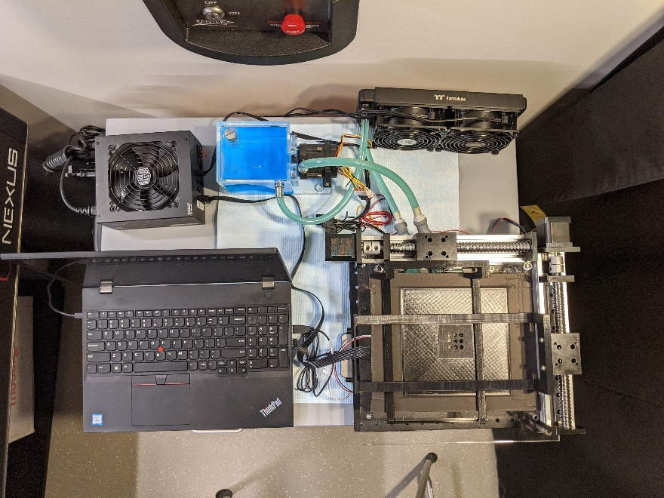
Fig. S2 Top view of the full setup.

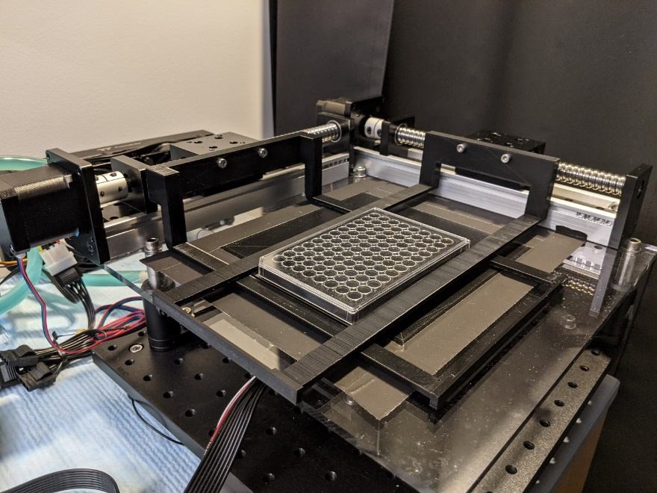
Fig. S3 The PDT platform, with a 96-well plate loaded.

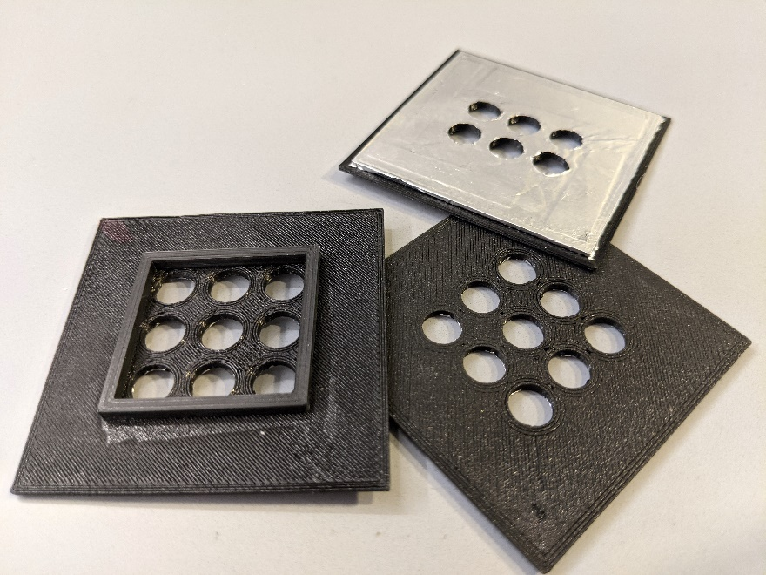
Fig. S4 The spatial light filters for a 3×3 group in a ultra low attachement (ULA) plate (left), a 3×3 group in a flatt-bottom plate (lower right), and a 2×3 group in a flat bottom plate (upper right). Notice the upper right filter is flipped bottom up to show the aluminum heat shield.

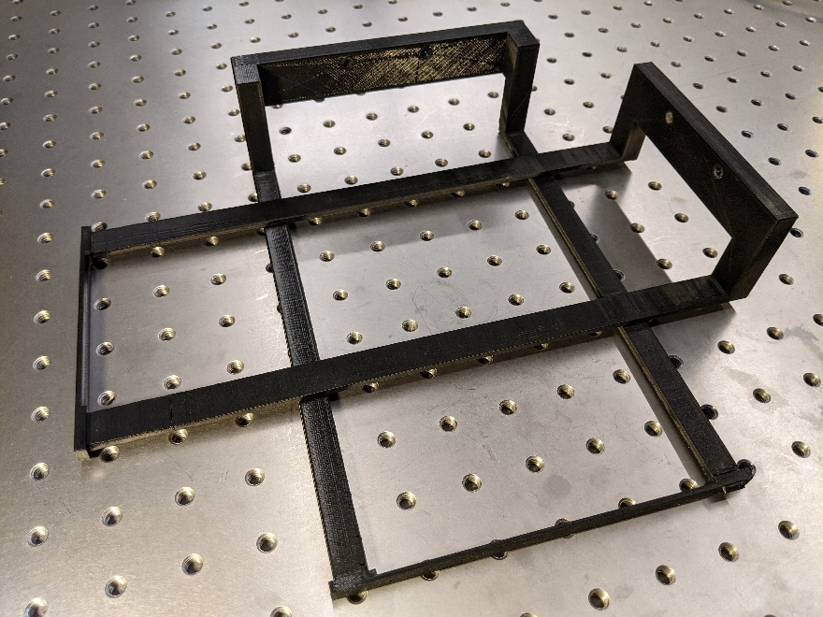
Fig. S5 The two 3D-printed robot arms.

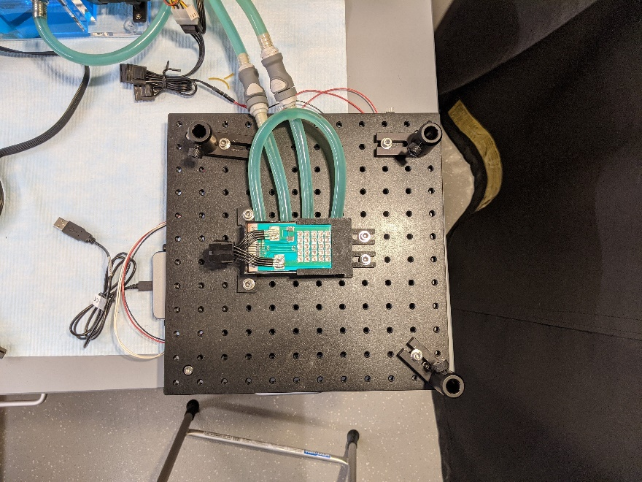

Fig. S6 The LED array module under the well plate platform

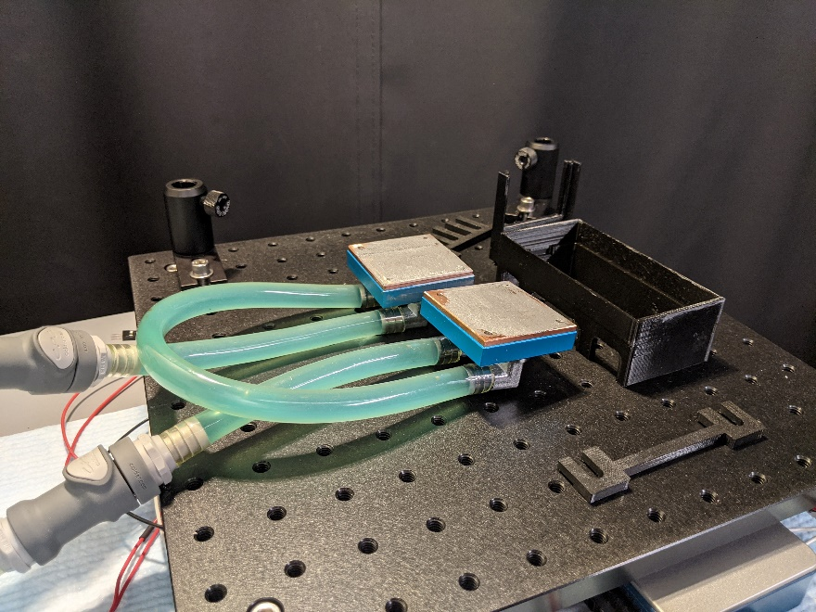

Fig. S7 The individual parts of the LED array module.

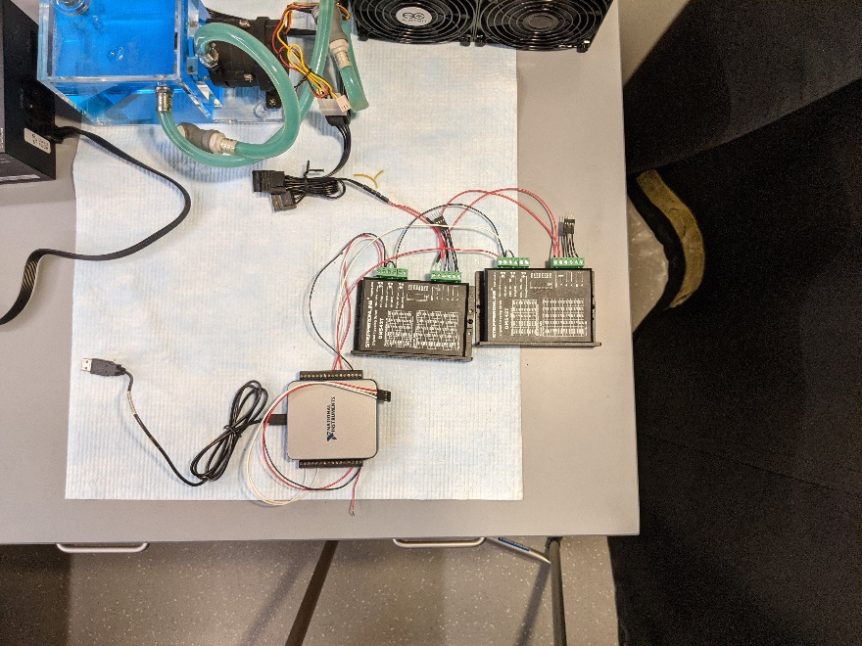

Fig. S8 The controller (grey) and the stepper motor driver modules (black) under the optical breadboard

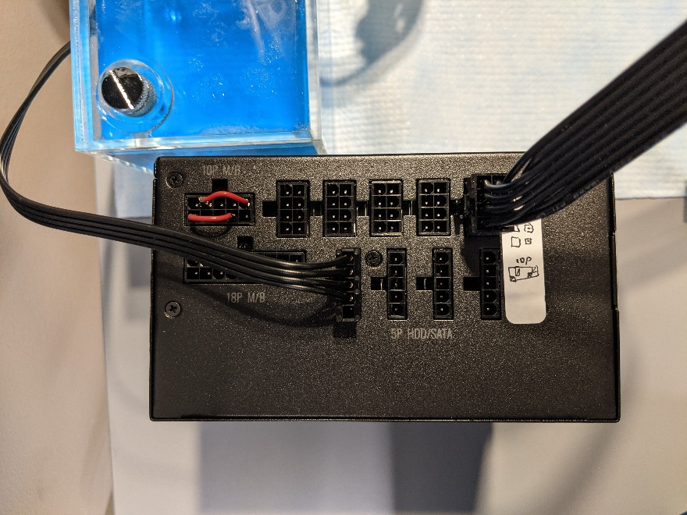

Fig. S9 The wiring of the ATX power supply. The two jumper wires (red) are used to keep the power on without a computer motherboard.

