Supplementary Information

Satoshi Tamashiro, Izumi Nakayama, Koichiro Gibo, Junichi Izawa,

Comparison of Mainstream End Tidal Carbon Dioxide on Y-Piece Side Versus Patient Side of Heat and Moisture Exchanger Filters in Critically Ill Adult Patients: a prospective observational study

Content
Supplemental Table 1: Mean differences and 95% limits of agreement in Bland-Altman analyses.
Supplemental Figure 1: The relationship between tidal volume and differences in Y-piece side EtCO₂ and patient side EtCO₂.

Supplemental Table 1. Mean differences and 95% limits of agreement in Bland-Altman analyses.
Difference | Mean difference (95% CI) | SD of difference | LOA | Lower LOA 95% CI | Upper LOA 95% CI
PaCO₂ - EtCO₂ on Y-piece side (mm Hg) | 0.99 (-0.66–2.63) | 4.93 | -8.67 to 10.65 | -11.51– -5.84 | 7.82–13.49
PaCO₂ - EtCO₂ on patient side (mm Hg) | 0.87 (-0.80–2.54) | 5.00 | -8.93 to 10.67 | -11.81– -6.06 | 7.80–13.55

CI, confidence interval; SD, standard deviation; LOA, limits of agreement; EtCO₂, End-tidal carbon dioxide.

Supplemental Figure 1. The relationship between tidal volume and differences in Y-piece side EtCO₂ and patient side EtCO₂.

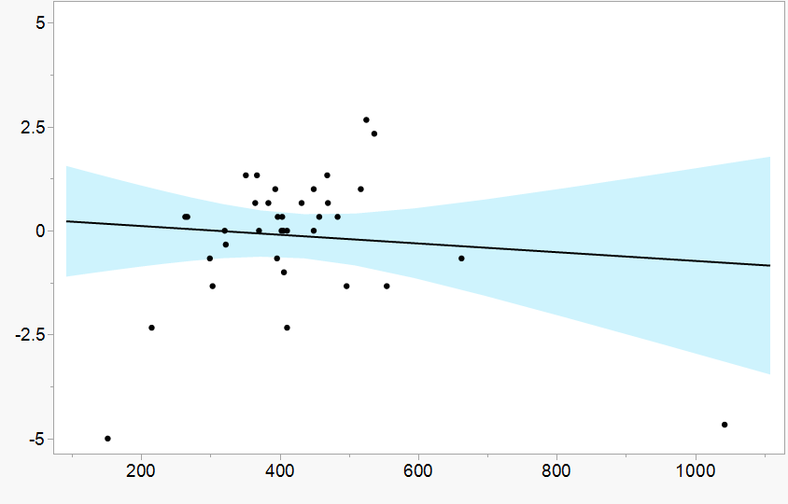
Correlation coefficient = -0.096
Linear regression coefficient = -0.001 (95% CI, -0.005–0.003)
Y-piece side EtCO₂ - patient side EtCO₂
(mm Hg)
Tidal volume (mL)

Differences between Y-piece side EtCO₂ and patient-side EtCO₂ were plotted against tidal volume. The tidal volume was the average of tidal volume at the time of the Y-piece side EtCO₂ measurement and tidal volume at the time of the patient side EtCO₂ measurement. Pearson’s correlation coefficient and regression coefficient of unadjusted linear regression of EtCO₂ differences on tidal volume are presented. The fitted regression line with 95% CI (blue-tinged area) is presented. EtCO₂, end-tidal carbon dioxide.

