**Supplementary file**

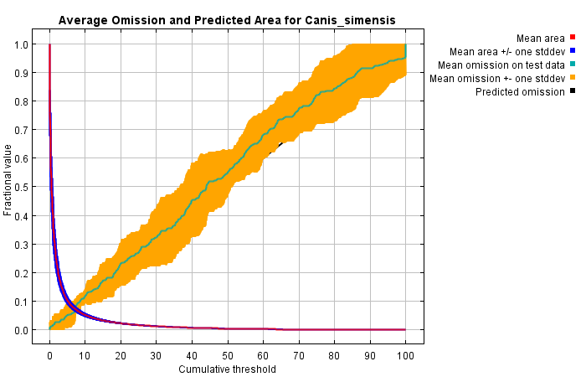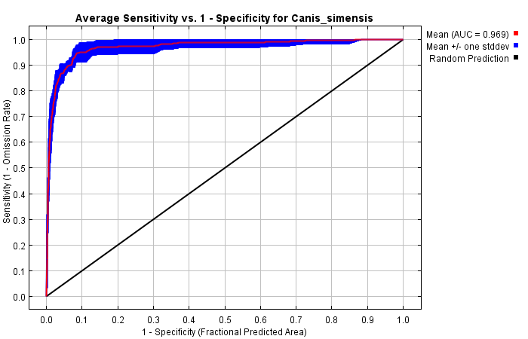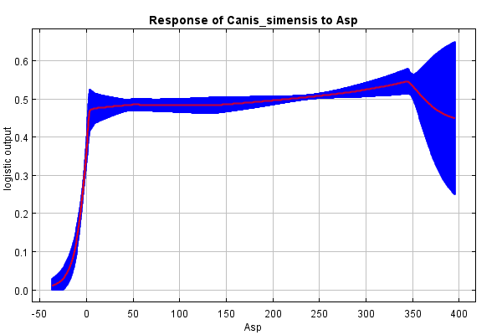

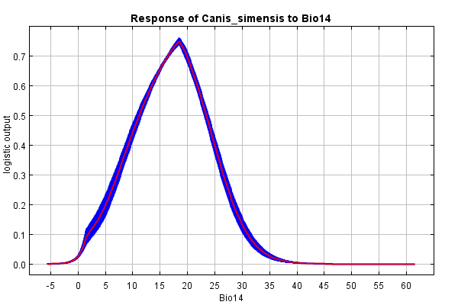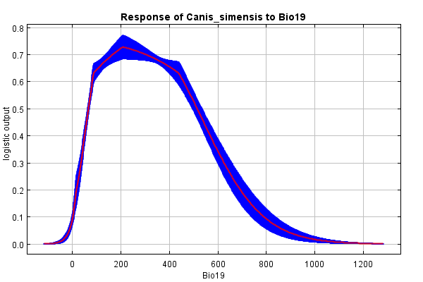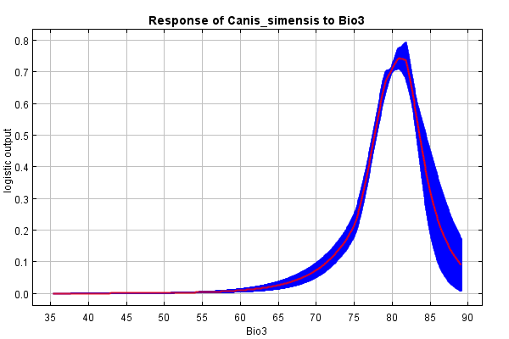

Figure S1. Current test omission rate response curve used for modelling

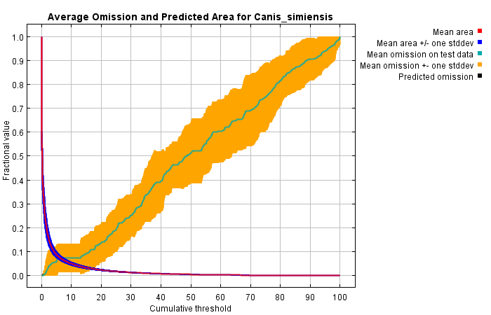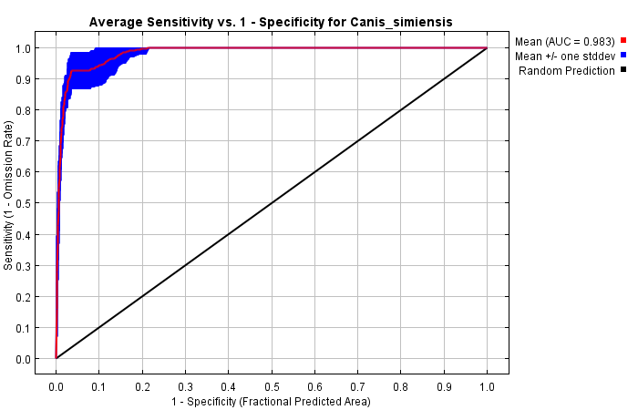

1. BCC-CSM5 2050 2.6

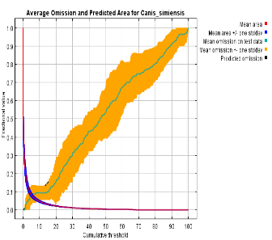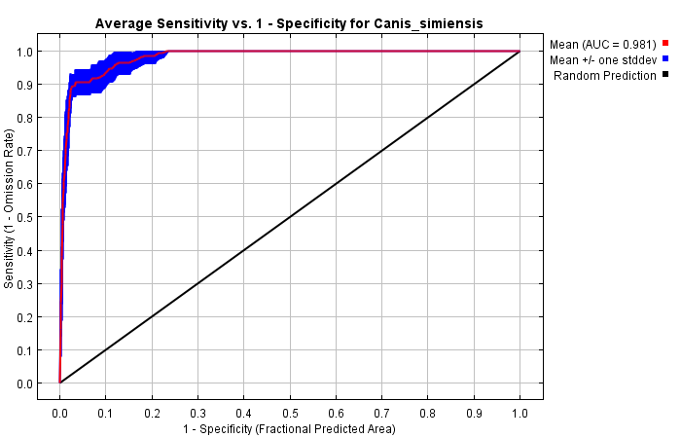

1. BCC-CSM5 2050 4.5

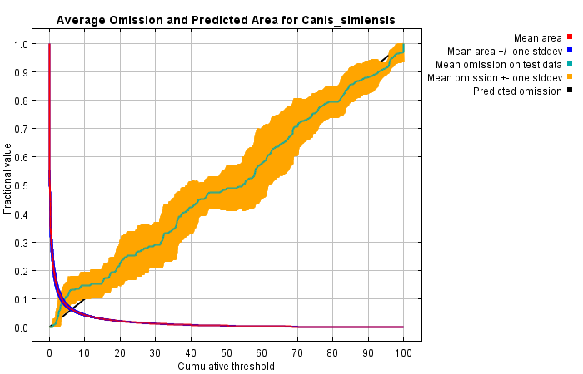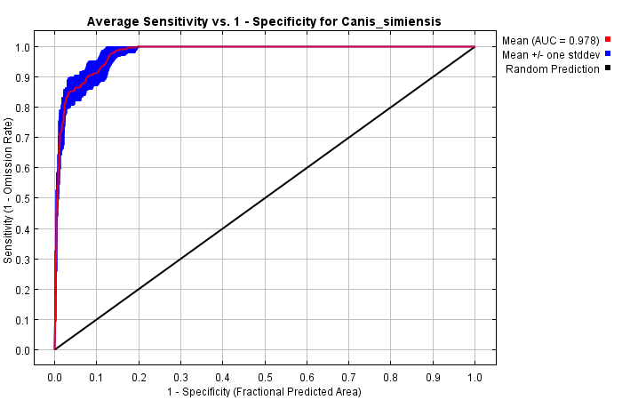

1. BCC-CSM5 2050 8.5

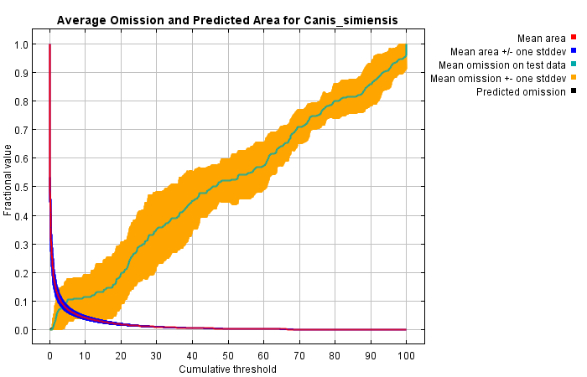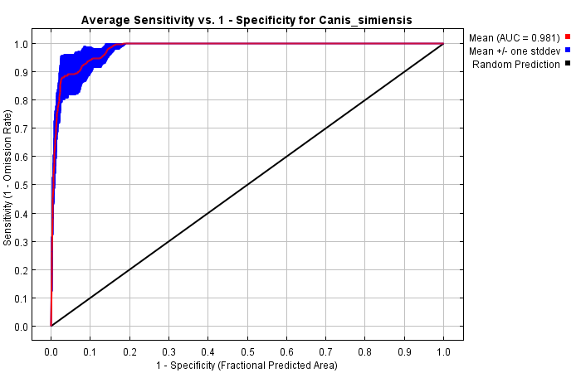

1. BCC-CSM5 2070 2.6

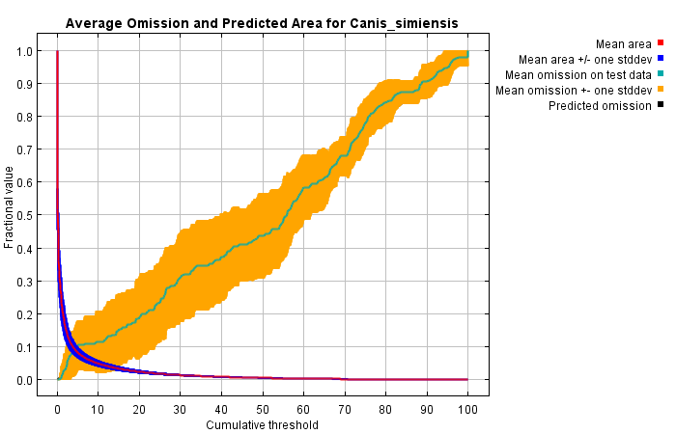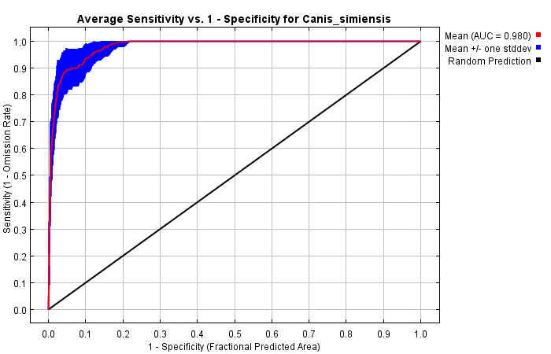

1. BCC-CSM5 2070 4.5

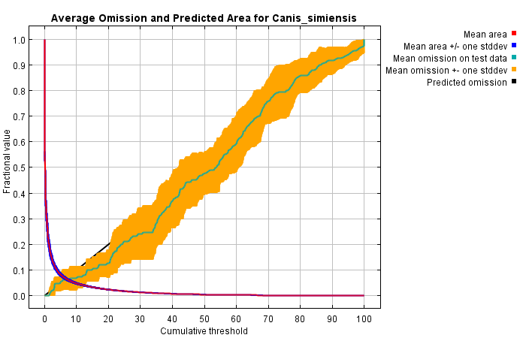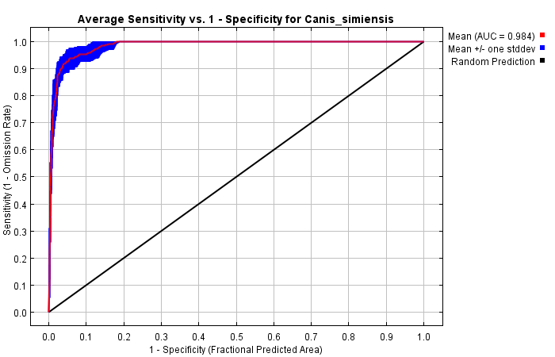

1. BCC-CSM5 2070 8.5

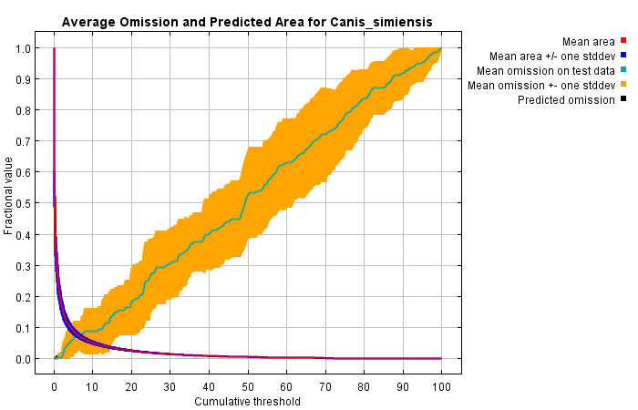 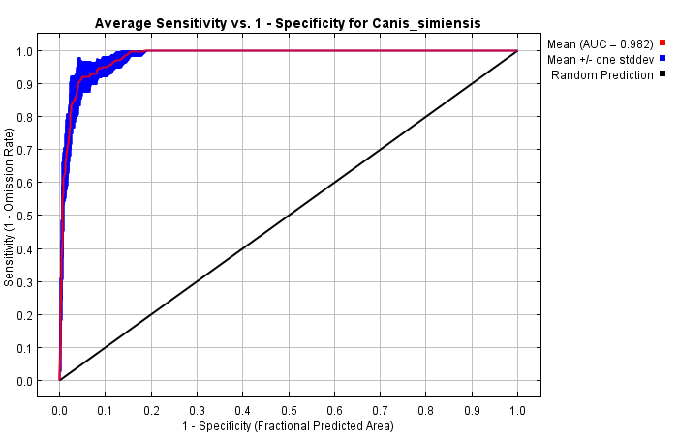

h. CanESM 2050 2.6

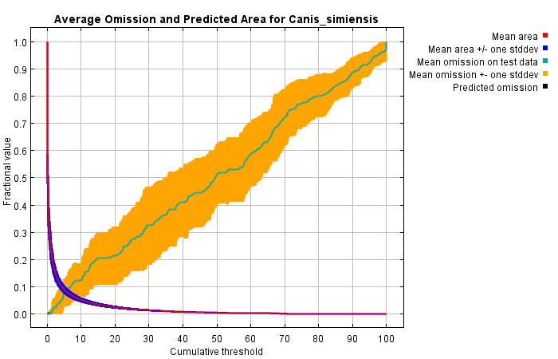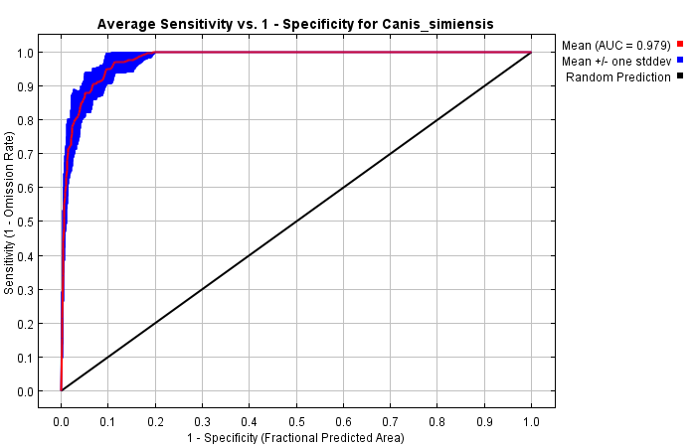

1. CanESM 2050 4.5

CanESM 2050 8.5

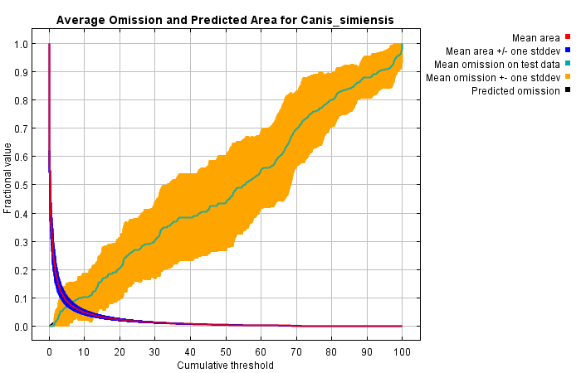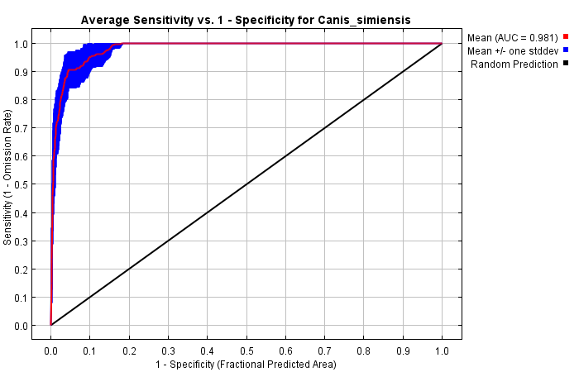

j. CanESM 2050 8.5

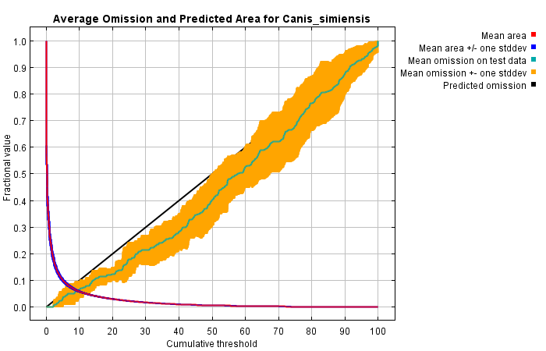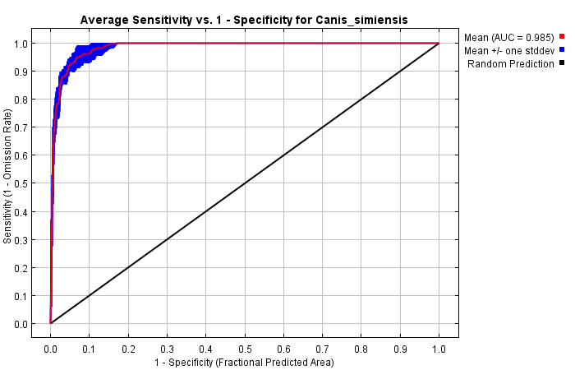

k. CanESM 2070 2.6

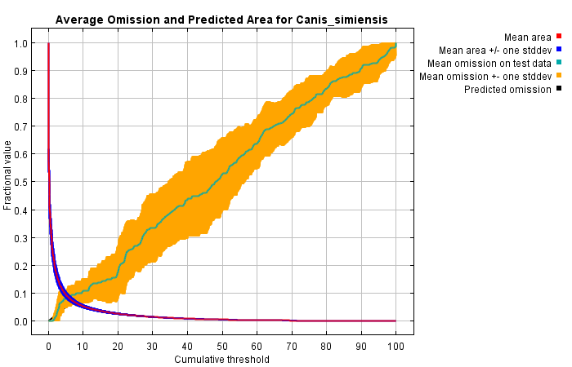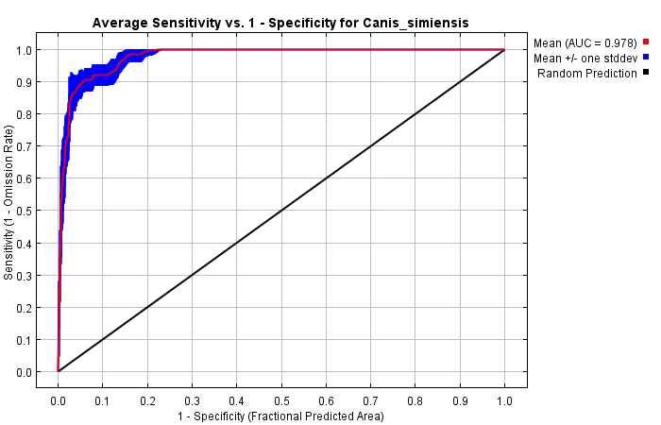

l. CanESM 2070 4.5

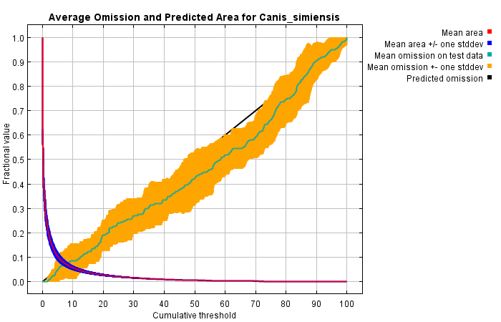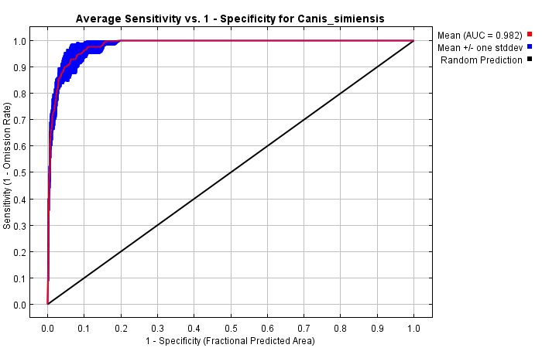

m. CanESM 2070 8.5

Figure S2. The test omission rate and receiver operating characteristic (ROC) curve predicted area as a function of the cumulative threshold for the future predictor variables used for modelling.

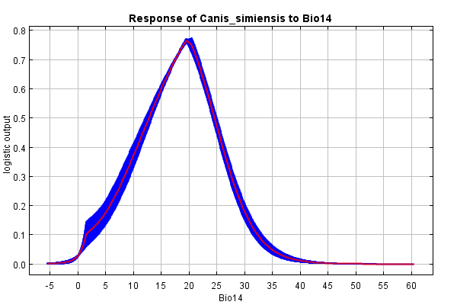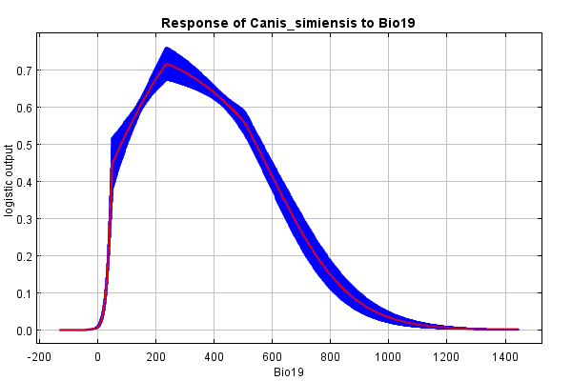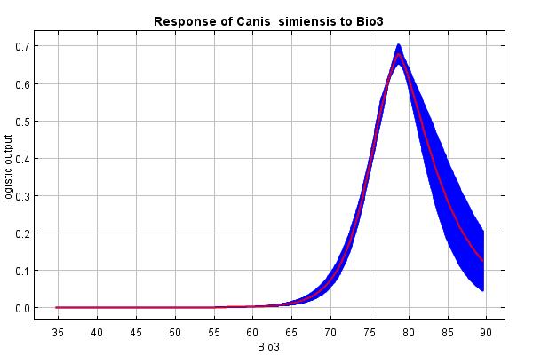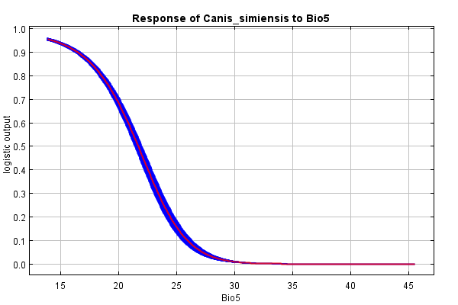

1. BCC-CSM5 2050 2.6

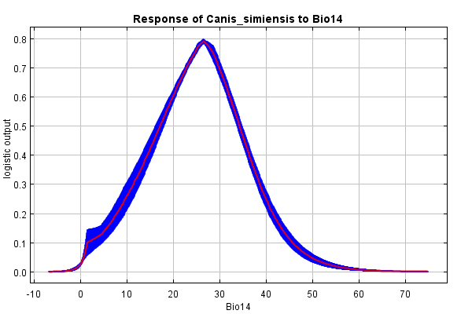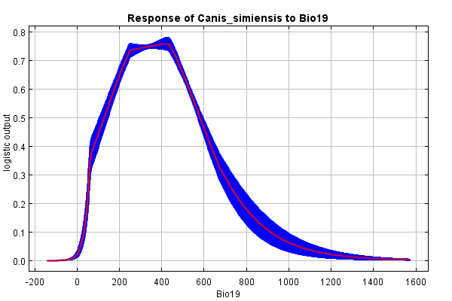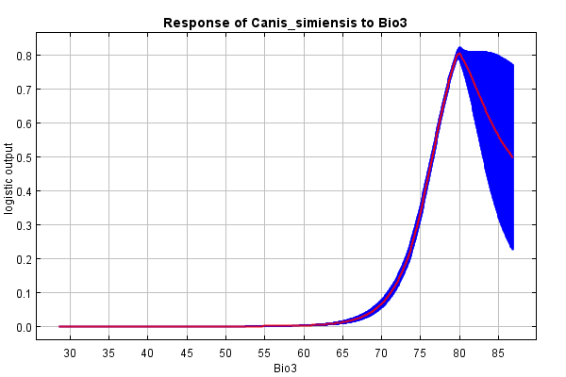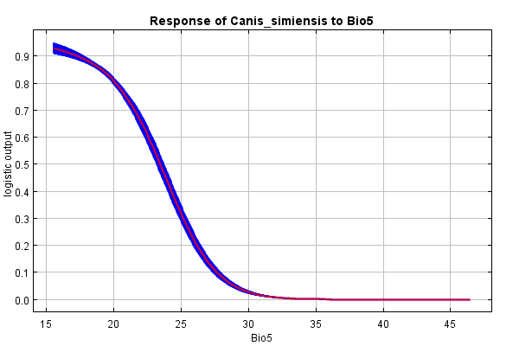

1. BCC-CSM5 2070 8.5

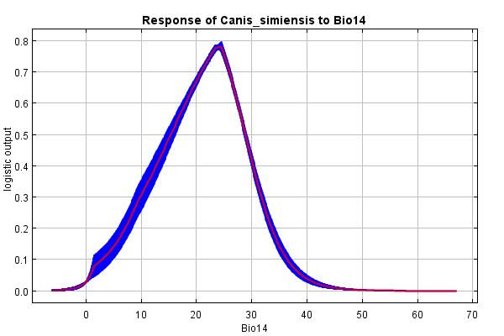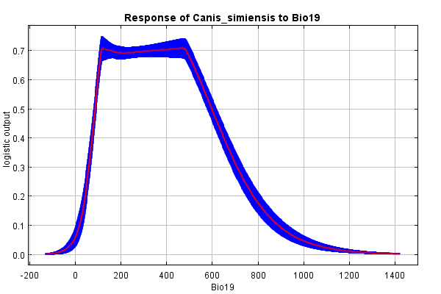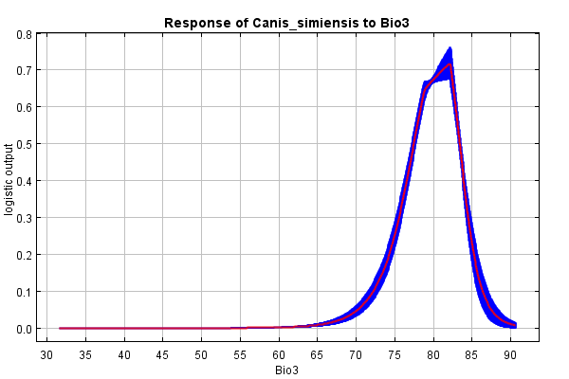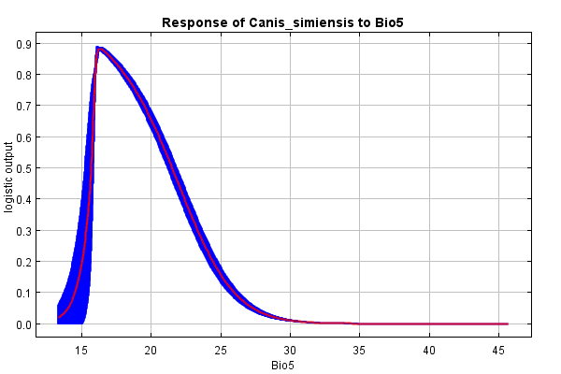

1. CanESM 2050 2.6

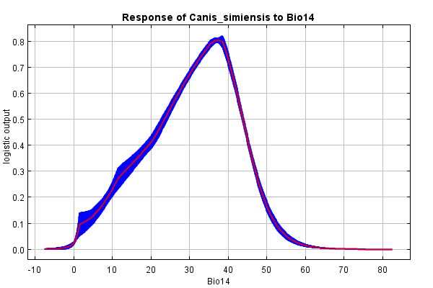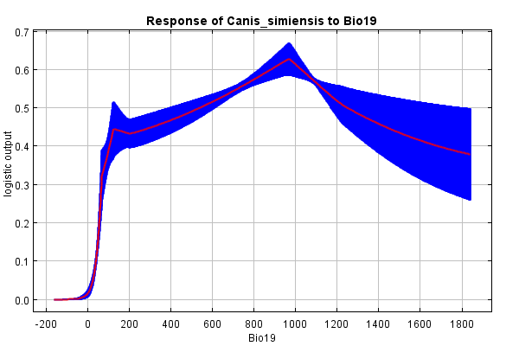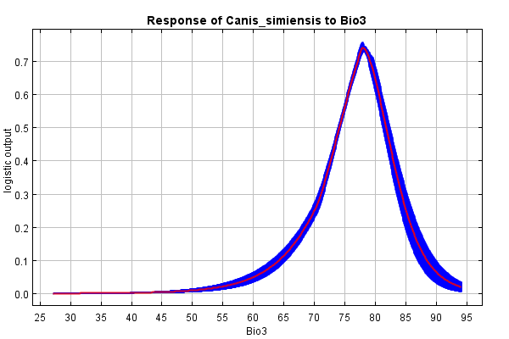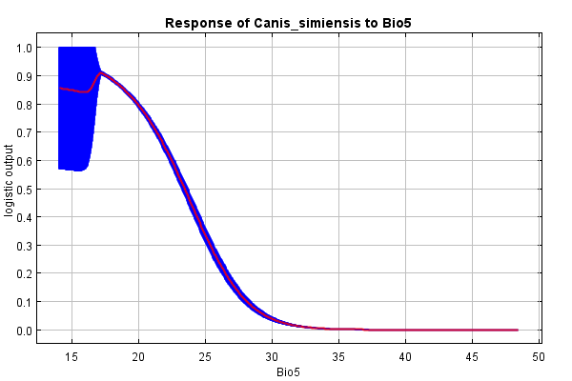

1. CanESM 2070 8.5

Figure S3. Representative response curves of the most relevant environmental factors affecting the distribution of C. simensis (SSP 2.6 and SSP 8.5) from both global climates modeling systems BCC-CSM5 and CanESM.

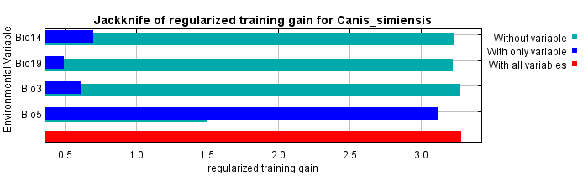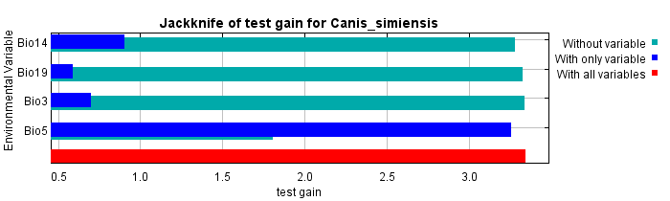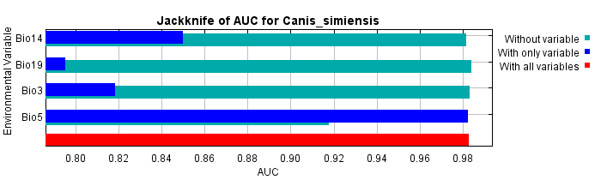

1. BCC-CSM5 2050 2.6

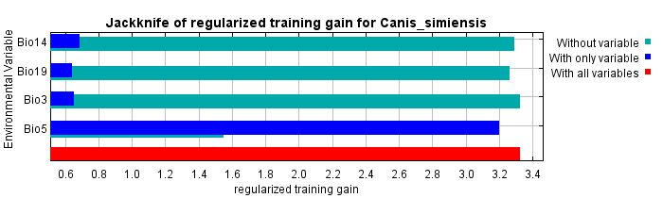 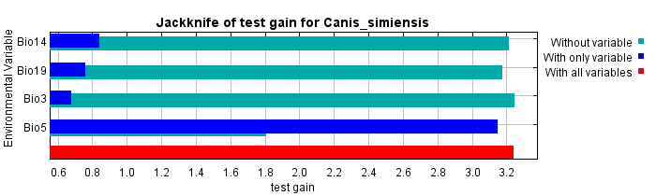 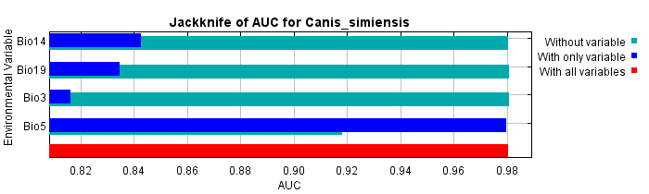

1. BCC-CSM5 2050 4.5

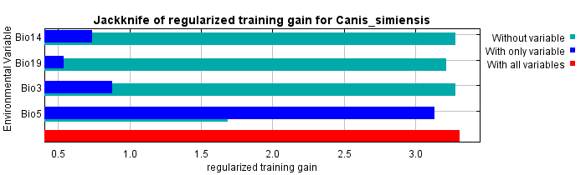 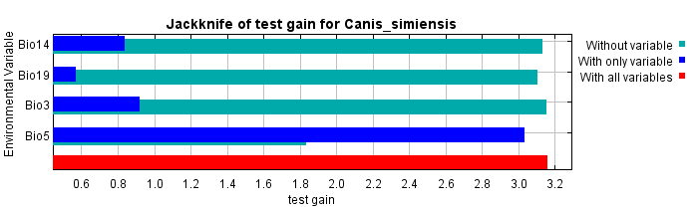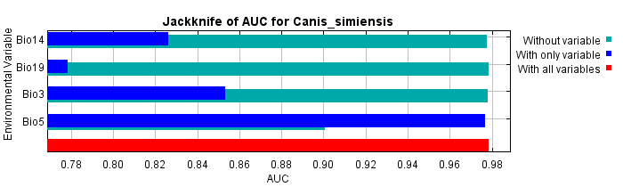

1. BCC-CSM5 2050 4.5

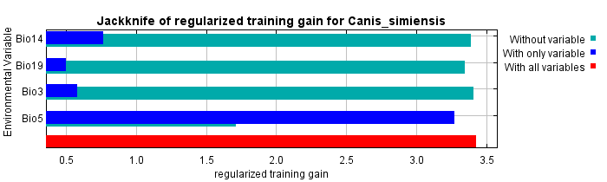 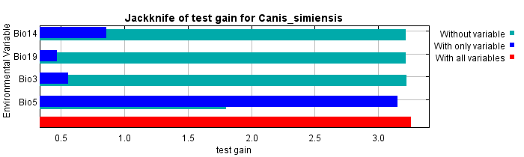 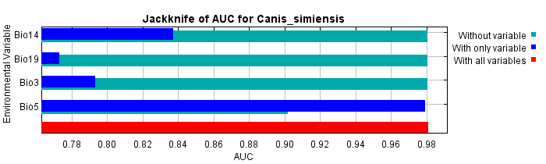

1. BCC-CSM5 2070 2.6

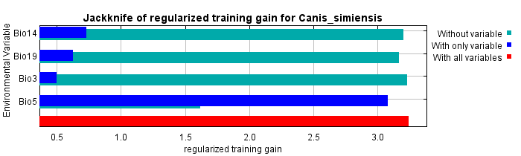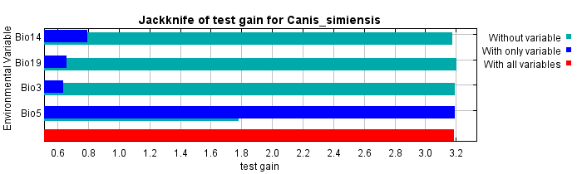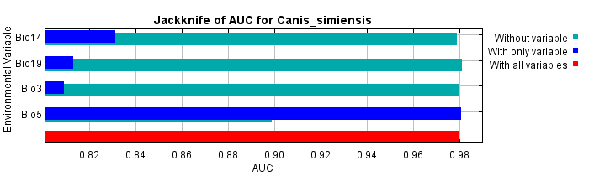

1. BCC-CSM5 2070 4.5

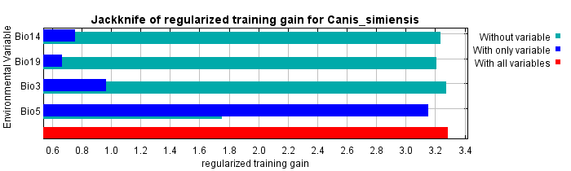 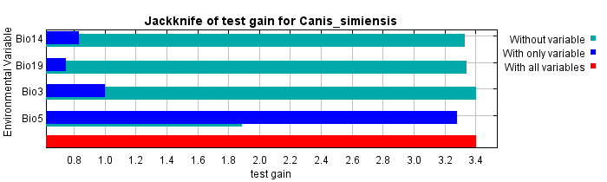 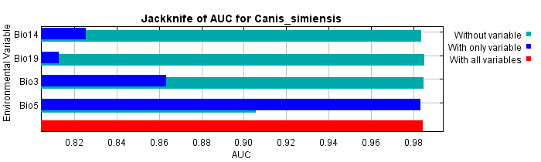

1. BCC-CSM5 2070 8.5

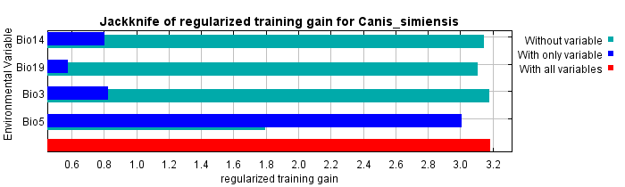 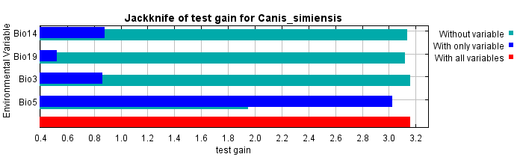 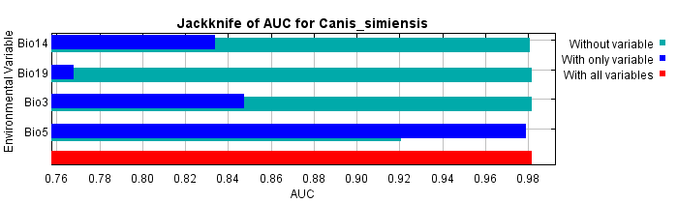

1. CanESM 2050 2.6

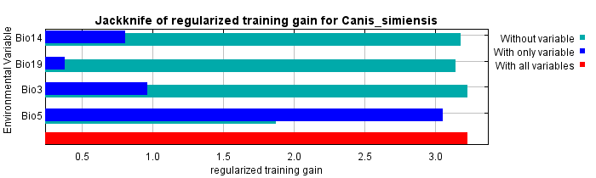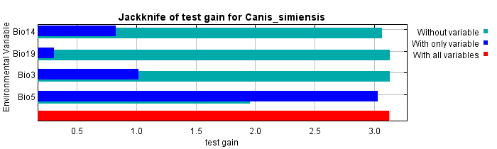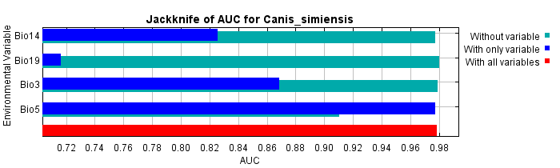

1. CanESM 2050 4.5



1. CanESM 2050 8.5

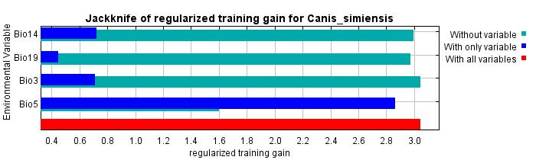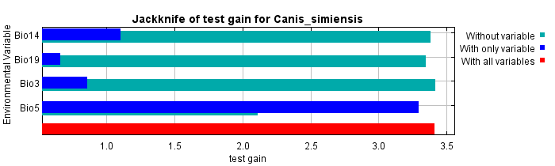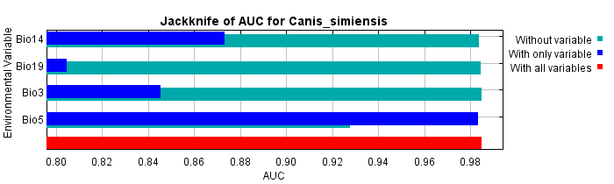

1. CanESM 2070 2.6

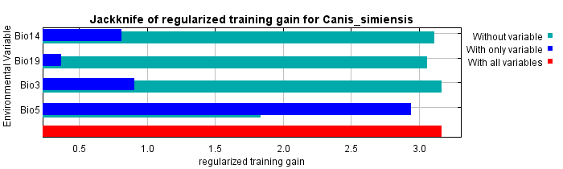 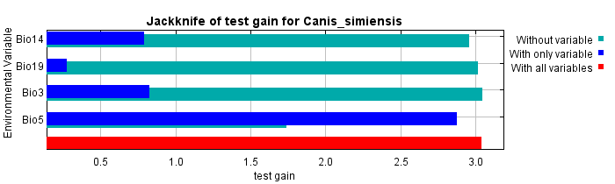 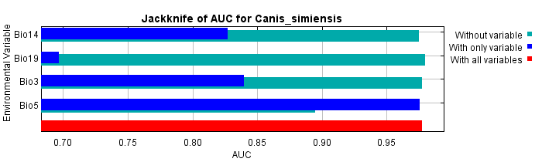

1. CanESM 2070 4.5

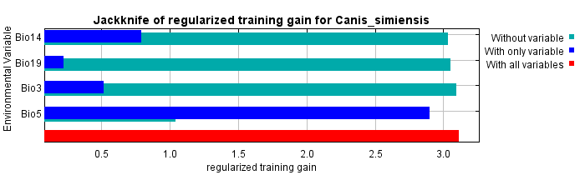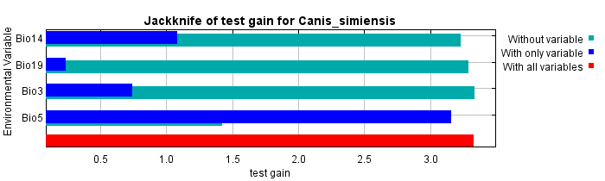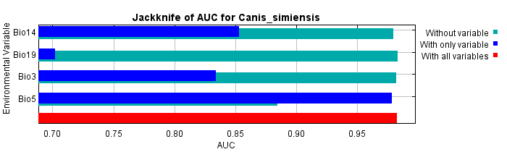

1. CanESM 2070 8.5

Figure S4. Relative predictive power of different bioclimatic variables based on the jackknife of regularized training gain in the MaxEnt models for *Canis* *simensis*, 2050s and 2070s under different future scenarios for both BCC-CSM5 AND CanESM bioclimate system respectively. The figure shows training gain, test gain and jackknife AUC respectively in each scenario.

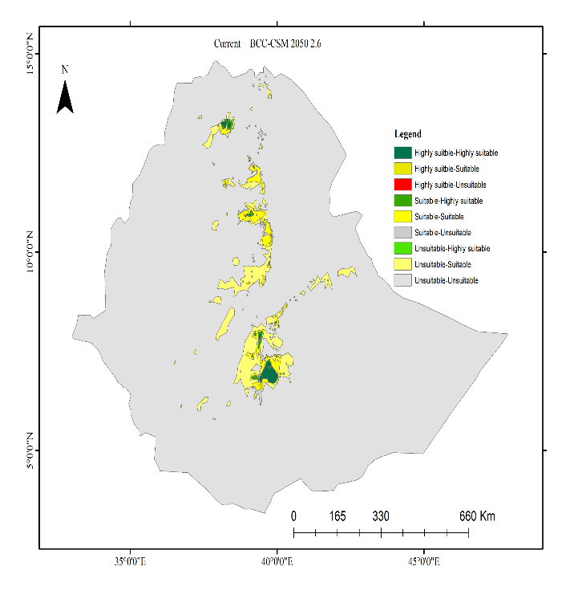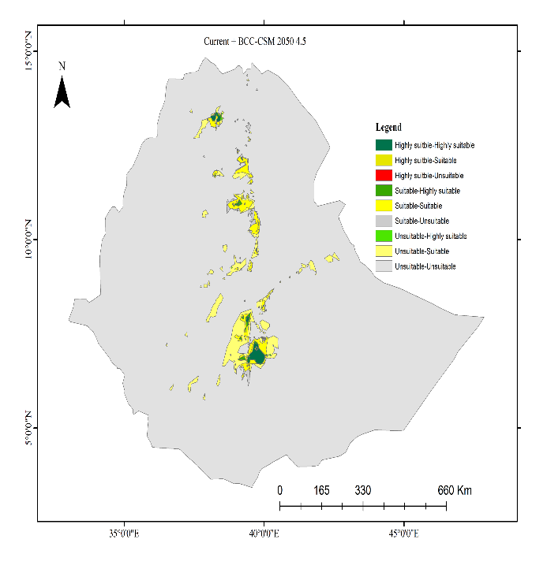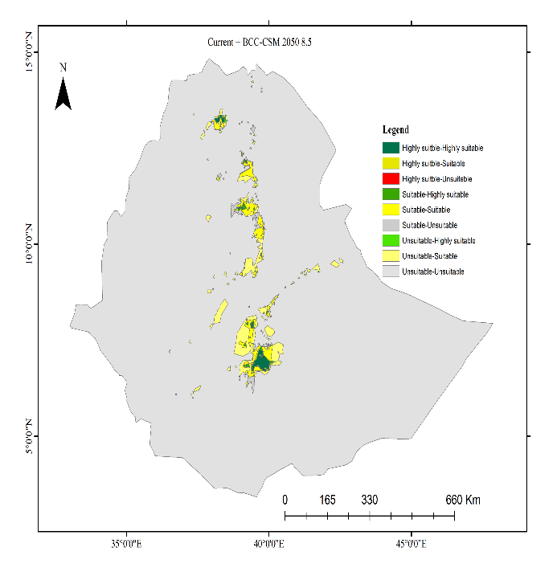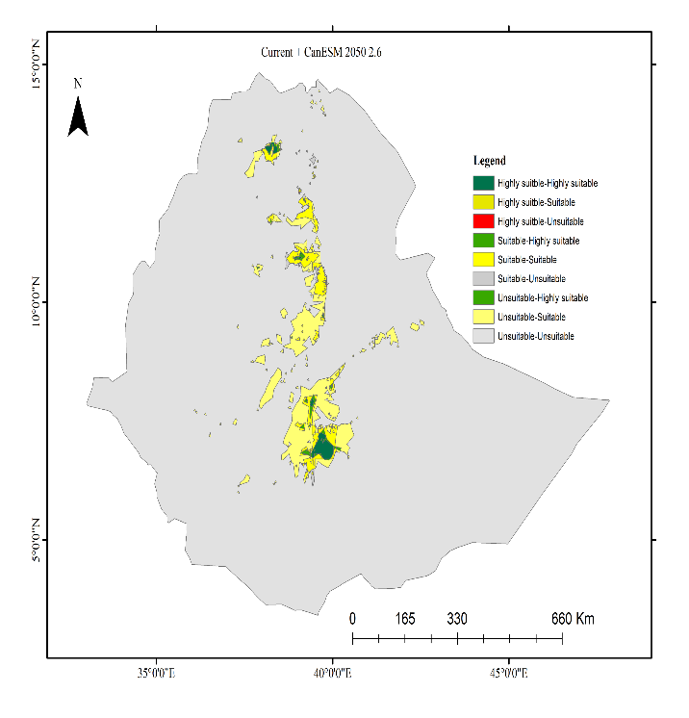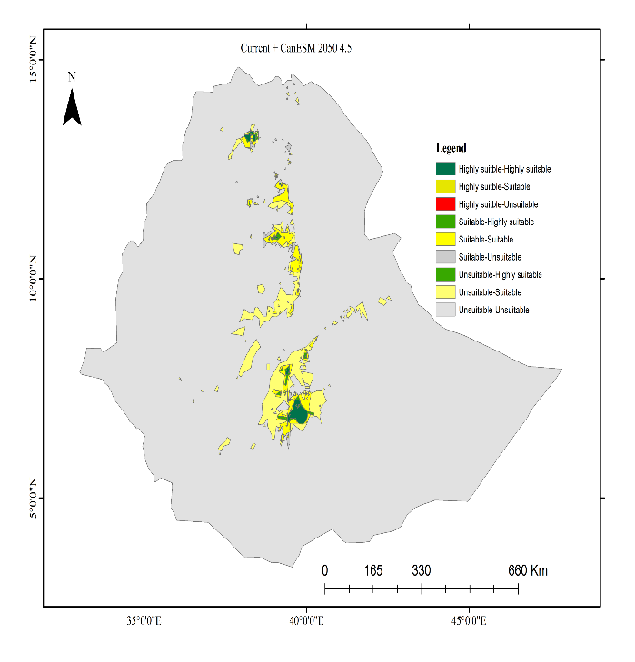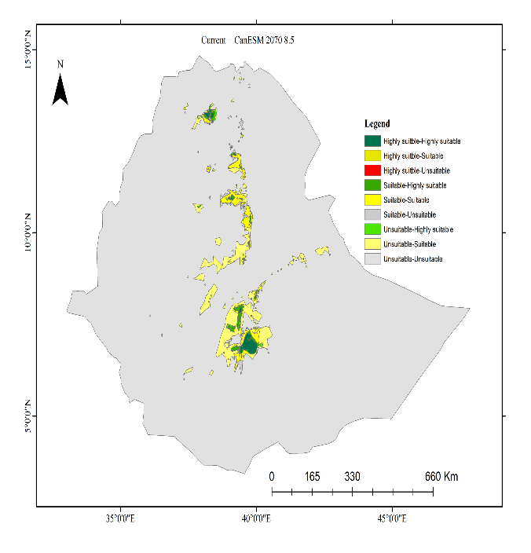

a

c

e

b

d

f

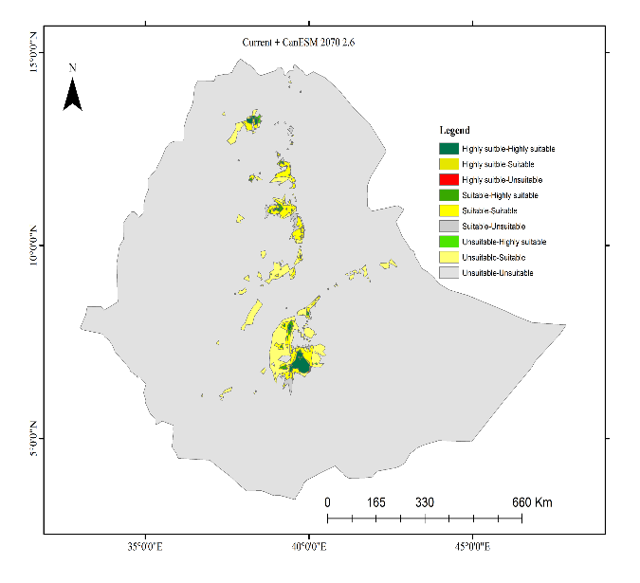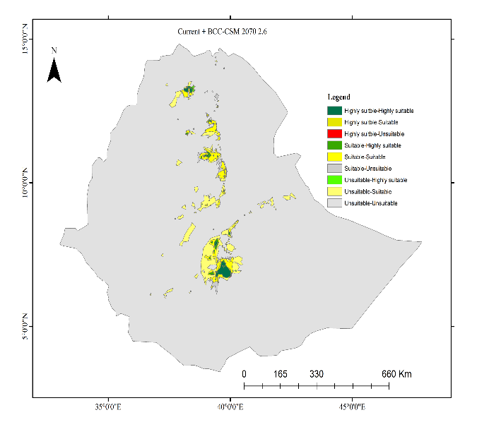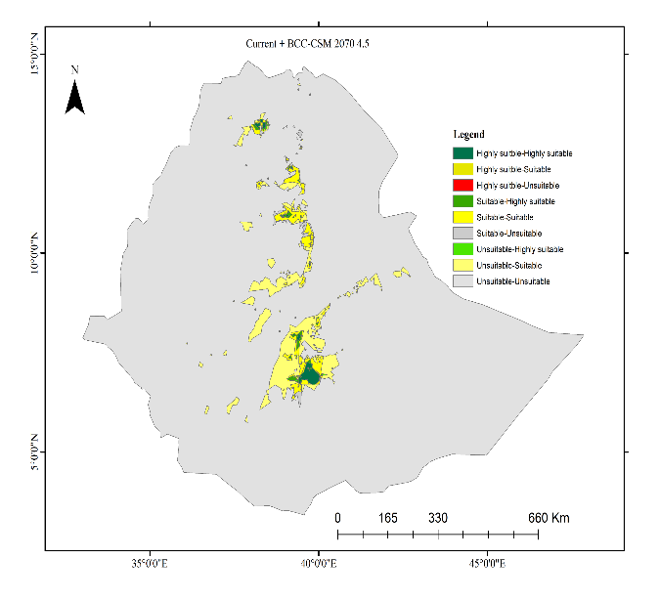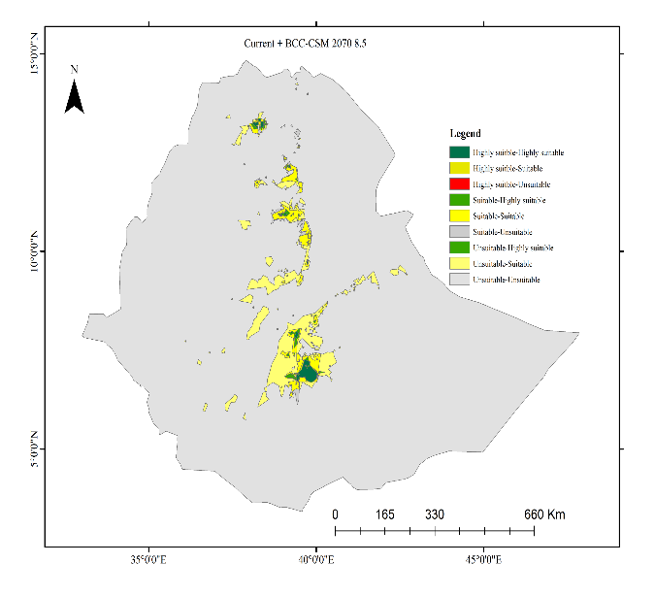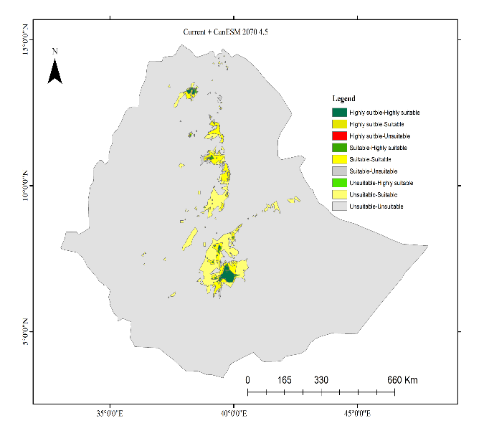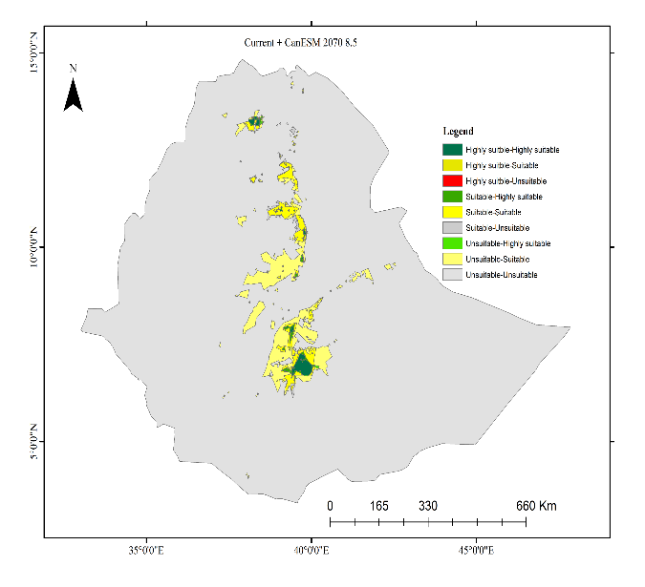

g

i

i

h

k

l



k

j

l

Figure S5 Predicted habitat suitability area change C. simensis under different climate change scenarios developed by BCC-CSM5 and CanESM.



Figure S6 Ethiopian wolves are expected to thrive in a variety of habitats.

Table S1: Habitat suitability of *C*. *siminsis* in different scenarios

|  |  |  |  |  |  |  |  |  |  |
| --- | --- | --- | --- | --- | --- | --- | --- | --- | --- |
| Scenarios | GCM | Habitat predicted to be suitable | Highly suitable | % | Suitable | % | Unsuitable | % | Total |
| Current |  | 2779658 | 346454.1 | 0.31 | 2433204 | 2.15 | 1.1E+08 | 97.54 | 1.13E+08 |
| 2050 2.6 | BCC-CSM | 5402991 | 491207.5 | 0.43 | 4911784 | 4.34 | 1.08E+08 | 95.22 | 1.13E+08 |
|  | CanESM | 5937167 | 513494.4 | 0.45 | 5423672 | 4.80 | 1.07E+08 | 94.75 | 1.13E+08 |
| 2050 4.5 | BCC-CSM | 4122934 | 447341.7 | 0.40 | 3675592 | 3.25 | 1.09E+08 | 96.35 | 1.13E+08 |
|  | CanESM | 5217248 | 497934.2 | 0.44 | 4719313 | 4.17 | 1.08E+08 | 95.39 | 1.13E+08 |
| 2050 8.5 | BCC-CSM | 3550526 | 435702.4 | 0.39 | 3114824 | 2.75 | 1.1E+08 | 96.86 | 1.13E+08 |
|  | CanESM | 4747086 | 773450.4 | 0.68 | 3973636 | 3.51 | 1.08E+08 | 95.80 | 1.13E+08 |
| 2070 2.6 | BCC-CSM | 4053780 | 485162.2 | 0.43 | 3568618 | 3.16 | 1.09E+08 | 96.42 | 1.13E+08 |
|  | CanESM | 5695400 | 515044.8 | 0.46 | 5180355 | 4.58 | 1.07E+08 | 94.96 | 1.13E+08 |
| 2070 4.5 | BCC-CSM | 3752658 | 480697.5 | 0.42 | 3271961 | 2.89 | 1.09E+08 | 96.68 | 1.13E+08 |
|  | CanESM | 4896918 | 451891.9 | 0.40 | 4445026 | 3.93 | 1.08E+08 | 95.67 | 1.13E+08 |
| 2070 8.5 | BCC-CSM | 5401549 | 510788.7 | 0.45 | 4890760 | 4.32 | 1.08E+08 | 95.22 | 1.13E+08 |
|  | CanESM | 5534774 | 513457.5 | 0.45 | 5021317 | 4.44 | 1.08E+08 | 95.11 | 1.13E+08 |