Bovine-based breast milk fortifier and neonatal outcomes in premature infants <32 weeks’ gestational age.

European Journal of Paediatrics

Kate Jordan, Laura De Rooy, Justin Richards, Anay Kulkarni

Corresponding author: anay.kulkarni@stgeorges.nhs.uk

SUPPLEMENTARY INFORMATION

Characteristics of the study cohort are described in Table 1. The total cohort included N = 952 preterm infants born at SGH at GA <32 weeks from Jan 2010 – September 2020, whose treatment was complete at the time of analysis. All statistical analyses were run for the total cohort and subgroups by GA, as listed in Supplementary Table 1.

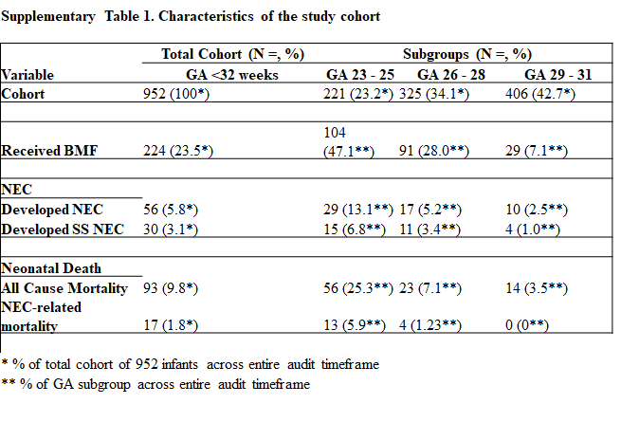

BMF use did not increase the odds or risk of developing the negative outcomes of interest in this study (NEC, surgical/severe NEC, or all-cause mortality), as listed in Supplementary Table 2. Neither the risk of developing NEC nor all-cause mortality were increased if bovine-based BMF was introduced on postnatal days 8 – 13. Breastfeeding rate on live discharges were not statistically reduced if on BMF.

Table 2: Association of breast milk fortifier with the development of negative outcomes in preterm infants <32 weeks GA, including subgroup analyses
Variable | OR | CI | P value | RR | CI | P value | NNT
Development of NEC if on BMF
Total cohort, <32 weeks GA | 0.62 | 0.30 to 1.29 | .2 | 0.64 | 0.32 to 1.28 | .21
GA 23 - 25 | 0.31 | 0.13 to 0.76 | .01 | 0.36 | 0.16 to 0.90 | .01 | 4.70 - 30.33
GA 26 - 28 | 0.16 | 0.02 to 1.24 | .07 | 0.17 | 0.02 to 1.27 | .08
GA 29 - 31 | 1.46 | 0.18 to 11.94 | .72 | 1.44 | 0.19 to 11.01 | 0.72
Development of Surgical/Severe NEC if on BMF
Total cohort, <32 weeks GA | 0.23 | 0.06 to 0.98 | .05 | 0.24 | 0.06 to 0.99 | .05 | 18.04 - 344.95
GA 23 - 25 | 0.16 | 0.03 to 0.71 | .02 | 0.17 | 0.04 to 0.75 | .02 | 6.36 - 37.66
GA 26 - 28 | 0.11 | 0.01 to 1.94 | .13 | 0.12 | 0.01 to 1.98 | .14
GA 29 - 31 | 1.4 | 0.07 to 26.76 | .82 | 1.4 | 0.08 to 25.39 | .82
All Cause Mortality if on BMF
Total cohort, <32 weeks GA | 0.28 | 0.13 to 0.59 | .009 | 0.31 | 0.15 to 0.63 | .001 | 7.95 - 27.42
GA 23 - 25 | 0.25 | 0.10 to 0.61 | .003 | 0.3 | 0.13 to 0.67 | .003 | 3.91 - 15.65
GA 23- 25, mortality >10 days postnatal
GA 26 - 28 | 0.11 | 0.02 to 0.86 | .04 | 0.12 | 0.02 to 0.91 | .04 | 6.98 - 53.79
GA 29 - 31 | 0.40 | 0.02 to 6.79 | .52 | 0.41 | 0.02 to 6.63 | .53
Development of NEC if BMF introduced on postnatal days 8 - 13
Total cohort, <32 weeks GA | 1.74 | 0.36 to 8.39 | .69 | 1.67 | 0.40 to 7.05 | .49
All cause mortality if BMF introduced on postnatal days 8 - 13
Total cohort, <32 weeks GA | 1.16 | 0.14 to 9.69 | .89 | 1.15 | 0.15 to 8.75 | .89
Breastfeeding rates on live-discharges if on BMF
Total cohort, <32 weeks GA | 0.56 | 0.41 to 0.77 | .003 | 0.8 | 0.70 to 0.92 | .001 | 4.81 - 15.97

NEC Mortality

NEC rates and mortality rates of infants who developed NEC are described in Supplementary Figure 1. Developing surgical/severe NEC had a mortality rate of 56.7%.

Supplementary Figure 1: NEC- related mortality at St George’s University Hospital neonatal unit from 2010 – 2020 in preterm infants <32 weeks’ GA.
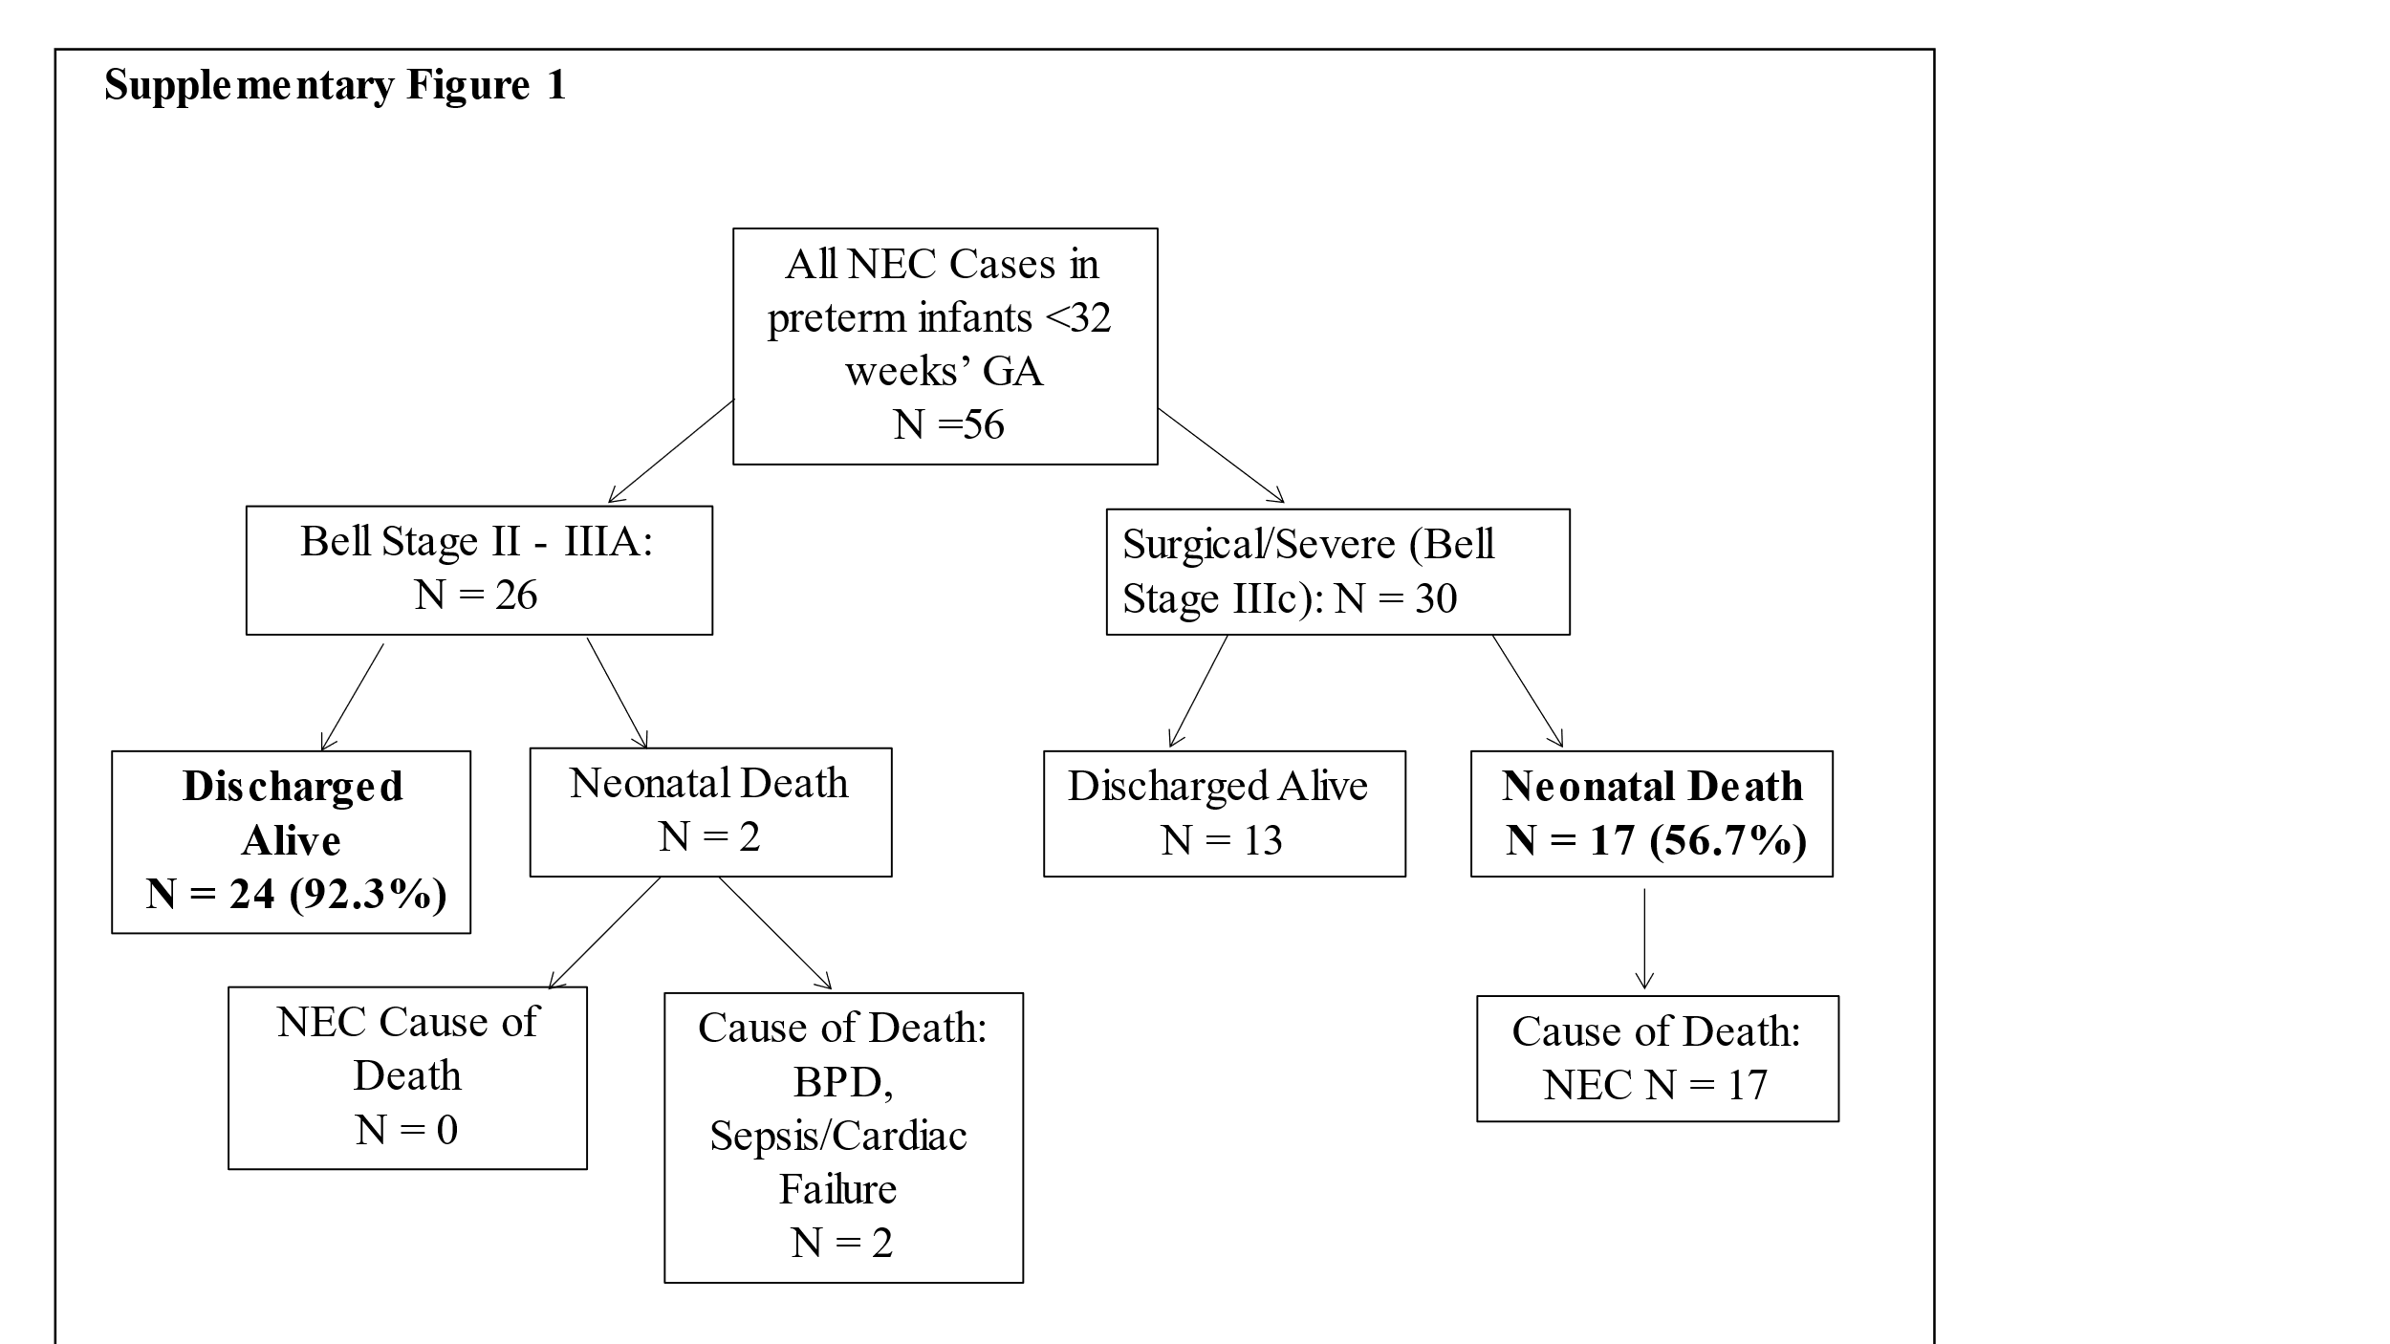

Breastfeeding
Breastfeeding rates of preterm infants <32 weeks’ GA on discharge across the audit timeframe are shown in Supplementary Figure 2) for infants who receive any breastmilk (Fig S2a) and infants who are exclusively breastfed (Fig S2b). Contrasting with the significant use of BMF over time from 2010 – 2020, rates of breastfeeding on discharge remained stable.

Supplementary Figure 2: Breastfeeding rates on discharge from the neonatal unit (NICU) of St George’s University Hospital (SGH) from 2010 – 2020. Fig 1a Infants (% admissions) <32 weeks’ GA at birth who receive any breast milk as nutrition on discharge across the 10-year audit timeframe. Fig 1b. Infants (% admissions) <32 week’s GA at birth who are exclusively breastfed on discharge.

