Supplementary Material

Glossary.
Definitions used here in this manuscript based on standard definitions within the UN SEEA framework (UNCEEA 2021).

Ecosystem extent | The size of an ecosystem in terms of spatial area.
Ecosystem condition | Ecosystem condition is the state of an ecosystem measured in terms of its abiotic and biotic characteristics relative to reference levels.
Physical ecosystem services | Ecosystem services are the contributions of ecosystems to economic and other human activity. Physical ecosystem services describe the ecosystem services generated by ecosystem assets in volume terms.  For example, the number of fish produced by an ecosystem and caught by commercial fishers, or the number of visits to a park.
Monetary valuation of ecosystem services | Monetary valuation of ecosystem services describe the ecosystem services generated by the ecosystem asset in monetary terms. This component converts the physical ecosystem service component into its monetary value. For example, the price of the fish that the commercial fisher can sell less the cost of capital and labour.

Methods. Assessing future management options

Total cost comprises variable costs and fixed costs and differs by restoration activity (Table S5). The variable cost (VC) associated with restoring the area i using fencing is ${VC}_{i}=P_{F}×{Perimeter}_{i}$, where $P_{F}$ is the price per unit of fencing (listed in Table 3) and ${Perimeter}_{i}$is the distance around restoration area i. At sites where coastal levees need to be removed to restore the ecosystem, the key variable that drives the cost is the volume of dirt that needs to be removed. The variable cost associated with restoring area i, which is located within the original pristine ecosystem (no collapsed) k, by removing the levee is ${VC}_{ik}=P_{BW}×{{BW}_{k}×W}_{ik}$ where $P_{BW}$ is the price per unit of levee removed (listed in Table 3) and ${BW}_{k}$ is the volume of levee k which equals to half of the length of the levee multiplied by the width and the height, where its width equals 11 metres and height equals 3 metres (taken as the average levee width and height in the region).$W_{ik}$ is restoration area i as a proportion of total area of the original ecosystem that can be restored by removing the levee. The weighting was applied as we assumed that the removal of the levee would restore a number of areas (i) that were originally part of one asset (k) but are now not contiguous due to human intervention. We also assumed that 50 percent of the levee would need to be removed to restore that area.

Fixed costs sourced from similar local tidal marsh restoration projects are listed in Table S5. The fixed cost for site works for levee removal is spread across the different sites using the weight used in the variable cost estimates. The project management cost includes coordination with the landowner and contractor to undertake the works as well as consultation with local government and scientists. While we have used numbers here from similar local projects, these were all less than 20 ha in size. As such, we estimated how these values might scale up to large restoration areas (Table S5). Additionally, the cost estimates presented here do not factor local hydrology, elevation and surrounding infrastructure representing an estimate only. Additional site-specific investigations would need to be conducted to provide accurate restoration cost estimates before projects were implemented. No ongoing maintenance costs were included in cost estimates.

a) b)
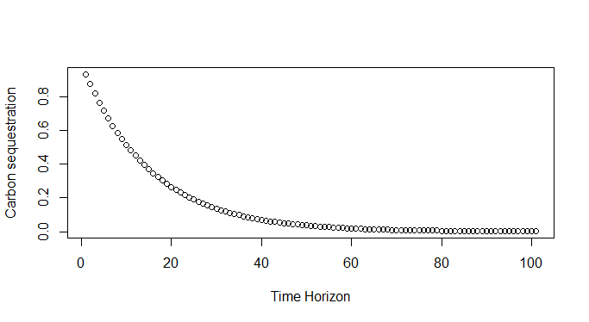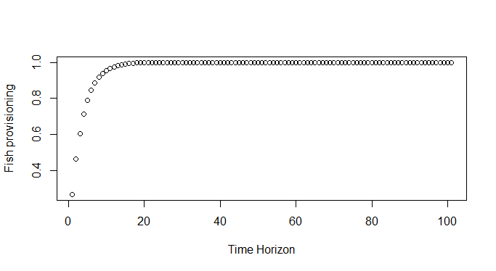
c)
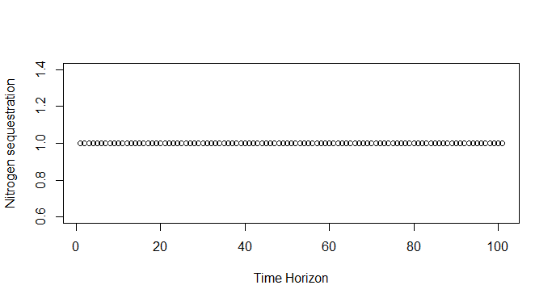
Figure S1. The projected the yearly returns under each time horizon using a number of linear and nonlinear functions that relate the restoration trajectory with ecosystem service provision. The function used differed depending on the ecosystem service a) Aboveground biomass carbon sequestration (based on the inverse relationship with biomass) b) Fish production (Warren et al. 2002, Able et al. 2004, Borja et al. 2010, Orth et al 2020) c) Soil Carbon and Nitrogen sequestration (Greiner et al 2013, Marba et al 2015, Orth et al 2020, Gulliver et al. 2020). We do not project changes to ecosystem service quantities that may depend on other exogenous factors, such as population growth and climate change.

a) 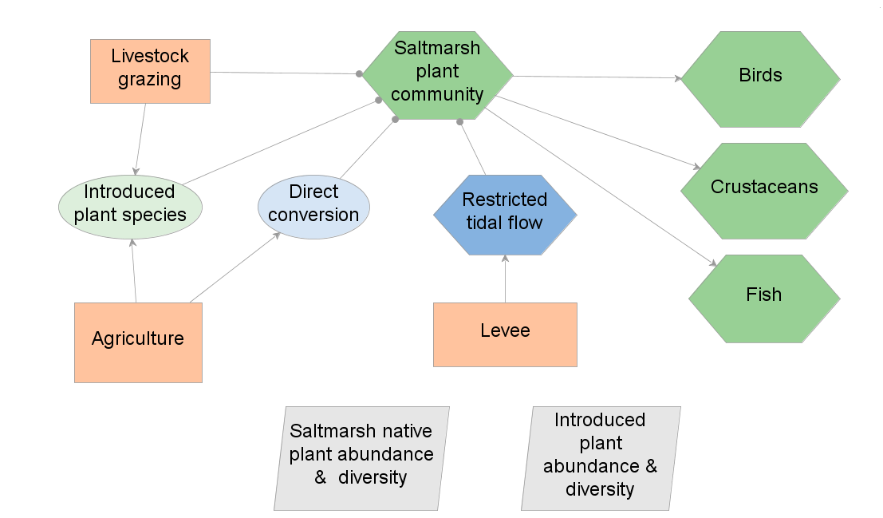

b) 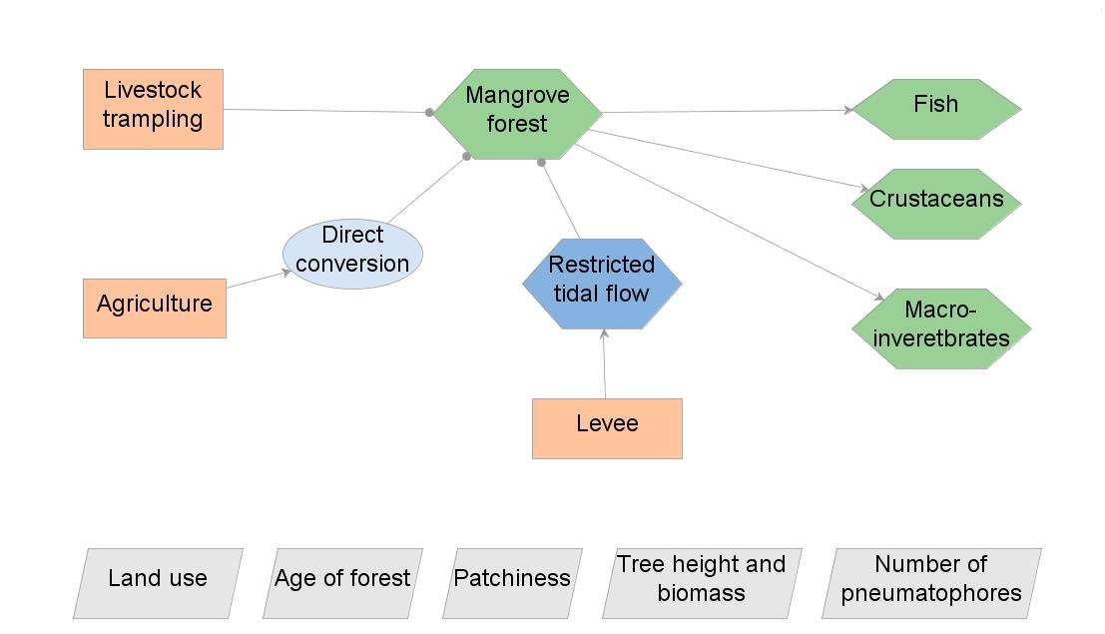

c) 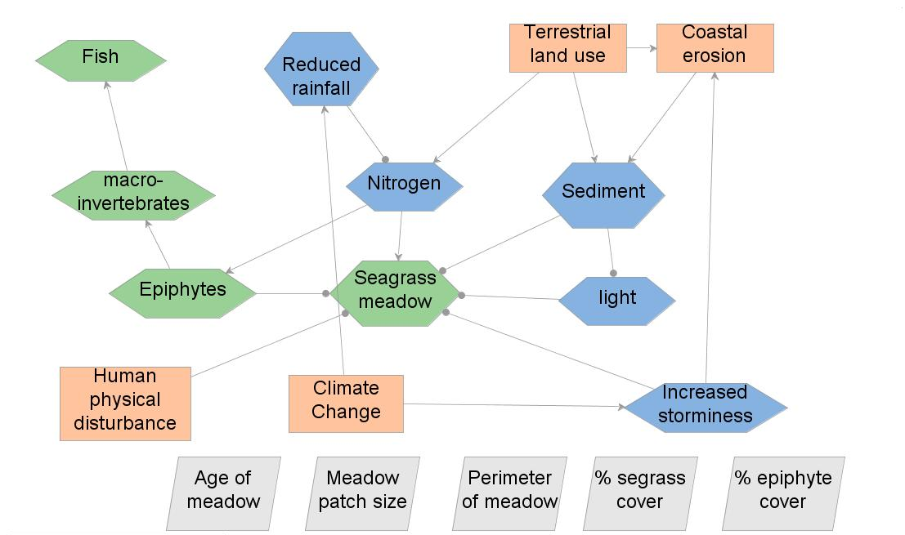
Figure S2. Conceptual models used to guide the assessment of condition of a) tidalmarsh b) mangrove and c) seagrass ecosystems. Green = chartaceristic biota, blue = the abiotic environment (dark blue) and processes (light blue), pink = threats to the ecosystem and grey = indicators of condition.
Table S1 Ecosystem classifications based on previous mapping (Biotopes) and how this was related to the global ecosystem typology (Keith et al. 2020).
Biotope Level 2 | Biotope  Level 3 | Biotope Level 4 | Corresponding Global Ecosystem Typology (Keith et al. 2020)
Sublittoral sediment | Sublittoral mud 2 - Port Phillip Bay | Corio Bay muds | M1.8 Subtidal mud plains
Sublittoral sediment | Sublittoral sand 2 - Port Phillip Bay | Elwood / Seaford shallow sand | M1.7 Subtidal sand beds
Sublittoral sediment | Sublittoral mud 2 - Port Phillip Bay | Hobsons Bay / Williamstown silty muds | M1.8 Subtidal mud plains
Sublittoral sediment | Sublittoral sand 2 - Port Phillip Bay | Capel Sound intermediate muddy sand | M1.7 Subtidal sand beds
Sublittoral sediment | Sublittoral sand 2 - Port Phillip Bay | Port Phillip Heads coarse tidal sands | M1.7 Subtidal sand beds
Sublittoral sediment | Sublittoral sand 2 - Port Phillip Bay | Symonds DMG tidal sands | M1.7 Subtidal sand beds
Sublittoral sediment | Sublittoral sand 2 - Port Phillip Bay | Port Phillip Bay intermediate muddy sand | M1.7 Subtidal sand beds
Sublittoral sediment | Sublittoral sand 2 - Port Phillip Bay | Port Phillip Bay southern muddy sand | M1.7 Subtidal sand beds
Sublittoral sediment | Sublittoral sand 2 - Port Phillip Bay | Swan / Clifton seagrass sands | M1.7 Subtidal sand beds
Sublittoral sediment | Sublittoral sand 2 - Port Phillip Bay | Werribee / St Leonards / Mornington shallow sand | M1.7 Subtidal sand beds
Sublittoral sediment | Sublittoral sand 2 - Port Phillip Bay | Swan / Clifton seagrass sands sand | M1.7 Subtidal sand beds
Sublittoral sediment | Sublittoral sand 2 - Port Phillip Bay | Southern tidal sands sand | M1.7 Subtidal sand beds
Sublittoral sediment | Sublittoral sand 2 - Port Phillip Bay | Great Sands intermediate lower | M1.7 Subtidal sand beds
Sublittoral sediment | Sublittoral mud 2 - Port Phillip Bay | Great Sands silty-mud | M1.8 Subtidal mud plains
Sublittoral sediment | Sublittoral mud 2 - Port Phillip Bay | Curlewis seagrass sandy-mud | M1.8 Subtidal mud plains
Sublittoral sediment | Sublittoral sand 2 - Port Phillip Bay | Great Sands intermediate upper | M1.7 Subtidal sand beds
Sublittoral sediment | Sublittoral mud 2 - Port Phillip Bay | Port Phillip Bay southern central muds | M1.8 Subtidal mud plains
Sublittoral sediment | Sublittoral mud 2 - Port Phillip Bay | Corio Bay silty-muds | M1.8 Subtidal mud plains
Sublittoral sediment | Sublittoral sand 2 - Port Phillip Bay | Seaford intermediate muddy sand | M1.7 Subtidal sand beds
Sublittoral sediment | Sublittoral sand 2 - Port Phillip Bay | Werribee-Mornington intermediate upper muddy sand | M1.7 Subtidal sand beds
Sublittoral sediment | Sublittoral sand 2 - Port Phillip Bay | Pt Wilson / Altona shallow sand | M1.7 Subtidal sand beds
Sublittoral sediment | Sublittoral mud 2 - Port Phillip Bay | Port Phillip Bay northern central muds | M1.8 Subtidal mud plains
Sublittoral sediment | Sublittoral sand 2 - Port Phillip Bay | Beaumaris shallow sand | M1.7 Subtidal sand beds
Sublittoral sediment | Sublittoral mud 2 - Port Phillip Bay | Port Phillip Bay northern deep lower muds | M1.8 Subtidal mud plains
Sublittoral sediment | Sublittoral sand 2 - Port Phillip Bay | Campbells Cove shallow sand | M1.7 Subtidal sand beds
Sublittoral sediment | Sublittoral mud 2 - Port Phillip Bay | Melbourne Channel North muds | M1.8 Subtidal mud plains
Sublittoral sediment | Sublittoral mud 2 - Port Phillip Bay | Yarra channel muds and clays | M1.8 Subtidal mud plains
Sublittoral sediment | Sublittoral sand 2 - Port Phillip Bay | Rye shallow sand | M1.7 Subtidal sand beds
Sublittoral sediment | Sublittoral sand 2 - Port Phillip Bay | Elwood / Seaford shallow | M1.7 Subtidal sand beds
Sublittoral sediment | Sublittoral mud | Wreck on sublittoral mud | M1.8 Subtidal mud plains
Sublittoral sediment | Sublittoral sand | Sand slope | M1.7 Subtidal sand beds
Sublittoral sediment | Sublittoral mud 2 - Port Phillip Bay | Port Phillip Bay northern central muds anchor scar field | M1.8 Subtidal mud plains
Sublittoral sediment | Sublittoral mud 2 - Port Phillip Bay | Williamstown / Melbourne channel mud and clays | M1.8 Subtidal mud plains
Sublittoral sediment | Sublittoral mud | Mud channel | M1.8 Subtidal mud plains
Sublittoral sediment | Sublittoral mud 2 - Port Phillip Bay | Port Phillip Bay southern central muds relic channel | M1.8 Subtidal mud plains
Sublittoral sediment | Sublittoral mud 2 - Port Phillip Bay | Port Phillip Bay northern deep lower muds anchor scar field | M1.8 Subtidal mud plains
Sublittoral sediment | Sublittoral mud 2 - Port Phillip Bay | Port Phillip Bay Northern DMG muds | M1.8 Subtidal mud plains
Sublittoral sediment | Sublittoral mud 2 - Port Phillip Bay | Port Phillip Bay northern deep lower muds relic channel | M1.8 Subtidal mud plains
Sublittoral sediment | Sublittoral mud 2 - Port Phillip Bay | Port Phillip Bay Northern DMG Extension muds | M1.8 Subtidal mud plains
Sublittoral sediment | Sublittoral mud 2 - Port Phillip Bay | Port Phillip Bay northern central muds relic channel | M1.8 Subtidal mud plains
Sublittoral sediment | Sublittoral mud 2 - Port Phillip Bay | Port Phillip Bay northern central muds pit | M1.8 Subtidal mud plains
Sublittoral sediment | Sublittoral sand | Infralittoral sand | M1.7 Subtidal sand beds
Sublittoral sediment | Sublittoral mud 2 - Port Phillip Bay | Port Phillip Bay northern deep lower muds raised tubes | M1.8 Subtidal mud plains
Sublittoral sediment | Sublittoral mud 2 - Port Phillip Bay | Port Phillip Bay northern deep lower muds pit | M1.8 Subtidal mud plains
Sublittoral sediment | Sublittoral sand 2 - Port Phillip Bay | Werribee-Mornington intermediate upper | M1.7 Subtidal sand beds
Sublittoral sediment | Sublittoral sand 2 - Port Phillip Bay | Werribee-Mornington intermediate upper muddy sand anchor scar field | M1.7 Subtidal sand beds
Sublittoral sediment | Sublittoral sand 2 - Port Phillip Bay | Campbells Cove shallow | M1.7 Subtidal sand beds
Sublittoral sediment | Sublittoral sand 2 - Port Phillip Bay | Campbells Cove shallow sand relic channel | M1.7 Subtidal sand beds
Sublittoral sediment | Sublittoral sand 2 - Port Phillip Bay | Werribee-Mornington intermediate upper muddy sand relic channel | M1.7 Subtidal sand beds
Sublittoral sediment | Seaweed communities on sublittoral sediment | Drift seaweed mats | M1.8 Subtidal mud plains
Sublittoral sediment | Sublittoral mud 2 - Port Phillip Bay | Port Phillip Bay South East DMG muds | M1.8 Subtidal mud plains
Littoral sediment | Coastal saltmarshes and saline reedbeds | Coastal saltmarsh - Wet saltmarsh shrubland | MFT1.3 Coastal saltmarshes & reedbeds
Littoral sediment | Coastal saltmarshes and saline reedbeds | Coastal saltmarsh aggregate | MFT1.3 Coastal saltmarshes & reedbeds
Littoral sediment | Coastal saltmarshes and saline reedbeds | Coastal saltmarsh - Wet saltmarsh herbland | MFT1.3 Coastal saltmarshes & reedbeds
Littoral sediment | Mangroves | Southern Avicennia marina mangrove | MFT1.2 Intertidal forests and shrublands
Littoral sediment | Coastal saltmarshes and saline reedbeds | Coastal hypersaline saltmarsh | MFT1.3 Coastal saltmarshes & reedbeds
Littoral sediment | Coastal saltmarshes and saline reedbeds | Coastal tussock saltmarsh | MFT1.3 Coastal saltmarshes & reedbeds
Littoral sediment | Coastal saltmarshes and saline reedbeds | Saline aquatic meadow | MFT1.3 Coastal saltmarshes & reedbeds
Littoral sediment | Coastal saltmarshes and saline reedbeds | Berm grassy shrubland | MFT1.3 Coastal saltmarshes & reedbeds
Littoral sediment | Coastal saltmarshes and saline reedbeds | Coastal dry saltmarsh | MFT1.3 Coastal saltmarshes & reedbeds
Littoral sediment | Coastal saltmarshes and saline reedbeds | Coastal saltmarsh - coastal saline grassland | MFT1.3 Coastal saltmarshes & reedbeds
Infralittoral rock | Low energy infralittoral rock |  | M1.6 Subtidal rocky reefs
Sublittoral sediment | Sublittoral seagrass beds | Zostera and Ruppia beds | M1.1 Seagrass meadows
Infralittoral rock |  |  | M1.6 Subtidal rocky reefs
Sublittoral sediment | Seaweed communities on sublittoral sediment |  | M1.8 Subtidal mud plains
Sublittoral sediment | Sublittoral biogenic reefs | Pyura reefs | M1.6 Subtidal rocky reefs
Sublittoral sediment | Seaweed communities on sublittoral sediment | Caulerpa beds | M1.8 Subtidal mud plains
Infralittoral rock | Low energy infralittoral rock | Caulerpa communities on low energy subtidal rock. | M1.6 Subtidal rocky reefs
Sublittoral sediment | Sublittoral seagrass beds | Halophila beds | M1.1 Seagrass meadows
Infralittoral rock | Low energy infralittoral rock | Codium communities on low energy subtidal rock. | M1.6 Subtidal rocky reefs
Infralittoral rock | Moderate energy infralittoral rock | Amphibolis stands | M1.1 Seagrass meadows
Infralittoral rock | High energy infralittoral rock | High energy subtidal rock Phyllospora-Ecklonia communities | M1.6 Subtidal rocky reefs
Littoral sediment | Coastal saltmarshes and saline reedbeds | Estuarine wetland | MFT1.3 Coastal saltmarshes & reedbeds
Littoral sediment | Coastal saltmarshes and saline reedbeds | Miscellaneous | MFT1.3 Coastal saltmarshes & reedbeds
Littoral sediment | Coastal saltmarshes and saline reedbeds | Estuarine flats grassland | MFT1.3 Coastal saltmarshes & reedbeds
Littoral sediment | Coastal saltmarshes and saline reedbeds | Brackish Lignum swamp | MFT1.3 Coastal saltmarshes & reedbeds
Littoral sediment | Coastal saltmarshes and saline reedbeds | Seasonally inundated sub-saline herbland | MFT1.3 Coastal saltmarshes & reedbeds
Littoral sediment | Coastal saltmarshes and saline reedbeds | Unvegetated (open water/bare soil/mud) | MFT1.3 Coastal saltmarshes & reedbeds
Sublittoral sediment |  |  | M1.7 Subtidal sand beds
Sublittoral sediment | Sublittoral sand | Sand sublittoral sediment bar | M1.7 Subtidal sand beds
Littoral sediment |  | Bass River delta | MT1.2 Muddy Shorelines
Littoral sediment |  |  | MT1.2 Muddy Shorelines
Littoral sediment | Coastal saltmarshes and saline reedbeds | Coastal saltmarshWet saltmarsh shrubland | MFT1.3 Coastal saltmarshes & reedbeds
Littoral sediment | Coastal saltmarshes and saline reedbeds | Coastal saltmarshWet saltmarsh herbland | MFT1.3 Coastal saltmarshes & reedbeds
Littoral sediment | Coastal saltmarshes and saline reedbeds | Brackish Herbland | MFT1.3 Coastal saltmarshes & reedbeds
Littoral sediment | Coastal saltmarshes and saline reedbeds | Estuarine scrub | MFT1.3 Coastal saltmarshes & reedbeds
Littoral sediment | Coastal saltmarshes and saline reedbeds | Coastal saltmarshcoastal saline grassland | MFT1.3 Coastal saltmarshes & reedbeds
Littoral sediment | Mangroves | Mangrove shrubland | MFT1.2 Intertidal forests and shrublands
Littoral sediment | Littoral sediments dominated by seagrass | Seagrass beds on littoral sediments | M1.1 Seagrass meadows
Infralittoral rock | Moderate energy infralittoral rock | Amphibolis antarctica on moderate energy rock with sandy veneer | M1.6 Subtidal rocky reefs
Infralittoral rock | Moderate energy infralittoral rock |  | M1.6 Subtidal rocky reefs
Sublittoral sediment | Rhodolith beds | Rhodolith beds in tide-swept sheltered channels | M1.6 Subtidal rocky reefs
Littoral sediment | Mangroves |  | MFT1.2 Intertidal forests and shrublands
Littoral rock |  |  | MT1.1 Rocky shorelines
Circalittoral rock | Tide-swept channels of circalittoral rock | Moderate energy tide-swept faunal communities | M1.6 Subtidal rocky reefs
Sublittoral sediment | Sublittoral biogenic reefs | Sublittoral bryozoan reef and sediment | M1.6 Subtidal rocky reefs

Table S2. Framework (state and transition model) for determining tidal marsh and mangrove condition based on existing mapping and land use data. This table was put together based on data and descriptions from Laegdsgaard et al. 2009, Boon et al. 2014, Sinclair and Kohout 2018 and the conceptual models (Figure S2).

Current or historical tidal marsh or mangroves | Levee restricting tidal flow | Agriculture occurring | Impact on biodiversity | Impact on ecosystem services | Condition/  Relative severity of decline
Historical |  |  | - No tidal marsh or mangrove plant species present.  - Animal species community is entirely altered. | Not functioning as tidal marsh or mangrove | Collapsed
Current | Yes | Yes | - Plant community is characterised by low native saltmarsh or mangrove species abundance &/or diversity.  - High abundance of invasive plant species.  - Disturbance via livestock pugging and grazing impacts reduces invertebrate abundance and diversity | - No contribution to fisheries due to levee restricting flow.  - Contribution to coastal protection.  - Soil carbon & nitrogen sequestration is significantly reduced. High CO₂e emissions | High  (90-99% relative disturbance severity)
Current | Yes | No | - Native plant abundance, biomass and diversity is low  - Low abundance of invasive species | - No contribution to fisheries.  - Minimal contribution to coastal protection  - Soil carbon & nitrogen sequestration is reduced. Medium CO₂e emissions | Medium  (70-89% relative disturbance severity)
Current | No | Yes | - Native plant abundance/biomass reduced due to livestock grazing,  - Lower plant diversity compared to natural sites.  - Invasive plant species present and can be dominant | - Contribution to fisheries,  - Minimal coastal protection  - Soil carbon & nitrogen sequestration is reduced.  - Low CO₂e emissions | Low  (50-69% relative disturbance severity)
Current | No | No | - Plant diversity, and abundance/biomass is highest  - no invasive plant species present | Highly productive ecosystems contributing multiple ecosystem services (fisheries, coastal protection, carbon and nitrogen sequestration). | Natural (within natural variability)

Table S3. Framework for assessing seagrass condition based on historical seagrass mapping to determine the age of seagrass meadows and if they are currently not present, how long since they last were. Where they have collapsed, this would now be classified as subtidal sand beds or subtidal mud plains.

1966-1970 | 1980 -1990 | 2000’s | 2010s | Current minimum age of seagrass meadow | Relative severity of disturbance  (Condition)
Present | Present | Present | Present | >45 | <30  Natural
Absent | Present | Present | Present | 31 | <30  Natural
Present | Absent | Present | Present | 11 | 30-49  Low
Absent | Absent | Present | Present | 11 | 30-49  Low
Present | Present | Absent | Present | 1 | 50-79  Medium
Absent | Present | Absent | Present | 1 | 50-79  Medium
Present | Absent | Absent | Present | 1 | 50-79  Medium
Absent | Absent | Absent | Present | 1 | 50-79  Medium
Present | Present | Present | Absent | 0 | 80-99  High
Absent | Present | Present | Absent | 0 | 80-99  High
Present | Absent | Present | Absent | 0 | 80-99  High
Absent | Absent | Present | Absent | 0 | 80-99  High
Present | Present | Absent | Absent | 0 | Collapsed
Absent | Present | Absent | Absent | 0 | Collapsed
Present | Absent | Absent | Absent | 0 | Collapsed

Table S4. Framework (state and transition model) for determining the transition between collapsed tidal marsh and mangrove and how restoration could improve condition.

 | Current tidal marsh & mangrove condition |  |  | Restoration scenarios
Condition/  Relative severity of decline | Current tidal marsh or mangroves | Levee restricting tidal flow | Grazing/ Agriculture occurring | Does current land use allow for restoration? | Removal of levee | Add fence to exclude livestock | Resulting ecosystem condition
Collapsed | Historical | Yes | Yes | Yes | Yes | Yes | Natural
Collapsed | Historical | Yes | No | Yes | Yes | NA | Natural
Collapsed | Historical | No | Yes | Yes | NA | Yes | Natural

Table S5 The variable and fixed costs associated with the two restoration actions to improve tidal marsh and mangrove condition. These numbers were collated from local projects conducting fencing or levee removal restoration, so are realistic for this location. However, these costs are indicative and any future restoration project in this region or elsewhere would need a site based assessment. These numbers are not applicable in other regions. These estimates do not include costs of monitoring the recovery of saltmarsh and mangroves, and any biodiversity or resultant ecosystem services.
Rehabilitation activity | Variable cost per unit | Fixed cost
Fencing | $15 per metre | Stay - AUD$100  Gate - AUD$200  Material transportation - AUD$100  Project management: AUD$20,000
levee removal | $6 per cubic meter | <10 ha Project Management (PM) = AUD$20,000,  Hydrological Assessment (HA)=AUD$30,000,  Bathymetry modification (BM)=AUD$20,000  10-50 ha PM=AUD$40,000, HA= AUD$50,000​ BM=AUD$50,000​  50-200 ha PM=AUD$80,000, HA=AUD$100,000​ BM=AUD$100,000.

Table S6. Ecosystem service gains with restoration used for the assessment of how saltmarsh restoration scenarios can improve ecosystem services

 | Mangrove | Tidal marsh
Soil Carbon sequestration  (t/CO2e/ha/yr) | Port Phillip = 0.824  Western Port = 0.65 | Port Phillip = 4.04  Western Port = 2.51
Plant biomass carbon sequestration  (kg/m²/yr) | 5.4 until 40 years | 0.03
Nitrogen assimilation  (Mg/N/ha/yr) | Port Phillip =0.165  Western Port =0.013 | Port Phillip = 0.051  Western Port = 0.12
Recreational fish catch  (kg/ha/yr) | Port Phillip = 11.12  Western Port = 11.15 | Port Phillip = 1.56  Western Port = 2.81

Table S7. sensitivity analysis showing the net benefits with using different discount rates (1%, 3%, 5%, 7% and 11%).
Year | Bay | Restoration action | 1% | 3% | 5% | 7% | 11%
20 | PPB | Fencing | 7,577,913 | 6,065,506 | 4,898,897 | 3,986,938 | 2,685,722
20 | WPB | Fencing | 480,635 | 368,583 | 282,150 | 214,584 | 118,177
20 | PPB | Levee removal | 49,001,543 | 40,160,376 | 33,340,664 | 28,009,575 | 20,402,981
20 | WPB | Levee removal | 8,927,500 | 7,342,132 | 6,119,281 | 5,163,386 | 3,799,535
20 | PPB | Fencing or Levee removal | 12,090,851 | 9,866,864 | 8,151,371 | 6,810,341 | 4,896,909
20 | WPB | Fencing or Levee removal | 12,140,830 | 9,794,038 | 7,983,875 | 6,568,883 | 4,550,005
20 | All | All | 90,219,272 | 73,597,498 | 60,776,238 | 50,753,706 | 36,453,331
50 | PPB | Fencing | 18,686,030 | 11,878,365 | 8,062,709 | 5,771,542 | 3,308,341
50 | WPB | Fencing | 1,303,335 | 799,107 | 516,478 | 346,762 | 164,293
50 | PPB | Levee removal | 113,936,893 | 74,140,939 | 51,835,541 | 38,441,935 | 24,042,661
50 | WPB | Levee removal | 20,584,364 | 13,441,889 | 9,439,109 | 7,035,920 | 4,452,787
50 | PPB | Fencing or Levee removal | 28,425,278 | 18,414,643 | 12,803,741 | 9,434,591 | 5,812,467
50 | WPB | Fencing or Levee removal | 29,397,063 | 18,823,794 | 12,898,362 | 9,340,873 | 5,517,039
50 | All | All | 212,332,963 | 137,498,738 | 95,555,940 | 70,371,623 | 43,297,589
100 | PPB | Fencing | 31,192,859 | 15,019,390 | 8,931,261 | 6,032,020 | 3,336,597
100 | WPB | Fencing | 2,229,487 | 1,031,706 | 580,796 | 366,051 | 166,386
100 | PPB | Levee removal | 187,048,769 | 92,502,606 | 56,912,881 | 39,964,628 | 24,207,837
100 | WPB | Levee removal | 33,714,722 | 16,739,477 | 10,350,944 | 7,309,377 | 4,482,451
100 | PPB | Fencing or Levee removal | 46,816,502 | 23,033,503 | 14,080,941 | 9,817,623 | 5,854,017
100 | WPB | Fencing or Levee removal | 48,834,934 | 23,705,463 | 14,248,220 | 9,745,691 | 5,560,952
100 | All | All | 349,837,272 | 172,032,144 | 105,105,042 | 73,235,390 | 43,608,239

Table S8. Extent of the different marine and coastal ecosystems and their percentage of the total area in Port Phillip and Western Port in southeast Australia.

 | Port Phillip Bay |  | Western Port |  | ALL
 | Area  (Ha) | % | Area  (Ha) | % | Area  (Ha) | %
Marine realm
Rocky reef | 3,654 | 2% | 3,067 | 4% | 6,721 | 3%
Seagrass meadows | 6,788 | 3% | 10,505 | 14% | 17,293 | 6%
Subtidal mud plains | 105,216 | 54% | 17,453 | 24% | 122,669 | 46%
Subtidal sand beds | 77,886 | 40% | 37,259 | 51% | 115,145 | 43%
Marine Total | 193,544 | 99% | 68,284 | 94% | 261,828 | 97%
Coastal realm
Intertidal forests & shrublands | 4 | 0% | 1,726 | 2% | 1,730 | 1%
Intertidal marshes | 2,492 | 1% | 2,672 | 4% | 5,164 | 2%
Marine / terrestrial Total | 2,496 | 1% | 4,398 | 6% | 6,894 | 3%
Total | 196,040 | 100% | 72,682 | 100% | 268,722 | 100%

