Supplemental Material
High-Performance Paper-based Biocathode fabricated by Screen-printing an improved Mesoporous Carbon Ink and by Oriented Immobilization of Bilirubin Oxidase
Noya Loew^{1,‡}, Isao Shitanda^{1,3,‡,*}, Himeka Goto¹, Hikari Watanabe¹, Tsutomu Mikawa³, Seiya Tsujimura^{2,4}, and Masayuki Itagaki^{1,3}
¹ Department of Pure and Applied Chemistry, Faculty of Science and Technology, Tokyo
University of Science Noda, 2641 Yamazaki, Chiba 278-8510, Japan.
² Research Institute for Science and Technology, Tokyo University of Science, 2641 Yamazaki, Noda, Chiba 278-8510, Japan
³ RIKEN Center for Biosystems Dynamics Research, 1-7-22 Suehirocho, Tsurumiku,
Yokohama, Kanagawa 230-0045, Japan
⁴ Division of Materials Sciences, Faculty of Pure and Applied Sciences, University of
Tsukuba,1-1-1Tennodai, Tsukuba, Ibaraki, 305-8573, Japan
* Corresponding author: shitanda@rs.tus.ac.jp, ‡: N. L and I. S. are equal contributors.
S1
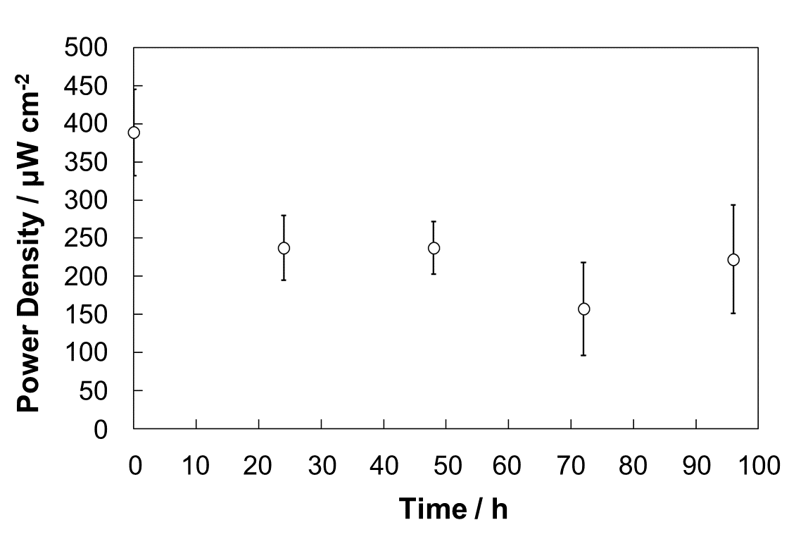
Fig. S1. Storage stability of BFCs. Power density of biofuel cell fabricated using MgOC inks with CMC and bilirubin as guide for BOD immobilization and stored for 24, 48, 72, or 96 h. Storage conditions: room temperature; ambient humidity. Evaluation conditions: 1 M phosphate buffer, pH 7.0; 100 mM lactate; humidity 70%; temperature 36 ºC. Biocathode enzyme: BOD; bioanode enzyme: LOx; bioanode mediator: 1,2-NQ.

