APPENDICES
Appendix A.1 Terms used by nDepth™ algorithm to identify (flag) OUP positive reports
Opioid terms |  | Problem use terms
codeine | analgesic | addict | abusing | aberrancy
codeine | narcotic | addicted | misusing | aberrant
codeine | opiate | addiction | overusing | diversion
fentanyl | opioid |  | over using | divert
hydrocodone |  |  | abuse
methadone |  |  | abuser
morphine |  |  | misuse
oxy |  |  | misuser
oxy-ir |  |  | overuse
oxycod |  |  | overuser
oxycodone |  |  | over use
oxyContin percocet polypharmacy vico  Vicodin |  | over user
Appendix A.2 Highlighted phrases used in the semi-assisted manually review process
Semi assisted manual review highlighted words
abus* | opioid use disorder | diversion/divert
misus* | dependent | high
overus* | dependency | euphoria
over us* | heroin | abnormal urine drug screen
Addict* | Crav* | dirty urine
inconsistent urine | Lost prescriptions | alcohol abus*
unauthorized dose increase | Less suggestive words | early refills
taking more than  prescribed | marijuana | immediate taper
Narcan | narcotic | naloxone

Appendix A.3 ICD-9 codes used to define OUP
Class Codes
Diagnosis Category | ICD-9-CM Codes
Opioid Abuse and dependence | - 304.00 (opioid dependence unspecified)  - 304.01 (opioid dependence continuous)  - 305.50 (opioid abuse unspecified)  - 305.51 (opioid abuse continuous)  - 304.71 (opioid/other dependence continuous)  - 304.02 (opioid dependence episodic)  - 304.70 (opioid/other dependence unspecified)  - 305.52 (opioid abuse episodic)  - 304.72 (opioid/other dependence episodic)
Poisoning | - Non-specific code 965 Poisoning by analgesics antipyretics and antirheumatics  - Non-specific code 965.0 Poisoning by opiates and related narcotics  - Specific code 965.00 Poisoning by opium (alkaloids), unspecified  - Specific code 965.01 Poisoning by heroin  - Specific code 965.02 Poisoning by methadone  - Specific code 965.09 Poisoning by other opiates and related narcotics  - E850.0 Accidental poisoning by heroin  - E850.1 Accidental poisoning by methadone  - E850.2 Accidental poisoning by other opiates and related narcotics
Appendix A.4 Frequency distribution of positive ICD-9 codes for OUP
Frequency distribution of positive ICD-9 codes for OUP
ICD-9 Codes | Description | N (%)
304 | opioid dependence unspecified | 24 (49%)
305.5 | opioid abuse unspecified | 9 (18%)
304.01 | opioid dependence continuous | 5 (10%)
965 | Non-specific code 965.0 Poisoning by opiates and related narcotics | 3 (6%)
965.01 | Specific code 965.01 Poisoning by heroin | 3 (6%)
E850.2 | E850.2 Accidental poisoning by other opiates and related narcotics | 2 (4%)
E850.0 | E850.0 Accidental poisoning by heroin | 1 (2%)
965.09 | Specific code 965.09 Poisoning by other opiates and related narcotics | 1 (2%)
304.71 | opioid/other dependence continuous | 1 (2%)
Grand Total |  | 49 (100) *
*4 out of 45 patients had two positive ICD-9 codes for OUP

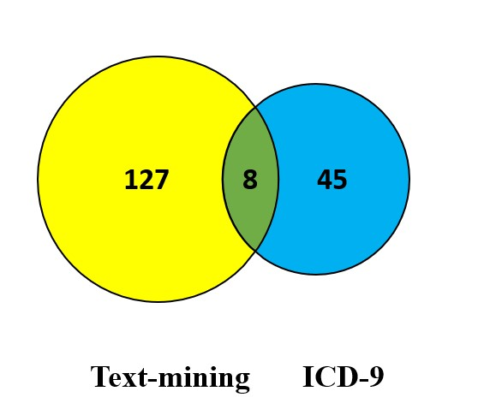
Appendix A.5 Venn diagram of the overlap between the two positive cohorts of opioid Use problem in the study

