**Si/O isotopic composition of JHZs**

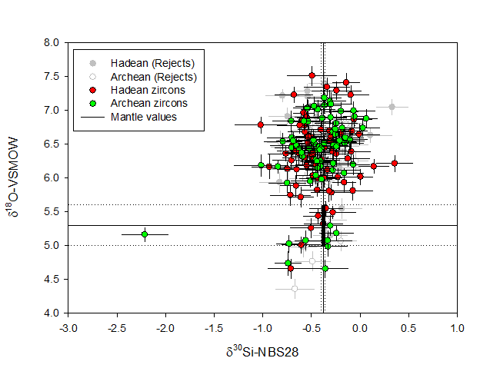

**Figure S1**: δ30Si and δ18O values (±2 s.e.) of Hadean and Archean zircons discussed in this study (Table ST2). Note the two sub-populations. Some analyses were rejected if a grain crack was noticed in the sputtering pit. The black lines are mantle zircon values and the black field represents the overlap between Si and O mantle zircon isotopic values (See Supplementary information).



C

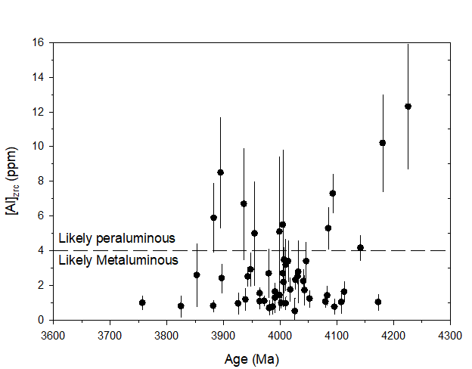

A

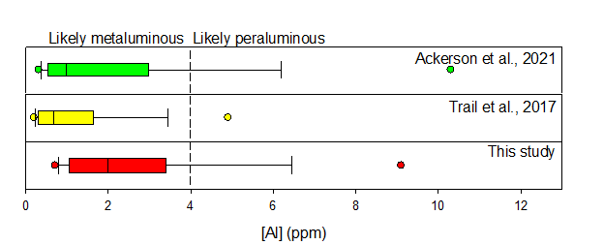

B

***Figure S2 A****. [Al] content of our JHZs plotted vs age. The aluminosity for JHZs is unchanged from the Hadean to the Archean.* ***B.*** *[Al] content of JH zircons from this study compared to those reported in* ***[61]*** *and* ***[62]****. This study, as with the other two, shows a large number of zircons that indicate metaluminous melts. The data points in each panel are the 5th and 95Th percentile of each dataset.* ***C.*** *Crystallization T of our JHZs compared to those of* ***[6]****. All temperatures have been derived using the Ti-in-zircon thermometer****18****.*

***Fig S3:******a-e.*** *Some representative CL images of the zircons we analyzed. The CL images were taken using a Cameca SXFive Electron Microprobe housed at Syracuse University.*



***Fig S4:*** *REE patterns of JHZs we analyzed showing characteristic low LREE, high HREE, positive Ce anomalies and negative Eu anomalies. (See online methods for rejection criteria). The gaps in the pattern are because all not all REEs were analyzed.*



***Fig S5:*** *D (±2 s.e.) values measured in this study at 1100 °C and 1300 °C (1100 and 1300) compared to previous studies ((B&B, 2012)****34*** *and (P&G, 2016)****60****).*

**References not in the main document or Online methods**

1. Trail, D., Tailby, N., Wang, Y., Harrison, T.M. & Boehnke, P. Aluminum in zircon as evidence for peraluminous and metaluminous melts from the Hadean to present. *Geochem. Geophy. Geosy.* **18**, 1580-1593 (2017).