Supporting Information

Atomic-resolution structures from polycrystalline covalent organic frameworks crystals with enhanced Cryo-cRED

Jian Li^{1, 2,#} , Cong Lin^{1,3}, Tianqiong Ma¹, Junliang Sun ^{*1}
1 College of Chemistry and Molecular Engineering, Beijing National Laboratory for Molecular Sciences, Peking University, Beijing, China.
2 Berzelii Center EXSELENT on Porous Materials, Department of Materials and Environmental Chemistry, Stockholm University, Stockholm, 10691, Sweden.
3 Department of Mechanical Engineering, The Hong Kong Polytechnic University, Kowloon, Hong Kong, China.
# Present address: Department of Fibre and Polymer Technology, School of Engineering Sciences in Chemistry, Biotechnology and Health, KTH Royal Institute of Technology, Tekninkringen 56-58, Stockholm, SE-100 44, Sweden.

Table of Contents

Section 1: Supporting Figures and tables
Figure S1 Schematic of the synthesis of E-FCOF-5 and C-FCOF-5 (a), 3D-TPB-COF-OMe，3D-TPB-COF-Me and 3D-TPB-COF-OH (b).
Figure S2 Powder X-ray diffraction (PXRD) pattern of E-FCOF-5 and C-FCOF-5 (a), 3D-TPB-COF-OMe，3D-TPB-COF-Me and 3D-TPB-COF-OH (b).
Figure S3 Scanning electron microscope (SEM) image of FCOF-5 (a), 3D-TPB-COF-OMe (b)，3D-TPB-COF-Me (c) and 3D-TPB-COF-OH (d).
Figure S4 (a) Overview of the E-FCOF-5 nano-crystals prepared on the TEM grid; (b) ED pattern of E-FCOF-5 with a high resolution of 0.82 Å at the beginning of the cRED data collection; (c) ED pattern of E-FCOF-5 at the final stage of cRED data collection.
Figure S5 Reconstructed 3D reciprocal lattice of E-FCOF-5. (a) Overview of reconstructed lattice; (h0l) (b), (0kl) (c), and (hk0) (d) slices cut from the reconstructed reciprocal lattice.
Figure S6 Reconstructed 3D reciprocal lattice from the 22 cRED datasets of E-FCOF-5. The 16 datasets marked with # belong to the selected cluster for structure solution and refinement.
Figure S7 Six-fold interpenetrated pts topology of E-FCOF-5 (left), and C-FCOF-5 (right).
Figure S8 Reconstructed 3D reciprocal lattice from the 22 cRED datasets of C-FCOF-5. The 16 datasets marked with # belong to the selected cluster for structure solution and refinement.
Figure S9 Reconstructed 3D reciprocal lattice of C-FCOF-5. (a) Overview of the reconstructed lattice; (h0l) (b), (0kl) (c), and (hk0) (d) slices cut from the reconstructed reciprocal lattice.
Figure S10 ED pattern of C-FCOF-5 with a high resolution of 0.79Å during cRED data collection.
Figure S11 The geometry of TFMB in E-FCOF-5 (a) (e, g, pink) and C-FCOF (b)(f, g, orange) obtained by refinement of cryo-cRED data at atomic resolution (this study). The geometry of TFMB in E-FCOF-5 (c) (e, dark green) and C-FCOF (d)(f, light green) obtained by PXRD simulation (previous study1). (e) The geometry comparison of TFMB between (a) and (c). (f) The geometry comparison of TFMB between (b) and (d). (g) The geometry comparison of TFMB between (a) and (b).
Figure S12 Pattern of 3D-TPB-COF-OMe with a high resolution of 0.87 Å during cRED data collection
Figure S13 Reconstructed 3D reciprocal lattice of 3D-TPB-COF-OMe. (a) Overview of the reconstructed lattice; (h0l) (b), (0kl) (c), and (hk0) (d) slices cut from the reconstructed reciprocal lattice.
Figure S14 Potential density maps of 3D-TPB-COF-OMe from refinement against on a single dataset (dataset 4# in table S1) with 65.9% completeness.
Figure S15 ED pattern of 3D-TPB-COF-Me with a high resolution of 0.90Å during cRED data collection.
Figure S16 Reconstructed 3D reciprocal lattice of 3D-TPB-COF-Me. (a) Overview of the reconstructed lattice; (h0l) (b), (0kl) (c), and (hk0) (d) slices cut from the reconstructed reciprocal lattice.
Figure S17 ED pattern of 3D-TPB-COF-OH with a resolution of 1.2Å during cRED data collection.
Figure S18 Reconstructed 3D reciprocal lattice of 3D-TPB-COF-OH. (a) Overview of the reconstructed lattice; (h0l) (b), (hk0) (c), and (0kl) (d) slices cut from the reconstructed reciprocal lattice.
Figure S19 (a) Reconstructed 3D reciprocal lattice from the 5 cRED datasets of 3D-TPB-COF-OH. The datasets marked with # belong to the selected cluster for structure solution and refinement. (b) The cut distance in dendrogram is represented by the blue line at 0.41 for HCA, 4 cRED datasets for 3D-TPB-COF-OH (in orange), which were selected for the structure determination and refinement.
Figure S20 The porous structure of 3D-TPB-COF-OMe (a), 3D-TPB-COF-Me (d) and 3D-TPB-COF-OH(g). Single pts network of 3D-TPB-COF-OMe (b), 3D-TPB-COF-Me (e).and 3D-TPB-COF-OH (h). The five-fold interpenetrated pts topology of 3D-TPB-COF-OMe (c), 3D-TPB-COF-Me (f) and 3D-TPB-COF-OH. Color scheme: C, gray; N, blue; H, white.
Table S1 Summary of the cRED indexing and procession results for the E-FCOF-5 crystals.
Table S2 cRED experimental parameters, crystallographic data, and structure refinement details of E-FCOF-5.
Table S3 Summary of the cRED datasets indexing and procession results for the C-FCOF-5 crystals.
Table S4 cRED experimental parameters, crystallographic data, and structure refinement details of C-FCOF-5.
Table S5 Summary of the cRED datasets indexing and procession results for all the 3D-TPB-COF-OMe crystals.
Table S6 cRED experimental parameters, crystallographic data, and structure refinement details of 3D-TPB-COF-OMe
Table S7 Summary of the cRED datasets indexing and procession results for all the 3D-TPB-COF-Me crystals.
Table S8 cRED experimental parameters, crystallographic data, and structure refinement details of 3D-TPB-COF-Me
Table S9 Summary of the cRED datasets indexing and procession results for the 3D-TPB-COF-OH crystals.
Table S10 cRED experimental parameters, crystallographic data, and structure refinement details of 3D-TPB-COF-OH.

Section 2: Reference

Section 1: Supporting Figures and tables

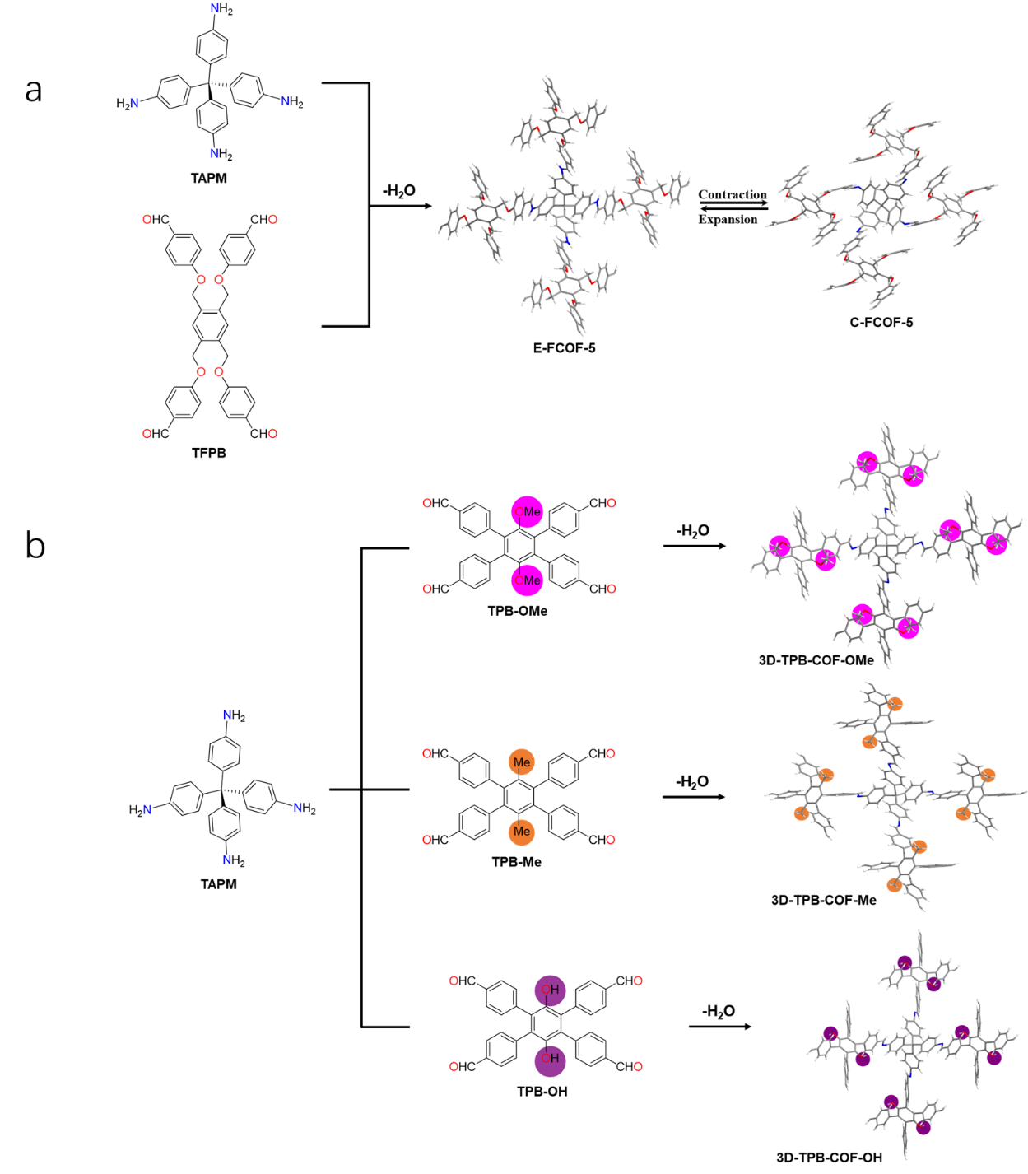

Figure S1 Schematic of the synthesis of E-FCOF-5 and C-FCOF-5 (a), 3D-TPB-COF-OMe，3D-TPB-COF-Me and 3D-TPB-COF-OH (b).

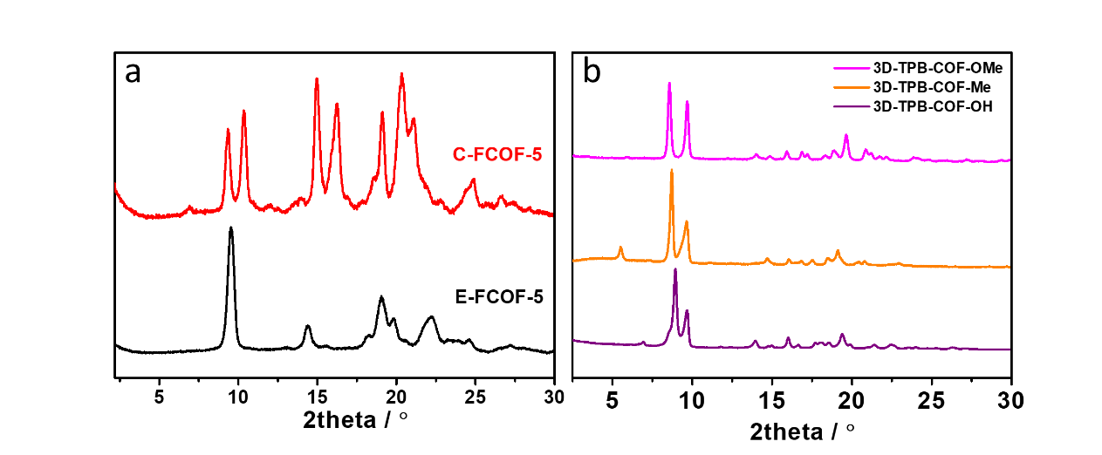
Figure S2 Powder X-ray diffraction (PXRD) pattern of E-FCOF-5 and C-FCOF-5 (a), 3D-TPB-COF-OMe，3D-TPB-COF-Me and 3D-TPB-COF-OH (b).

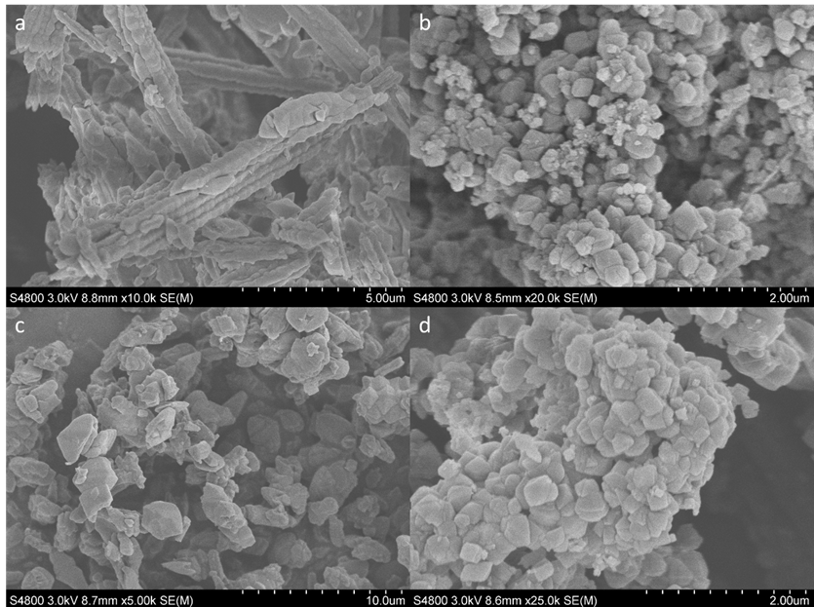
Figure S3 Scanning electron microscope (SEM) image of FCOF-5 (a), 3D-TPB-COF-OMe (b)，3D-TPB-COF-Me (c) and 3D-TPB-COF-OH (d).

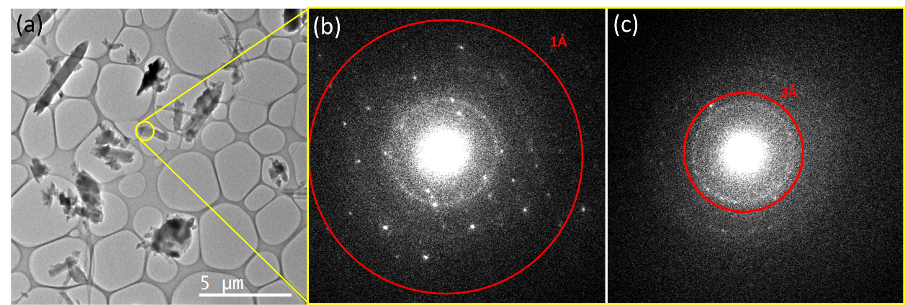
Figure S4 (a) Overview of the E-FCOF-5 nano-crystals prepared on the TEM grid; (b) ED pattern of E-FCOF-5 with a high resolution of 0.82 Å at the beginning of the cRED data collection; (c) ED pattern of E-FCOF-5 at the final stage of cRED data collection.
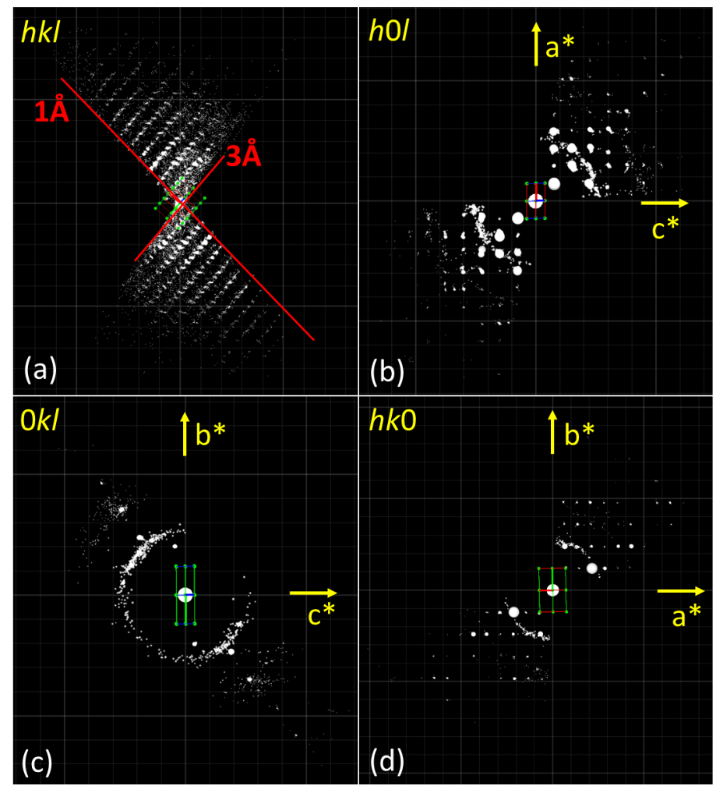
Figure S5 Reconstructed 3D reciprocal lattice of E-FCOF-5. (a) Overview of reconstructed lattice; (h0l) (b), (0kl) (c), and (hk0) (d) slices cut from the reconstructed reciprocal lattice.
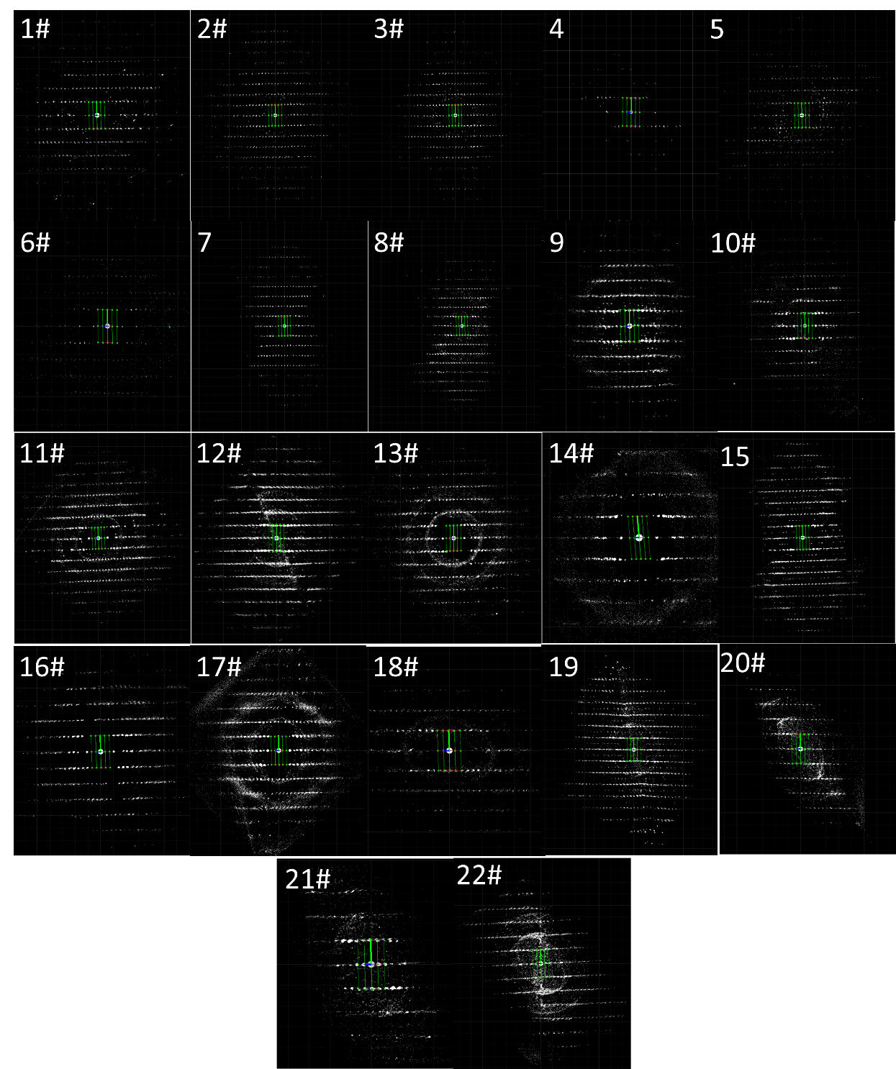
Figure S6 Reconstructed 3D reciprocal lattice from the 22 cRED datasets of E-FCOF-5. The 16 datasets marked with # belong to the selected cluster for structure solution and refinement.

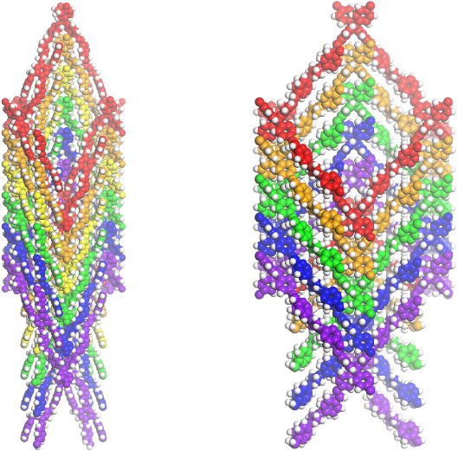
Figure S7 Six-fold interpenetrated pts topology of E-FCOF-5 (left), and C-FCOF-5 (right).
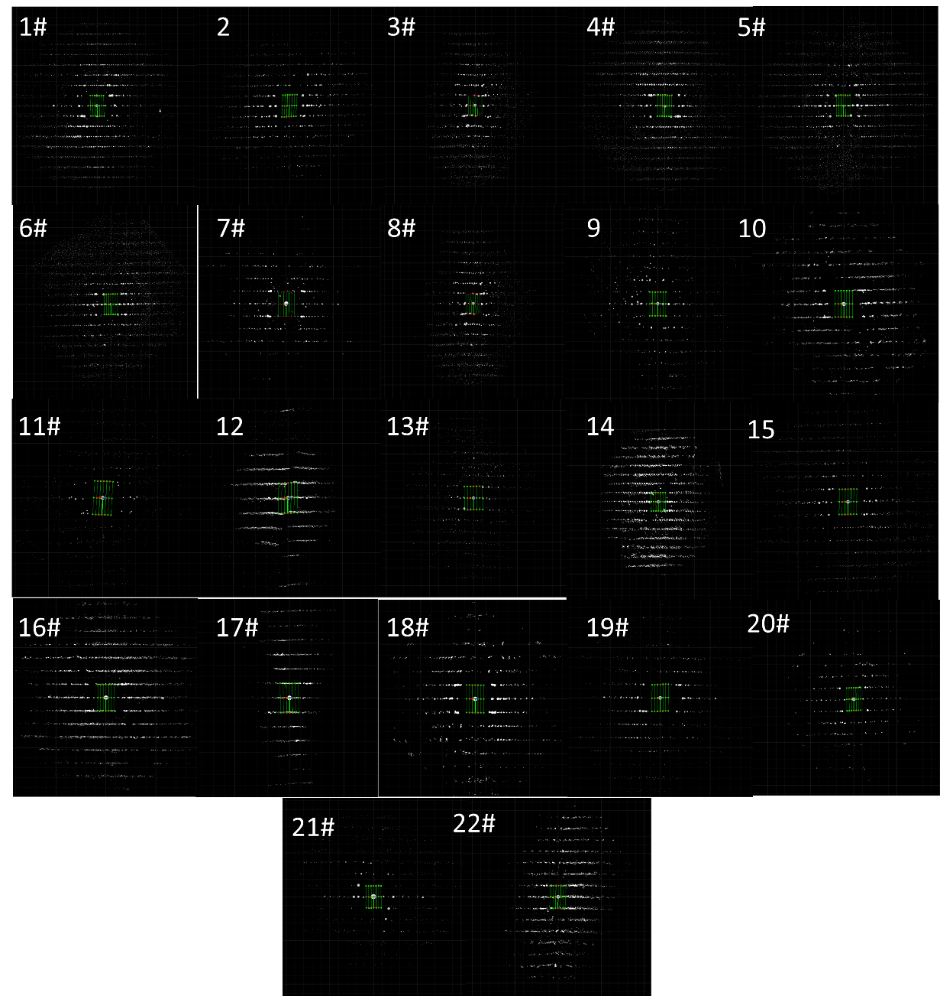
Figure S8 Reconstructed 3D reciprocal lattice from the 22 cRED datasets of C-FCOF-5. The 16 datasets marked with # belong to the selected cluster for structure solution and refinement.
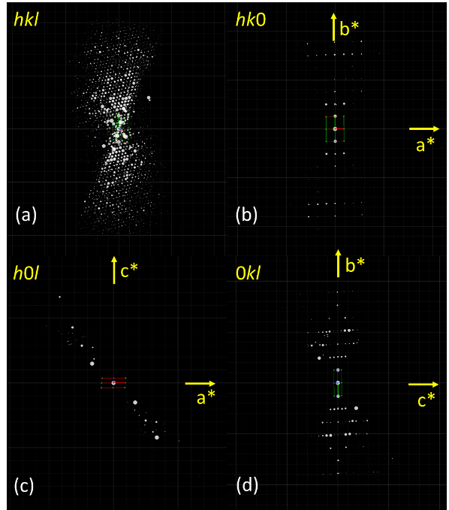
Figure S9 Reconstructed 3D reciprocal lattice of C-FCOF-5. (a) Overview of the reconstructed lattice; (h0l) (b), (0kl) (c), and (hk0) (d) slices cut from the reconstructed reciprocal lattice.
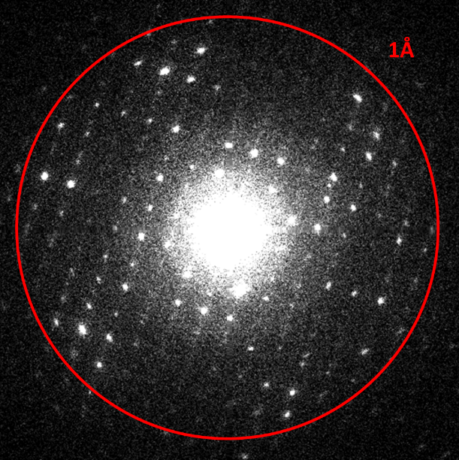
Figure S10 ED pattern of C-FCOF-5 with a high resolution of 0.79Å during cRED data collection.

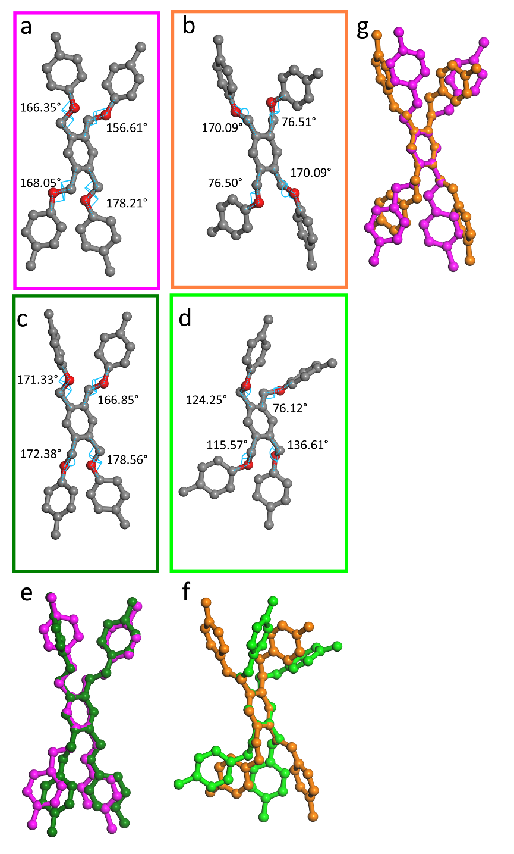
Figure S11 The geometry of TFMB in E-FCOF-5 (a) (e, g, pink) and C-FCOF (b)(f, g, orange) obtained by refinement of cryo-cRED data at atomic resolution (this study). The geometry of TFMB in E-FCOF-5 (c) (e, dark green) and C-FCOF (d)(f, light green) obtained by PXRD simulation (previous study¹). (e) The geometry comparison of TFMB between (a) and (c). (f) The geometry comparison of TFMB between (b) and (d). (g) The geometry comparison of TFMB between (a) and (b).

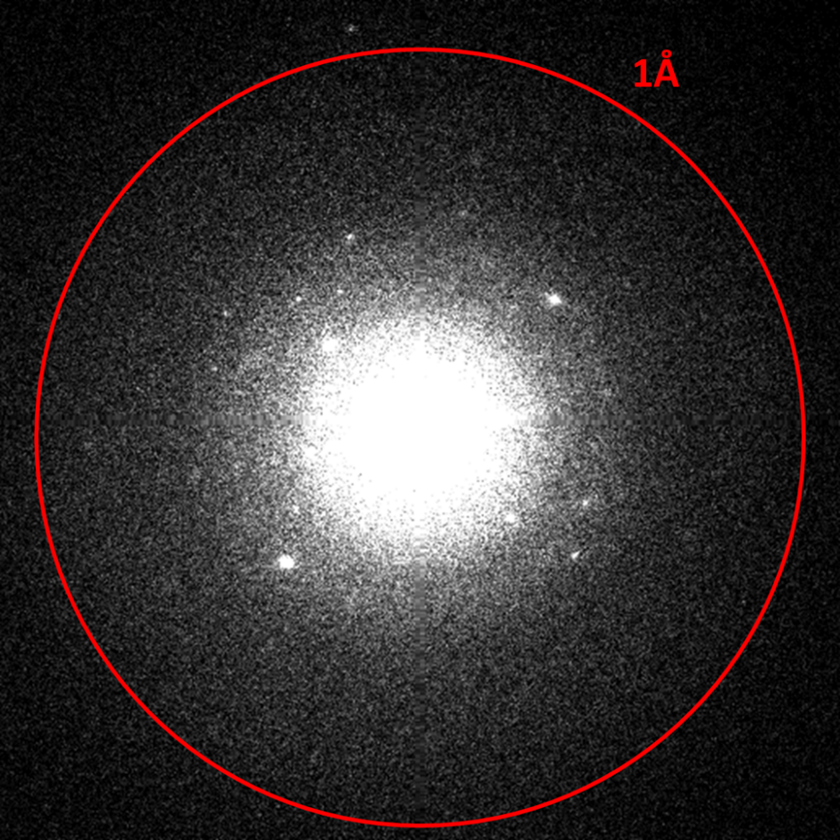
Figure S12 ED pattern of 3D-TPB-COF-OMe with a high resolution of 0.87 Å during cRED data collection
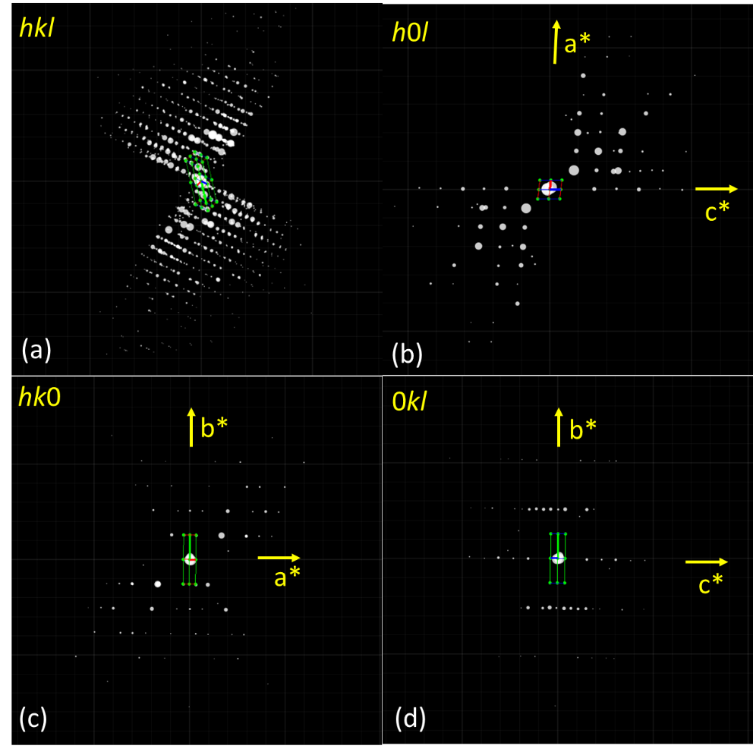
Figure S13 Reconstructed 3D reciprocal lattice of 3D-TPB-COF-OMe. (a) Overview of the reconstructed lattice; (h0l) (b), (0kl) (c), and (hk0) (d) slices cut from the reconstructed reciprocal lattice.
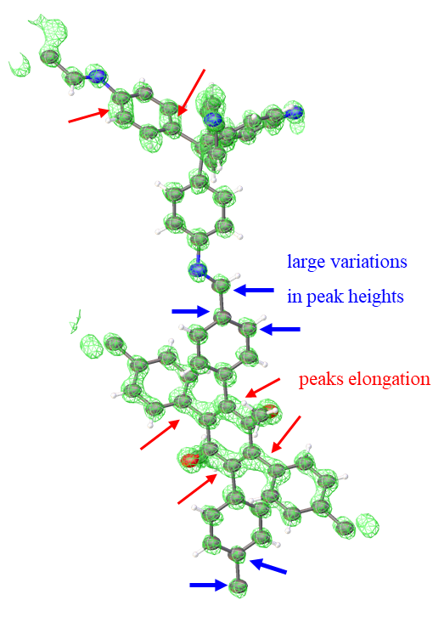
Figure S14 Potential density maps of 3D-TPB-COF-OMe from refinement against on a single dataset (dataset 4# in table S1) with 65.9% completeness.

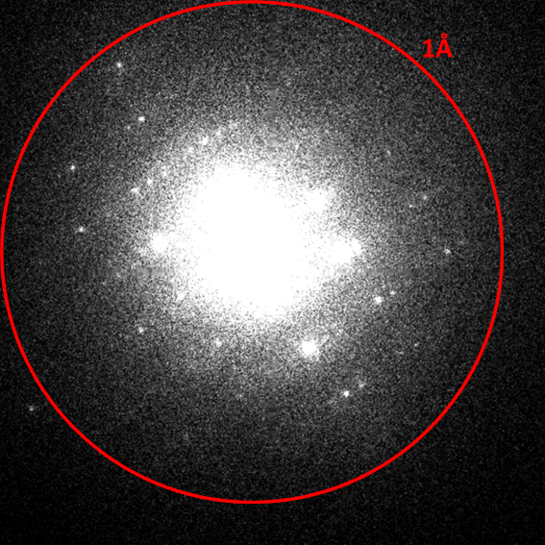
Figure S15 ED pattern of 3D-TPB-COF-Me with a high resolution of 0.90Å during cRED data collection
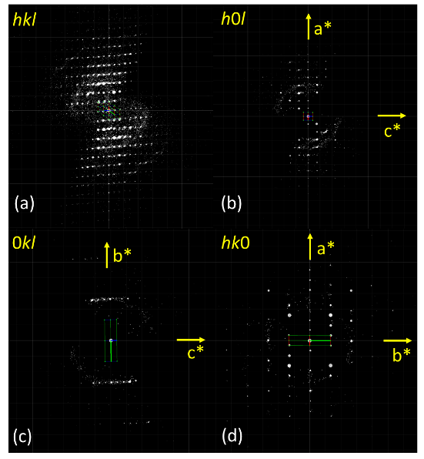
Figure S16 Reconstructed 3D reciprocal lattice of 3D-TPB-COF-Me. (a) Overview of the reconstructed lattice; (h0l) (b), (0kl) (c), and (hk0) (d) slices cut from the reconstructed reciprocal lattice.

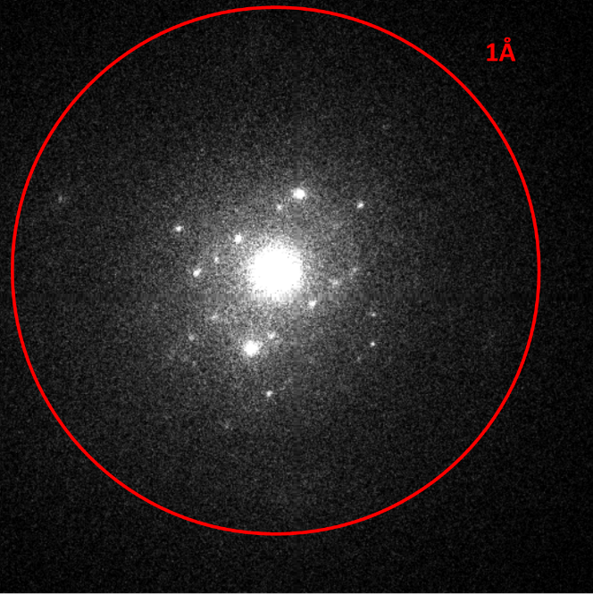
Figure S17 ED pattern of 3D-TPB-COF-OH with a resolution of 1.2Å during cRED data collection.
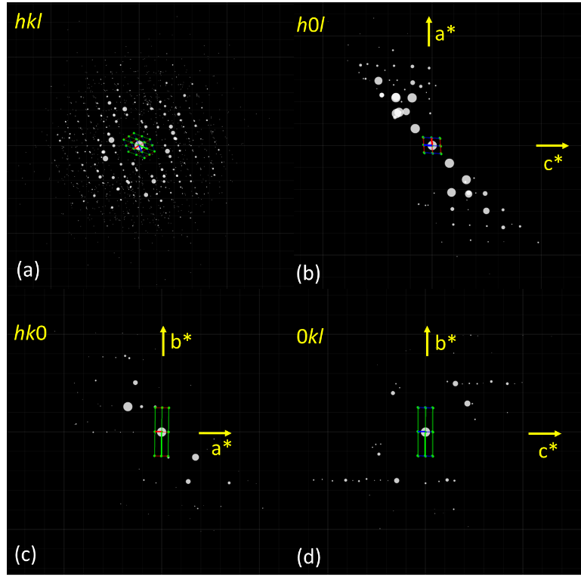
Figure S18 Reconstructed 3D reciprocal lattice of 3D-TPB-COF-OH. (a) Overview of the reconstructed lattice; (h0l) (b), (hk0) (c), and (0kl) (d) slices cut from the reconstructed reciprocal lattice.
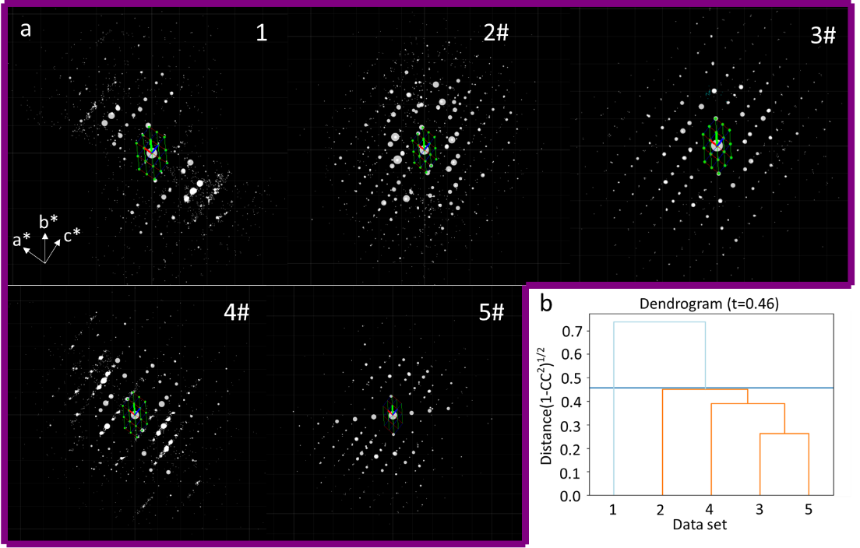
Figure S19 (a) Reconstructed 3D reciprocal lattice from the 5 cRED datasets of 3D-TPB-COF-OH. The datasets marked with # belong to the selected cluster for structure solution and refinement. (b) The cut distance in dendrogram is represented by the blue line at 0.41 for HCA, 4 cRED datasets for 3D-TPB-COF-OH (in orange), which were selected for the structure determination and refinement.
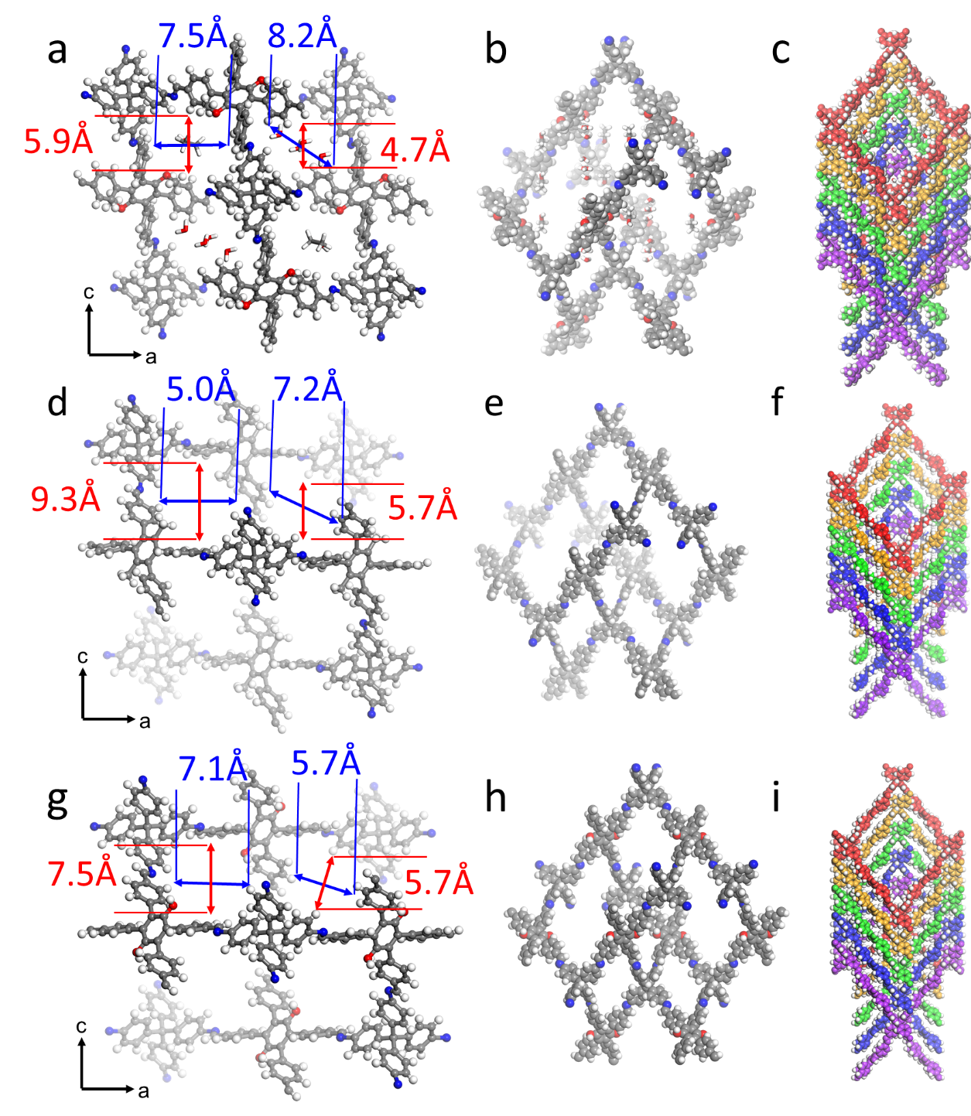

Figure S20 The porous structure of 3D-TPB-COF-OMe (a), 3D-TPB-COF-Me (d) and 3D-TPB-COF-OH(g). Single pts network of 3D-TPB-COF-OMe (b), 3D-TPB-COF-Me (e).and 3D-TPB-COF-OH (h). The five-fold interpenetrated pts topology of 3D-TPB-COF-OMe (c), 3D-TPB-COF-Me (f) and 3D-TPB-COF-OH. Color scheme: C, gray; N, blue; H, white.

Table S1 Summary of the cRED indexing and procession results for the E-FCOF-5 crystals.
Dataset | a (Å) | b (Å) | c (Å) | α (°) | β (°) | γ (°) | Volume  (Å³) | Rotation angle (°) / Data collection time (s) | Completeness (%) | Resolution  (Å) | Redundancy
1# | 14.58 | 8.51 | 26.49 | 90 | 92.97 | 90 | 3282.34 | 74.1/164.3 | 33 | 1.13 | 0.88
2# | 14.58 | 8.61 | 26.23 | 90 | 91.49 | 90 | 3291.62 | 68.5/151.88 | 29 | 1.07 | 0.6
3# | 14.33 | 8.42 | 26.42 | 90 | 91.57 | 90 | 3186.59 | 61.9/137.25 | 32 | 1.16 | 0.7
4 | 13.1 | 8.48 | 26.17 | 90 | 95.57 | 90 | 2893.43 | 61.9/137.25 | 33 | 1.16 | 0.69
5 | 13.39 | 8.78 | 23.85 | 90 | 104.9 | 90 | 2709.06 | 71.5/158.53 | 42 | 0.88 | 0.72
6# | 13.45 | 7.94 | 25.66 | 90 | 93.79 | 90 | 2734.31 | 71.3/158.09 | 35 | 0.85 | 0.77
7 | 13.68 | 8.21 | 27.57 | 90 | 90.94 | 90 | 3096.04 | 75.9/168.29 | 35 | 1.15 | 0.92
8# | 13.36 | 8.42 | 25.2 | 90 | 91.49 | 90 | 2833.81 | 34.3/76.05 | 27 | 1.29 | 0.49
9 | 13.87 | 8.7 | 26.11 | 90 | 90.79 | 90 | 3150.36 | 55.6/123.28 | 37 | 0.89 | 0.63
10# | 13.73 | 8.66 | 26.05 | 90 | 90.17 | 90 | 3097.37 | 73.9/163.85 | 43 | 0.87 | 0.82
11# | 13.52 | 8.67 | 25.93 | 90 | 89.95 | 90 | 3039.47 | 95.2/211.08 | 45 | 0.88 | 1.01
12# | 13.6 | 8.66 | 26.19 | 90 | 90.54 | 90 | 3084.41 | 94.3/209.09 | 45 | 0.88 | 1.01
13# | 13.51 | 8.67 | 26.04 | 90 | 90.37 | 90 | 3050.04 | 46.2/102.43 | 29 | 0.89 | 0.51
14# | 13.52 | 8.63 | 25.99 | 90 | 90.51 | 90 | 3032.32 | 82.4/182.7 | 46 | 0.87 | 0.83
15 | 12.35 | 9.83 | 31.21 | 90 | 89.81 | 90 | 3788.88 | 57.8/128.15 | 33 | 0.89 | 0.42
16# | 13.61 | 8.63 | 26.11 | 90 | 89.73 | 90 | 3066.69 | 78.2/173.39 | 40 | 0.91 | 0.88
17# | 14.18 | 8.6 | 26.02 | 90 | 90.19 | 90 | 3173.07 | 50.5/111.97 | 28 | 0.89 | 0.56
18# | 14.09 | 8.52 | 26.22 | 90 | 91.30 | 90 | 3146.81 | 84.1/186.47 | 46 | 0.88 | 1.04
19 | 13.45 | 9.41 | 28.61 | 90 | 80.52 | 90 | 3571.64 | 62.2/137.91 | 38 | 0.92 | 0.54
20# | 13.95 | 8.53 | 26.02 | 90 | 90.65 | 90 | 3096.01 | 61.8/137.02 | 37 | 0.91 | 0.76
21# | 13.96 | 8.6 | 26.16 | 90 | 92.41 | 90 | 3137.87 | 34.5/76.49 | 25.1 | 0.82 | 0.42
22# | 13.8 | 8.46 | 26.74 | 90 | 90.99 | 90 | 3121.37 | 46.4/102.88 | 23 | 0.87 | 0.51
Datasets marked with # belong to the selected cluster for structure solution and refinement.

Table S2: cRED experimental parameters, crystallographic data, and structure refinement details of E-FCOF-5.

cRED experimental parameters and crystallographic data
Number of datasets | 16
Tilt step | 0.23°
Wavelength | 0.0251 Å
Program for data process | XDS
Program for structure solution | ShelxT
Crystal system | Monoclinic
Unit cell dimensions | a = 13.710(3)Å  b = 8.634(1) Å  c = 26.409(5)Å  β = 91.409(5)°
Possible space group | Pc, P2/c
Resolution | 0.82 Å
Completeness | 96.5%
Redundancy | 9.22
R_{int} | 51.70%
No. of reflections | 66388
No. of unique reflections | 5879
Structure refinement against cRED data
Formula | 2(C₆₃ H₄₆ N₄ O₄), 3(C₂ H₆ O)
Crystal system | Monoclinic
Space group | P2/c
Unit cell dimensions | a = 13.710(3)Å  b = 8.634(1) Å  c = 26.409(5)Å  β = 91.409(5)°
Volume | 3125.2(11)Å³
Z | 1
F(000) | 506
Dataset (h, k, l) | -16~17, -10~10, -30~27
Tot., Uniq. Data, R_{int} | 66388, 5879, 44.72%
Observed Data [Fo > 4sig(Fo)] | 1788
N_{reflections}, N_{parameters}, N_{restraints} | 5879, 134, 26
R₁, wR₂, Gof | 0.3082, 0.6602,1.346
I/𝜎 | 3.7
ρ_{min} / ρ_{max} (e⁻ / Å³) | -0.1/0.1

Table S3 Summary of the cRED datasets indexing and procession results for the C-FCOF-5 crystals.
Dataset | a (Å) | b (Å) | c (Å) | α (°) | β (°) | γ (°) | Volume (Å³) | Rotation angle (°) / Data collection time (s) | Completeness (%) | Resolution (Å) | Redundancy
1# | 10.87 | 7.93 | 27.06 | 90 | 94.14 | 90 | 2326.45 | 51.9/115.07 | 31 | 0.89 | 0.79
2 | 10.86 | 8.42 | 27.54 | 90 | 88.48 | 90 | 2517.41 | 34.3/76.05 | 23 | 0.91 | 0.44
3# | 11.25 | 7.92 | 27.98 | 90 | 96.01 | 90 | 2479.29 | 45.3/100.44 | 31 | 0.88 | 0.76
4# | 10.62 | 7.75 | 27.16 | 90 | 95.63 | 90 | 2224.60 | 66.4/147.22 | 43 | 0.91 | 1.02
5# | 11.43 | 7.94 | 26.59 | 90 | 94.63 | 90 | 2405.25 | 76.6/169.84 | 39 | 0.85 | 1.01
6# | 11.00 | 7.59 | 26.56 | 90 | 94.19 | 90 | 2211.54 | 73.4/162.74 | 38 | 0.88 | 1
7# | 11.43 | 7.48 | 26.51 | 90 | 93.07 | 90 | 2263.24 | 21.3/47.22 | 15 | 0.91 | 0.32
8# | 11.71 | 7.88 | 27.22 | 90 | 98.00 | 90 | 2487.26 | 57/126.38 | 34 | 0.85 | 0.81
9 | 11.2 | 7.84 | 26.94 | 90 | 95.14 | 90 | 2356.03 | 41.1/91.13 | 25 | 0.86 | 0.7
10 | 10.24 | 7.89 | 27.78 | 90 | 94.80 | 90 | 2236.54 | 34.5/76.49 | 20 | 0.92 | 0.37
11# | 11.02 | 7.57 | 27.09 | 90 | 97.46 | 90 | 2240.72 | 45.9/101.77 | 31 | 0.86 | 0.59
12 | 10.69 | 7.5 | 26.64 | 90 | 96.79 | 90 | 2120.86 | 45.6/101.10 | 22 | 0.84 | 0.6
13# | 10.62 | 7.58 | 26.36 | 90 | 97.45 | 90 | 2104.05 | 40.9/90.68 | 23 | 0.87 | 0.54
14 | 10.92 | 7.88 | 26.35 | 90 | 95.15 | 90 | 2258.23 | 57.3/127.05 | 29 | 0.85 | 0.68
15 | 10.27 | 8.43 | 26.79 | 90 | 94.38 | 90 | 2312.58 | 47.2/104.65 | 29 | 0.82 | 0.42
16# | 10.88 | 7.55 | 26.42 | 90 | 94.28 | 90 | 2164.17 | 81.1/179.82 | 46 | 0.87 | 1.04
17# | 10.71 | 7.55 | 27.32 | 90 | 92.44 | 90 | 2207.10 | 41.6/92.23 | 25 | 0.85 | 0.57
18# | 11.68 | 8.07 | 26.71 | 90 | 96.98 | 90 | 2498.96 | 64.7/143.45 | 38 | 0.86 | 0.96
19# | 11.00 | 7.69 | 25.85 | 90 | 95.03 | 90 | 2178.20 | 57.6/127.71 | 33 | 0.9 | 0.81
20# | 10.94 | 7.71 | 26.26 | 90 | 97.13 | 90 | 2197.80 | 34.3/76.05 | 24 | 0.92 | 0.53
21# | 10.76 | 7.72 | 25.9 | 90 | 96.84 | 90 | 2136.11 | 45.4/100.66 | 32 | 0.79 | 0.65
22# | 10.8 | 7.59 | 27.04 | 90 | 97.33 | 90 | 2198.38 | 45.6/101.10 | 29 | 0.88 | 0.71
Datasets marked with # belong to the selected cluster for structure solution and refinement.

Table S4 cRED experimental parameters, crystallographic data, and structure refinement details of C-FCOF-5.

cRED experimental parameters and crystallographic data
Number of datasets | 16
Tilt step | 0.23°
Wavelength | 0.0251 Å
Program for data process | XDS
Program for structure solution | ShelxT
Crystal system | Monoclinic
Unit cell dimensions | a = 10.9511(2) Å  b = 7.7945(1) Å  c = 26.8214(6) Å  β = 95.247(3)°
Possible space group | Pc, P2/c
Resolution | 0.81 Å
Completeness | 94%
Redundancy | 10.0
R_{int} | 47.91%
No. of reflections | 49801
No. of unique reflections | 3973
Structure refinement against cRED data
Formula | C₁₂₆H₉₂N₈O₈
Crystal system | Monoclinic
Space group | P2/c
Unit cell dimensions | a = 10.9511(2) Å  b = 7.7945(1) Å  c = 26.8214(6) Å  β = 95.247(3)°
Volume | 2279.85(8) Å³
Z | 1
F(000) | 506
Dataset (h, k,l) | -13~13, -8~8, -31~29
Tot., Uniq. Data, R_{int} | 49801, 3973, 47.91%
Observed reflections [Fo > 4sig(Fo)] | 2035
N_{reflections}, N_{parameters}, N_{restraints} | 3973, 273, 0
R₁, wR₂, Gof | 0.2192, 0.5377,1.437
I/𝜎 | 3.5
ρ_{min} / ρ_{max} (e⁻ / Å³) | -0.3/0.2

Table S5 Summary of the cRED datasets indexing and procession results for all the 3D-TPB-COF-OMe crystals.

Dataset | a (Å) | b (Å) | c (Å) | α (°) | β (°) | γ (°) | Volume (Å³) | Rotation angle (°) / Data collection time (s) | Completeness (%) | Resolution (Å) | Redundancy
1 | 30.62 | 7.82 | 26.03 | 90 | 97.42 | 90 | 6180.55 | 53.36 | 37 | 0.83 | 0.67
2 | 31.54 | 7.62 | 26.13 | 90 | 96.11 | 90 | 6244.27 | 47.01 | 34.4 | 0.82 | 0.58
3 | 31.09 | 7.59 | 26.9 | 90 | 93.95 | 90 | 6332.52 | 87.50 | 54.7 | 0.79 | 0.95
4# | 30.62 | 7.67 | 26.4 | 90 | 96.17 | 90 | 6164.24 | 103.25 | 65.9 | 0.87 | 1.55
5# | 30.6 | 7.68 | 25.97 | 90 | 97.47 | 90 | 6051.23 | 103.39 | 63.9 | 0.88 | 1.62
6 | 31.04 | 7.65 | 25.94 | 90 | 96.78 | 90 | 6116.49 | 96.74 | 64.1 | 0.86 | 1.48
7 | 30.75 | 7.75 | 25.97 | 90 | 97.29 | 90 | 6138.89 | 10.56 | 10 | 0.87 | 0.14
8# | 31.13 | 7.65 | 25.89 | 90 | 97.28 | 90 | 6115.73 | 19.26 | 17.1 | 0.87 | 0.28
9# | 30.48 | 7.73 | 26.18 | 90 | 96.66 | 90 | 6126.60 | 71.30 | 57.8 | 0.87 | 1.06
10# | 30.86 | 7.77 | 25.94 | 90 | 97.14 | 90 | 6171.63 | 92.52 | 60.2 | 0.88 | 1.49
11# | 30.68 | 7.75 | 25.8 | 90 | 96.53 | 90 | 6094.65 | 37.57 | 32.6 | 0.89 | 0.61
Datasets marked with # belong to the selected cluster for structure solution and refinement.

Table S6 cRED experimental parameters, crystallographic data, and structure refinement details of 3D-TPB-COF-OMe

cRED experimental parameters and crystallographic data
Number of datasets | 6 | 1
Tilt step | 0.23° | 0.23°
Wavelength | 0.0251 Å | 0.0251 Å
Program for data procession | XDS | XDS
Program for structure solution | ShelxT | ShelxT
Crystal system | Monoclinic | Monoclinic
Unit cell dimensions | a = 30.705(6) Å  b = 7.715(1) Å  c = 26.113(5)Å  β = 96.76(3)° | a = 30.705(6) Å  b = 7.715(1) Å  c = 26.113(5)Å  β = 96.76(3)°
Possible space group | Cc, C2/c | Cc, C2/c
Resolution | 0.79 Å | 0.86 Å
Completeness | 91.8% | 65.9%
Redundancy | 8.43 | 1.55
R_{int} | 41.36% | 13.78%
No. of reflections | 54798 | 7657
No. of unique reflections | 5186 | 3562
Structure refinement against cRED data
Formula | C₆₁H₄₂N₄O₂, 2(C_{1.08}H_{3.70}O_{0.54}), 4(H2O) | C₆₁H₄₂N₄O₂
Crystal system | Monoclinic | Monoclinic
Space group | C2/c | C2/c
Unit cell dimensions | a = 30.705(6) Å  b = 7.715(1) Å  c = 26.113(5)Å  β = 96.76(3)° | a = 30.705(6) Å  b = 7.715(1) Å  c = 26.113(5)Å  β = 96.76(3)°
Volume | 6143(2)Å³ | 6143(2)Å³
Z | 4 | 4
F(000) | 1037 | 1037
Dataset (h, k, l) | -36~36/-8~8/-30~28 | -26~27/-8~8/-27~28
Tot., Uniq. Data, Rint | 54798, 5186, 41.36% | 7657,3562,13.78%
Observed reflections [Fo > 4sig(Fo)] | 2001 | 705
N_{reflections}, N_{parameters}, N_{restraints} | 5186,256, 16 | 3562,58, 17
R₁, wR₂, Gof | 0.2280, 0.5606,1.356 | 0.2478, 0.5935,1.161
I/𝜎 | 4.8 | 4.5
ρ_{min} / ρ_{max} (e⁻ / Å³) | -0.2/0.2 | -0.2/0.2

Table S7 Summary of the cRED datasets indexing and procession results for all the 3D-TPB-COF-Me crystals.

Dataset | a (Å) | b (Å) | c (Å) | α (°) | β (°) | γ (°) | Volume (Å³) | Rotation angle (°) / Data collection time (s) | Completeness (%) | Resolution (Å) | Redundancy
1 | 30.67 | 7.67 | 26.72 | 90 | 91.07 | 90 | 6284.48 | 120.7/267.62 | 69 | 0.90 | 1.32
2 | 30.76 | 7.62 | 26.89 | 90 | 90.61 | 90 | 6302.41 | 89.5/198.44 | 56 | 0.91 | 1.44
3# | 30.98 | 7.64 | 26.77 | 90 | 90.67 | 90 | 6335.67 | 124.3/275.60 | 67 | 0.90 | 1.31
4# | 31.01 | 7.72 | 26.49 | 90 | 90.26 | 90 | 6341.56 | 124.5/276.05 | 59 | 0.90 | 1.35
5# | 30.98 | 7.67 | 26.81 | 90 | 90.14 | 90 | 6370.48 | 112.8/250.11 | 64 | 0.92 | 1.36
6# | 30.95 | 7.69 | 26.37 | 90 | 89.82 | 90 | 6276.17 | 120.9/268.07 | 64 | 0.90 | 1.34
7# | 30.95 | 7.65 | 26.55 | 90 | 89.85 | 90 | 6286.15 | 106.1/235.25 | 61 | 0.90 | 1.32
8# | 31.38 | 7.62 | 26.13 | 90 | 90.06 | 90 | 6248.08 | 104.5/231.70 | 54 | 0.90 | 1.22
Datasets marked with # belong to the selected cluster for structure solution and refinement.

Table S8 cRED experimental parameters, crystallographic data, and structure refinement details of 3D-TPB-COF-Me

cRED experimental parameters and crystallographic data
Number of datasets | 6
Tilt step | 0.23°
Wavelength | 0.0251 Å
Program for data procession | XDS
Program for structure solution | ShelxT
Crystal system | Monoclinic
Unit cell dimensions | a = 30.987(6) Å  b = 7.666(1)Å  c = 26.549(5)Å  β = 90.27(3)°
Possible space group | Cc, C2/c
Resolution | 0.8 Å
Completeness | 99.7%
Redundancy | 8.65
R_{int} | 38.88%
No. of reflections | 67595
No. of unique reflections | 6195
Structure refinement against cRED data
Formula | C₆₁ H₄₂ N₄
Crystal system | Monoclinic
Space group | C2/c
Unit cell dimensions | a = 30.987(6) Å  b = 7.666(1)Å  c = 26.549(5)Å  β = 90.27(3)°
Volume | 6307(2) Å³
Z | 4
F(000) | 1024
Dataset (h, k, l) | -37~38/-9~9 -30~32
Tot., Uniq. Data, Rint | 67595, 6195, 38.88%
Observed reflections [Fo > 4sig(Fo)] | 2076
N_{reflections}, N_{parameters}, N_{restraints} | 6195,187, 12
R₁, wR₂, Gof | 0.2114, 0.5368,1.15
I/𝜎 | 4.2
ρ_{min} / ρ_{max} (e⁻ / Å³) | -0.2/0.2

Table S9 Summary of the cRED datasets indexing and procession results for the 3D-TPB-COF-OH crystals.

Dataset | a (Å) | b (Å) | c (Å) | α (°) | β (°) | γ (°) | Volume (Å³) | Rotation angle (°) / Data collection time (s) | Completeness (%) | Resolution (Å) | Redundancy
1 | 29.52 | 7.81 | 25.97 | 90 | 92.976 | 90 | 5979.33 | 105.34 | 65.6 | 0.81 | 1.10
2# | 28.82 | 8.01 | 26.02 | 90 | 95.857 | 90 | 5975.31 | 106.67 | 72.1 | 0.81 | 1.20
3# | 29.08 | 7.94 | 26.36 | 90 | 95.855 | 90 | 6054.64 | 126.23 | 79.5 | 0.82 | 1.42
4# | 28.97 | 7.96 | 26.11 | 90 | 96.798 | 90 | 5978.66 | 98.28 | 62.9 | 0.82 | 1.11
5# | 29.45 | 7.83 | 27.28 | 90 | 95.948 | 90 | 6256.72 | 80.23 | 46.8 | 0.79 | 0.78
Datasets marked with # belong to the selected cluster for structure solution and refinement.

Table S10 cRED experimental parameters, crystallographic data, and structure refinement details of 3D-TPB-COF-OH.

cRED experimental parameters and crystallographic data
Number of datasets | 4
Tilt step | 0.23°
Wavelength | 0.0251 Å
Program for data procession | XDS
Program for structure solution | ShelxT
Crystal system | Monoclinic
Unit cell dimensions | a = 29.550(6) Å  b = 7.842(1) Å  c = 26.730(5)Å  β = 96.86(3)°
Possible space group | Cc, C2/c
Resolution | 0.8 Å
Completeness | 95.5%
Redundancy | 16.32
R_{int} | 42.33%
No. of reflections | 30380
No. of unique reflections | 5517
Structure refinement against cRED data
Formula | C₅₉ H₃₈ N₄ O₂
Crystal system | Monoclinic
Space group | C2/c
Unit cell dimensions | a = 29.550(6) Å  b = 7.842(1) Å  c = 26.730(5)Å  β = 96.86(3)°
Volume | 6150(2)Å³
Z | 4
F(000) | 1007
Dataset (h, k, l) | -34~32/ -9~9/ -33~30
Tot., Uniq. Data, R_{int} | 30380, 5517, 42.33%
Observed reflections [Fo > 4sig(Fo)] | 679
N_{reflections}, N_{parameters}, N_{restraints} | 5117, 55, 22
R₁, wR₂, Gof | 0.2603, 0.6391,0.863
I/𝜎 | 2.3
ρ_{min} / ρ_{max} (e⁻ / Å³) | -0.2/0.2

Section 2: Reference
1, X. Liu, J. Li, B. Gui, G. Lin, Q. Fu, S. Yin, X. Liu, J. Sun, C. Wang, J. Am. Chem. Soc. 2021, 143, 2123-2129.

